Software Specification Document

OpenOffice.org Impress
Object Selection Positioning and Modification

Specification Status
Last Change | Feb 10, 2010
Status
Abstract
Object selection, positioning, and modification will be reworked to improve interaction with user. This specification only describes changes from the current OpenOffice.org 3.2 behavior.
i-Team Members
Role | First Name, Last Name, Initials | E-Mail Address
I-Team Lead | Andreas Bartel (AB) | andreas.bartel@sun.com
Specification Author | Frank Loehmann (FL) | frank.loehmann@sun.com
User Experience | Frank Loehmann (FL) | frank.loehmann@sun.com
Development | Andre Fischer (AF) | andre.fischer@sun.com
Quality Assurance | Wolfram Garten (WG)  Christoph Lukasiak (CLU) | wolfram.garten@sun.com  christoph.lukasiak@sun.com
Accessibility | Wolfram Garten (WG) | wolfram.garten@sun.com
Documentation | Uwe Fischer (UFI) | uwe.fischer@sun.com
Other roles

Contents
Abstract 1
i-Team Members 1
References and Reference Documents 3
Acronyms and Abbreviations 3
1 Detailed Specification 4
1.1 All Applications 4
1.1.1 Changes to Object Creation Behavior 4
1.1.2 Changes to Object Selection Behavior (24048, 72551) 4
1.1.2.1 Document in Edit Mode 4
1.1.2.2 Protected Shapes or Document in Read-Only Mode 5
1.1.2.3 Object Without Filling 6
1.1.2.4 Multi-Selection Behavior 6
1.1.2.5 Selection Frame 7
1.1.3 Changes to Objects Handling/Modification 8
1.1.3.1 New Object Handles 8
1.1.3.2 Creating Shapes on Already Selected Shapes 9
1.1.3.3 Activating the Text Edit Mode for an Object 9
1.2 Impress & Draw 10
1.2.1 Changes to Object Selection 10
1.2.1.1 Leave Grouped Objects 10
1.2.1.2 Text Edit Mode for Objects 10
1.2.1.3 Table 10
1.2.1.4 Object Rotation 10
1.2.2 Changes to Objects Handling/Modification 10
1.2.2.1 Duplicate Objects 10
1.2.2.2 Make Objects Same Size 10
1.2.2.3 Alignment 10
1.2.2.4 Table 10
1.2.2.5 Visual Aids 10
2 Accessibility 11
3 Migration 11
4 Configuration 11
5 File Format 11
6 Open Issues 11
Document Change History 12

References and Reference Documents
Reference Document | Check | Location (URL)
Specification Process Entry Check |  | N/A
Product Requirement, RFE, issue [Required] |  | I??????
Accessibility Check [Required] |  | See section 2 Accessibility below
Product Concept Document |  | http://so-doc/Projects/Renaissance/1_Planning/Renaissance_UI_Complexity_Reduction_Impress.odt
Competitive Analysis |  | <Please enter location here>
IDL Specification |  | <Please enter location here>
Test Case Specification [Required] |  | <Please enter location here>
Software Specification Rules | N/A | N/A
<Other, e.g. references to related specs>
Acronyms and Abbreviations
Acronym / Abbreviation | Definition
<WYSIWYG> | <What You See Is What You Get>

Detailed Specification

All Applications

Changes to Object Creation Behavior
Shapes can be created by drawing them while left mouse button is pressed. A single click into the document/presentation creates a default sized object of the currently chosen type. This is the same behavior like hitting return on a selected shape tool in the toolbar.

Changes to Object Selection Behavior (24048, 72551)
The cursor always gives direct feedback about the current mode/state and allows the user to select any object that is not part of the current selection. The behavior is valid for all modes (rotation, edit points, normal selection). Mouse pointer feedback for object handles is kept unchanged.

Document in Edit Mode
If a document is in edit mode the following cursors are shown when moving the cursor above a shape.
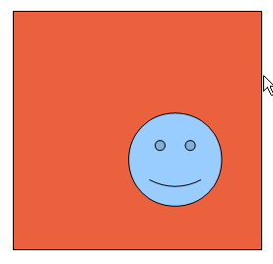Illustration 1: Selection cursor beside any shape
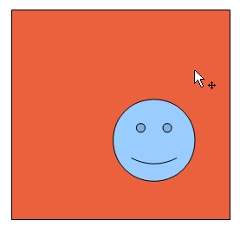Illustration 2: Select to move cursor if shape is unselected
Note: The standard selection cursor looks different in Writer.
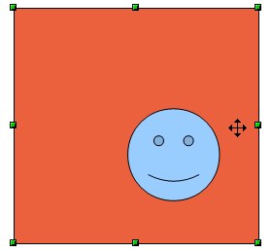Illustration 3: Move cursor over an already selected object
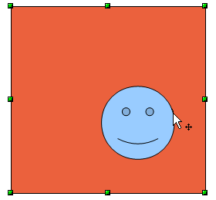Illustration 4: Select to move cursor onto unselected object above a selected shape.
Note: An unselected object can be selected at any time. The mouse pointer gives feedback like shown in Illustration 4. The present selection will be withdrawn automatically while selecting the new object.

Protected Shapes or Document in Read-Only Mode
If a shape has a protected position (protected attribute or protected layer) or the document itself is in read-only mode, the cursor is a selection only cursor because the shape cannot be moved. Furthermore the handles show a stop sign on mouse over (already implemented).
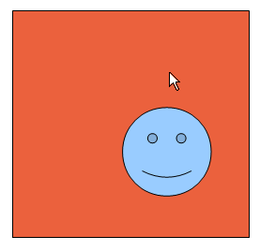Illustration 5: Select cursor if shape is unselected
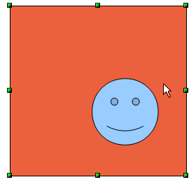Illustration 6: Select cursor over an already selected object

Object Without Filling
Selectable area for unfilled objects will be extended to 5 pixel (if the border is thinner) to make selecting the shape easier.
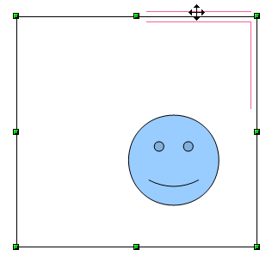Illustration 7: Extended selection area for outline objects

Multi-Selection Behavior
A multi-selection of objects shows handles for each selected object. (50209) A modification, made by any handle, will be applied to all selected object in the same way (i.e. rotating the smiley will rotate all the selected rectangles too), but the multi selection will not be handles like a grouped object. anymore.
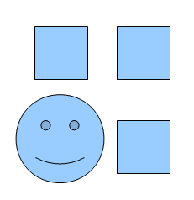Illustration 8: Multiple unselected shapes
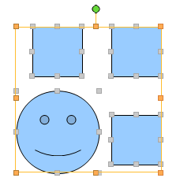
Illustration 9: Selection of multiple shapes (New proposal A)

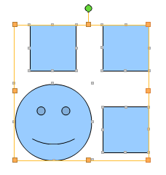
Illustration 10: Selection of multiple shapes (New proposal B)
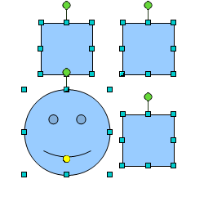
Illustration 11: Selection of multiple shapes (old proposal)

Selection Frame
The selection frame now shows a transparent filling like in Writer and Calc.
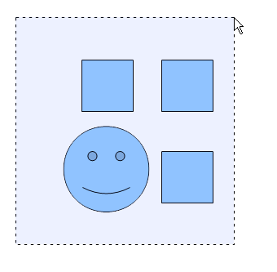Illustration 12: The selection frame shows a transparent filling

Changes to Objects Handling/Modification

New Object Handles

Handle Style
The new object handles are flat without any 3D effect. See illustration below for details.
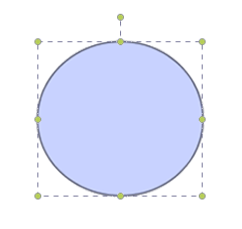Illustration 13: Proposal FL1
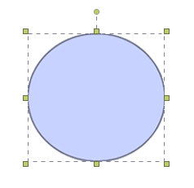Illustration 14: Proposal FL2

New Rotation Handle
Furthermore a new rotation handle is shown at the upper side of an object, connected by a line to the center handle like shown below. The rotation point is set to the middle of an object by default.
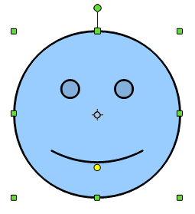Illustration 15: Proposal for new rotation handle
The separate rotation mode is kept to keep the distort functionality, but the button will be removed from the Impress toolbar by default.

Creating Shapes on Already Selected Shapes
If a drawing tool (i.e. rectangle) is chosen from the toolbar, the new shape can also be created above an already selected shape. The selection of this shape will be withdrawn, as soon as the creation of the new shape has been finished. Then the new shape is selected.

Activating the Text Edit Mode for an Object

Text Edit Mode for Textboxes
If the text box tool has been chosen, the user has to click on a shape to start the edit mode, even if a shape is already selected. This is done for consistency reasons.
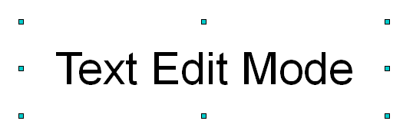Illustration 16: Selected text object (not in edit mode)
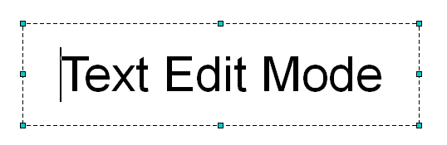Illustration 17: Text box in edit mode (text box with invisible outline)
- No flickering on entering leaving text mode
- Text alignment within text boxes or other shapes should work from the Text Format toolbar

Text Edit Mode for Shapes
A double click on an object enters the text edit mode
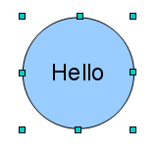Illustration 18: Selected shape with text
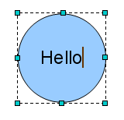Illustration 19: Shape in edit mode
- A transparent background for text is used. So if the text exceeds the shape or the shape has an advanced fill like gradients, the text is always shown WYSIWYG.
- TBD: WYSIWYG text edit mode for rotated text
  - because selection of rotated objects with text not possible.
- Wrap text automatically if it becomes larger than the shape it is?

Impress & Draw

Changes to Object Selection

Leave Grouped Objects
- Add a direct interaction to enter/leave a group object

Text Edit Mode for Objects

Table
- Unnecessary flickering when selecting cell via mouse.

Object Rotation
- Selection of rotated objects with text not possible.

Changes to Objects Handling/Modification

Duplicate Objects
- Allow duplicate object via context menu and shortcut (+ space bar while moving)

Make Objects Same Size
- Make objects same size (54281)

Alignment
- Text alignment within text boxes or other shapes should work from the Text Format toolbar
- TBD: Wrap text automatically if it becomes larger than the shape it is in
- Display snapping orientation/guiding lines for positioning and alignment of all objects

Table
- Resize table rows & columns equally.

Visual Aids
- Display visual aid to
  - create a circle from an oval
  - create a square from a rectangle
  - create a triangle with equal sides
- Add visual aid that helps rotating objects (by e.g. 15° steps)

Accessibility
Accessibility is the responsibility of the I-Team, beginning with UX, DEV and QA, to ensure that the following requirements are fulfilled:
- Is the feature fully keyboard accessible?
(Ex: “I can go everywhere and use every function using the keyboard only”)
<Start typing here>
- Have I specified visual alternatives for the case that the specified feature includes audio as output?
<Start typing here>
- Are text alternatives for all icons and graphics available?
<Start typing here>
- Don't provide important information in colors alone
(Ex: marking important information hard coded in red)
<Start typing here>
- Does the specified feature respect system settings for font, size, and color for all windows and user interface elements?
<Start typing here>
- Have I ensured that flash rates do not exceed 2 hertz for blinking text, objects, or other elements? In any case, try to avoid flashing UI elements
<Start typing here>
- Ensure that assistive technology(AT) (like ZoomText or Orca) is able to read everything.
<Start typing here>

Migration
<Start typing here ----- If this part is irrelevant state a reason for its absence!>

Configuration
<Start typing here ----- If this part is irrelevant state a reason for its absence!>

File Format
<Start typing here ----- If this part is irrelevant state a reason for its absence!>

Open Issues
Issue | Initials | Date
<State Issue here, State “None”, if all issues are solved> |  | <Format: Dec 31, 2000>
<...> |  | <Format: Dec 31, 2000>

Document Change History
Rev. | Change | Initials | Date
1 | Initial Specification | FL | December 07, 2009
2 | Update Mock-ups | FL | December 08, 2009
3 | Adjust Spec Outline | FL | December 17, 2009
4 | Re-size, rotation | FL | January 4, 2009
5 | Handles | FL | January 7, 2009
6. | Multi selection | FL | January 8, 2009

