Software Specification Document

OpenOffice.org Impress
Slide View, Preview and Sorter Rendering

Specification Status
Last Change | Feb 10, 2010
Status
Abstract
Rendering of the Slide view with preview or Outline and Sorter in Impress will be reworked to make better use of screen real estate, to improve visibility of selections and to give appropriate feedback to users.
i-Team Members
Role | First Name, Last Name, Initials | E-Mail Address
I-Team Lead | Andreas Bartel (AB) | andreas.bartel@sun.com
Specification Author | Frank Loehmann (FL) | frank.loehmann@sun.com
User Experience | Frank Loehmann (FL) | frank.loehmann@sun.com
Development | Andre Fischer (AF) | andre.fischer@sun.com
Quality Assurance | Wolfram Garten (WG)  Christoph Lukasiak (CLU) | wolfram.garten@sun.com  christoph.lukasiak@sun.com
Accessibility | Wolfram Garten (WG) | wolfram.garten@sun.com
Documentation | Uwe Fischer (UFI) | uwe.fischer@sun.com
Other roles

Contents
Abstract 1
i-Team Members 1
References and Reference Documents 3
Acronyms and Abbreviations 3
1 Detailed Specification 4
1.1 General Changes 4
1.1.1 Removed Mode Tabs 4
1.2 Slide View 4
1.2.1 Default Zoom & View 4
1.2.2 Scrollbars 5
1.2.2.1 Horizontal 5
1.2.2.2 Vertical 5
1.2.2.3 Page Up/Down Buttons 5
1.2.3 Panes 6
1.2.3.1 Slide Preview Pane 6
1.2.3.2 Tasks Pane 8
1.2.3.3 Speaker Notes Pane 9
1.3 Outline View 10
1.4 Slide Sorter View 11
1.5 High Contrast Mode 11
1.5.1 Color Configuration 12
1.6 Slide Navigation in Slide View, Preview Sorter and Presentation 13
2 Accessibility 13
3 Migration 14
4 Configuration 14
5 File Format 14
6 Open Issues 14
Document Change History 14

References and Reference Documents
Reference Document | Check | Location (URL)
Specification Process Entry Check |  | N/A
Product Requirement, RFE, issue [Required] |  | i107215
Accessibility Check [Required] |  | See section 2 Accessibility below
Product Concept Document |  | http://so-doc/Projects/Renaissance/1_Planning/Renaissance_UI_Complexity_Reduction_Impress.odt
Competitive Analysis |  | <Please enter location here>
IDL Specification |  | <Please enter location here>
Test Case Specification [Required] |  | <Please enter location here>
Software Specification Rules | N/A | N/A
<Other, e.g. references to related specs>
Acronyms and Abbreviations
Acronym / Abbreviation | Definition
<WYSIWYG> | <What You See Is What You Get>

Detailed Specification

General Changes

Removed Mode Tabs
The view mode tabs for Notes and Handout will be dropped. Notes functionality moves to an additional pane at the bottom. See below for a Slide view mock-up showing the new speaker notes pane.

Slide View
Rendering of the Slide View (previously called Normal) in Impress will be reworked to make better use of screen real estate and to provide better visibility and feedback..
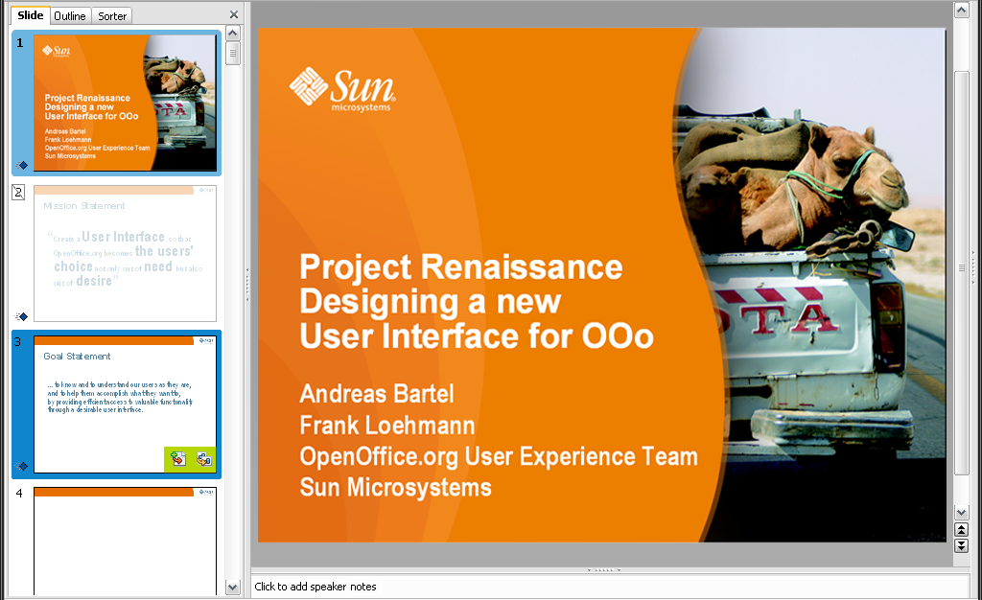Illustration 1: Slide view with less modes and a new notes pane at the bottom.
The Normal view gets renamed to Slide.
- “Mode Tabs” - Label Properties |  | Comment
Label : | Slide | EN-US

Default Zoom & View
The Slide view is the default view and always comes up with a zoom set to Zoom to Page by default. This ensures that the whole slide is visible at any time. This makes resizing of the Slide Sorter and/or the whole application window much more comfortable.

Scrollbars

Horizontal (62210, 62210, 92069)
The horizontal scrollbar is not shown if the complete slide and all objects beside the slides are visible in current view.

Vertical
TBD

Page Up/Down Buttons
The vertical scrollbar shows page up and down buttons at the lower end of the vertical scrollbar.

Panes

Slide Preview Pane
Rendering of the Slide Sorter in Impress will be reworked to make better use of screen real estate. Default settings are designed to work best with a screen resolution of 1024*764 and higher. Lower resolutions like typically found on Netbooks should not totally break the functionality, but might not be optimal for use with Impress.
Current slide
Gradient from
#B7DAF0 to #6DB5E1
Normal slide preview
Slide on mouse over
Gradient from
#0E85CD to # 044C99
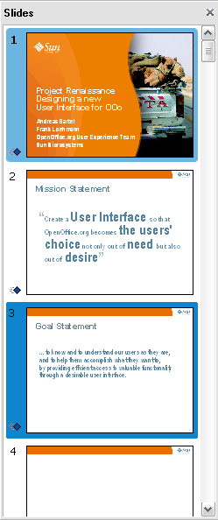Illustration 2: Slide sorter showing different types of selections in a screen resolution of 1024*768

Slide Frame Colors
The slide highlighting frame has a solid borders and the slide shows a shadow.
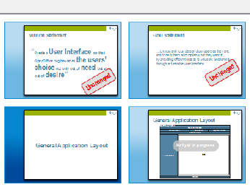Illustration 3: Colors and shadow
Left, right, bottom color: #0E85CD
Upper border color: #6DB5E1

Slide Frame Size

Mock-up
<Andeas>

Default Size
TBD

Maximum Size
TBD (half window size?)

Resizing
The Slide Preview size can be resized by dragging the divider between Slide Preview and Slide view area. The automatic two column slide preview mode has been removed.
The slide previews will be recalculated asynchronously to provide a good image quality at any time.

Selection Visualization

Normal Slide
See 1.2.3.1 Slide Preview Pane on page 6 for a detailed illustration.

Current Slide
See 1.2.3.1 Slide Preview Pane on page 6 for a detailed illustration.

Hidden Slide
A hidden slide is shown grayed out like shown in the mock-up below.
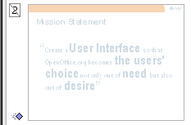Illustration 4: Hidden slide

Multi Selection of Slides
A multi selection of slides is shown in mouse over highlighting. See 1.2.3.1 Slide Preview Pane on page 6 for a detailed illustration.

Slide Mouse Over
See 1.2.3.1 Slide Preview Pane on page 6 for a detailed illustration.

Tasks Pane
The Tasks pane will not be shown by default, but could still be opened manually. This saves more screen real estate that can be used to show the current slide. Functionality (i.e. Slide Layout, Slide Design) of the Tasks pane will be made accessible via menu buttons in the toolbar.
Issues:
- Issue: A hidden task pane reappears on insert a page (95600, 69328)
- Focus change from menu to a pane is hardly visible. Especially if the category is already shown. (61690, 105273)
- Proposal: Scrolling in slide sorter pane should be very smooth. (54334)
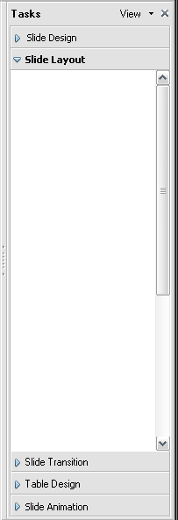Illustration 5: Tasks pane

- “Tasks Pane” - Label Properties |  | Comment
- Label : | Slide Design | EN-US
- Label : | Slide Layout | EN-US
- Label : | Slide Transition | EN-US
- Label : | Table Design | EN-US
- Label : | Shape Animation | EN-US

Speaker Notes Pane
A new Speaker Notes pane is shown at the bottom of the Slide View and replaces the old separated view mode. This pane can be hidden by minimizing it, but it is shown by default. See 1.2 Slide View on page 4 for mock-up of the new notes pane.
- “Speaker Notes” - Label Properties |  | Comment
Label: | Speaker Notes | EN-US
Default text: | Click to add speaker notes

Outline View
The Outline view moves to the left side of the view and replaces the Slide preview. Current slide is shown on the right. This Slide view is fully editable.
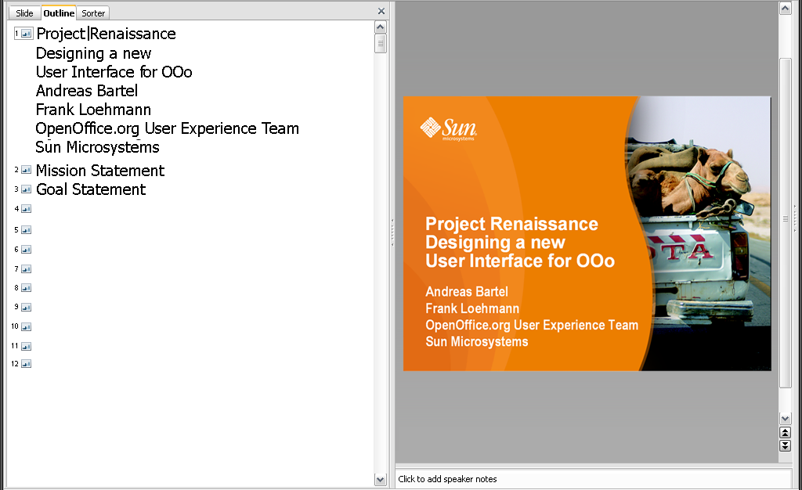Illustration 6: Outline View

Slide Sorter View
Rendering of the Slide Sorter view in Impress has been reworked to make better use of screen real estate and to provide better visibility and feedback. It uses the same highlighting for slides defined in the Slide view on page 4.
Zoom slider in status bar is shown to change the size of the slide thumbs.
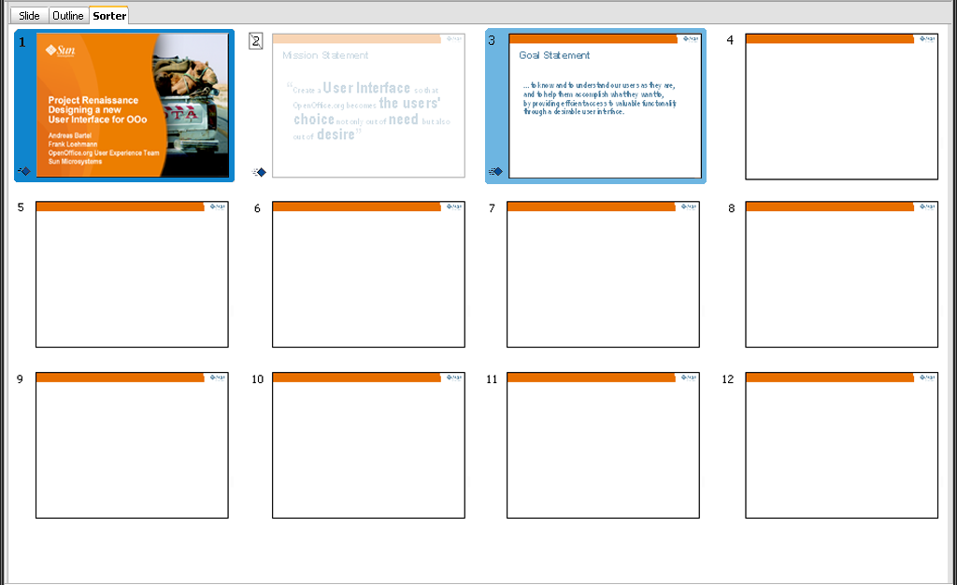Illustration 7: Slide Sorter view
The Slide Sorter view gets renamed to Sorter.
- “Mode Tabs” - Label Properties |  | Comment
Label : | Sorter | EN-US

High Contrast Mode
Selections and highlighting must be accessible. Therefore the high contrast mode must be supported. In high contrast mode the appearance settings are overruled to use system colors for best visibility.

Color Configuration
The highlighting color for Slide selections can be configured in the Appearance dialog of OOo.
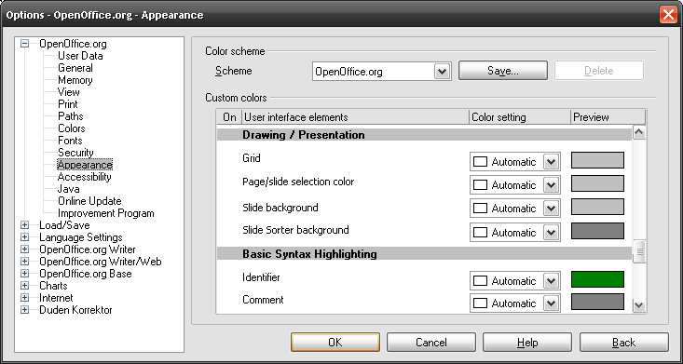Illustration 8: Tools-Options-Appearance Dialog

- “Slide selection” - DropDown Listbox Properties |  | Comment
Enabled: | Always
Disabled: | Never
Items: | <Color list>
Item Selected: | Automatic
DropDown  ListBox Label: | Slide selection | EN-US
- “Slide background” - DropDown Listbox Properties |  | Comment
Enabled: | Always
Disabled: | Never
Items: | <Color list>
Item Selected: | Automatic
DropDown  ListBox Label: | Slide background | EN-US
- “Slide background” - DropDown Listbox Properties |  | Comment
Enabled: | Always
Disabled: | Never
Items: | <Color list>
Item Selected: | Automatic
DropDown  ListBox Label: | Slide Sorter background | EN-US

Slide Navigation in Slide View, Preview Sorter and Presentation
The slide navigation includes keyboard and mouse wheel and is defined as follows:
 | Slide Preview Pane |  | Slide View |  | Slide Sorter |  | Presentation
 | Function |  | Function |  | Function |  | Function
Arrow Key Up | previous | x | previous | x | above | x | previous | x
Arrow Key Down | next | x | next | x | below | x | next | x
Arrow Key Left |  |  | previous | x | left | x | previous | x
Arrow Key Right |  |  | next | x | right | x | next | x
Page Up | previous | x | previous | x |  | ? | previous | x
Page Down | next | x | next | x |  | ? | next | x
Pos1 (jump to first slide) | first | x | first | x | first | x | first | x
End (jump to last slide) | last | x | last | x | last | x | last | x
Mouse Scroll Wheel Up | go up | x | previous | x |  | ? | previous | x²
Mouse Scroll Wheel Down | go down | x¹ | next | x² |  | ? | next | x²

Accessibility
Accessibility is the responsibility of the I-Team, beginning with UX, DEV and QA, to ensure that the following requirements are fulfilled:
- Is the feature fully keyboard accessible?
(Ex: “I can go everywhere and use every function using the keyboard only”)
<Start typing here>
- Have I specified visual alternatives for the case that the specified feature includes audio as output?
<Start typing here>
- Are text alternatives for all icons and graphics available?
<Start typing here>
- Don't provide important information in colors alone
(Ex: marking important information hard coded in red)
<Start typing here>
- Does the specified feature respect system settings for font, size, and color for all windows and user interface elements?
<Start typing here>
- Have I ensured that flash rates do not exceed 2 hertz for blinking text, objects, or other elements? In any case, try to avoid flashing UI elements
<Start typing here>
- Ensure that assistive technology(AT) (like ZoomText or Orca) is able to read everything.
<Start typing here>

Migration
<Start typing here ----- If this part is irrelevant state a reason for its absence!>

Configuration
<Start typing here ----- If this part is irrelevant state a reason for its absence!>

File Format
<Start typing here ----- If this part is irrelevant state a reason for its absence!>

Open Issues
Issue | Initials | Date
<State Issue here, State “None”, if all issues are solved> |  | <Format: Dec 31, 2000>
<...> |  | <Format: Dec 31, 2000>

Document Change History
Rev. | Change | Initials | Date
1 | Initial Specification | FL | Nov 25, 2009
2 | Update Mock-ups | FL | December 03, 2009
3 | Spec update | FL | December 07, 2009
4 | New selection & highlight color | FL | February 04, 2010
5 | Add slide frame colors | FL/AB | February 08, 2010

In the slide pane mouse wheel up/down should just scroll through slides without changing the selection. Consequently the selected slide would remain the same.
In slide view mouse wheel up/down should resemble same behavior as page-up or page-down.

