Software Specification Document

OpenOffice.org 2.0.4 and higher
OpenOffice.org NetBeans Integration: description.xml

Specification Status
Last Change | May 7, 2007
Status | - PRELIMINARY  status is the initial conception of a specification.  - STANDARD  A specification with status Standard is considered to be stable and has the approval of the i-Team.  - OBSOLETE  An Obsolete specification is a specification that has been identified unnecessary. For example due to; technology changes or changes in other standards or specifications.

Abstract
The intention of the OpenOffice.org NetBeans Integration: description.xml project is to support the properties/features for extensions that came with the introduction of the description.xml into OpenOffice.org. These features are
- Versioning of Extensions
- Dependencies on special Office versions
- Update URLs of Extensions
- License files
See the article on the description.xml in the Developer's Guide (as of now, only the online version):
http://api.openoffice.org/docs/DevelopersGuide/Extensions/Extensions.xhtml#1_5_description.xml

i-Team Members
Role | First Name, Last Name, Initials | E-Mail Address
Project Lead | Jürgen Schmidt (jsc) | juergen.schmidt@sun.com
Specification Owner | Steffen Grund (sg) | steffen.grund@sun.com
User Experience
Development | Steffen Grund (sg) | steffen.grund@sun.com
Quality Assurance | Thorsten Bosbach (tbo) | thorsten.bosbach@sun.com
Documentation
Other roles
Based on a verbal agreement between Lutz Höger and Jürgen Schmidt, we decided that a team member of the office user experience team isn't necessary because this specification is off topic of normal office features and address developers only and provides an integration in an external application (NetBeans IDE).

Contents
Abstract 1
i-Team Members 1
References and Reference Documents 3
Acronyms and Abbreviations 4
1 Detailed Specification 5
2 Open Issues 6
Document Change History 6

References and Reference Documents
Give references to any documentation relevant with regards to this specification.
Before writing a specification make sure that the items of the Specification Process Entry Check have been addressed.
Reference Document | Check | Location (URL)
Specification Process Entry Check |  | N/A
Product Requirement,, RFE, issue (required) |  | <Please enter location here>
Product Concept Document |  | <Please enter location here>
Competitive Analysis |  | <Please enter location here>
Test Case Specification (required) |  | <Please enter location here>
Software Specification Rules | N/A | N/A
<Other, e.g. references to related specs>

Acronyms and Abbreviations
State any acronyms and or abbreviations used in this specification in the table below.
Acronym / Abbreviation | Definition
SDK | Software Development Kit
deploy/deployment | Means the installation of office extension packages into an office installation
nbm | NetBeans module/plugin, comparable with an office extensions package, means a plugin extending the base functionality of NetBeans with some new functions.

Detailed Specification
The properties for extensions are available via the context menu of an extension. It is quite desirable to add these properties to the general properties of the project, but this is not yet possible with NetBeans 5.5, only from version 6 on.

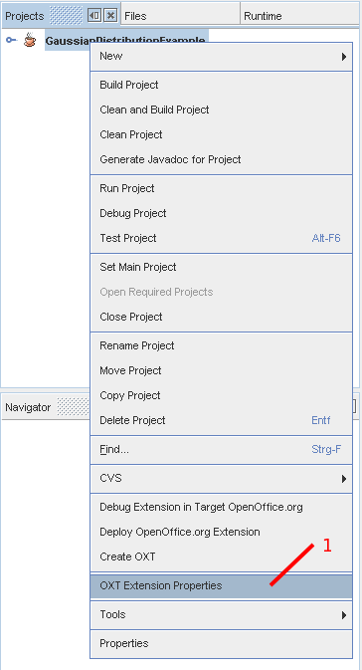Figure 1: Context menu of an extension project

Table 1: User Interface elements of Figure 1
# | Type | Properties |  | Comment
1 |  | Control Properties  Features: The context menu of the component shows the entry to open the dialog for extension properties. |  |  | Clicking on “OXT Extension properties will open a dialog with 4 tabs.
1 |  | OXT Extension properties

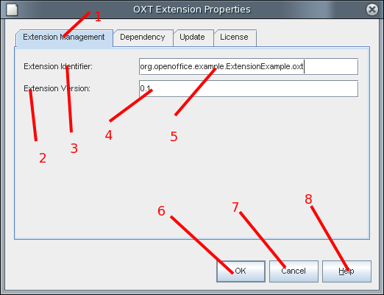Figure 2: Extension Management
Table 2: User Interface elements of Figure 2
# | Type | Properties |  | Comment
1 |  | Control Properties  Features: Tab for the first property panel
1 |  | Extension Management
2 |  | Control Properties  Enabled: Yes |  |  | Label for #4
2 |  | String English  Extension Version | String German
3 |  | Control Properties  Enabled: Yes |  |  | Label for #5
3 |  | String English  Extension Identifier | String German
4 |  | Control Properties  Enabled: Yes  Editable: Yes  Initial Text Inside Field: 1.0.0  Drag Enabled: No  Initial Caret Position: <End>  Characters Allowed: [0-9.] (all needed for versioning)  Characters not Allowed: all others  Selection Starts: 0  Selection Ends: 0  Selected Text:  ToolTip Text:  A11Y Text:  Other...:  Password Field Properties  Echo Character:  Other...: |  |  | Enter a version number for the extension: encouraged is the <major>.<minor>.<bugfix> system.
4 |  | String English | String German
5 |  | Control Properties  Enabled: Yes  Editable: Yes  Initial Text Inside Field: <package of registration class>.<ExtensionName>  Drag Enabled: No  Initial Caret Position: <End>  Characters Allowed: [A-Za-z.]  Characters not Allowed: all not allowed  Selection Starts: 0  Selection Ends: 0  Selected Text:  ToolTip Text:  A11Y Text:  Other...:  Password Field Properties  Echo Character:  Other...: |  |  | A unique identifier for the extension. Default is the initial text inside.
5 |  | String English | String German
6 |  | Control Properties  Enabled: Yes  Icon: No  Resizeable: No  Has Menu: No  Menu Items:  ToolTipText: |  |  | Button provided by NetBeans; no tool tip
6 |  | String English  OK | String German  <Enter String Here>
7 |  | Control Properties  Enabled: Yes  Icon: No  Resizeable: No  Has Menu: No  Menu Items:  ToolTipText: |  |  | Button provided by NetBeans; no tool tip
7 |  | String English  Cancel | String German
8 |  | Control Properties  Enabled: Yes  Icon: No  Resizeable: No  Has Menu: No  Menu Items:  ToolTipText: |  |  | Button provided by NetBeans; no tool tip; opens help of NetBeans with an own designed help text.
8 |  | String English  Help | String German

Table 3: Tab order of Figure 2
Tab Order | Comment
#5, #4, #6, #7, #8, #1

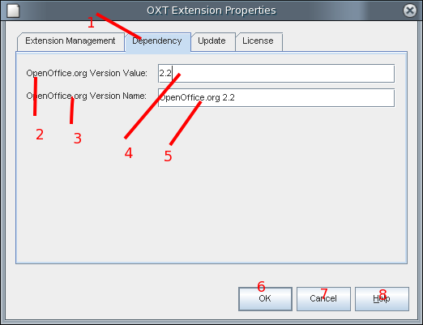Figure 3: Dependency

Table 4: User Interface elements of Figure 3
# | Type | Properties |  | Comment
1 |  | Control Properties  Features: Tab for the second property panel
1 |  | Dependency
2 |  | Control Properties  Enabled: Yes
2 |  | String English  OpenOffice.org Version Value | String German
3 |  | Control Properties  Enabled: Yes
3 |  | String English  OpenOffice.org Version Name | String German
4 |  | Control Properties  Enabled: Yes  Editable: Yes  Initial Text Inside Field:  Drag Enabled: No  Initial Caret Position: <End>  Characters Allowed: [0-9.]  Characters not Allowed: all except allowed  Selection Starts: 0  Selection Ends: 0  Selected Text:  ToolTip Text:  A11Y Text:  Other...:  Password Field Properties  Echo Character:  Other...: |  |  | Numerical value for the OpenOffice.org version.  Although shown with content in Figure 3 above, this field should be empty at start: noting no dependency on any OpenOffice.org version.
4 |  | String English | String German
5 |  | Control Properties  Enabled: Yes  Editable: Yes  Initial Text Inside Field:  Drag Enabled: No  Initial Caret Position: <End>  Characters Allowed: <all>  Characters not Allowed:  Selection Starts: 0  Selection Ends: 0  Selected Text:  ToolTip Text:  A11Y Text:  Other...:  Password Field Properties  Echo Character:  Other...: |  |  | Name for the OpenOffice.org version.  Although shown with content in Figure 3 above, this field should be empty at start: noting no dependency on any OpenOffice.org version.
5 |  | String English | String German

Table 5: Tab order of Figure 3
Tab Order | Comment
#4, #5, #6, #7, #8, #1

Note: #6, #7, #8 are specified under Figure 2.

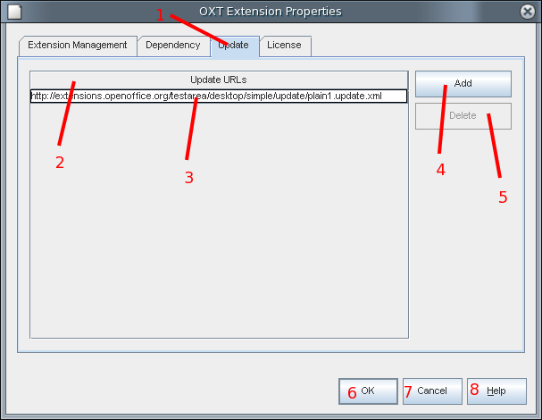Figure 4: Update Properties

Table 6: User Interface elements of Figure 4
# | Type | Properties |  | Comment
1 |  | Control Properties  Features: Tab for the third property, update url
1 |  | Update
2 |  | Control Properties  Enabled: Yes |  |  | This is not really a label, but a table header.  Unfortunately, tables are not in the “Type” drop-down list.
2 |  | String English  Update URLs | String German
3 |  | Control Properties  Enabled: Yes  Editable: Yes  Initial Text Inside Field:  Drag Enabled: No  Initial Caret Position: 0  Characters Allowed: Characters for URLs  Characters not Allowed:  Selection Starts: 0  Selection Ends: 0  Selected Text:  ToolTip Text:  A11Y Text:  Other...:  Password Field Properties  Echo Character:  Other...: |  |  | This is not really a label, but a table cell.  Unfortunately, tables are not in the “Type” drop-down list.
3 |  | String English | String German
4 |  | Control Properties  Enabled: Yes  Icon: No  Resizeable: No  Has Menu: No  Menu Items:  ToolTipText: |  |  | Clicking on this button adds a new line for entering a URL.
4 |  | String English  Add | String German
5 |  | Control Properties  Enabled: No  Icon: No  Resizeable: No  Has Menu: No  Menu Items:  ToolTipText: |  |  | Delete the currently selected line (table cell). Is disabled if no line is selected.
5 |  | String English  Delete | String German

Remark: To add some additional value for the user, it is an idea to include a “Check” button, that checks the selected URL. The result could be a dialog with an OK status when the URL is accessible or a “FAILED” state when the URL has syntax errors. (the underlying xml file is faulty?)

Table 7: Tab order of Figure 4
Tab Order | Comment
#3, #4, #5 | stepping through the lines in #3, if there is more than one

Note: #6, #7, #8 are specified under Figure 2.

Open Issues
Questions and unsolved will arise during the creation process of the specification. Make sure that no open issue are left, when the specification gets the state “Standard”
Issue | Initials | Date
<State Issue here, State “None”, if all issues are solved> |  | <Format: Dec 31, 2000>
<...>

Document Change History
Rev. | Change | Initials | Date
1 |  |  | <Format: Dec 31, 2000>
2
3
<...>

