Toolbar Specification

Document - ID | Specification Owner | Last Change | Status
 | Christian Jansen | December 10, 2007 | Final
Conforms to
Applies to | all OOo modules
Task ID(s) | EaseOfUse-5: i20055, i50428
Category | Feature

Abstract
Toolbars in OpenOffice.org are completely renewed. They have further on a context sensitive behavior, but without the toolbar toggle known from OpenOffice.org 1.1 or earlier. New is also that each OpenOffice.org program module can have its own toolbar configuration. The OpenOffice.org 2.0 toolbars provide a lot of usability enhancements which allow an easier customization of the toolbars.

i-Team Members
 | Name | E-mail Address
User Experience | Christian Jansen (CJ) | Christian.Jansen@sun.com
Development | Carsten Driesner (CD) | Carsten.Driesner@Sun.COM
 | Stephan Schäfer (SSA) | Stephan.schaefer@sun.com
Quality Assurance | Thorsten Martens (TM) | Thorsten.Martens@sun.com
Documentation | Uwe Fischer (UFI) | Uwe.Fischer@sun.com

Approved for Implementation
 | Approved by | Date
User Experience | Christian Jansen (CJ) | January 29, 2004
 | Matthias Müller-Prove | January 22, 2004
Development | Carsten Driesner (CD) | January 15, 2004
Quality Assurance | Thorsten Martens (TM)
Documentation | Uwe Fischer (UFI) | January 15, 2004
String Review | Elizabeth Matthis | 23.04.04

Document Change History
Rev | Change | Initials | Date
1.0 | initial draft | CJ | 9/15/03
1.1 | new sections 6.1.4Context Sensitivity of Toolbars | MMP | 10/2/03
1.2 | Suggestions UFI-1 and UFI-2 | UFI | 10/6/03
1.3 | got ok from CD on 6.1.4 Context Sensitivity of Toolbars | MMP | 10/9/03
1.4 | got ok from MBA on 6.1.4 Context Sensitivity of Toolbars | MMP | 10/10/03
1.5 | got ok from UFI | CJ | 01/15/04
1.6 | review | MMP | 01/22/04
1.7 | Changes added | CJ | 01/29/04
1.8 | Changes in Context Sensitivity & Magnetic Area for Sub Toolbars Added. | CJ | 06/23/04
1.9 | Note added that this specification is not a ui spec for the toolbar look. | CJ | 07/13/04
2.0 | Added that toolbars have to be docked above a status bar | CJ | 07/13/04
2.1 | Link to Issue List added | CJ | 07/26/04
2.2 | String changed in 6.9:  “Standard-Einstellungen ~herstellen ---> Standardbefehl ~wiederherstellen”  "Restore Default Settings" --> "Restore Default Command" | CJ | 11/01/04
2.3 | Closer States Added | CJ | 03/14/05
2.4 | CTRL & Drag feature added | CJ | 03/15/05
2.5 | Added: Closing a context sensitive toolbar permanently | CJ | March 27, 2006
2.6 | Add new changed Icon dialog | FL | September 24, 2007
2.7 | Made some changes for: 83555 | FL | December 10, 2007

Contents
Glossary 1
1 Motivation 1
2 User Scenarios 1
3 Goals 1
4 Requirements and Dependencies 1
4.1 Requirements 1
5 Competitive Analyses 2
5.1 MS Office XP 2
5.2 Corel WordPerfect 6
5.3 Lotus Word Pro 10
6 Detailed Specification 12
6.1 Toolbar Placement 13
6.1.1 Default Toolbars 13
6.1.2 Initial Placement of Docked Toolbars 14
6.1.3 Initial Placement of Floating Toolbars 15
6.2 Elements of a Toolbar 16
6.3 Context Sensitive Toolbars 18
6.3.1 Visibility of context sensitive toolbars 19
6.4 Context Insensitive Toolbars 19
6.5 Changing Context Modes of Context Sensitive Toolbar 20
6.5.1 Changing Context Mode When Context is Active 20
6.6 Moving Toolbars 20
6.6.1 The Toolbar Closer 21
6.7 Magnetic Edges 21
6.8 Sub-Toolbars 25
6.8.1 Tearing-Off sub-Toolbars 27
6.9 Key-board Navigation 29
6.10 View -> Toolbars Menu 30
6.10.1 Behavior of View ->Toolbars Menu Entries Check Mark 31
6.11 Customizing Toolbars 31
6.11.1 User Interface Updates 32
6.11.2 When will the information of the toolbar state be saved? 32
6.12 Quick Customization of Toolbars 33
6.12.1 Quick Customization using Drag & Drop 36
6.13 Customize Toolbars Dialog 37
6.13.1 Toolbar Area 40
6.13.2 Toolbar Content Area 44
6.13.3 Description Area 53
6.13.4 Read Only Mode 54
6.14 Sun Java[TM] Desktop System Configuration Manager 54
7 Future Tasks 54
8 Notes 54
9 References 54

Glossary
Term | Description
Toolbar | A common graphical user interface component, consisting of a permanently visible row of button icons which, when clicked with the mouse, cause the program to perform some action such as printing the current document or changing the mode of operation.
Combo Button
Normal.dot | Please find a detailed information here:  http://pubs.logicalexpressions.com/Pub0009/LPMArticle.asp?ID=151

Motivation
The toolbar concept of OpenOffice.org 1.x is dated and has loads of usability issues. One prominent example is the toolbar toggle located at the end of a toolbar. Its usage is not clear. Another major issue is that depending on the context the items change automatically. This causes sometimes the effect that needed functionality is hidden. A new toolbar concept must be created to provide up-to-date, easy to use handling and good looking toolbars.

User Scenarios
- User A writing a research paper wants to create an own custom toolbar, which fits exactly his needs. Because he knows exactly what toolbar buttons he needs most.
- User B wants to create a document which shall be used as template for certain actions. The template provides also macros. Colleagues using this template shall have fast access for running these macros. User B decides to bind a custom Toolbar to the document.
- User C the wants to move toolbars easy.

Goals
For OpenOffice.org the tool bar concept will be reworked. This includes an improved user experience and by having a more common handling of toolbars. Goals for this release is to have a improved toolbar handling which is more compatible with behaviors users learned in competitor product.

Requirements and Dependencies

Requirements
Toolbars in OpenOffice.org need to be flexible as possible. They have to fulfill the following requirements.
- No toolbar switching by using the toolbar toggle buttons
- They have to provide user feedback while moving
- Each module of OpenOffice.org shall have its own toolbar configuration
- Docking shall be allowed at every window type
- Moving toolbars must be easier
- Customization must be easier
- Sub-Toolbars shall be real toolbars

Competitive Analyses
This section gives an short overview over the toolbar concepts of MS Office XP, Corel Word Perfect, and Lotus Word Pro.

MS Office XP
Toolbars in Microsoft Office can contain buttons or combo buttons. Microsoft Office automatically customizes toolbars (like they do with menus). This customization feature tracks how often users use commands. When users first start an Office program, only the most basic commands appear. During work the Office program customizes the toolbar buttons that users see only the most often needed commands. During work, the Office programs displays context sensitively (Figure 1) additional toolbars. For example adding an picture to a Word document opens automatically the Picture toolbar, when the picture is selected. Leaving the picture closes the toolbar.
By default most of the Office program toolbars are docked but a couple of them appear floated the first time they are called.
While moving toolbars, toolbars are always visible and they snap to window borders.
Microsoft Office toolbars can be positioned next to each other in the same row. When multiple toolbars are in the same row, and there is not enough room to display all items of the toolbars, Microsoft Office displays the most recently used items. Or after first start the most important items of a toolbar.
If there is not enough space for displaying all toolbar items in one row, the toolbar Toolbar Options button displays an chevron located at the top of the Options button A click on the Toolbar Options opens a menu which display the hidden items and gives users also access (Figure 2) for modifying the toolbar.

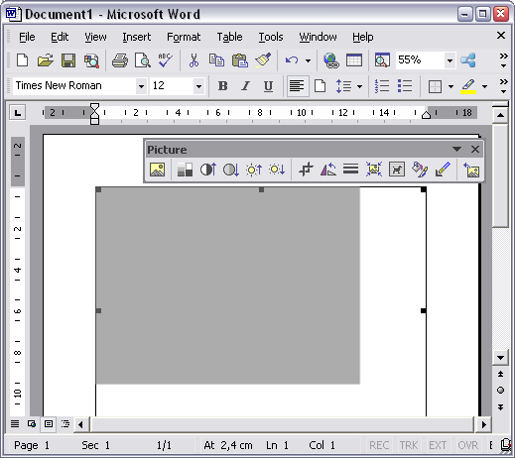Figure 1MS Office has context sensitive toolbars.

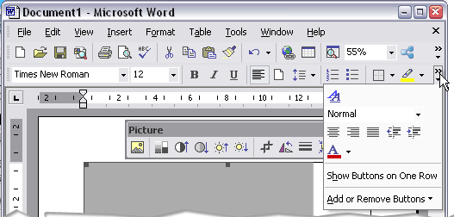Figure 2 Toolbar Options menu

Users can customize the toolbars from a special dialog called “Customize Toolbars”. Users can access the dialog from the Tools -> Customize menu or directly from the toolbar (Toolbar Options -> Add or Remove Buttons -> Customize...).
As seen in figure 3 users can create own custom toolbars, hide or display toolbars. Adding or removing items can be done from the 'Customize Commands' tab (Figure 4).For adding items users have to drag each item from the Commands list to the toolbar they want to customize. For removing or modifying items users have to select the item in the toolbar. In selected state a right click opens the “Modify selection” menu (this menu is also available at the Customize -> Commands tab (Figure 5).
Own custom toolbars can be saved to a currently opened document, or when the custom toolbar shall appear always it has to be save to the “Normal.dot”

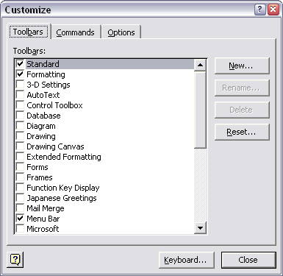Figure 3 Microsoft Office Customize Toolbars dialog.

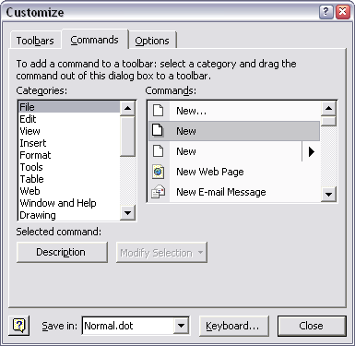Figure 4 Customize Commands tab page.
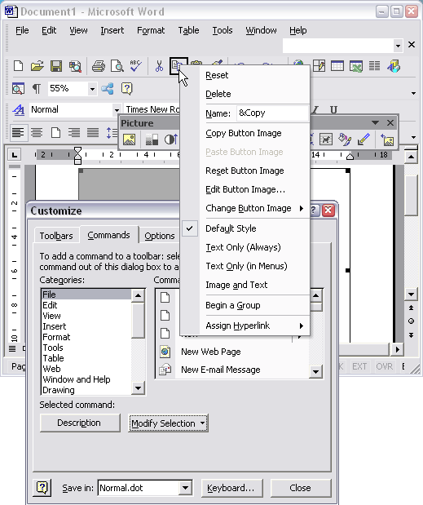Figure 5 Microsoft Word in customize mode. The menu is opened by a right click.

Corel WordPerfect
Compared to Microsoft Office, WordPerfect provides more static toolbars. They don't change their feature set by priorities or most recently used. These toolbars (Figure 6) contain a fixed set of buttons and sub menus. By default these toolbars are docked, but can change their state to float by moving them outside of the toolbar areas or by double clicking them.
Like Microsoft Corel WordPerfect has context sensitive toolbars (called Property Bars). In general WordPerfect provides one main toolbar and a second toolbar which changes its item set depending on the context. The context sensitive toolbars are called Property Bars. WordPerfect toolbars can have more than one row, even when they are docked.
Like in Microsoft Office adding, modifying or removing items to toolbars can be done by using the 'Customize Settings' dialog (Figure 7). Users have to select the type of toolbar first the want to modify. It is only possible to modify one toolbar at each time. Due to the concept of having static and context sensitive toolbars users have to define a contexts when toolbars shall appear. When a non context sensitive toolbar was selected the Toolbar Edit (Figure 8) dialog opens, if a context sensitive toolbar was select the Property Bar editor (Figure 9) will be opened.
Adding items can be done by dragging items from the “Toolbar Editor” or “Property Bar Editor” to the toolbar. Removing can be done by context-clicking an item and choosing Delete. The context menu offers also the entry point to a dialog from where the icon appearance and the name of the item can be changed.

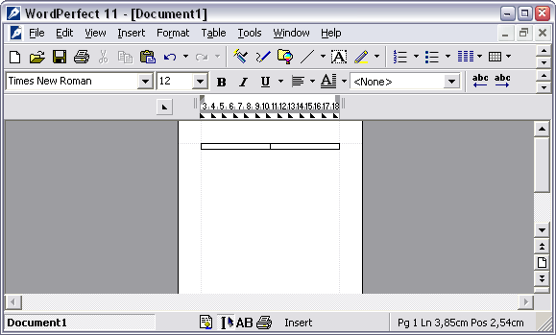Figure 6 Toolbars in WordPerfect 11. Note that when the whole toolbar doesn't fit into the application they display buttons for toggling between the visible and the hidden parts.

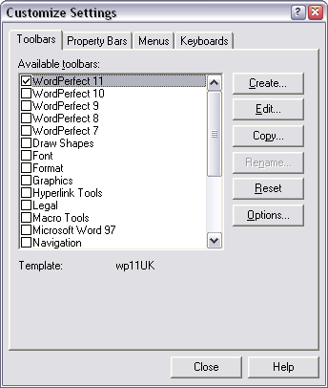Figure 7 WordPerfects Customize Settings dialog.

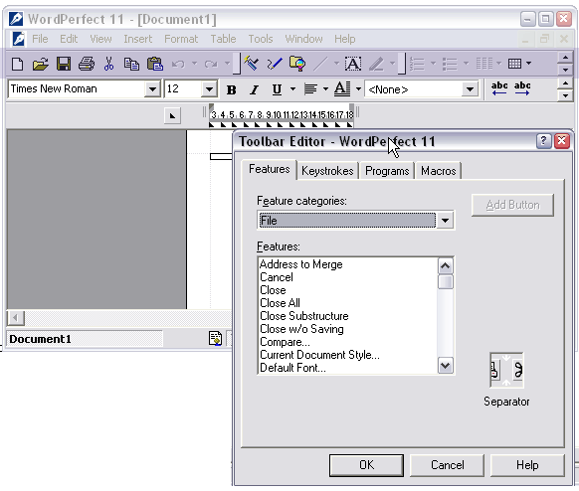Figure 8 WordPerfects Toolbar Editor
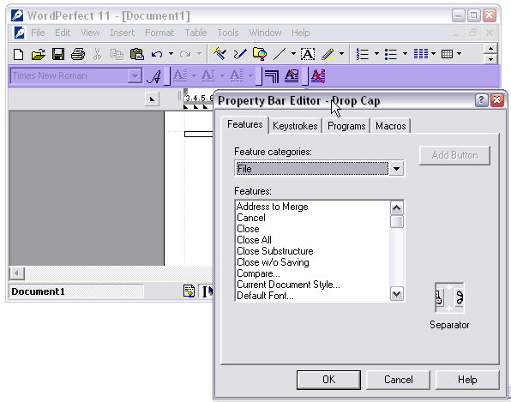Figure 9 WordPerfects Property Toolbar Editor

Lotus Word Pro
Starting WordPro the first time two default sets of toolbars are displayed (Figure 10). Toolbars in Lotus Word Pro are are a collection of SmartIcons (SmartIcons represent mouse shortcuts for Word Pro actions, commands, and scripts.) Each collection of SmartIcons can be saved as .smi files. SMI files are configuration file which store setting like a menu or a toolbar configuration.
The two default toolbars are displayed do behave differently. The first one is like in WordPerfect a static one. The other toolbar changes its content depending on the selected content.
Toolbars can be docked or floated, and they snap to all application window edges.
Customization of toolbars is also possible. Selecting from the File menu -> User Setup -> SmartIcons Setup... opens a configuration dialog (Figure 11.) Users have to select from the "Bar Name" box the toolbar they want to modify. Next step is to select one item out of a long list of available items. This item lists are grouped according the WordPro menu organizations. The selected has icon to be dragged into the toolbar displayed in the “SmartIcons Setup..”. Dialog. It is not possible to drag the icon directly into a toolbar.
User can also rename or modify items. Therefore users have to select 'Edit Icon...' from the 'SmartIcons Setup...' Dialog. 'Edit Icon..'. opens another dialog. This dialog (Figure 12) allows users to modify the SmartIcon look, the name of the function or to create a new SmartIcon.
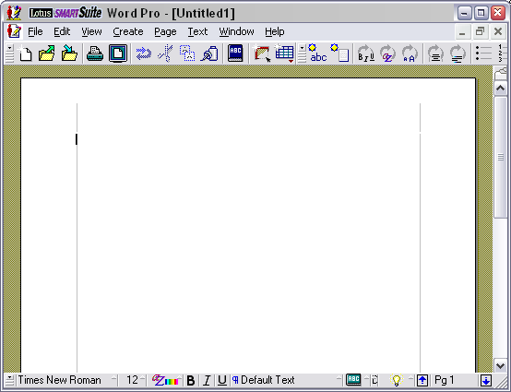Figure 10 Lotus Word Pro comes with two default toolbars.

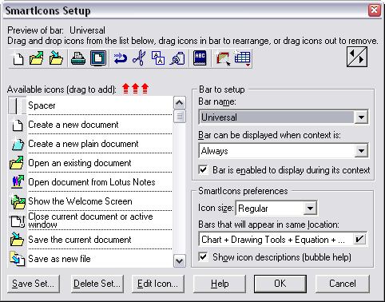Figure 11 SmartIcon Configuration Dialog

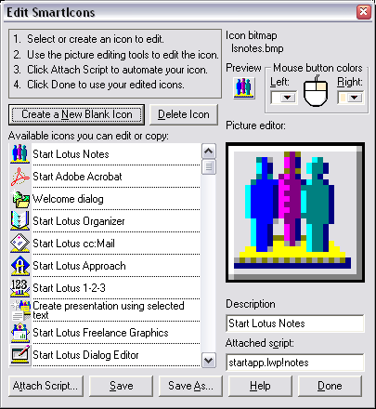Figure 12 Edit SmartIcons dialog.

Detailed Specification
Note: The toolbars shown in this specification are mockups. They are only ment as an example and shall not be used as guideline for designing the new look of OpenOffice.org toolbars.
A toolbar is a user interface elements which is usually placed along the top of a window and contains a number of buttons that perform common functions which are frequently used. Toolbars can contain buttons, text fields, slider controls or combo boxes. From a toolbar it is also possible to open sub toolbars or to open a drop-down menu. Toolbars can be dragged from one location to another. If the toolbar is dragable this visualized by an area located at the leading edge of a toolbar.
Figure 13 shows a sample toolbar (design of the toolbar may vary until OpenOffice.org 2.0 final). The toolbar has a drag area at the leading edge some different controls are placed in the toolbar and at the end a button set for modifying the toolbar. In left to right user interface the controls have to be mirrored.
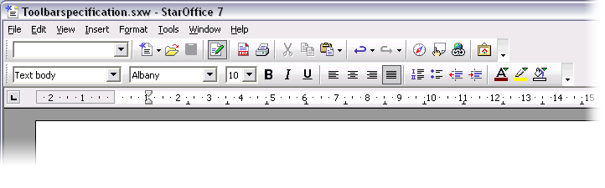Figure 13 Mock-up of redesigned toolbars

The following chapters cover the handling of OpenOffice.org's toolbars in more detail.

Toolbar Placement
Toolbars a generally located along the top of a window under the menu bar.
Depending on the length of a toolbar and the initially needed feature set additional toolbars can be located in the working window.
Figure 14 shows an example of toolbars located in the upper left of an application window
Figure 14 Possible Toolbar positions
Toolbar 2
Toolbar 1
Menu Bar
T
o
o
l
b
a
r
3

When users move a toolbar from the initial location to an other one, is last location has to be remembered. After restarting the application all the toolbars have to be located at the position the user has placed them before exiting the application.
A major changes, compared to OpenOffice 1.1, is that every single module of OpenOffice.org has its own toolbar configuration. For example if users want to have “Toolbar 1” located vertically in OpenOffice.org Writer this change will not have any impact on the position of “Toolbar 1” in OpenOffice.org Calc.

Default Toolbars
Every OpenOffice.org module shall come with a default set of visible toolbars. These default toolbars are docked (see chapter 6.1.2), and are located in the upper left of the application window. The table below lists the toolbar which shall be visible after first start.
Module | Toolbars | Position
OpenOffice.org Writer | Standard Toolbar
 | Formatting Toolbar
OpenOffice.org Calc | Standard Toolbar
 | Formatting Toolbar
OpenOffice.org Impress | Standard Toolbar
 | Formatting Toolbar
 | Drawing Toolbar
OpenOffice.org Draw | Standard Toolbar
 | Drawing Toolbar
 | Drawing Attribute Toolbar
OpenOffice.org HTML Document | Standard Toolbar
 | Formatting Toolbar
OpenOffice.org Master Document | Standard Toolbar
 | Formatting Toolbar
OpenOffice.org Math | Standard Toolbar
OpenOffice.org Basic IDE | TBD
OpenOffice.org Database | TBD
OpenOffice.org StartModule | Standard Toolbar

Initial Placement of Docked Toolbars
When users want to have additional toolbars added to the default set the toolbars can be opened by calling them from the View-Toolbars menu or they appear context sensitively. This context sensitive behavior is very important to complete a task without getting interrupted.
For example when users insert a table into a text document they have to click the “Insert Table” button located in the Standard toolbar. When the toolbar was insert and the text cursor is placed in the Table automatically the Table toolbar shall appear. This toolbar shall be placed docked next to the Formatting toolbar (Figure 15). Context-sensitivity is described in 6.1.4 Context Sensitivity of Toolbars.

Figure 15 Initial placements of toolbars
Menu bar
Toolbar 1
Toolbar 2
Toolbar 3
Toolbar 4
Toolbar 5
Toolbar 6
Toolbar 1
Toolbar 2
Toolbar 7
Toolbar 3

In OpenOffice.org 2.0 it will be possible to dock toolbars nearly to every window border. It is also possible to dock toolbars at the application window edges. It is also possible to dock toolbars to frame windows. A frame window is for example a docked Stylist or a Navigator. The image below shows the areas where toolbars can be docked.
Figure 16 This figure shows the areas – marked as green – where toolbars can be docked.
Toolbars docked at the bottom area of a window shall always be docked above status bar.
A docked toolbar looks like a floated toolbar but has three major differences. First, it is has no window decorations. Second, a docked toolbar provides a drag area which indicates that a toolbar is movable, and third, it provides an indicator which appears when items of a toolbar are truncated and therefore be hidden.

Initial Placement of Floating Toolbars
Some of the new OpenOffice.org toolbars will appear floated by default. These floated toolbars be default located in the upper left. Figure 17 shows the initial placement. Some of the new OpenOffice.org toolbars will appear by default floated. These floated toolbars located by default in the upper left (15 pixel lower and 15 pixel more to the right). Shows the initial placement in pixel. When users open more than one floating toolbar they have to appear cascaded.

Figure 17 Positioning of floating toolbars
Menu bar
Toolbar 1
Toolbar 2
T
o
o
l
b
a
r
3
Toolbar 4
Toolbar 5
15
15
15
15
15
15
OpenOffice.org has to remember the last position of a toolbar persistently. Additionally, every module has to have its own toolbar configuration where the last position is saved. OpenOffice.org has to remember the last position of a toolbar persistently.

Elements of a Toolbar
There is a minimum set of features every toolbar has to provide. They must have a handle for moving the toolbar.
The drag area is indicated by a number of dots located at the left hand side (Figure 18).

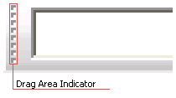Figure 18 Drag Area Indicator
The active area of the Drag Area is a little bit larger than the visible part (Figure 19).

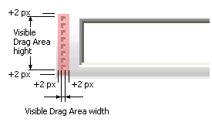Figure 19 The drag area is larger than the visible part of it
When a toolbar has a couple of different items they should be clustered into sections. A section has to have at least one item and is visualized by a vertical divider. This divider is called “Separator”.
On the right side the toolbar shall provide an Option Button. This Option Button has two functions:
- It is being used for having a quick access to the toolbar modification options. This is explained in detail in Chapter 6.12 Quick Customization of Toolbars.
- The second function is to indicate when items of the toolbar are hidden.

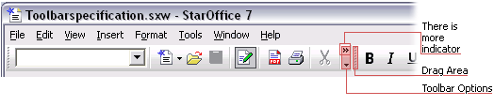Figure 20 Items display in docked state.
Automatic hiding of toolbar items is necessary when the application window width is less than the toolbar length or, if for example two or more toolbars are placed next to each other. When toolbars are placed next to each other and not enough space is available to show the full set of toolbar items the items with less priority shall be automatically hidden. For example a toolbar with 10 items has 10 priority values. The toolbar item with the priority 10 is the most unimportant item. It will be hidden first. It shall be possible to give items the same priority value. This means items with the same value will be hidden at the same time. Separators shall be deleted when the last item of a command group is hidden. From the moment when the first item is hidden the “There is more indicator” appears. A docked and truncated toolbar changes its appearance by displaying all hidden items when changing its state from docked to floating.

Figure 21 Show the order of hiding less important toolbar items. The number display the priority of each item.
1
3
4
2
5
1
3
2
1
2
1

Clicking the Option Button when the “There is more indicator” is visible opens the Toolbar Options menu. This menu display additionally to the standard menu items (specified in Chapter 6.7 Quick Customization of Toolbars) all hidden toolbar items. Figure 22 shows an example toolbar with an opened Toolbar Options menu.

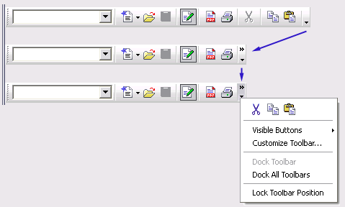Figure 22 Example Toolbar with Options menu opened.

Context Sensitive Toolbars
The basic idea of the toolbars in OpenOffice.org is that they are visible if the user needs them, and that they are not in the way if the user does not need them. We also like to keep the user interface as calm and uncluttered as possible. This means that just a limited set of toolbars are context sensitive.
Some toolbars can be context sensitive while others are context insensitive.
A context sensitive toolbar has an associated context. The state of the application defines whether the context is active or not.
The diagram below visualizes the differences between context sensitive and context insensitive toolbars

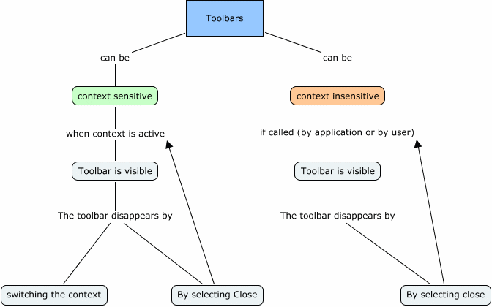

Contexts are orthogonal to each other. They can change without having any effect on other contexts.
For example:
- Users can edit an image inside of a table cell -> table context and image context are active
- Then the user selects a bullet list in another table cell –> the table context remains unchanged, the image context is deactivated and the list context is activated.

Visibility of context sensitive toolbars
The visibility of context sensitive toolbars is controlled by the application
- A context sensitive toolbar is visible when the context is active.
- A context sensitive toolbar is invisible if the context is not active.
- A context sensitive toolbar is visible, but the toolbar items are inactive if the toolbar got called by the user from View -> Toolbars.
- A context sensitive toolbars appears on mouse button up.

Context Insensitive Toolbars
The visibility of context insensitive toolbars is controlled by the application or by the user.
- A context insensitive toolbar is visible when called by the application.
- A context insensitive toolbar is visible when called by the user.
- A context insensitive toolbar is invisible when closed by the application.
- A context insensitive toolbar is invisible when closed by the user.

Changing Context Modes of Context Sensitive Toolbar
The context sensitivity of context sensitive toolbars can be switched ON or OFF by toggling the check marked state of context sensitive toolbars, in View -> Toolbars menu.
- Switching context sensitivity applies to the active module, only.

Changing Context Mode When Context is Active
Given is that a context dependent toolbar is displayed.
Switching the context sensitivity OFF
- Closes the toolbar.

If the same context is given again
- The toolbar is not displayed

Switching the context sensitivity ON (context active)
- Displays the toolbar with context dependent items, enabled

Switching the context sensitivity ON (context inactive)
- Displays the toolbar with context dependent items, disabled

Moving Toolbars
All Toolbars (the only exceptions the Calc Formula Bar or any Status Bars) can be managed with mouse operations. For moving a toolbar user have to click on the "drag area" on the left side of the toolbar (marked by vertical arranged dots) and drag it with the mouse. When the mouse pointer is located over the drag area the mouse pointer changes its look from pointer shape to arrow shape which points into four directions (Figure 23)

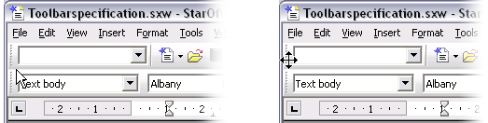Figure 23 Pointer changes when it is located over the dragging are.
During the move, the toolbar shall be always visible. This requirement is of coarse influenced by the system settings, when users select in the preferences of Windows or GNOME/KDE that windows during a drag appear as outline, than OpenOffice.org has to conform to these settings. The default settings of Windows XP, GNOME 2.4 and KDE 3.2 are that during a drag the toolbar is always visible.
NOTE: Rows 234 – 237 changed due to self drawn window decorations
Moving the toolbar out of the toolbar area (Figure 24) turns the toolbar into a floating toolbar. A floating toolbar provides a window border. On Windows the window border is the standard border type which is used for tool windows. The Gnome platform does not support these type of window so the standard window border is used.

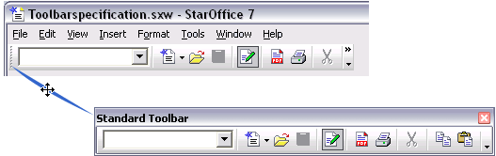Figure 24 Moving a toolbar from docked to floated state.

Figure 25 Floating toolbars can be moved by holding the left mouse button down on the title bar.

If users drag a toolbar to the edge of an OpenOffice.org module window it gets docked. The toolbar has to transform its alignment depending on the window edge. A horizontal aligned floating toolbar dock at the vertical window edge shall turn vertically.
Pressing CTRL while moving a floated toolbar prevents it of being docked in docking areas.

The Toolbar Closer
Each toolbar provides floating or docked state a close mechanism.
- Close mechanism floating toolbar: Closer located on the right hand side in title bar of toolbar
- Close mechanism docked toolbar: Toolbar menu entry; called “Close toolbar”
- No close mechanism: No closer, no “Close toolbar” menu entry

Magnetic Edges
Toolbars, Tool Windows, Task Panel and module window provide magnetic edges. These magnetic edges assist users by snapping toolbars to it correct location and also prevent for accidentally being undocked.
Definition of the Magnetic Edges:
User Interface Element | Magnetic Area for Undocking
Left Module-, Tool Window or Task Panel Edge | 45 px
Top Module-, Tool Window or Task Panel Edge | 45 px
Right Module-, Tool Window or Task Panel Edge | 45 px
Bottom Module-, Tool Window or Task Panel Edge | 45 px
User Interface Element | Magnetic Area for Docking
Left Module-, Tool Window or Task Panel Edge | 10 px
Top Module-, Tool Window or Task Panel Edge | 10 px
Right Module-, Tool Window or Task Panel Edge | 10 px
Bottom Module-, Tool Window or Task Panel Edge | 10 px
Moving Within a Toolbar Area | Magnetic Areas of the Toolbar
Moving the toolbar within its toolbar area | 0 px
Moving toolbar between two toolbars | 8 px
Moving one toolbar under/above another | Toolbar edge  + 4 px
Aligning toolbars
Where to Snap?
Moving a toolbar to horizontal border | Dock horizontally
Moving a toolbar to vertical border | Dock vertically
Moving one toolbar into a corner | Dock horizontally  by default  Move direction

Moving Toolbars Within a Docking area.
Dragging / Moving toolbars shall be possible within a docking area. For example it shall be possible to move toolbar A, initially located on the right hand side of toolbar B to the following locations:
- Before,
- Below, and
- Above
A
B
A
A
A
= Drag Direction

Sub-Toolbars
Toolbars can contain so called sub-toolbars. A sub toolbar appears when a toolbar button extended by an arrow shaped symbol got pressed (Figure 26). These buttons are called Combo Buttons. OpenOffice.org has two types of user interface elements which can be opened by a Combo Button.
- Clicking the Combo Button can open a pull down menu [].
- clicking the Combo Button can open a sub-toolbar.
This section describes the Combo Button which opens a sub-toolbar.
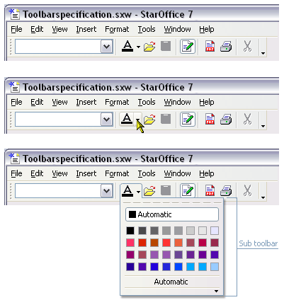Figure 26 Opened Font Color sub-toolbar.

Sub-toolbars provide nearly the same feature set like standard toolbars. They can handle the same kind of controls like standard toolbars do. If they are designed to be customizable they provide a Toolbar Options button. A big difference compared to standard toolbars is how they are being teared-off for turning them into floating windows.
Due to GNOME limitations OpenOffice.org sub-toolbar can't be teared-off by dragging them some pixels away from the Combo Button. The combo button performs the following actions (the list below the image relates to figure 27):
Figure 27 The combo button is divided into two areas
Button Area (BA)
Drop Down Area (DDA)
- A short-click on the Button Area (BA) icon triggers the function (on mouse down)
- A long-click on the BA icon opens the menu or subtoolbar (on mouse down)
- Any sort of click on the Drop Down Area (DDA) arrow opens the menu or subtoolbar (on mouse down).
When a subtoolbar is teared-off and floating somewhere on the screen and the user opens a second instance of the same subtoolbar the second subtoolbar has to behave the same way like the first. they can be teared-off in the same way. The most important difference is that the already existing floating subtoolbar gets automatically closed when the new subtoolbar gets teared-off. The new subtoolbar shall be positioned at its default location and not at the located of the now closed first subtoolbar. Figure 28 illustrates the behavior.

Figure 28 Tearing-off sub-toolbar when same toolbar has a second instance in floating state.
X
X
1.
2.
The second floating
subtoolbar shall be
closed in the moment
of releasing the other.

Tearing-Off sub-Toolbars
For tearing a sub-toolbar off users have to click and hold down the mouse button the dashed line (Tear-Off Ribbon) (Figure 29 & 30) located at the upper edge of the sub-toolbar. After the move it shall release on mouse button up. If a sub-toolbar floats already somewhere on the screen and a second instance of the same toolbar has been called by clicking the drop down indicator, both instances shall be visible. Tearing off and than releasing the second instance shall close the first instance on mouse up.

Mouse over effects for Tear-Off Ribbon:
The Tear-Off Ribbon shall only get active if the mouse pointer is located over the ribbon longer than .5 Seconds. This assures that the mouse over effect get not active while the user is moving the mouse with normal speed over the Tear-Off Ribbon.

Magnetic Area:
Sub-toolbars shall have also a magnetic area like standard toolbars have. For tearing off a sub-toolbar users shall move the mouse pointer 15 px out off the Tear-Off Ribbon.
On the other hand a sub toolbar shall also snap to the combo button from where it has been released.
The Snap area shall be 10px and is only active while dragging a directly teared-off sub-toolbar.

2.
1.
15 px
5 px
5 px
15 px
5 px
5 px
M=Magnetic Area
M
M

Figure 29 Sub-toolbar and its elements.

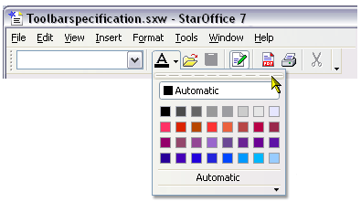Figure 30 Mouse over a Tear-Off Ribbon
The hot area of the Tear-Off Ribbon is a little bit larger than the ribbon is displayed. The hot area shall provide a height of 8 pixel. This makes it much easier for the user to tear-off a sub-toolbar. Figure 31 shows this in detail. Depending on the location of the toolbar from where a sub-toolbar was opened the Tear-Off ribbon has to appear on the left, on the right at the top or at the button of the sub-toolbar. This is also true for the Option button.

Figure 31 Position of Tear-Off Ribbons and Toolbar-Options indicators.

When the teared-off, the sub-toolbar turns into toolbar with window decorations. In floating state it provides no Tear-Off Ribbon (Figure 32).
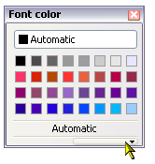Figure 32 Sub-toolbar in floated state.

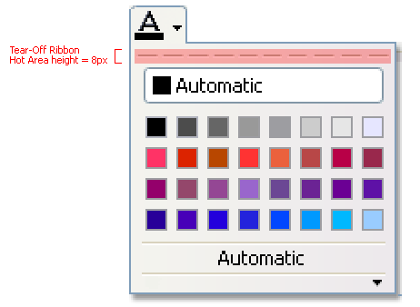Figure 33 Hot state are of Tear-Off Ribbon

Key-board Navigation
Like each other user interface in OpenOffice.org the toolbars shall be accessible by keyboard too. The table below lists the key-board short-cuts and a short description.
Keyboard Shortcut | Description
F10 | Selects the menu bar
SHIFT+F10 | When in
ENTER | Performs the action of the selected toolbar item
ALT | Selects the menu bar
CTRL+TAB | After pressing F10 or ALT this shortcut selects a toolbar. Repeating CTRL+TAB moves the focus among other opened toolbars or task panels.
CTRL+SHIFT+TAB | Same functionality like CTRL+TAB but moves the focus in the opposite direction.
TAB | When in a toolbar TAB selects the next available item. When the last toolbar item is selected TAB moves the focus to the first item.
SHIFT+TAB | When in a toolbar SHIFT+TAB selects the previous item. When the first toolbar item is selected SHIFT+TAB moves the focus to the last item.
LEFT ARROW | When in a toolbar LEFT ARROW selects the next available item. When the first toolbar item is selected LEFT ARROW moves the focus to the last item.
RIGHT ARROW | When in a toolbar RIGHT ARROW selects the next available item. When the last toolbar item is selected RIGHT ARROW moves the focus to the first item.
DOWN ARROW | When in a toolbar and an item which can be opened (drop down list boxes, sub-toolbars,) DOWN ARROW opens the item. The focus moves to the first item of the list or sub-toolbar.
SHIFT+DOWN ARROW | When in a toolbar and an item which can be opened (drop down list boxes, sub-toolbars,) DOWN ARROW opens the item. The focus moves to the first item of the list or sub-toolbar.
UP ARROW | When in a toolbar and an item which can be opened (drop down list boxes, sub-toolbars,) UP ARROW opens the item. The focus moves to the first item of the list or sub-toolbar.
HOME | Selects the first item of a toolbar
END | Selects the last item of a toolbar
ESC | Exits the toolbar or closes a sub-toolbar. Exiting a sub-toolbar moves the focus back to the toolbar.
ALT+CTRL+ PLUS key on numeric keypad | Calls Customize Keyboard with the command preselected with the command preselected which is focused
ALT+Mouse drag | Allows moving a selected toolbar item
CTRL+Mouse drag | Prevents floating toolbars of being docked in docking areas.
SHIFT+CTRL+STRG + Mouse drag | Allows to duplicate a selected toolbar item

View -> Toolbars Menu
The View -> Toolbars menu lists toolbars specified in [].
In addition to the toolbar list the menu entries specified below are displayed
Menu Item | Behavior
... | List of toolbars
-------------------- | Separator
Customize... | Calls “Customize Toolbar” dialog with Toolbar tab selected
Reset | - Restores the factory default context settings of context sensitive toolbars.  - Has to be enabled if:  - the context behavior of one context sensitive toolbar has changed

Behavior of View ->Toolbars Menu Entries Check Mark
Each toolbar related menu entry can be extended by a check mark.
The check mark has to be displayed in the following cases:
- For Context Sensitive Toolbars
  - If the context is active and if the context related toolbar is visible
- For Context Insensitive Toolbars
  - If the toolbar is visible
The check mark must not be displayed in the following cases:
- For Context Sensitive Toolbars
  - If the context is not active and if the context related toolbar not visible
  - If the toolbar got changed to context insensitive and the toolbar is not visible
- For Context Insensitive Toolbars
  - If the toolbar is not visible
Item | English | German | Comments
Menu Item | ~Customize... | ~Anpassen...
 | ~Reset | ~Wiederherstellen

Customizing Toolbars
The section is divided into two parts The first part provides information about the toolbar configuration concept the second is the user interface specification.
OpenOffice.org differentiates between two types of toolbars.
- Module dependent toolbars: These are toolbars where the configuration is stored in the OpenOffice.org configuration and
- Document dependent toolbars: These are connected to a document, and appear only when the special document is opened.
OpenOffice.org saves only the structure of a toolbar but not states like the location into a document. In other words, user A creates a document which contains a custom toolbar. User A positions the toolbar in the lower right. Now, user A gives this document to colleague B. User B opens the document, the toolbar appears not in the lower right but at the default position of toolbars.
OpenOffice.org stores only toolbar items, the states of the items and the toolbar name into the document, but not states like open or closed, docked, floated or the position. This information will be stored in the User configuration. Doing such assures every user can have the OpenOffice.org user interface configuration they prefer.
States saved for Document Dependent Toolbars | Saved to Module | Saved to Document
Toolbar Name |  | X
Structure of Toolbar |  | X
Position of Item |  | X
Custom Images |  | X
Custom Label (user gives a button a new name) |  | X
Toolbar Position | X
Toolbar Open/Closed (user driven) | X
Toolbar Docked/Floated | X

States saved for Module Dependent Toolbars | Saved to Module | Saved to Document
Toolbar Name | X
Structure of Toolbar | X
Position of Item | X
Custom Images | X
Custom Label (user gives a button a new name) | X
Toolbar Position | X
Toolbar Open/Closed (user driven) | X
Toolbar Docked/Floated | X
Context Sensitivity Flag | X

User Interface Updates
When more than one window of one OpenOffice.org module is opened and the user configures into one of the opened windows a module dependent toolbar. All windows have to display the newly created toolbar visible right after closing the Customize Toolbar dialog.
Figure 34 below visualizes the workflow:
Figure 34 User Interface updates
Doc 1
Doc 2
Customize
Toolbars
Customize
Toolbars
User
wants
to
add
a
custom
toolbar
(C1)
User
creates
the
toolbar
bonded
to the
module
User
closes
Customize
Toolbars
with
OK
Doc 2
Doc 1
C1
C1

When will the information of the toolbar state be saved?
The states of the Toolbars will be saved when users save the document or when the close the application. Users shall not be confronted by warning that the document was modified when for example the toolbar changed its state from docked to floating or the position changed.

Quick Customization of Toolbars
Every Toolbar shall have a quick customization option (Figure 37). It shall be accessible by clicking a drop down push button located a the end of each toolbar. Clicking the button open a menu which provides the following options:
- Dock Toolbar
- Lock Toolbar Position
- Dock All Toolbars
- Visible Buttons
- Customize Toolbar...
- Close Toolbar
Between 'Dock All Toolbars' and 'Visible Buttons' shall be a separator. So, the menu look like listed in the table below:

Menu
Visible Buttons > | List of buttons
Customize Toolbar...
--------------
Dock Toolbar
Dock All Toolbars
Lock Toolbar Position
------
Close Toolbar

Dock Toolbar
Docks the toolbar at its last docked position. This command is active only when the toolbar is in floating state. When the floating toolbar never had a docked default position the toolbar gets docked behind the first toolbar located at the top of the module or if not enough space is available it gets docked below the toolbar set located at the top of a module. Please have a look at Figure 36.
Lock Toolbar
The Lock Toolbar command prevents the toolbar of being moved or undocked. This command is active if the toolbar is docked. When the toolbar is in locked state it provides no drag area (Figure 35).A locked toolbar shall only be prevented for being moved but further react on contexts.
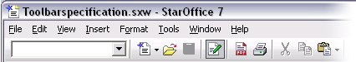Figure 35 Locked toolbars have no drag area.
Dock All Toolbars
Dock All Toolbars docks all floating toolbars at its last docked position. This command is active when the toolbar is in floating state.
Visible Buttons
Visible Buttons open a sub menu. This sub menu lists all commands which are applied to the toolbar. Commands showing a check mark are visible by default.
Customize Toolbar...
This entry opens the Customize Toolbar dialog.
Close Toolbar
This entry closes the toolbar. It is enabled when the toolbar is docked or when the toolbar is in floating state
Figure 36

User interface mockup of the quick customize features.
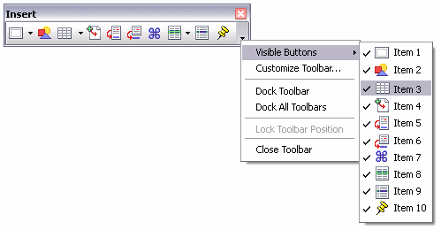Figure 37: Toolbar quick customization feature.
String Table
Item | English | German | Comments
Menu Name | Toolbar Options | Symbolleisten-Optionen
Menu command | Visible ~Buttons | Sichtbare ~Schaltflächen | This command is named diff than in some competitor products because our customize option is at the same level, not on the submenu (one less mouse-click). This is therefore not the only way to add or remove buttons from toolbars. The command name thus stays the same as in previous OO.o releases.
Menu command | ~Customize Toolbar... | ~Symbolleiste anpassen... | Opens the “Customize” dialog with the Toolbars tab page in front.
Menu command | ~Dock Toolbar | Symbolleiste an~docken
Menu command | Dock ~All Toolbars | ~Alle Symbolleisten andocken
Menu command | ~Lock Toolbar Position | Symbolleisten~position sperren
Menu command | Close ~Toolbar | Symbolleiste s~chließen

Quick Customization using Drag & Drop
Toolbars shall be also customizable by using drag & drop. It shall be possible to move, remove and to duplicate a toolbar item. For doing such modification users shall press a modifier key (listed in the table below) and select a toolbar item with the mouse. Holding down the main (left) mouse button while pressing the keyboard shortcut moves or duplicates the selected item. Figure 38 - 40 illustrates the interaction. During drag the mouse pointer shall be extended by a rectangle. The rectangle simulates the item which shall be moved.
For moving, removing or duplicating item users have to press a modifier key during the drag & drop interaction.
Keyboard Shortcut Windows | Keyboard Shortcuts Unix | Action
ALT+ Main Mouse Click, Hold | Shift Main Mouse Click, Hold | Move or delete item
SHIFT+CTRL+ Main Mouse Click, Hold | SHIFT+CTRL+ Main Mouse Click, Hold | Duplicate item

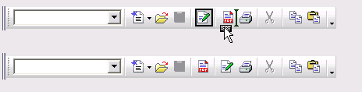Figure 38 Moving one item to another position (ALT+ Left Mouse Button Click, Hold).

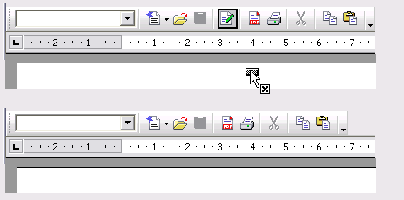Figure 39 Removing a toolbar item by moving it into the document area (ALT+ Left Mouse Button Click, Hold).

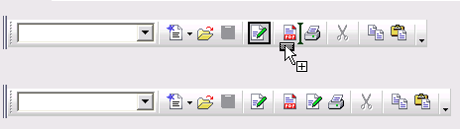Figure 40 Duplicating a toolbar item (SHIFT+CTRL+STRG + Left Mouse Button Click, Hold).

Customize Toolbars Dialog
Customization can be done from the Customize - Toolbars dialog. It can be accessed in four ways.
- Users go to Tools/Customize.../Toolbars
- From the View menu (View/Toolbars) and than they select Customize...
- They open a context menu while the mouse pointer is over a toolbar 'Customize...' or
- They click Toolbar Options at the end of a toolbar 'Customize Toolbar'.
Item | English | German | Comments
Dialog title | Customize | Anpassen | Was “Configuration”; Will be found under View – Toolbars – Customize, for example.
Tools Menu entry | Customize... | Anpassen... | Was “Configure...” as in under Tools – Configure... but is to be changed to match the new dialog title that resulted out of the consolidation of the two previous pages “Customize” and “Configuration”
Toolbar context menu entry | Customize... | Anpassen... | [Consolidation of the two toolbar context menu entries “Configure...” and “Customize”]

When the dialog opens it appears as shown in figure 41. The Toolbars tab page is divided into three main areas. One area for adding and modifying toolbars, an area for modifying the content of a toolbar, and an area which displays a description of the selected toolbar item.
Figure 41 Customize Toolbars dialog
String list
Item | English | German | Comments
Text Label | %PRODUCTNAME %MODULENAME Toolbars | %PRODUCTNAME %MODULENAME Symbolleisten | The variable %MODULENAME will be replaced with the name of the module, e.g. Writer, from which the “Customize” dialog was called.
Button | ~New... | ~Neu...
Drop Down Button (DD) | ~Toolbar | ~Symbolleiste
DD Menu Command | ~Rename... | ~Umbenennen | On menu of 'Toolbar' Drop Down Button
DD Menu Command | ~Delete | ~Entfernen | On menu of 'Toolbar' Drop Down Button
DD Menu Command | R~estore Default Settings | Standard Einstellungen ~herstellen | On menu of 'Toolbar' Drop Down Button
DD Menu Command | ~Icons Only | Nur ~Symbole | On menu of 'Toolbar' Drop Down Button
DD Menu Command | ~Text Only | Nur ~Text | On menu of 'Toolbar' Drop Down Button
DD Menu Command | I~cons & Text | S~ymbole & Text | On menu of 'Toolbar' Drop Down Button
Fixed line | Toolbar content | Symbolleisteninhalt
Text Label | Commands | Befehle
Button | ~Add Commands... | ~Befehle hinzufügen... | Opens dialog (see Fig 53)
Button DD | Command | Befehl
DD Menu Command | ~Rename... | ~Umbenennen | On menu of 'Command' Drop Down Button
DD Menu Command | ~Delete | ~Entfernen | On menu of 'Command' Drop Down Button
DD Menu Command | Restore Default Command | Standardbefehl ~wiederherstellen | On menu of 'Command' Drop Down Button
DD Menu Command | ~Begin a Group | ~Gruppe beginnen | Adds a Separator before an icon on the toolbar. To “end” the group, you just “begin” another group.
DD Menu Command | ~Icon only | Nur ~Symbol | On menu of 'Command' Drop Down Button
DD Menu Command | ~Text only | Nur ~Text | On menu of 'Command' Drop Down Button
DD Menu Command | Icon & Te~xt | S~ymbol & Text | On menu of 'Command' Drop Down Button
DD Menu Command | ~Change Icon... | Symbol a~ustauschen... | On menu of 'Command' Drop Down Button
DD Menu Command | Reset Ic~on | Symbol ~zurücksetzen | On menu of 'Command' Drop Down Button
ToolTip | Move Up | Nach oben | CLARIFY SHORTCUTS
ToolTip | Move Down | Nach Unten | CLARIFY SHORTCUTS
Text Label | ~Save in | ~Speichern in
Separator | Description | Beschreibung

Toolbar Area
This area (Figure 42) provides three controls a drop down list box (labeled Toolbar) a 'New...' button and a drop down push button. The 'Toolbar' drop down lists all toolbars available for the module from where the Customize Toolbar dialog was opened. For example in Writer []:
- Standard
- Formatting
- Table
- Picture
- Numbering & Bullets
When the Customize toolbar dialog was opened directly from a toolbar this toolbar has to be preselected for customization.
Figure 42 Toolbar area of the Customize Toolbars dialog.
A click on the 'New...' button opens the 'New Toolbar' (Figure 43) dialog. Users can give the custom toolbar a name of their choice. The dialog proposes a default name 'Custom Toolbar'. If the user does not change the proposed name and creates an additional custom toolbar, OpenOffice.org shall propose 'Custom Toolbar 1'. Next would be 'Custom Toolbar 2' etc. Doing this assures that OpenOffice.org proposes only unique names.
The default name is selected, so that it is easy for the user to overwrite the default name. Next is that users have to specify if the toolbar configuration shall be saved to the module or to a currently opened document. By default the module is preselected for example OpenOffice.org Writer. After choosing OK the custom toolbar shall be added to the Toolbar drop down list box. The custom toolbar shall be selected and the Toolbar Item list shall be empty (Figure 44). By pressing OK, an empty floating toolbar with the space for one item shall shall be placed on the module window. It is important that the toolbar will be position at a place where it will not be hidden by the Customize dialog.
Each Toolbar has to have a unique User Interface name. This rule is a module wide rule. For example it is not possible to have two toolbars named 'Standard' dependent to one module or the current document.
But it shall come to no conflicts when user A has created a custom toolbar (for example named Custom 1) dependent to one module. Now user A gets a document from user B dependent with a custom toolbar. This custom Toolbar from user B is also called Custom1. In this situation both toolbars are listed in the View/Toolbar menu.
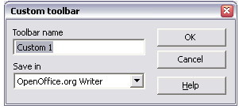Figure 43 Dialog for entering the name and for specifying to which object the configuration shall be saved.
Item | English | German | Comments
Dialog Title | New Toolbar | Neue Symbolleiste | EM->CJ: I think you should go with the name “New Toolbar” as stated in 357 above. “Custom Toolbar” could get confused with “Customize Toolbar” and the Button that opens this dialog is “New...”  OK
Label | ~Toolbar name | ~Name der Symbolleiste
Label | ~Save in | ~Speichern in
Button (default) | OK | OK
Button | Cancel | Abbrechen
Button | ~Help | ~Hilfe

Figure 44 Empty Toolbar Items list after creating a new Custom toolbar.

The 'Modify' drop down push button provides the following commands (the table at the end of the list displays when each command is active). The menu appears on short click. And opens like a standard menu.
- Rename...
- Delete
- Restore Default Settings
- Symbols only
- Text only
- Symbols & Text
Modify Toolbar
Rename...
Delete
Restore Default Settings
-------------
Symbols only
Text only
Symbols & Text

All command are specified in detail below:

Rename...
Changes the name of a selected toolbar. This command is only enabled for custom toolbars. Selecting this command calls a Rename dialog (Figure 45). The text field in this dialog displays the current name of the toolbar in selected state. This makes is easier for the user to overwrite the name.
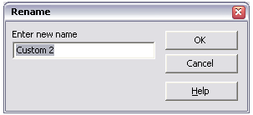Figure 45 Rename dialog.

Item | English | German | Comments
Dialog Title | Rename Toolbar | Symbolleiste umbennen
Label | ~New name | ~Neuer Name
Button (default) | OK | OK
Button | Cancel | Abbrechen
Button | Help | ~Hilfe
placeholder | Custom Toolbar %n | Benutzerdefinierte Symbolleiste %n | %n will be replaced at runtime by a number starting with 1 and increasing as necessary.

Delete
The Delete command allows user to delete custom toolbars. It is not possible to delete a OpenOffice.org build-in toolbars. Users can only delete custom toolbars. If the user dismisses the configuration toolbar dialog all deleted toolbars are still existing.

Restore Default Settings
Restore Default Settings resets the whole toolbar back to factory default. This command is active when a standard toolbar has been modified. It is inactive for custom toolbars.

Symbols only
This command changes the look of the whole toolbar to symbol state.
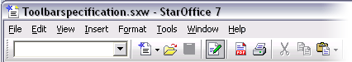Figure 46 Toolbar displaying symbols only
Text only
Text only shows only the command name in the toolbar.
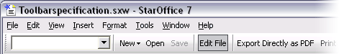Figure 47 Toolbar displaying text only.
Symbols & Text
Symbols & Text displays for the whole toolbar the command name right under the command symbol.
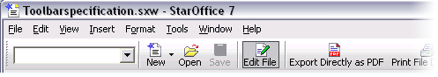Figure 48Toolbar displaying text & symbols

Command Matrix
The table below shows in which state a command can be executed.
Command | Build-In Toolbar selected | Custom Toolbar selected
New... | X | X
Rename... | - | X
Delete | - | X
Restore default settings | X | -
Symbols only | X | X
Text only | X | X
Symbols & Text | X | X
X = can be executed
- = disabled

Command checked | Symbols only | Text only | Symbols & Text
Symbols only | x | - | -
Text only | - | x | -
Symbols & Text | - | - | x

Toolbar Content Area
Within this area (Figure 49) users can modify the content of a custom or module toolbar. For example adding commands to the toolbar or rearranging commands.

Figure 49 Area 2 of the Customize toolbars dialog.

Toolbar Commands List Box
The Toolbar Items list box lists all available items of the selected toolbar from the Toolbar drop down list box. When users create a new toolbar the list box is empty. Items can be rearranged by using drag & drop or by using the Up & Down buttons located at the right hand side of the list box.
Figure 50 Custom Toolbar containing three items.

Each item provides a check box. When the check box is in selected state the item is visible in the toolbar. Additionally added items are checked by default (Figure 50).Separators do not provide a check box for toggling visibility.

Add Command...
The 'Add Command...' command allows users to add commands to the selected toolbar. Selecting the command calls the 'Add item' dialog (Figure 52). The dialog is a modeless dialog. User can select from the Commands category the commands they want to add to the toolbar. Adding items can be done by keyboard or for the mouse orientated user by drag & drop (Figure 50).Users can drag commands directly into existing toolbar or into the Command list field of the Customize Toolbars tab. The drag & drop interaction shall be visually enhanced compared with OpenOffice.org 1.1.
During the drag the mouse pointer shall be extended by a rectangle. The rectangle simulates the selected command. Over a toolbar OpenOffice.org shall indicate exactly where the command will be placed. Dragging the command somewhere over the module or desktop window cancels the actions. Please compare this with the Quick Customization using Drag & Drop described in Chapter 6.8.1
When the user chooses to add commands by keyboard the commands will be add below the current selection in the Commands list of the Customize Toolbars tab.
If possible the Add Command dialog should not overlap the item list in the configure dialog, because this is the target for new toolbar commands.
Figure 51
Commands listed in the Commands list which are displaying a triangle on the right hand side are commands which open a sub menu or sub toolbar. In the moment of selecting a command the Description field displays the content of the extended ToolTip.
Figure 51 illustrates the workflow of adding items.
Figure 52Adding Items to a toolbar

Figure 53 Add Commands dialog of OpenOffice.org 2.0

Item | English | German | Comments
Dialog Title | Add Commands | Befehle hinzufügen | Title of dialog opened by the button of the same name on the toolbars customization dialog.
Label | To add a command to a toolbar, select the category and then the command. Then drag the command to where you want it on the desired toolbar. Alternatively, you can drag the command to the Commands list of the Toolbars tab page in the Customize dialog. | Um Befehle einer Symbolleiste hinzuzufügen, wählen Sie zuerst eine Kategorie und dann den Befehl. Ziehen Sie den Befehl direkt auf die gewünschte Symbolleiste. Alternativ ziehen Sie den Befehl in die Befehlsliste auf der Registerseite 'Symbolleisten' im Dialog 'Anpassen'.
Label | ~Category | ~Kategorie
Label | C~ommands | ~Befehle
Separator | Description | Beschreibung
Button (default) | ~Add | ~Hinzufügen
Button | Cancel | Abbrechen
Button | ~Help | ~Hilfe
EM-CJ: where is the description text?
CJ->EM: The description shall be created outomatically by using the extended help tip of each command. OK, good to know.
Command
The 'Command' drop down push button gives users access to commonly needed commands for modifying the content of a toolbar. For example from here users can add or remove items. The Modify Selection drop down bush button contains the following commands:
- Rename...
- Remove
- Restore Default Settings
- Begin Group
- Symbols only
- Text only
- Symbols & Text
- Change Symbol
- Reset Symbol
The menu shall be structured so the list shall look like shown in the table below.
Command
Rename...
Remove
Restore Default Settings
----------
Begin Group
---------
Symbols only
Text only
Symbols & Text
---------
Change Symbol...
Reset Symbol

All commands are specified in detail below:

Rename...
This command allows users to rename commands. The same dialog appears like when remaining toolbars.
Remove
Remove removes the currently selected command without any warning. The selection, after removing one commands, jumps to the next available command or separator above. If the user removes the last item the toolbar shall be deleted as well. OpenOffice.org pushes an alert to make sure that this is intended by the user.
Alert type: Question
Item | English | German | Comments
Dialog Title | %PRODUCTNAME % PRODUCTVERSION | %PRODUCTNAME % PRODUCTVERSION
Question Text | There are no more commands on the toolbar. Do you want to delete the toolbar? | Die Symbolleiste beinhaltet keine Befehle mehr. Soll die Symbolleiste gelöscht werden?
Button (Default) | Yes | Ja
Button | No | Nein

Restore Default Settings
The Restore Default Settings command restores the factory default setting of a modified toolbar item.
Insert Separator
Insert Separator add a separator to the toolbar item list. The separator shall be inserted below the current selected item.
Symbol only
Symbol only displays the item as symbol only
Text only
Text only displays the item as text only
Symbols & Text
Displays the Text beneath the symbol. When selected in a toolbar with a display Symbol & Text this option has no effect.
Change Symbol...
'Change Symbol...' opens a small icon browse dialog (Figure 54). In this dialog users can select from a list of custom icons and they also can add icons to the icon collection by importing them. Clicking import opens a file picker. The File picker points by default to the icon directory of OpenOffice.org. Icons for import shall be in PNG format and shall have a size of 16x16 or 26 by 26 pixel [].
The File picker shall allow:
- Multi selection of images for import
- And shall remember the last visited folder.
- PNG format shall be preselected

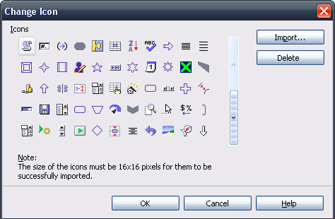Figure 54: Icon Chooser with Import functionality.

Item | English | German | Comments
Dialog Title | Change Icon | Symbol austauschen
Label | ~Icons | ~Symbole
Button (default) | OK | OK
Button | Cancel | Abbrechen
Button | ~Help | ~Hilfe
Button | ~Import... | ~Importieren...
 | Delete | -- | Removes currently selected icon.
Info text | Note: The size of an icon should be 16x16 pixel to achieve best quality. Higher sized icons will be scaled automatically.

If the user picks an icon in an unsupported file format, an alert shall be displayed informing the user that the file could not be imported because they provide not astandard format. The list shall show the volume if needed a shortened path and the file name plus its extension (Figure 55).
If the user picks an icon in a different size than the expected 16*16 or 26 * 26, the image is automatically adjusted:
- Scale down larger sized icons to 16*16/26*26 Pixel pixel without request. (always keeps aspect ratio of the icon on scaling!). Center icon vertically and horizontally on a transparent background.
- If the icon is smaller than 16*16/26*26, put the provided icon as is on a centered 16x16/26*26 transparent background.
Delete Button
The following query dialog is shown, if the delete button is pressed.
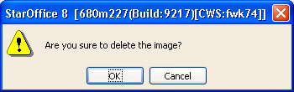
Item | English | German | Comments
Dialog Title | $PRODUCTNAME | --
Label | Are you sure to delete the icon? | --
Buttons | Yes | -- | Default
Buttons | No | --

Icon Replacement Confirmation Dialog
The following dialog is shown, if the imported icon's file name is already present,
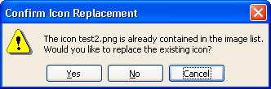
Item | English | German | Comments
Dialog Title | Confirm Icon Replacement | --
Label | The icon %FILENAME is already contained in the image list. Would you like to replace the existing icon? | --
Button | Yes | -- | Default, replaces the existing icon.
Button | No | -- | Skipps the durrent icon.
Button | Cancel | -- | Aborts the import process.

Alert type: Information
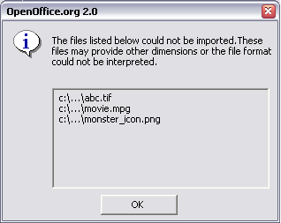Figure 55 Alert which is displayed if files couldn't be loaded.(outdated mock-up)

Item | English | German | Comments
Dialog Title | %PRODUCTNAME %PRODUCTVERSION | %PRODUCTNAME %PRODUCTVERSION
Info Text | The files listed below could not be imported. The file format could not be interpreted.
Button (default) | OK | OK

Reset Symbol
The 'Reset Symbol' command resets the symbol of command to the state before the modification. The table below lists the state when each command is available or not.

The table below list which menu command shall be active or inactive when a command is selected.
State | Active | Inactive
New or empty toolbar | Add Item...
 |  | Insert Separator
 |  | Rename...
 |  | Delete
 |  | Restore Default Settings
 |  | Symbols only
 |  | Text only
 |  | Symbols & Text
 |  | Change Symbol...
 |  | Reset Symbol
State | Active | Inactive
Item Selected | Add Item...
 | Insert Separator
 | Rename...
 | Delete
 |  | Restore Default Settings
 | Symbols only
 | Text only
 | Symbols & Text
 | Change Symbol...
 |  | Reset Symbol
State | Active | Inactive
Modified Item Selected | Add Item...
 | Insert Separator
 | Rename...
 | Delete
 | Restore Default Settings
 | Symbols only
 | Text only
 | Symbols & Text
 | Change Symbol...
 | Reset Symbol
State | Active | Inactive
Separator Selected | Add Item...
 | Insert Separator
 |  | Rename...
 | Delete
 |  | Restore Default Settings
 |  | Symbols only
 |  | Text only
 |  | Symbols & Text
 |  | Change Symbol...
 |  | Reset Symbol

Description Area
The description Area (Figure 56) displays the extended ToolTip of an selected toolbar item. The description area shall remain empty when a Separator is selected.

Figure 56 Description are of Customize Toolbars.

Read Only Mode
For read only mode it shall be possible to hide toolbars if needed. Modifying a toolbar shall only be possible for toolbars which are bound to the module. Toolbar bound to a document can only change their appearance. This means users can switch between show Icons, Icons & Text or Text these changes will not be saved. This feature is located in the 'Toolbar' drop down push button.

Sun Java[TM] Desktop System Configuration Manager
The Sun Java[TM] Desktop System Configuration Manager is a Web application that enables the centralized management of StarOffice settings or user preferences. By using this application, it is possible to allow or to forbid users the modification of toolbars. The system administrator can change the behavior of the features listed below:
Sun Java[TM] Desktop System Configuration Manager Config Items
Enable/Disable Customize Toolbars
Enable/Disable Toolbars being moved
...

Future Tasks
- Icon Editor (with basic functionality!) for creating custom toolbar images.

Notes
MMP-1 Issue. Detailed specification of contexts is required for the specific specifications of the different toolbars.
UFI-1 suggestion: Beim freien Fenster (Abb.3) sieht man nicht unbedingt, dass man es irgendwo andocken kann. Vielleicht kann die Titelleiste ganz links auch so ein "Griffraster" bekommen?
UFI-2 suggestion: Ich würde mir wünschen, dass auch die Windows für Navigator, Stylist, Preview, Gallery usw. Controls bekommen, mit denen sie an- und abgedockt werden.

References
Source: Microsoft User Interface Guidelines
Source: Apple Human Interface Guideline
Source: GNOME User Interface Guidelines
Source: JLF Guidelines
Toolbar Issue List: http://specs.openoffice.org/ui_in_general/toolbar_concept/issues/issues.html

A specification covering the pull down menu can be found here.
OpenOffice Toolbar Content Specification, C.Jansen, Sun Microsystems, Inc http://specs.openoffice.org/appwide/toolbars/toolbar_Content_Spec.odt
The list will be completed when we know all the toolbars OpenOffice.org Writer provides 2.0.
Size, Format & default Folder may vary until OpenOffice 2.0 is released.

