Software Specification Document

OpenOffice.org Writer
Enhance Chapter Number Capability on Writer Indexes

Specification Status
Last Change | Feb 20, 2008
Status
Abstract
This specification describes the implementation of the new outline chapter number feature in text indexes (Writer) as described in ODF specification 1.2, draft 6, chapter “7.12.1.1 Display Chapter Format”.
The six index types available in OpenOffice.org will gain the ability to insert the outline chapter number level in the index entry structure together with the maximum index level to be examined to show the chapter number.
The possibility to chose the outline numbering format will be available as well, if not already present.
In order to achieve this, the Illustration, Table, Object, and User-Defined indexes will be added the 'Chapter no.' item.
This change affects the following indexes: Table of Contents, Illustration index, Tables index, Table of objects, User-Defined index and Alphabetical index.
i-Team Members
Role | First Name, Last Name, Initials | E-Mail Address
I-Team Lead | Giuseppe Castagno (beppec56) | beppec56@openoffice.org
Specification Author | Giuseppe Castagno (beppec56) | beppec56@openoffice.org
User Experience | Frank Loehmann (fl) | Frank.Loehmann@Sun.COM
Development | Giuseppe Castagno (beppec56),  Oliver-Rainer Wittmann (od),  Framk Meies (fme) | beppec56@openoffice.org,  Oliver-Rainer.Wittmann@sun.com  Frank.Meies@Sun.COM
Quality Assurance | Michael Ruess (mru) | mru@openoffice.org
Documentation | Uwe Fischer (ufi) | Uwe.Fischer@Sun.COM

Contents
Abstract 1
i-Team Members 1
References and Reference Documents 3
Acronyms and Abbreviations 3
1 Detailed Specification 4
1.1 Changes to "Table of Contents" dialog 4
1.2 Changes to Alphabetical Index 6
1.3 Changes to other index dialogs 6
1.4 Changes to the API interface for indexes 7
2 Migration 7
2.1 Text documents from previous version 7
2.2 Open text documents with previous version 7
3 Configuration 7
4 File Format 7
5 Open Issues 7
Document Change History 8

References and Reference Documents
Reference Document | Check | Location (URL)
Specification Process Entry Check |  | N/A
Product Requirement, RFE, issue [Required] |  | Issue i53420. Implements suggestion to ODF 1.2 showed in this proposal.
Product Concept Document
Competitive Analysis
IDL Specification
Test Case Specification [Required]
Software Specification Rules | N/A | N/A
ODF 1.2 specification, draft 6, Sep 12th, 2007 edition |  | http://www.oasis-open.org/committees/download.php/25268/OpenDocument-v1.2-draft6.odt
Index and tables specification |  | http://specs.openoffice.org/writer/index/index_and_tables_dialog.sxw
Acronyms and Abbreviations
Acronym / Abbreviation | Definition

Detailed Specification
In order to explain in detail what will happen, a document will be used as an example.
With the following document structure:
- table of contents with pages numbered as: i, ii, iii...
- the document body, with pages numbered as: 1, 2, 3...
- appendix, with pages numbered as: A-1, A-2, A-3...; B1- B-2.....
- attachment, with pages numbered as: 1-1, 1-2, 1-3...; 2-1, 2-2....
It should be possible to generate indexes for this page numbering scheme as shown in the following illustration (monospaced text for clarity).
Table of Contents
1 Chapter 1............................1
1.1 First level.......................1
1.1 Second level.....................2
Appendix A...........................A-1
A.1 Appendix heading................A-2
Attachement 1........................1-1
Attachement 2........................2-1
Illustration 1: example of Table of contents

In other words it should be possible to insert in an index structure description the maximum outline level to be examined when generating the index body, and the format of the numbering to be used.

Changes to "Table of Contents" dialog
The 'Chapter no.' token ('E#') of the table of contents level structure gets a couple of new controls. They are needed in order to control the format and the maximum evaluation level used to print the item in the index line.
This is an addition to an already existent user interface, the remaining part of the dialog remains unaffected by this change.
The new items will behave the same for all the levels.
1
2
5
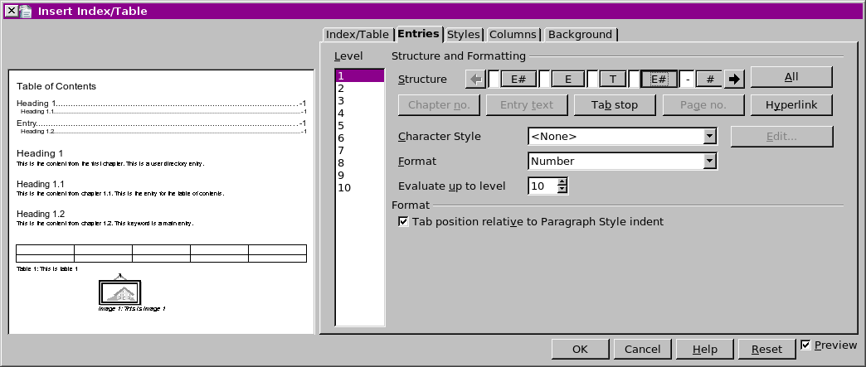Figure 1.: New Table of contents dialog (mock up, beppec56 2008-01-17)
4
3
Table 1: New user Interface elements of figure Figure 1.
- “E#” - Button Properties |  | Comment
Enabled: | Behavior unchanged
Disabled: | Behavior unchanged
Press: | See interface elements below
Other: | This interface element description was added in order to explain the behavior of the new items.  There is no change of this element behavior with respect to the current stable implementation (version 2.3.1).
Button Label: | E# | EN-US

- “Format” - Label Properties |  | Comment
Label: | Format | EN-US.  Displayed when #1 is pressed or if  Not displayed otherwise.

- “Numbering” - DropDown Listbox Properties |  | Comment
Enabled: | Displayed when #1 pressed.
Disabled: | Not displayed when #1 is not present or not pressed if present.
Max. Row Count: | 2
Rows Visible: | 1
Items: | - Number ; <Additional Language (Optional)>  - Number without separator; <Additional Language (Optional)>
Item Selected: | 1 | Default selected, when first opened.
Sorting by  Drag & Drop: | <Enabled/Disabled>
Other: | <Specify Other Properties Here>
DropDown  ListBox Label: |  |  | EN-US
DropDown  ListBox Label: | <Additional Language (Optional)> |  | e.g. DE

- “Evaluated level” - Label Properties |  | Comment
Label: | Evaluate up to level |  | EN-US  Displayed when #1 pressed  Not displayed otherwise.
Label: | <Additional Language (Optional)> |  | e.g. DE

- “Level” - SpinField Properties |  | Comment
Enabled: | Displayed when #1 pressed.
Disabled: | Not displayed when #1 is not present or not pressed if present.
Min. Value: | 1
Max. Value: | 10
Start Value: | The value of the current outline level if already inserted, a value of 10 if new or opening an old format document. | Default selected, when first opened.
Steps: | 1
Measurement Unit: | The outline level number
Other: | <Specify Other Properties Here>
SpinField Label: | NF_LEVEL_OL |  | EN-US
SpinField Label: | <Additional Language (Optional)> |  | e.g. DE

Some additional comments on control #3, as an example, suppose you have a current heading as “[2.4] Working with Tables”. The plain chapter in this example is 2.4. According to the outline numbering that is in place it is displayed with the prefix “[“ and the suffix “]”. The chapter title is “Working with Tables”.
By selecting item 1 in control #3, “[2.4]” will be displayed; by selecting item 2 in control #3, “2.4” will be displayed.

Changes to Alphabetical Index
The dialog to insert the “Alphabetical Index” is added two new controls to the already present ”Chapter info” button: they are the the same as #4 and #5 in Table 1 above.

Changes to other index dialogs
The dialogs “Illustration Index”, “Index of Tables”, “User-Defined Index” and the “Tables of Objects” are added the “Chapter info” button and related controls, the same button and behavior present in Alphabetical indexes as described in Changes to Alphabetical Index above.

Changes to the API interface for indexes
The com.sun.star.text.DocumentIndexLevelFormat API service will be added a new property and its behavior will change as follows:
- in order to add the possibility to control the outline level a new property 'ChapterLevel' is added, it will have the behavior of control #5 in Table 1;
- it will be possible to use the TokenType TokenChapterInfo (chapter info) in illustration indexes, table indexes, user indexes, table of objects and alphabetical indexes, not only on alphabetical indexes;
- it will be possible to use the ChapterFormat property in chapter info and entry number, not only on chapter info,
- it will be possible to use the new ChapterLevel property in chapter info and entry number only.

Migration

Text documents from previous version
Old documents do not have this feature, opening them will simply show the new controls at their default values.

Open text documents with previous version
While opening text document updated to this feature with old version of the application the new settings are ignored.
The index bodies will remain the same if not updated.

Configuration
No change in configuration are needed.

File Format
The ODF file format generated will be version 1.2, draft 6 (current public version as of Jan 20, 2008). See Migration above for details.
Details on changed format are available on “ODF 1.2 specification, draft 6, Sep 12th, 2007 edition”, in chapter “7.12.1 Chapter information”, see “References and Reference Documents” on top of this document for detail on how to obtain a copy.

Open Issues
Issue | Initials | Date
<...>

Document Change History
Rev. | Change | Initials | Date
1 | First specification draft |  | Feb 12th, 2008
2 | Added link | FL | February 20, 2008
3
<...>

