Software Specification Document

OpenOffice.org Writer
New Default Table Formatting Behavior

Specification Status
Last Change | April 24, 2006
Status

Abstract
Predefined character formatting inside tables is unwanted by the user as we have learned in OOo 2.0 usability studies. Furthermore the formatting, used in the paragraph were the table has been inserted, is expected to be used in the table as well.
i-Team Members
Role | First Name, Last Name, Initials | E-Mail Address
Project Lead | Frank Loehmann | frank.loehmann@sun.com
Specification Owner | Frank Loehmann | frank.loehmann@sun.com
User Experience | Frank Loehmann | frank.loehmann@sun.com
Development | Frank Meies | frank.meies@sun.com
Quality Assurance | Michael Rüß | michael.ruess@sun.com
Documentation | Uwe Fischer | uwe.fischer@sun.com

Contents
Abstract 1
i-Team Members 1
References and Reference Documents 3
1 Detailed Specification 4
1.1 Old Table Formatting Behavior in OpenOffice.org Writer 4
1.2 New Table Formatting Behavior for OpenOffice.org 5
2 Migration 6
3 Configuration 7
4 File Format 7
5 Open Issues 7
Document Change History 7

References and Reference Documents
Reference Document | Check | Location (URL)
Specification Process Entry Check |  | N/A
Product Requirement,, RFE, issue (required) |  | i60422, i60430
Product Concept Document |  | <Please enter location here>
Competitive Analysis |  | <Please enter location here>
Test Case Specification (required) |  | <Please enter location here>
Software Specification Rules | N/A | N/A
<Other, e.g. references to related specs>

Detailed Specification

Old Table Formatting Behavior in OpenOffice.org Writer
The old table handling assigns the paragraph style "Table Heading" to the header row of a table and the style "Table Contents" to the rest of the table. Furthermore the already used hard formatting of the normal text area is not copied to the table, so that the default font defined in the Standard paragraph style is used instead.
The Insert Table dialog has an option for creating table headers. See Illustration 2 for details.
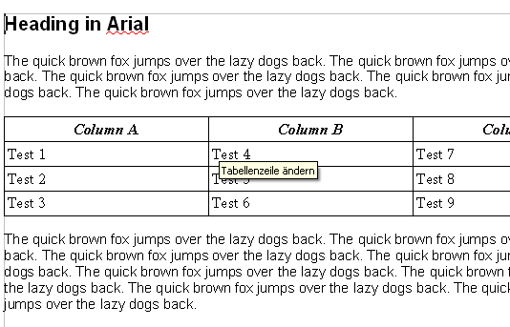
Illustration 1: Newly created (default) table in OOo 2.0.2 in surrounding hard formatted text document. This results in a different font used inside the table. Furthermore in often unwanted formatting (centered, bold, italic) for column headers.
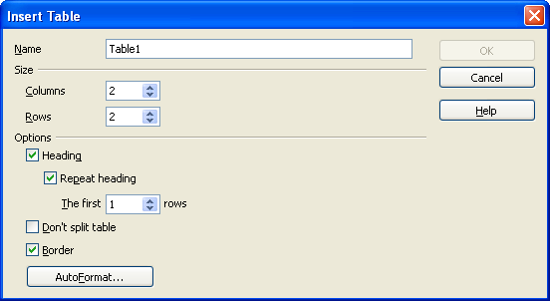Illustration 2: Insert Table dialog shows the option "Heading" turned on by default

New Table Formatting Behavior for OpenOffice.org
The heading feature for tables is turned off by default in Writer to match user's expectation monitored in usability tests. The "Table Contents" paragraph style will still be assigned to the whole table. This is important due to the "Do not count" attribute which is important for the paragraph numbering feature.
List of changes
If a table is inserted into a newly created Writer document:
- "Heading" option for tables is turned off by default
- "Repeat Heading" option is turned off by default too
- Table headings and repeat headings are also turned off by default, if a table gets inserted in a document by the table control in the object bar.
- The following text attributes
  - font
  - and font size
are copied (by using a hard attribute) to all paragraphs of the newly created table:
  - if set directly (hard) or via the paragraph style
  - or via a parent of the paragraph style.
Exception: If the paragraph style, which is applied to the newly paragraphs within the table ("Table Contents" or "Table Heading") already has one of this attributes set (directly or via one of its parent styles), then this attribute will not be copied.
- No "Italic" attribute is set in the "Table Heading" paragraph style anymore for new documents. Existing documents with tables inside will not be affected, because then this style is already present and assigned.
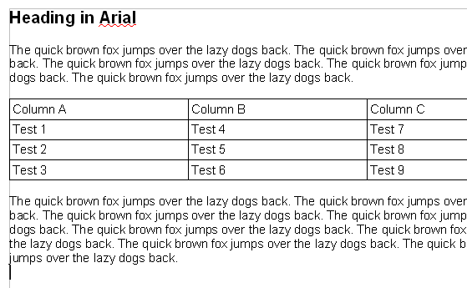
Illustration 3: Newly created table in OOo in a surrounding hard formatted text document - hard formats have been copied into table and Table Heading paragraph style has not been assigned to table header (1 row).

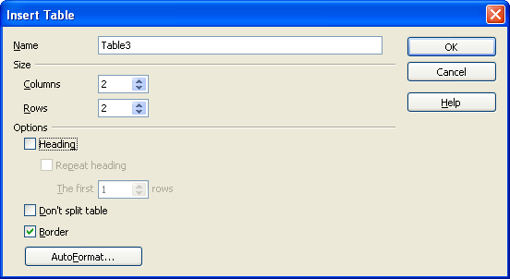
Illustration 4: New Insert Table dialog defaults

Migration
Existing documents will look exactly the same they did in current OOo 2.0.2.

Configuration
Configuration | Group | Setting | Type | Default | Comment
Writer.xcs | Table | Header | Boolean | False | The default is to have no table header
Writer.xcs | Table | RepeatHeader | Boolean | False | The default is to have no repeated header
Writerweb.xcs | Table | Header | Boolean | False | The default is to have no table header
Writerweb.xcs | Table | RepeatHeader | Boolean | False | The default is to have no repeated header

File Format
No file format changes.

Open Issues
Issue | Initials | Date
MRU had concerns that a user could be irritated by changing formatting behavior for new documents only. FL: Changed formatting default to new behavior regardless if new or old document. Discussed with MMP, because of own concerns to do so as a result of the change for the new numbering behavior, where old and new formats are mixed in old documents. | FL | 04 April 2006
 | FL | 24. April 2006

Document Change History
Rev. | Change | Initials | Date
1 | Initial draft of specification | FL | March 28, 2006
2 | Check draft | FL | March 29, 2006
3 | Added configuration settings | FME | April 13, 2006
4. | Change behavior to grab also for attributes set by paragraph styles | FL | April 24, 2006

Behavior description is based on OpenOffice.org 2.0.2
This was a violation of typography rules, due to two different emphasis have been used at the same time.

