Software Specification Document

Template Management Dialog

Specification Status
Last Change | Aug 11, 2006
Status

Abstract
The Remove function in the Template Manager and the Edit function in the Template Manager and the dialog in “File/New/Templates and Documents” needs to respect protected templates that have been installed by extensions or office installation.

i-Team Members
Role | First Name, Last Name, Initials | E-Mail Address
Project Lead | Mikhail Voitenko | Mikhail.Voitenko@Sun.COM
Specification Owner | Matthias Müller-Prove /MMP | mprove@sun.com,
User Experience | Matthias Müller-Prove /MMP | mprove@sun.com,
Development | Mikhail Voitenko /MAV | Mikhail.Voitenko@Sun.COM
Quality Assurance | Thorsten Martens /TM | Thorsten.Martens@Sun.COM,
Documentation | Uwe Fischer /UFI | Uwe.Fischer@Sun.COM
Other roles
<State reason here, if one role is not represented in i-Team.>

Contents
Abstract 1
i-Team Members 1
References and Reference Documents 3
Acronyms and Abbreviations 4
1 Detailed Specification 5
2 Migration 7
3 Configuration 7
4 File Format 8
5 Open Issues 8
Document Change History 8

References and Reference Documents
Reference Document | Check | Location (URL)
Specification Process Entry Check |  | N/A
Product Requirement,, RFE, issue (required) |  | <Please enter location here>
Product Concept Document |  | <Please enter location here>
Competitive Analysis |  | <Please enter location here>
Test Case Specification (required) |  | http://staroffice-doc/Teams/QA/Test_case_specifications/Framework/Framework/Template_Management_Dialog/template-management-dialog.html
Software Specification Rules | N/A | N/A
Options > OpenOffice.org > Paths |  | http://specs.openoffice.org/appwide/options_settings/OOoPaths.odt

Acronyms and Abbreviations
Acronym / Abbreviation | Definition
OOo | OpenOffice.org

Detailed Specification
The Template Management dialog provide functionality to delete template groups or single templates.
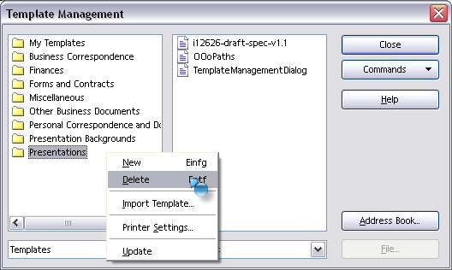Illustration 1: Remove function in Tempalte Management Dialog
However, with the new extensions concept the user should no longer be able to remove templates that have been installed along with an extension or preinstalled by the office installation.
Therefore the Remove command is not part of the context menu for a folder if
- all templates in a folder are installed by extensions.
The Remove command is not part of the context menu for a template file if
- the template file was installed by an extension.
If a folder should be removed and not all template files in that folder can be removed then
- all removable template files are removed
- all template file that had been installed by an extension remain where they are, and
- an Information Alert informs the user, that not all items in that folder could be deleted.
Table 1: User Interface elements of Alert.
# | Type | Properties |  | Comment
<#> |  | Control Properties  State: modal  Closable: yes  Close Operation: do nothing  Is iconifiable: no  Is maximizable: no  Resizable: no  Always On Top: yes  Other...: Inforamtion Alert with OK button
<#> |  | String English  Some template files are protected and can not be deleted. | String German  Einige Templates sind geschützt und konnten daher nicht gelöscht werden.

Editing of templates
In addition the Template Manager and the “File/New/Templates and Documents” dialog should not allow to edit a template that have been installed by an extensions or preinstalled by the office installation. Thus the edit function for such templates should be disabled in the mentioned dialogs.

Illustration 2: Edit function in Tempalte Management Dialog

Illustration 3: Edit function in “File/New/Templates and Documents” Dialog

Migration
n/a

Configuration
n/a

File Format
n/a

Open Issues
Issue | Initials | Date
<State Issue here, State “None”, if all issues are solved> |  | <Format: Dec 31, 2000>
<...>

Document Change History
Rev. | Change | Initials | Date
1 | set up document | MMP | Jul 4, 2006
2 | Add the section about templates editing | MAV | Jul 10, 2006
3 | Remove version/product name from specification | MAV | Aug 11, 2006
<...>

