Translation of the OpenOffice.org Extras
How-To Manual
Version: 2
Contact: Volker Ahrendt (volker.ahrendt@sun.com)
Ilko Höpping (ilko.hoepping@sun.com)
Table of Contents
Getting started ... 1
General Rules 1
To be translated parts of the documents/files 2
Not to be translated parts of the documents/files 2
Translation of ... 3
... Autotexts 3
... OpenOffice.org Impress Layout Templates 4
... OpenOffice.org Impress Presentation Templates 5
... Wizard Templates (OpenOffice.org Writer) 5
Agenda Wizard 5
Fax and Letter Wizards 5

Getting started ...
- For translation of the OpenOffice.org Extras please use the current (English) release of OpenOffice.org.
- The documents/files are located in the folder “...\en-US” of each section, e.g. ...
  - OpenOffice.org_installation_path\share\autotext\en-US
  - OpenOffice.org_installation_path\share\template\en-US\...
    - ...layout
    - ...presnt
    - ...wizard\agenda
    - ...wizard\fax
    - ...wizard\letter\en-US
  - etc.
  - Please ignore the folder OpenOffice.org_installation_path\share\template\wizard
- Please save the translated files into a new sub-folder (“...\languageID”). The name of the language folder must be the ISO code (ISO 639-1) of the regarding language e.g. “...\hu” (Hungarian), “...\pl” (Polish), “...\ru” (Russian), etc.
Attention! – Do not double-click on templates to open. If you do so, a new document will be created. → Right-click the regarding template and choose “Open”.

General Rules
- The cursor position in a document must be on the top of the first page.
- The document must have a zoom factor of 100%, presentations and drawings should be scaled to “Entire page”.

To be translated parts of the documents/files
In general the following parts of the OpenOffice.org Extras need to be translated or localized:
- The language of a document must be set correctly → paragraph style “Default”:
  - Open “Styles and Formatting”: right-click on style “Default” – Modify... – Font → Language
- Title and description → File – Properties
- Contents
- Contents of second page in Writer templates, if necessary → To check this, insert a manual page break at the bottom of the first page (ctrl+enter).
- Custom paragraph styles, if existent → “Styles and Formatting”
Default view is “Automatic”. To save time please set the view to “Custom Styles”.
- Names of tables, frames, graphics, etc. → “Navigator”
- Notes → “Navigator”
- Contents of fields (double click on a field), e.g. <Placeholders>

Not to be translated parts of the documents/files
- File names of templates and autotexts
- Names of sections in OpenOffice.org Writer templates → “Navigator”
- Text in angle brackets, e.g. <City>, <Name>, <Date>, <Time>, <Location>, etc. in OpenOffice.org Writer, e.g. wizard templates (Agenda Wizard, Fax Wizard, Letter Wizard) – Attention! These strings are no placeholders (see above).
- User fields in Report Wizard templates, i.e. GroupField1 to GroupField4 and Column1 to Column4

Translation of ...
In addition to the general translation there are several specific characteristics in the following areas of the OpenOffice.org Extras:

... Autotexts
- → “...\share\autotext\en-US”
- Backup the autotexts in your English OpenOffice.org installation. → “OpenOffice.org_installation_path\share\autotext\en-US”
- Open a Writer Document.
- Choose Edit – Autotext...
- There you can rename/edit the categories and autotexts (see screenshots).
  - Attention! After renaming the category of an autotext, the file name will be changed, too. So you have to manually rename the file name back to “crdbus50.bau”, “standard.bau”, and “template.bau”.
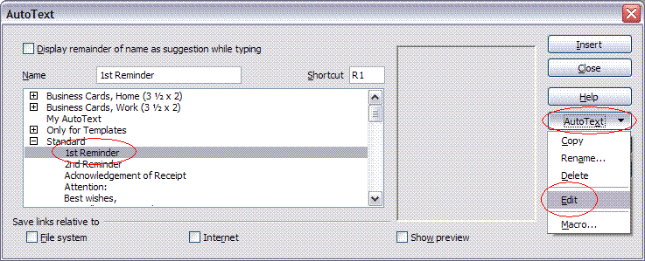Illustration 1: Edit AutoText
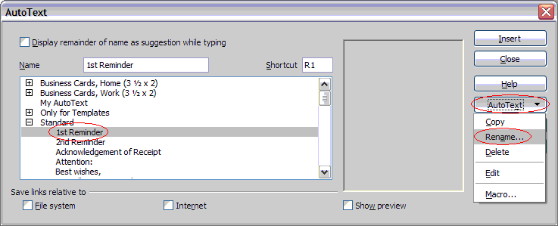Illustration 2: Rename AutoText – Step 1
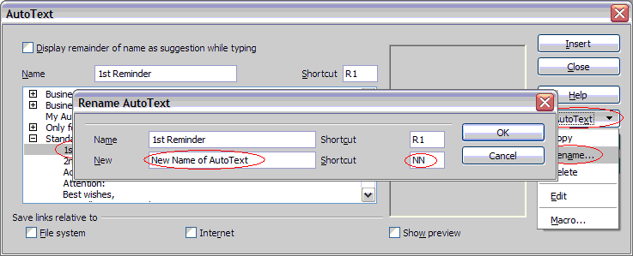Illustration 3: Rename AutoText – Step 2
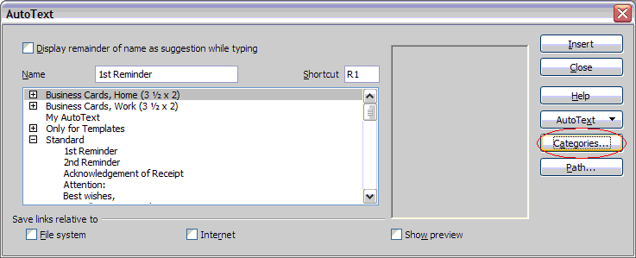Illustration 4: Rename AutoText Category – Step 1
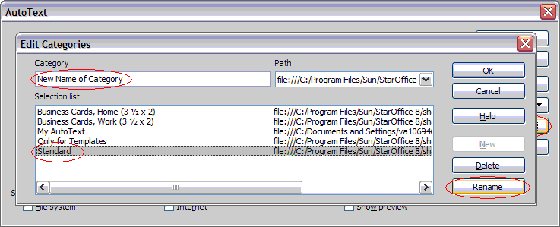Illustration 5: Rename AutoText Category – Step 2

... OpenOffice.org Impress Layout Templates
- → “...\share\template\en-US\layout”
- You only have to translate title and description of these files (see above).

... OpenOffice.org Impress Presentation Templates
- → “...\share\template\en-US\presnt”
- Do not forget to translate the slide names.

... Wizard Templates (OpenOffice.org Writer)
- → “...\share\template\en-US\wizard\...
- Do not translate names of tables, sections, textmarks or custom paragraph styles in any wizard template!

Agenda Wizard
- There are 20 templates:
  - 1simple.ott – 10grey.ott
  - aw-1simple.ott – aw-10grey.ott
- You only have to translate the first 10 templates and afterwards save them additionally as aw-... - This will save you time, because the contents of the regarding files are not different.

Fax and Letter Wizards
- Additionally these templates also need to be localized, i.e. the layouts of the templates have to be adapted to the regarding local circumstances. But please be aware not to delete any paragraphes or sections, because the structures of the documents must be obtained.

