Software Specification Document

OpenOffice.org
PDF Export Dialog

Specification Status
Last Change | Sep 2, 2010
Status

Abstract
OOo 2.0.3: The PDF Export dialog gets a bunch of additional options to control how the generated PDF document opens in Adobe Reader. They are layout and magnifications options, as well as options that control the user interface of Adobe Reader itself.
OOo 2.0.4: Security settings for PDF export dialog control the encryption level of the generated PDF. The idea is to implement encryption according to PDF version 1.4, in its basic incarnation.
OOo 2.2: Default zoom level and number of disclosed levels in bookmark hierarchy can be set.
OOo 3.3: Allow duplicate form field names. Optionally embed the 14 standard fonts.
OOo 3.4: simplify security tab page.

i-Team Members
Role | First Name, Last Name, Initials | E-Mail Address
Project Lead | Philipp Lohmann /PL | pl@openoffice.org,
Specification Owner | Matthias Müller-Prove /MMP | mprove@sun.com,
User Experience | Matthias Müller-Prove /MMP | mprove@sun.com,
Development | Philipp Lohmann /PL  Giuseppe Castagno /beppec56 | pl@openoffice.org,  beppec56@openoffice.org,
Quality Assurance | Hasan Ilter /HI | hasan.ilter@sun.com,
Documentation | Uwe Fischer /UFI | uwe.fischer@sun.com,
Product Program Manager for Legal Aspects | Götz Wohlberg /GW | goetz.wohlberg@sun.com

Contents
Abstract 1
i-Team Members 1
References and Reference Documents 3
Acronyms and Abbreviations 3
1 Detailed Specification 4
1.1 Content of the PDF 4
1.2 Dialog 4
1.3 First Tab: General 4
1.4 Second Tab: Initial View 6
1.5 Third Tab: User Interface 12
1.6 Fourth Tab: Security Settings 15
1.6.1 Intro 15
1.6.2 Implementation 16
1.6.3 Some words on the passwords 16
1.6.4 Dialog Design 17
1.6.5 Password Dialog 20
1.6.6 Notes 20
1.6.7 Printing permissions 21
1.6.8 Configuration 21
2 Migration 21
3 Configuration 21
4 File Format 22
5 Open Issues 22
6 Competitive Analysis 23
6.1 OpenOffice.org 2.0.0 – 2.0.2 23
6.2 Adobe Acrobat 5 23
6.3 Adobe Acrobat 7 – German Version 24
7 Document Change History 24
7.1 Related PDF Specifications and Documents 25

References and Reference Documents
Reference Document | Check | Location (URL)
Specification Process Entry Check |  | N/A
Product Requirement,, RFE, issue (required) |  | OOo 2.0.3: i61139  OOo 2.0.4: i12626  OOo 2.2: i68581
Product Concept Document |  | <Please enter location here>
Competitive Analysis |  | see below
Test Case Specification (required) |  | http://www.openoffice.org/nonav/issues/showattachment.cgi/35389/pdf-export-test.html  http://www.openoffice.org/nonav/issues/showattachment.cgi/37957/pdf-export.html
Software Specification Rules | N/A | N/A
PDF Export OOo 2.0 |  | http://specs.openoffice.org/appwide/pdf_export/PDFExport.sxw
PDF Reference, third edition Adobe Portable Document Format Version 1.4

Acronyms and Abbreviations
Acronym / Abbreviation | Definition
OOo | OpenOffice.org
PDF | Portable Document Format
Permission password | Password of the document's owner, the person who can change the document permissions
Document Open Password | Password of the document's user, the person who can only “see” the document if she knows the user password.
iff | if and only if

Detailed Specification

Content of the PDF
Quote from PDF Export - UI specification v.1.0:
In general the content of the PDF file is equivalent to the output generated for printing. This means that invisible objects of a document are not part of the PDF file.

Dialog
The PDF Options dialog is a modal dialog.
Compared to OOo 2.0.0/2.0.2, the PDF Options dialog is expanded by 2 additional tabs. All controls of the former dialog are move to the first tab page of the new tab control.
The dialog has Export and Cancel buttons at the bottom. The online help can be called with the Help button at the bottom right of the dialog.
The settings made in the dialog are persistent from session to session. They are stored in OOo's configuration. The default values are defined in the string tables below.
The dialog always opens on the first tab page.

First Tab: General
Changes since 2.0.4:
- added option for exporting bookmarks or not
- added option to export form fields as PDF widget annotations or as simple print type fields (like in OOo 1.1)
- moved “Use transition effects” option to “Viewer preferences” tab page.
- added option for PDF/A
- added option to allow for duplicate form field names
- add option to embed the 14 standard fonts also in non PDF/A case
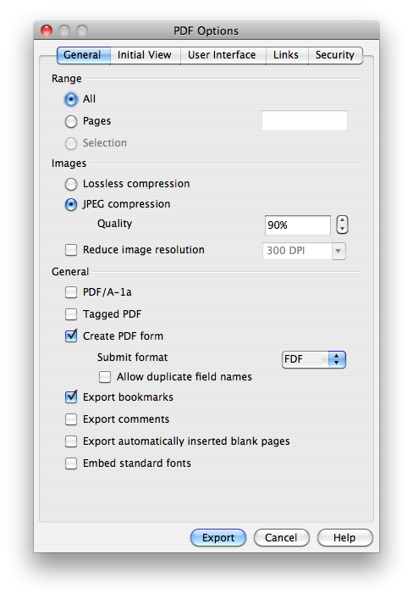Illustration 1: First Tab (snap shot; not final yet)

Table 1: User Interface elements of Figure Illustration 1: First Tab (snap shot; not final yet)
# | Type | Properties |  | Comment
<#> |  | Control Properties  State: modal  Closable: yes  Close Operation: Withdraw changes and close dialog  Is iconifiable: no  Is maximizable: no  Resizable: no  Always On Top: yes |  |  | dialog title
<#> |  | String English  PDF Options | String German  PDF Optionen |  | same as OOo 2.0.2
<#> |  | Control Properties  Icon: no  Enabled: yes
<#> |  | String English  E~xport | String German  Exportieren |  | same as OOo 2.0.2
<#> |  | Control Properties  Enabled: yes |  |  | tab title
<#> |  | String English  General | String German  Allgemein
<#> |  | Control Properties  Enabled: yes  Initially Checked: yes  TriState: no  ToolTip Text:  Other...:
<#> |  | String English  Export Bookmarks | String German  Lesezeichen exportieren
<#> |  | Control Properties  Enabled: if “PDF/A-1” is unchecked  Initially Checked: yes  TriState: no  ToolTip Text:  Other...:
<#> |  | String English  Create PDF form | String German  PDF Formular erzeugen
<#> |  | Control Properties  Enabled: if “Create PDF form” is checked and enabled  Visible Row Count: 4  Item Selected: FDF  Enable Sorting by DnD: no  A11Y Text:  ToolTip Text:
<#> |  | String English  <Enter String Here> | String German  <Enter String Here>
<#> |  | Control Properties  Enabled: Yes  Initially Checked: No  TriState: No  ToolTip Text:  Other...:
<#> |  | String English  PDF/A-1 | String German  PDF/A-1
<#> |  | Control Properties  Enabled: if “Create PDF form” is checked and enabled  Initially Checked: No  TriState: No  ToolTip Text:  Other...:
<#> |  | String English  Allow duplicate field names | String German
<#> |  | Control Properties  Enabled: If “PDF-A/1” is unchecked  Initially Checked: no  TriState: no  ToolTip Text:  Other...:
<#> |  | String English  Embed standard fonts | String German

Second Tab: Initial View
Comment: New for OOo 2.0.3
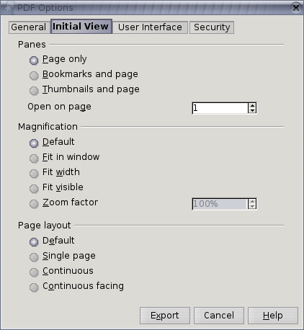Illustration 2: Second Tab

The option “First page is left” is only displayed in the dialog if “Tools-Options-Language Settings-Languages-Enabled for complex text layout” is marked.
If the option is marked than the PDF is displayed in the following way:
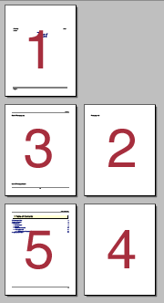Illustration 3: Page layout if first page is left

If the option is not visible and “Continuous facing” is marked, then the first page is displayed to the right.
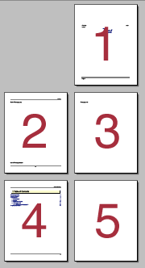Illustration 4: Page layout if "First page is left" is not marked or invisible
Changes since 2.0.4:
- added a zoom level option to “Magnification” section
- added an option to the “Panes” section to specify the first page that the reader application will show when it opens the exported PDF file.
The option “Open on page” defines the page that will be visible when the exported PDF document gets opened in the viewer application. (Comment: New for OOo 2.2)
If “Zoom factor” is selected, the initial zoom level of the PDF viewer application should be set to the specified value when the PDF file is opened. (Comment: New for OOo 2.2)

Table 2: User Interface elements of Figure Illustration 2
# | Type | Properties |  | Comment
<#> |  | Control Properties  Enabled: yes
<#> |  | String English  Initial View | String German  Anfangsdarstellung |  | tab title
<#> |  | Control Properties  Enabled: yes
<#> |  | String English  Panes | String German  Bereiche
<#> |  | Control Properties  Enabled: yes  Initially Marked: yes
<#> |  | String English  ~Page only | String German  Nur Seite
<#> |  | Control Properties  Enabled: yes  Initially Marked: no
<#> |  | String English  ~Bookmarks and page | String German  Lesezeichen-Fenster und Seite
<#> |  | Control Properties  Enabled: yes  Initially Marked: no
<#> |  | String English  ~Thumbnails and page | String German  Seiten-Fenster und Seite
<#> |  | Control Properties  Editable: yes  Enabled: yes  Minimum Value: 1  Maximum Value:  Start Value: 1  Steps: 1  Measurement unit: 1
<#> |  | String English  Open on page | String German  Öffnen auf Seite
<#> |  | Control Properties  Enabled: yes
<#> |  | String English  Magnification | String German  Vergrößerung
<#> |  | Control Properties  Enabled: yes  Initially Marked: yes
<#> |  | String English  ~Default | String German  Standard
<#> |  | Control Properties  Enabled: yes  Initially Marked: no
<#> |  | String English  ~Fit in window | String German  Fenstergröße
<#> |  | Control Properties  Enabled: yes  Initially Marked: no
<#> |  | String English  Fit ~width | String German  Fensterbreite
<#> |  | Control Properties  Enabled: yes  Initially Marked: no
<#> |  | String English  Fit ~visible | String German  Seitenbreite
<#> |  | Control Properties  Enabled: yes  Initially Selected: no
<#> |  | String English  ~Zoom factor | String German  Vergrößerungsstufe
<#> |  | Control Properties  Editable: yes  Enabled: iff “Zoom factor” is checked  Minimum Value: 50  Maximum Value: 1600  Start Value: 100  Steps: 1  Measurement unit: %  A11Y Text:  ToolTip Text:  Other...:
<#> |  | String English | String German
<#> |  | Control Properties  Enabled: yes
<#> |  | String English  Page layout | String German  Seitenlayout
<#> |  | Control Properties  Enabled: yes  Initially Marked: yes
<#> |  | String English  D~efault | String German  Standard
<#> |  | Control Properties  Enabled: yes  Initially Marked: no
<#> |  | String English  ~Single page | String German  Einzelne Seite
<#> |  | Control Properties  Enabled: yes  Initially Marked: no
<#> |  | String English  ~Continuous | String German  Fortlaufend
<#> |  | Control Properties  Enabled: yes  Initially Marked: no
<#> |  | String English  C~ontinuous facing | String German  Fortlaufend - Doppelseiten
<#> |  | Control Properties  Enabled: if and only if the option “Continuous facing” is marked  Initially Checked: no  TriState: no
<#> |  | String English  First page is ~left | String German  Erste Seite ist links

Third Tab: User Interface
Changes for OOo 2.2:
- added section “Transition effects” with option to use transition effects (moved from general page)
- added section “Bookmarks” with number of visible bookmark levels when the reader application opens the exported PDF file

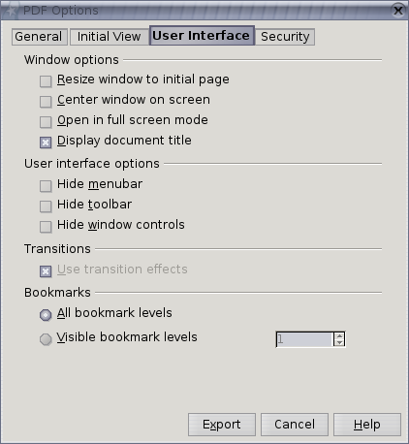Illustration 5: Third Tab

Table 3: User Interface elements of Figure Illustration 5
# | Type | Properties |  | Comment
<#> |  | Control Properties  ToolTip Text: <If needed Specify text here>  Acc. Descrip.: <If needed specify text here>  Acc. Text: <If needed specify text here>  Enabled: yes
<#> |  | String English  User Interface | String German  Benutzeroberfläche |  | tab title
<#> |  | Control Properties  ToolTip Text: <If needed Specify text here>  Acc. Descrip.: <If needed specify text here>  Acc. Text: <If needed specify text here>  Enabled: yes
<#> |  | String English  Window options | String German  Fensteroptionen
<#> |  | Control Properties  Enabled: yes  Initially Marked: no  TriState: no  ToolTip Text: <If needed specify tip here>  Acc. Descrip.: <If needed specify text here>  Acc. Text: <If needed specify text here>  Other...: <If needed specify here>
<#> |  | String English  ~Resize window to initial page | String German  Fenster an erste Seite anpassen
<#> |  | Control Properties  Enabled: yes  Initially Marked: no  TriState: no  ToolTip Text: <If needed specify tip here>  Acc. Descrip.: <If needed specify text here>  Acc. Text: <If needed specify text here>  Other...: <If needed specify here>
<#> |  | String English  ~Center window on screen | String German  Fenster auf Bildschirm zentrieren
<#> |  | Control Properties  Enabled: yes  Initially Marked: no  TriState: no  ToolTip Text: <If needed specify tip here>  Acc. Descrip.: <If needed specify text here>  Acc. Text: <If needed specify text here>  Other...: <If needed specify here>
<#> |  | String English  ~Open in full screen mode | String German  Im Vollbildmodus öffnen
<#> |  | Control Properties  Enabled: yes  Initially Marked: yes  TriState: no  ToolTip Text: <If needed specify tip here>  Acc. Descrip.: <If needed specify text here>  Acc. Text: <If needed specify text here>  Other...: <If needed specify here>
<#> |  | String English  ~Display document title | String German  Dokumenttitel anzeigen
<#> |  | Control Properties  ToolTip Text: <If needed Specify text here>  Acc. Descrip.: <If needed specify text here>  Acc. Text: <If needed specify text here>  Enabled: yes
<#> |  | String English  User interface options | String German  Benutzeroberflächenoptionen
<#> |  | Control Properties  Enabled: yes  Initially Marked: no  TriState: no  ToolTip Text: <If needed specify tip here>  Acc. Descrip.: <If needed specify text here>  Acc. Text: <If needed specify text here>  Other...: <If needed specify here>
<#> |  | String English  Hide ~menubar | String German  Menüleiste ausblenden
<#> |  | Control Properties  Enabled: yes  Initially Marked: no  TriState: no  ToolTip Text: <If needed specify tip here>  Acc. Descrip.: <If needed specify text here>  Acc. Text: <If needed specify text here>  Other...: <If needed specify here>
<#> |  | String English  Hide ~toolbar | String German  Werkzeugleisten ausblenden
<#> |  | Control Properties  Enabled: yes  Initially Marked: no  TriState: no  ToolTip Text: <If needed specify tip here>  Acc. Descrip.: <If needed specify text here>  Acc. Text: <If needed specify text here>  Other...: <If needed specify here>
<#> |  | String English  Hide ~window controls | String German  Fenstersteuerelemente ausblenden
<#> |  | Control Properties  Enabled: Yes
<#> |  | String English  Transition effects | String German  Übergangseffekte
<#> |  | Control Properties  Enabled: if document to be exported is a presentation  Initially Checked: yes  TriState: no  ToolTip Text:  Other...:
<#> |  | String English  Use transition effects | String German  Übergangseffekte benutzen
<#> |  | Control Properties  Enabled: yes
<#> |  | String English  Bookmarks | String German  Lesezeichen
<#> |  | Control Properties  Enabled: yes  Initially Selected: yes  ToolTip Text:
<#> |  | String English  ~All bookmark levels | String German  Alle Lesezeichenebenen
<#> |  | Control Properties  Enabled: yes  Initially Selected: no  ToolTip Text:
<#> |  | String English  ~Visible bookmark levels | String German  Aufgeklappte Lesezeichenebenen
<#> |  | Control Properties  Editable: yes  Enabled: iff “Visible bookmark levels” is selected  Minimum Value: 1  Maximum Value: 10  Start Value: 1  Steps: 1  Measurement unit: 1  A11Y Text:  ToolTip Text:  Other...:
<#> |  | String English | String German

Fourth Tab: Security Settings
Comment: New for OOo 2.0.4
Comment: The following sections are copied and edited from beppec56's spec draft v1.1 for security settings.

Intro
A PDF file can be encrypted to protect its content from unauthorized access.
The various aspects of the encryption and access control in a viewer are implemented through a software module called security handler.
There can be different security handler implementations, among them:
- Standard security handler. It permits access permissions and two passwords for a documents.
- Public key security handler. In this case the public key technology is used to encrypt a document and it's possible to specify a list of recipients, each list have its own access permissions. In this every list of recipients can be associated to different access permissions.
- Crypt filters (only PDF vers. 1.6). They permit a finer granularity over the document encryption. Every single stream can have its own filter.

Implementation
It's my opinion that currently only the Standard security handler should be implemented, for the following reasons:
- it gives two passwords protection with access permissions, sufficient for most uses;
- the building blocks needed are already present in OOo (MD5 digest, ARCFOUR cypher, the AES as specified on PDF v.1.6 is not yet available on OOo's source tree);
- the consumer applications (that is, the viewers) are all expected to support the Standard security handler;
- from what I'm seeing in issues i12626 and the other duplicates of it, it's what users request;
- it was relatively simple to implement in OOo (meaning that as of today I've already done most of the “grunt” work needed );
- keeping it to PDF v1.4, only ARCFOUR (RC4 compatible) encryption is provided.
For a detailed description of the encryption implementation, please see chapter 3.5 of PDF specification version 1.4.

Some words on the passwords
Implementing standard security means giving two access levels: owner and user and two different passwords, one for the owner permission level, the other for the user level.
The owner is defined as the person who can change the document permissions, so this password can be named “Permission password”; the user is defined as the person who can only “see” the document if she knows the user password, so we'll have a “Document Open Password”.
The PDF specification documents don't say anything about the passwords: you can leave the passwords blank (empty), I think that the encryption without at least the Permission Password is meaningless: you end up with a PDF document with fixed permissions, that can be changed simply by giving an empty Permission Password to the application used to edit the PDF.
MMP 7-Jul-2006: If just the Open Password is set, then you get a protected PDF that can only be opened by the person who knows the Open Password. This does make sense.
beppec56: true
If neither Open Password nor Permission Password is set, then you get an encrypted file without any security. This might make sense to prevent search engine tools from indexing your PDF file.
beppec56: Having neither open nor permission passwords set you end up with a file that has permission set as requested, but anyone can read it and anyone can modify those permission. This is an effect of the PDF spec implementation.
So if the search engines are smart enough to use the encryption PDF algorithm, they can easily index the PDF document by applying the algorithm with blank password. This worked so for a filter provided from Adobe years back.
MMP: // not sure if I still understand what I just wrote. It depends on the treatment of empty passwords.
beppec56: see rows 113 and 116 below.
Maybe, it's something that can be left to the user, a decision wether this PDF implementation permits empty or not Permission password should be made.
If the Document open password is left blank, than no Document open password will be needed to open the PDF, but the Permission password will still be needed to change the permissions.
That means a PDF file that can be opened by everyone.
If there is a Document open password but not a Permission password, then according to the PDF specification the Permission password is forced equal to the Document open password; that means there is a single password to operate on the document. (the same to open and change permissions)
The encryption is done “on the fly”, that is while exporting to PDF the file is encrypted; this may lead to a longer saving time when the file is saved as encrypted PDF compared to the non encrypted one, especially with huge files.
OOo 3.1 Update: no encrypted files without password anymore. The handling will be as follows: if no password is set, the file will not be encrypted. A text will be shown whether the file is going to be encrypted or not. Only setting the open password leads to an encrypted file.

Dialog Design
The UI is basically built adding a tab to the dialog as it is in OOo 2.0.3.
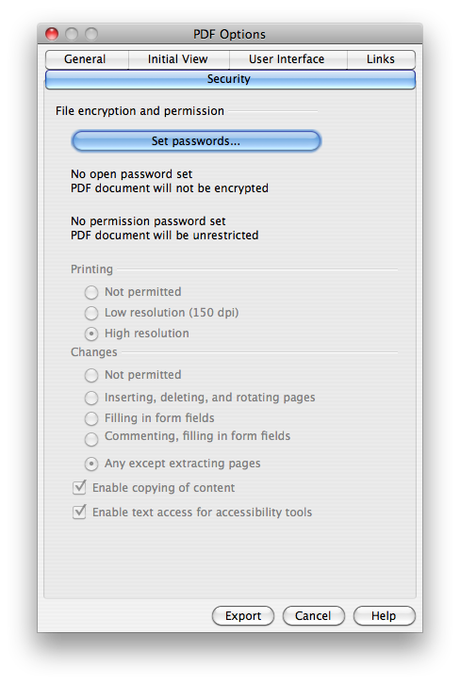Illustration 6: Password Security Tab (mockup, Jul 7, 2006

Comment. The dialogs box is 20 unit higher that the current one in OOo 2.0.3, whereas the width is the same.
Table 4: User Interface elements of Illustration 6
# | Type | Properties |  | Comment
1 |  | Control Properties |  |  | Tab page title
1 |  | String English  Security | String German  Sicherheit
2 |  | Control Properties  Label:
2 |  | String English  File encryption and permission | String German
3 |  | Control Properties  Icon: no  Enabled: iff #2 is marked
3 |  | String English  Set ~passwords... | String German  Öffnen-~Passwort setzen
4 |  | Control Properties  Enabled: yes
4 |  | String English  "Open password set\nPDF document will be encrypted"  or  "No open password set\nPDF document will not be encrypted"  depending on encryption being applied or not
5 |  | Control Properties  Enabled: yes
5 |  | String English  "Permission password set\nPDF document will be restricted"  or  "No permission password set\nPDF document will be unrestricted"  depending on a permission password set or not
6 |  | Control Properties  Enabled: iff #4 is marked AND #5 is not empty
6 |  | String English  Printing | String German  Drucken
7 |  | Control Properties  Enabled: iff #4 is marked AND #5 is not empty  Initially Marked: no
7 |  | String English  ~Not permitted | String German  ~Nicht gestattet
8 |  | Control Properties  Enabled: iff #4 is marked AND #5 is not empty  Initially Marked: no
8 |  | String English  ~Low resolution (150 dpi | String German  N~iedrige Auflösung (150 dpi)
9 |  | Control Properties  Enabled: iff #4 is marked AND #5 is not empty  Initially Marked: yes
9 |  | String English  ~High resolution | String German  ~Hohe Auflösung
10 |  | Control Properties  Enabled: iff #4 is marked AND #5 is not empty
10 |  | String English  Changes | String German  Än~derungen
11 |  | Control Properties  Enabled: iff #4 is marked AND #5 is not empty  Initially Marked: no
11 |  | String English  No~t permitted | String German  Ni~cht gestattet
12 |  | Control Properties  Enabled: iff #4 is marked AND #5 is not empty  Initially Marked: no
12 |  | String English  ~Inserting, deleting, and rotating pages | String German  Einfügen, Löschen und Rotieren von ~Seiten
13 |  | Control Properties  Enabled: iff #4 is marked AND #5 is not empty  Initially Marked: no
13 |  | String English  ~Filling in form fields | String German  ~Formulare ausfüllen
14 |  | Control Properties  Enabled: iff #4 is marked AND #5 is not empty  Initially Marked: no
14 |  | String English  ~Commenting, filling in form fields | String German  ~Kommentieren und Formulare ausfüllen
15 |  | Control Properties  Enabled: iff #4 is marked AND #5 is not empty  Initially Marked: no
15 |  | String English  ~Any except extracting pages | String German  ~Alles, bis auf Extrahieren von Seiten
16 |  | Control Properties  Enabled: iff #4 is marked AND #5 is not empty  Initially Marked: yes
16 |  | String English  Ena~ble copying of content | String German  Inha~lt kopieren erlauben
17 |  | Control Properties  Enabled: iff #4 is marked AND #5 is not empty  Initially Marked: yes
17 |  | String English  Enable text access for acce~ssibility tools | String German  Mit Unterstützung der ~Zugänglichkeit
18 |  | Control Properties  Enabled: yes  Visible: iff password is empty |  |  | string behind the password buttons
18 |  | String English  (empty) | String German  (leer)

The Security panes behaves a little different than the other PDF Export panes. Not all settings are kept for later use (with other words: not all settings are stored in the configuration)
#2 (Encrypt) and #4 (Restrict permissions) are always unmarked if the PDF Export dialog comes up.
The passwords (related to #3 and #5) are always empty when the dialog comes up. The passwords need to be entered each time for encryption or restricting the permissions.
All other settings are kept in the configuration for a future use of the dialog.

Password Dialog
The Password dialog is used to set either the Open Password or the Permission Password – the title of the dialog reflects this. It is possible to enter an empty password.

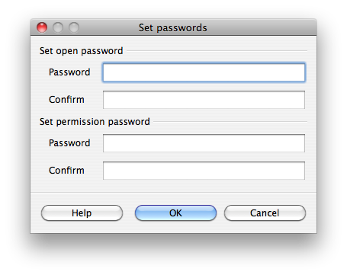Illustration 7: Password dialog (prototype June 2006)

Table 5: User Interface elements of Illustration 7
# | Type | Properties |  | Comment
<#> |  | Control Properties  State: modal  Closable: yes  Close Operation: do nothing  Is iconifiable: no  Is maximizable: no  Resizable: no  Always On Top: yes
<#> |  | String English  Set Passwords | String German |  | window title
<#> |  | Control Properties  Label:
<#> |  | String English  Set open password | String German
<#> |  | Control Properties  Enabled: Yes
<#> |  | String English  Password | String German
<#> |  | Control Properties  Enabled: Yes  Editable: Yes  Initial Text Inside Field:  Drag Enabled: No  Initial Caret Position: 0  Characters Allowed: ASCII  Characters not Allowed: Non-ASCII  Selection Starts: 0  Selection Ends: 0  Selected Text:  ToolTip Text:  A11Y Text:  Other...:  Password Field Properties  Echo Character: *  Other...:
<#> |  | String English | String German
<#> |  | Control Properties  Enabled: Yes
<#> |  | String English  Confirm | String German
<#> |  | Control Properties  Enabled: Yes  Editable: Yes  Initial Text Inside Field:  Drag Enabled: No  Initial Caret Position: 0  Characters Allowed: ASCII  Characters not Allowed: Non-ASCII  Selection Starts: 0  Selection Ends: 0  Selected Text:  ToolTip Text:  A11Y Text:  Other...:  Password Field Properties  Echo Character: *  Other...:
<#> |  | String English | String German
<#> |  | Control Properties  Label:
<#> |  | String English  Set permission password | String German
<#> |  | Control Properties  Enabled: Yes
<#> |  | String English  Password | String German
<#> |  | Control Properties  Enabled: Yes  Editable: Yes  Initial Text Inside Field:  Drag Enabled: No  Initial Caret Position: 0  Characters Allowed: ASCII  Characters not Allowed: Non-ASCII  Selection Starts: 0  Selection Ends: 0  Selected Text:  ToolTip Text:  A11Y Text:  Other...:  Password Field Properties  Echo Character: *  Other...:
<#> |  | String English | String German
<#> |  | Control Properties  Enabled: Yes
<#> |  | String English  Confirm | String German
<#> |  | Control Properties  Enabled: Yes  Editable: Yes  Initial Text Inside Field:  Drag Enabled: No  Initial Caret Position: 0  Characters Allowed: ASCII  Characters not Allowed: Non-Ascii  Selection Starts: 0  Selection Ends: 0  Selected Text:  ToolTip Text:  A11Y Text:  Other...:  Password Field Properties  Echo Character: *  Other...:
<#> |  | String English | String German

- beppec56: the password should need a double input, to confirm. I'm trying to figure out a way to do this.
MMP: I suppose this is not necessary. Passwords can be empty. The UI of the Security panel can deal with this situation.
- beppec56: how the passwords are saved in config ? Encrypted ? How ? Currently they are saved in clear text.
MMP: I suggest not to save them anywhere. (see above)
bepper56: OK.

The option described above can be mixed together.

Printing permissions
There is a permission selection that results in high or low resolution printing.
This behavior is honored by Acrobat reader only when printing in Windows. On Unix system the Acro reader prints only in high resolution, the behavior in Mac system is unknown to me. (see Appendix H, note 16 on PDF ref. V. 1.4 )
The High/Low resolution printing behavior is not honored at all by xpdf, gpdf and kpdf. That is they print always in high resolution, whatever the selection.

Configuration
Will be provided as soon as I'll have the English strings frozen, I'd like to use a similar text for the configuration item names.
MMP:

Tab page “Links”
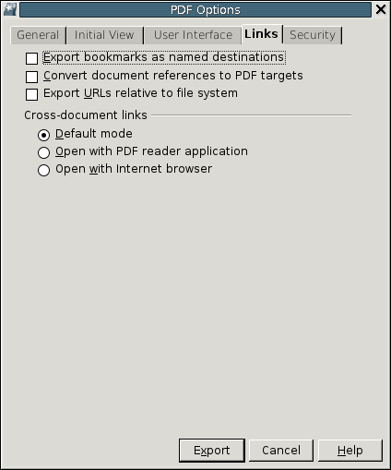Illustration 8: Tab page for link handling
Table <Table Number>: User Interface elements of Figure <Figure Number>
# | Type | Properties |  | Comment
String English  ~Convert document references to PDF targets |  |  | String German  <Enter String Here>
<#> |  | Control Properties  Enabled: yes  Initially Checked: no  TriState: no  ToolTip Text:  Other...:
<#> |  | String English  Export ~URLs relative to file system | String German  <Enter String Here>
<#> |  | Control Properties  Label: Cross-document links
<#> |  | String English  Cross-document links | String German  <Enter String Here>
<#> |  | Control Properties  Enabled: yes  Initially Selected: yes  ToolTip Text:
<#> |  | String English  ~Default mode | String German  <Enter String Here>
<#> |  | Control Properties  Enabled: yes  Initially Selected: no  ToolTip Text:
<#> |  | String English  ~Open with PDF reader application | String German  <Enter String Here>
<#> |  | Control Properties  Enabled: yes  Initially Selected: no  ToolTip Text:
<#> |  | String English  Open ~with Internet browser | String German  <Enter String Here>

Goals
The PDF document exported with the OOo can contains Hyperlinks that can point to targets internal to the document or external ones. Currently the external targets are resolved as absolute targets and the jump to the target is performed as an absolute “link action to a URL”. This action should be optionally changed to relative. Even if it seems simple, and is actually simple to change from absolute to current document position relative, the results may not be the best for use.

Throughout this document we use the Acrobat(r) Reader from Adobe(r) as the standard reader for a PDF or a series of PDF documents produced by OOo. Part of the discussion can be applied to other readers as well, but is currently unknown if they support the PDF features specified by the 1.4 version of the standard discussed here.

Objective of the proposal
The main idea is to have the possibility to produce a PDF integrated documentation, starting from OOo family of documents, e.g. Writers documents, Impress documents, Draw documents, where the links among the PDF documents are to be maintained in the OOo native formats.

For example, we may have this document structure, in directories starts from tree-test:

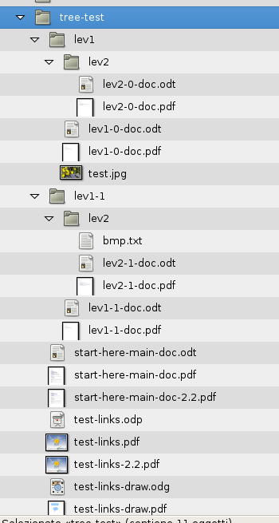

The documents in the figure above have the following links among them. The targets are to be maintained in full, e.g. both the file name and the bookmark inside that file, if available.

Link Action vs GoTo Action
Please find the definitions for Link actions an GoTo actions in the PDFReference V1.4

Absolute and relative

Absolute paths refer to a complete description of a filename including its directory structure from the root down. Relative paths refer to the current directory, for purposes of this specification this means relative to the directory containing the document the link originates from.

PDF destinations
Bookmark name (destination name) should be converted in order to be composed only of character meaningful for the console, e.g. The 'à' should for example become 25C325A0 (the conversion ois %C3%A0 in a URL ). This conversion is needed because the permitted character set of the name of the named destination and the character set of a URL fragment (for example the '%' sign is not allowed in named destination, whereas the '#' prepend is not allowed in URL mapping).

Different scenarios as example

Scenario 1
Base: Links are relative, action is to open in browser, bookmarks converted to PDF destinations, ODF targets converted to PDF targets

Generated in: | Use in GNU/Linux |  |  |  |  |  |  |  | Use in Windows
Generated in: | Start With Firefox |  |  |  | Start with Acrobat Reader |  |  |  | Start With Firefox |  |  |  | Start with Adobe
Generated in: | Check PDF |  | Check other files |  | Check PDF |  | Check other files |  | Check PDF |  | Check other files |  | Check PDF |  | Check other files
GNU/Linux | The PDF links are honored, Firefox opens links in the same window/tab, SOMETIMES  jump to correct destination | open in the same windows/tab, using the appropriate application |  | Jump to the target opening an Internet Browser.  Then the behavior is as for Firefox |  | Open in the appropriate application
Windows

Scenario 2
As Scenario 1, but open files in reader application instead of browser

Generated in: | Use in GNU/Linux |  |  |  |  |  |  |  | Use in Windows
Generated in: | Start With Firefox |  |  |  | Start with Acrobat Reader |  |  |  | Start With Firefox |  |  |  | Start with Adobe
Generated in: | Check PDF |  | Check other files |  | Check PDF |  | Check other files |  | Check PDF |  | Check other files |  | Check PDF |  | Check other files
GNU/Linux | The PDF links are honored, Firefox opens links in the same window/tab, DOES NOT jump to correct destination | open in the same windows/tab, using the appropriate application |  | The PDF links are not honored |  | Open in the appropriate application
Windows

Free notes

Relative to FS, then action as in 8.5.3 PDF 1.4, the PDF will work only in Acrobat Reader, xpdf does not work so are the others readers.

Opens as URI (opens browser)
A uniform resource identifier (URI) is a string that identifies (resolves to) a resource on the Internet—typically a file that is the destination of a hypertext link, although it can also resolve to a query or other entity. A URI action causes a URI to be resolved.
(the currently implemented action), good for every file, it seems that the Adobe Reader plugins treats the fragment part of the URL as if it were a named destination.

Opens as Launch actions
A launch action launches an application or opens or prints a document.
Not really useful, depends on the file system the system is in.

Opens as GoToR:
A remote go-to action is similar to an ordinary go-to action, but jumps to a destination in another PDF file instead of the current file.
This will work only when the target PDF document has the destination available, generated with the option: Export bokmark to named destination.

Export bokmark to named destination
Export OpenOffice.org bookmark to PDF (they become target for a GoToR action)

Migration
n/a

Configuration
The following configuration items affect PDF export and correspond to the UI controls in the dialog. The items are to be found at the path org.openoffice.Office/Common/PDF/Export
"UseLosslessCompression" oor:type="xs:boolean" default: false: Specifies if graphics are exported to PDF using a lossless compression eg. PNG or if they are compressed using the JPEG format.
"Quality" oor:type="xs:int" default: 90: Specifies quality of the JPG export. A higher value results in higher quality and file size.
"ReduceImageResolution" oor:type="xs:boolean" default: false : Specifies if the resolution of each image is reduced to the resolution specified by the property MaxImageResolution.
"MaxImageResolution" oor:type="xs:int" default: 300: If the property ReduceImageResolution is set to true all images will be reduced to the given value in DPI.
"UseTaggedPDF" oor:type="xs:boolean" default: false: Determines if PDF are created by using special tags also known as Tagged PDF.
"ExportNotes" oor:type="xs:boolean" default:false Specifies if notes are exported to PDF.
"ExportNotesPages" oor:type="xs:boolean" default:false: Specifies if notes pages are exported to PDF. (Notes pages are available in Impress documents only).
"ExportBookmarks" oor:type="xs:boolean" default:true Specifies if bookmarks are exported to PDF.
"OpenBookmarkLevels" oor:type="xs:int" default: -1: Specifies how many bookmark levels should be opened in the reader application when the PDF gets opened. -1 means all levels, non-negative numbers mean the respective number of levels.
"UseTransitionEffects" oor:type="xs:boolean" default: true: Specifies slide transitions are exported to PDF. This option is active only if storing Impress documents.
"ExportFormFields" oor:type="xs:boolean" default:true Specifies whether form fields are exported as widgets or only their fixed print representation is exported.
“EmbedStandardFonts” oor:type=”xs:boolean” default:false Specifies whether to embed the 14 standard PDF fonts or not.
"FormsType" oor:type="xs:int" default: 0: Specifies the submitted format of a PDF form. Values are: "0" for FDF format,"1" for PDF format, "2" for HTML format, "3" for XML format
"IsSkipEmptyPages" oor:type="xs:boolean" default: false: Specifies that automatically inserted empty pages are suppressed. This option is active only if storing Writer documents.
"HideViewerMenubar" oor:type="xs:boolean" default: false: Specifies whether to hide the PDF viewer menubar when the document is active.
"HideViewerToolbar" oor:type="xs:boolean" default: false: Specifies whether to hide the PDF viewer toolbar when the document is active.
"HideViewerWindowControls" oor:type="xs:boolean" default: false: Specifies whether to hide the PDF viewer controls when the document is active.
"ResizeWindowToInitialPage" oor:type="xs:boolean" default: false: Specifies that the PDF viewer window is opened full screen when the document is opened.
"CenterWindow" oor:type="xs:boolean" default: false: Specifies that the PDF viewer window is centered to the screen when the PDF document is opened.
"OpenInFullScreenMode" oor:type="xs:boolean" default: false: Specifies that the PDF viewer window is opened full screen, on top of all windows.
"DisplayPDFDocumentTitle" oor:type="xs:boolean" default: true: Specifies that the title of the document, if present in the document properties, is displayed in the PDF viewer window title bar.
"FirstPageOnLeft" oor:type="xs:boolean" default: false: Used with the value 3 of the PageLayout property when the first page (odd) should be on the left side of the screen.
"InitialView" oor:type="xs:int" default: 0: Specifies how the PDF document should be displayed when opened. "0" meaning neither outlines or thumbnails, "1" meaning the document is opened with outline pane opened, "2" meaning the document is opened with thumbnail pane opened
"Magnification" oor:type="xs:int" default: 0: Specifies the action to be performed when the PDF document is opened, "0" meaning opens with default zoom magnification, "1" meaning opens magnified to fit the entire page within the window, "2" meaning opens magnified to fit the entire page width within the window, "3" meaning opens magnified to fit the entire width of its boundig box within the window (cuts out margins), “4” means with a zoom level given in the “Zoom” property.
“Zoom” oor:type=”xs:int” default: 100: Specifies the zoom level a PDF document is opened with. Only valid if "Magnification" is set to "4".
"PageLayout" oor:type="xs:int" default: 0: Specifies the page layout to be used when the document is opened, "0" meaning display the pages according to the reader configuration, "1" meaning display one page at a time, "2" meaning display the pages in one column, "3" meaning display the pages in two columns odd pages on the right, to have the odd pages on the left the FirstPageOnLeft properties should be used as well.
"InitialPage" oor:type="xs:int" default: 1: Specifies the page on which a PDF document should be opened in the viewer application.
“SelectPdfVersion” oor:type=”xs:int” default: 0 specifies the type of PDF produced: 0 (default) PDF1.4, 1 PDF/A-1
“ExportLinksRelativeFsys” oor:type=”xs:boolean” default: false specifies whether links will be exported relative to file system.
“PDFViewSelection” oor:type=”xs:int” default: 0 specifies the viewer behaviour of links: 0 all links treated as URI, 1 all links handled by the reader application, 2 all links will be exported to use an internet browser
“ConvertOOoTargetToPDFTarget” oor:type=”xs:boolean” default:: false specifies that linked OOo document types will be exported to PDF, too
“ExportBookmarksToPDFDestination” oor:type=”xs:boolean” default:: false specifies to convert bookmarks into named PDF destinations.

File Format
Specification of the changes needed to the OpenOffice.org code in order to implement the PDF/A-1 export filter. These notes are intended as an aid to the implementation of ISO 19005-1:2005 (title: Document management – Electronic document file format for long-term preservation – Part 1: Use of PDF 1.4) AKA PDF/A-1. In order to grasp a good understanding of this spec, a copy of the ISO 19005-1 specification is needed.

Glossary
See the glossary in section 3 of the ISO 19005-1:2005.

File structure
The following quoted paragraphs document the changes made to make OOo's PDF compliant to ISO19005-1:2005. The mentioned headlines refer directly to the headlines in ISO19005-1:2005.

6.1.7 Stream objects
The stream keyword shall be followed either by a CARRIAGE RETURN (0Dh) and LINE FEED (0Ah) character sequence or by a single LINE FEED character. The endstream keyword shall be preceded by an EOL marker.
The value of the Length key specified in the stream dictionary shall match the number of bytes in the file following the LINE FEED character after the stream keyword and preceding the EOL marker before the endstream keyword.
NOTE 1 These requirements remove potential ambiguity regarding the ending of stream content.
A stream object dictionary shall not contain the F, FFilter, or FDecodeParams keys.
NOTE 2 These keys are used to point to document content external to the file. The explicit prohibition of these keys has the implicit effect of disallowing external content that can create external dependencies and complicate preservation efforts.

6.1.8 Indirect objects
The object number and generation number shall be separated by a single white-space character. The generation number and obj keyword shall be separated by a single white-space character.
The object number and endobj keyword shall each be preceded by an EOL marker. The obj and endobj keywords shall each be followed by an EOL marker.

6.2 Graphics

6.2.1 General
6.2.2 to 6.2.10 describe restrictions placed on both conforming files and readers. They are intended to address graphical rendering issues that do not involve fonts and interactive elements.

6.2.2 Output intent
A conforming file may specify the colour characteristics of the device on which it is intended to be rendered by using a PDF/A-1 OutputIntent. A PDF/A-1 OutputIntent is an OutputIntent dictionary, as defined by PDF Reference 9.10.4, that is included in the file’s OutputIntents array and has GTS_PDFA1 as the value of its S key and a valid ICC profile stream as the value its DestOutputProfile key.
If a file's OutputIntents array contains more than one entry, then all entries that contain a DestOutputProfile key shall have as the value of that key the same indirect object, which shall be a valid ICC profile stream.

6.2.3 Colour spaces

6.2.3.1 General
All colors shall be specified in a device-independent manner, either directly by the use of a device independent color space, or indirectly by the use of an OutputIntent. A conforming file may use any color space specified in PDF Reference, except as restricted in 6.2.3.2 to 6.2.3.4.
NOTE Specifying color in the device-independent manner described within 6.2.3 enables predictable color rendering based on a colorimetric definition and without reliance on assumptions or information external to the conforming file. It also provides a mechanism whereby a colorimetric definition can be associated with device-dependent color data.

6.2.3.2 ICCBased colour spaces
All ICCBased colour spaces shall be embedded as ICC profile streams as described in PDF Reference 4.5.
A conforming reader shall render ICCBased colour spaces as specified by the ICC specification, and shall not use the Alternate colour space specified in an ICC profile stream dictionary.

6.2.3.3 Uncalibrated colour spaces
A conforming file may use either the DeviceRGB or DeviceCMYK colour space but shall not use both. If an uncalibrated colour space is used in a file then that file shall contain a PDF/A-1 OutputIntent, as defined in 6.2.2. DeviceRGB may be used only if the file has a PDF/A-1 OutputIntent that uses an RGB colour space. DeviceCMYK may be used only if the file has a PDF/A-1 OutputIntent that uses a CMYK colour space.
When rendering a DeviceGray colour specification in a file whose OutputIntent is an RGB profile, a conforming reader shall convert the DeviceGray colour specification to RGB by the method described in PDF Reference 6.2.1.
When rendering a DeviceGray colour specification in a file whose OutputIntent is a CMYK profile, a conforming reader shall convert the DeviceGray colour specification to DeviceCMYK by the method described in PDF Reference 6.2.2.
When rendering colours specified in a device-dependent colour space a conforming reader shall use the file’s PDF/A-1 OutputIntent dictionary, as defined in 6.2.2, as the source colour space.

6.2.3.4 Separation and DeviceN colour spaces
A conforming reader shall obey the following rules when rendering colour spaces based on DeviceN or Separation colour spaces.
- If the named colourants in the colour space are all from the list Cyan, Magenta, Yellow, Black, the file has an OutputIntent, and that OutputIntent is a CMYK profile, then the colourants shall be treated as components of the colour space specified by the PDF/A-1 OutputIntent dictionary, as defined in 6.2.2, and the alternate colour space shall not be used.
- If the output device does not support the Separation colour space or DeviceN colourants, the Alternate colour space shall be used.
The Alternate colour space of a Separation or DeviceN colour space shall obey all restrictions on colour spaces specified in 6.2.3.2 and 6.2.3.3.

6.2.8 Extended graphics state
An ExtGState dictionary shall not contain the TR key. An ExtGState dictionary shall not contain the TR2 key with a value other than Default. A conforming reader may ignore any instance of the HT key in an ExtGState dictionary.
Use of the RI key shall conform to the rules of 6.2.9.

6.2.9 Rendering intents
Where a rendering intent is specified, its value shall be one of the four values defined in PDF Reference RelativeColorimetric, AbsoluteColorimetric, Perceptual or Saturation.
NOTE The default rendering intent is RelativeColorimetric.

6.2.10 Content streams
A content stream shall not contain any operators not defined in PDF Reference even if such operators are bracketed by the BX/EX compatibility operators.
Use of the ri operator shall conform to the rules of 6.2.9.
NOTE 1 Content streams are used for page descriptions, e.g. the Contents stream of a page object or the stream of a form XObject, as well as for the appearance stream of annotations, including form fields or Widget annotations.
NOTE 2 In earlier versions of the PDF format a PostScript operator PS was defined. As this operator is not defined in PDF Reference its use is implicitly prohibited by 6.2.10.

6.3 Fonts

6.3.1 General
The intent of the requirements in 6.3.2 to 6.3.8 is to ensure that future rendering of the textual content of a conforming file matches, on a glyph by glyph basis, the static appearance of the file as originally created and to allow the recovery of semantic properties for each character of the textual content.

6.3.2 Font types
All fonts used in a conforming file shall conform to the font specifications defined in PDF Reference 5.5.
For the purposes of this part of ISO 19005, multiple master fonts shall be considered a special case of Type 1 fonts; any requirement explicitly stated with regard to Type 1 fonts shall be implicitly required with regard to multiple master fonts.
NOTE It is the responsibility of the writer to ensure the conformance of all fonts. This part of ISO 19005 does not prescribe the manner in which font conformance is determined.

6.3.4 Embedded font programs
The font programs for all fonts used within a conforming file shall be embedded within that file, as defined in PDF Reference 5.8, except when the fonts are used exclusively with text rendering mode 3. A font is considered to be used if any of its glyphs are referenced in any of the following contexts:
- the Contents stream of a page object;
- the stream of a Form XObject;
- the appearance stream of an annotation, including form fields;
- the content stream of a Type 3 font glyph;
- the stream of a tiling pattern.

6.4 Transparency
If an SMask key appears in an ExtGState or XObject dictionary, its value shall be None.
A Group object with an S key with a value of Transparency shall not be included in a form XObject.
The following keys, if present in an ExtGState object, shall have the values shown:
- BM Normal or Compatible
- CA 1.0
- ca 1.0

6.5 Annotations

6.6 Actions

6.6.1 General
The Launch, Sound, Movie, ResetForm, ImportData and JavaScript actions shall not be permitted. Additionally, the deprecated set-state and no-op actions shall not be permitted. Named actions other than NextPage, PrevPage, FirstPage, and LastPage shall not be permitted. In response to each of the four allowed named actions, conforming interactive readers shall perform the appropriate action described in PDF Reference Table 8.45.
Interactive form fields shall not perform actions of any type.

6.6.2 Trigger events
A Widget annotation dictionary or Field dictionary shall not include an AA entry for an additional-actions dictionary. The document catalog dictionary shall not include an AA entry for an additional-actions dictionary.
NOTE These additional-actions dictionaries define arbitrary JavaScript actions. The explicit prohibition of the AA entry has the implicit effect of disallowing JavaScript actions that can create external dependencies and complicate preservation efforts.

6.6.3 Hypertext links
Conforming interactive readers may choose to make hyperlinks non-actionable, but in addition to the rendering behaviour defined by PDF Reference, as modified by this part of ISO 19005, they shall provide a mechanism to display the F and D keys of a GoToR action dictionary, the URI key of a URI action dictionary, and the F key of a SubmitForm action dictionary.

6.7 Metadata

6.7.1 General
6.7.2 to 6.7.11 specify requirements for metadata within conforming files. Metadata is essential for effective management of a file throughout its life cycle. A file depends on metadata for identification and description, as well as for describing appropriate technical and administrative matters. As a result, writers of conforming files may have to comply with various domain-specific metadata requirements defined external to this part of ISO 19005. This part of ISO 19005 outlines a structured, consistent framework that supports a broad variety of metadata requirements.

6.7.2 Properties
The document catalog dictionary of a conforming file shall contain the Metadata key. The metadata stream that forms the value of that key shall conform to XMP Specification. All metadata properties embedded in a file shall be in XMP form except for document information dictionary entries that have no XMP analogues, as defined in 6.7.3. Properties specified in XMP form shall use either the predefined schemas defined in XMP Specification 4, or extension schemas that comply with XMP Specification 4, and 6.7.8. Metadata object stream dictionaries shall not contain the Filter key.
NOTE 1 The explicit prohibition of the Filter key has the implicit effect of preserving the contents of XMP metadata streams as plain text that is visible to non-PDF aware tools.

NOTE 2 An extension schema is any XMP schema that is not defined in XMP Specification.

6.7.3 Document information dictionary
A document information dictionary may appear within a conforming file. If it does appear, then all of its entries that have analogous properties in predefined XMP schemas, as defined by Table 1, shall also be embedded in the file in XMP form with equivalent values. Any document information dictionary entry not listed in Table 1 shall not be embedded using a predefined XMP schema property.
NOTE 1 Since a document information dictionary is allowed within a conforming file, it is possible for a single file to be both PDF/A-1 (ISO 19005-1) and PDF/X (ISO 15930-4 and ISO 15930-6 [11]) conformant.
Table 1 — Crosswalk between document information dictionary and XMP properties
Document information dictionary |  | XMP
Entry | PDF type | Property | XMP type
Title | text string | dc:title | Text
Author | text string | dc:creator | seq Text
Subject | text string | dc:subject | Text
Keywords | text string | pdf:Keywords | Text
Creator | text string | xmp:CreatorTool | Text
Producer | text string | pdf:Producer | Text
CreationDate | date | xmp:CreateDate | Date
ModDate | date | xmp:ModifyDate | Date
NOTE The XML namespace URI for the prefix is <http://purl.org/dc/elements/1.1/>; the namespace URI for the prefix is <http://ns.adobe.com/pdf/1.3/>; and the namespace URI for the prefix is <http://ns.adobe.com/xap/1.0/>.

The value of the document information dictionary entries and their analogous XMP properties shall be equivalent. For properties that map from the PDF type to the XMP Text type, value equivalence shall be on a character-by-character basis, independent of encoding, comparing the numeric ISO/IEC 10646-1 code points for the characters.
NOTE 2 The explicit requirement for equivalence between the values of document information dictionary entries and their analogous XMP properties has the implicit effect of providing unambiguous interpretation of that property's value.
If the dc:creator property is present in XMP metadata then it shall be represented by an ordered Text array of length one whose single entry shall consist of one or more names. Equivalence between Author and dc:creator, shall be on a character-by-character basis, independent of encoding, comparing the numeric ISO/IEC 10646-1 code points for the characters.
EXAMPLE 1 The document information dictionary entry:
/Author (Peter, Paul and Mary)
is equivalent to the XMP property:
<dc:creator>
<rdf:Seq>
<rdf.:li>Peter, Paul, and Mary</rdf:li>
</rdf:Seq>
</dc:creator>

Date properties are formatted as a variable-length sequence of temporal components ranging in granularity: year, month, day, hour, minute, second. For properties that map between the PDF date type, defined by PDF Reference 3.8.2, and the XMP Date type, defined by Date and Time Formats, value equivalence shall be on a component-by-component basis, relative to Coordinated Universal Time (UTC), i.e., correcting for local time zone offset.
EXAMPLE 2 The document information dictionary entries:
/CreationDate (D:20040402)
/ModDate (D:20040408091132-05'00')
are equivalent to the XMP properties:
<xmp:CreateDate>2004-04-02</xmp:CreateDate>
<xmp:ModifyDate>2004-04-08T14:11:32Z</xmp:ModifyDate>

6.7.10 Font metadata
For all embedded Type 0, Type 1, or TrueType font programs, the embedded font file stream dictionary should include a Metadata entry whose value is an XMP metadata stream. The following XMP metadata elements should be supplied: xmp:Title, giving the value of the FontName key from the font's font descriptor dictionary; xmpRights:Copyright, giving the copyright statement; xmpRights:Marked, with the Boolean value true; xmpRights:Owner, giving the legal owner of the font; xmpRights:UsageTerms, giving a statement of the licensing terms under which the font is being used. Additional XMP metadata may be included at the discretion of the file writer.
NOTE 1 Font rights information is helpful in order to preserve the identity and scope of the intellectual property rights of the font copyright holder. While many fonts embed statements of copyright and licensing terms within the font itself, this is not a uniform practice. Therefore it is advantageous to require the explicit representation of rights statements in the conforming file. Even though this may be redundant, it obviates the necessity for some future system to have the ability to parse through the particular internal structure of font programs.

NOTE 2 The XML namespace URI for the prefix is <http://ns.adobe.com/xap/1.0/>; the namespace URI for the prefix is <http://ns.adobe.com/xap/1.0/rights/>.

6.7.11 Version and conformance level identification
The PDF/A version and conformance level of a file shall be specified using the PDF/A Identification extension schema defined in this subclause.
The Identification schema defined in Table 6 uses the namespace URI <http://www.aiim.org/pdfa/ns/id>. The required schema namespace prefix is pdfaid.
Table 6 — PDF/A identification schema
Property | Value type | Category | Description
pdfaid:part | Open Choice of Integer | Internal | PDF/A version identifier
pdfaid:amd | Open Choice of Text | Internal | Optional PDF/A amendment identifier
pdfaid:conformance | Closed Choice of Text | Internal | PDF/A conformance level: A or B

The value of pdfaid:part shall be the part number of ISO 19005 to which the file conforms. If the file conforms to a version of ISO 19005 that is defined by an amendment to a part, then the value of pdfaid:amd shall be the amendment number and year, separated by a colon.
A Level A conforming file shall specify the value of pdfaid:conformance as A. A Level B conforming file shall specify the value of pdfaid:conformance as B.
The values of the pdfaid:part, pdfaid:amd, and pdfaid:conformance properties do not by themselves determine conformance with a part of ISO 19005. The actual determination of conformance shall be performed as specified in Clause 5.

6.8 Logical structure

6.8.1 General
Subclause 6.8 is applicable only for files meeting Level A conformance. For Level B conformance the requirements of 6.8 can be ignored.
The intent of the requirements in 6.8.2 to 6.8.8 is to ensure the recovery of the textual content of a conforming file as a sequence of words defined in the natural reading order of the language in which they are written. Similarly, it ensures that the individual characters of each word are recoverable in their natural reading order. Furthermore, these requirements allow the recovery of higher-level semantic information concerning the logical structure of the document.
PDF/A-1 writers should not add structural or semantic information that is not explicitly or implicitly present in the source material solely for the purpose of achieving conformance. Examples of such information are structure hierarchy, natural language specification, alternative descriptions, non-textual annotations, replacement text and expansions of abbreviations and acronyms.
NOTE It is inadvisable for writers to generate structural or semantic information using automated processes without appropriate verification.

6.8.2 Tagged PDF

6.8.2.1 General
A Level A conforming file shall meet all of the requirements set forth for Tagged PDF in PDF Reference 9.7.
NOTE Tagged PDF defines conventions for explicitly declaring and describing the logical structural aspects of document content.

6.8.2.2 Mark information directory
The document catalog dictionary shall include a MarkInfo dictionary whose sole entry, Marked, shall have a value of true.
NOTE This setting indicates that the file conforms to the Tagged PDF conventions.

6.8.3 Artifacts

6.8.3.1 General
Pagination features such as running heads or page numbers, cosmetic layout features such as footnote rules or background screens, and production aids such as cut marks and colour bars should be specified as pagination, layout, and page artifacts, respectively, as described in PDF Reference 9.7.2.

6.8.3.2 Word breaks
For languages and script systems that normally use space characters to indicate word breaks, the following additional restriction shall apply:
Within show strings, word breaks shall be explicitly indicated by the presence of one or more space characters between all of the individual words in the show string. If a word ends at a show string boundary, one or more space characters shall be inserted at the end of the show string. Note that a single word may span two or more show strings; word breaks are indicated only by the explicit presence of one or more space characters, not by the boundaries of a show string. For the purposes of indicating word breaks, a sequence of two or more consecutive space characters is semantically equivalent to a single spacing character.

6.8.3.3 Structure hierarchy
The logical structure of the conforming file shall be described by a structure hierarchy rooted in the StructTreeRoot entry of the document catalog dictionary, as described in PDF Reference 9.6.
Each structure element dictionary in the structure hierarchy shall have a Type entry with the name value of StructElem.
Writers of conforming files should attempt to capture a document’s logical structure hierarchy to the finest granularity possible, making use of the standard structure types for grouping elements, block-level structure elements, paragraph-like elements, list elements, table elements, inline-level structure elements, link elements and illustration elements, as defined in PDF Reference 9.7.4, to the fullest extent possible.
NOTE The explicit description of a document’s logical structure will prove valuable to future efforts to recover the document’s full semantic value for the purposes of rendering or migration to other data formats.

6.8.3.4 Structure types
The definition of block-level structuring elements should follow the strongly structured paradigm as described in PDF Reference 9.7.4.
All non-standard structure types shall be mapped to the nearest functionally equivalent standard type, as defined in PDF Reference 9.7.4, in the role map dictionary of the structure tree root. This mapping may be indirect; within the role map a non-standard type can map directly to another non-standard type, but eventually the mapping must terminate at a standard type.

6.8.4 Natural language specification
The default natural language for all text in a file should be specified by the Lang entry in the document catalog dictionary.
All textual content within a file which differs from the default language should be indicated by use of a Lang property attached to a marked-content sequence, or by a Lang entry in a structure element dictionary, as described in PDF Reference 9.8.1.
If the Lang entry is present in the document catalog dictionary or in a structure element dictionary or property list, its value shall be a language identifier as defined by RFC 1766, Tags for the Identification of Languages, as described in PDF Reference 9.8.1.
All text strings encoded in Unicode whose language is not the default natural language for the file or not the natural language defined by the innermost enclosing structure element or marked-content sequence should indicate their language using the internal escape sequence described in PDF Reference 3.8.1.
NOTE The distinction between words foreign to a language and foreign words incorporated by common usage into a language is problematic. The intent of these requirements is to allow for future unambiguous semantic interpretation of textual content.

6.8.5 Alternate descriptions
All structure elements whose content does not have a natural predetermined textual analogue, e.g. images, formulae, etc., should supply an alternate text description using the Alt entry in the structure element dictionary, as described in PDF Reference 9.8.2.
NOTE Alternate descriptions provide textual descriptions that aid in the proper interpretation of otherwise opaque non-textual content.

6.8.6 Non-textual annotations
For annotation types that do not display text, the Contents key of an annotation dictionary should be specified with an alternative description of the annotation's contents in human-readable form.

6.8.7 Replacement text
All textual structure elements that are represented in a non-standard manner, e.g., custom characters or inline graphics, should supply replacement text using the ActualText entry in the structure element dictionary, as described in PDF Reference 9.8.3.
NOTE Replacement text provides textual equivalents that aid in the proper interpretation of otherwise opaque, unusual representations of textual components.

6.8.8 Expansions of abbreviations and acronyms
All instances of abbreviations and acronyms in textual content should be placed in a marked-content sequence with a Span tag whose E property provides a textual expansion of the abbreviation or acronym, as described in PDF Reference 9.8.4.
NOTE Abbreviation and acronym expansion provides textual equivalents that aid in the proper interpretation of otherwise opaque nomenclature.

6.9 Interactive Forms
The intent of the requirements of this subclause is to ensure that there is no ambiguity about the rendering of form fields.
A conforming reader shall not use form fields to change the rendered representation of the page or the content of the file at any time. A Widget annotation dictionary or Field dictionary shall not contain the A or AA keys.
The NeedAppearances flag of the interactive form dictionary shall either not be present or shall be false.
Every form field shall have an appearance dictionary associated with the field's data. A conforming reader shall render the field according to the appearance dictionary without regard to the form data.
NOTE Requiring an appearance dictionary ensures the reliable rendering of the form.

Open Issues
Issue | Initials | Date
APOC settings | MMP | Mar 8, 2006

Competitive Analysis

OpenOffice.org 2.0.0 – 2.0.2
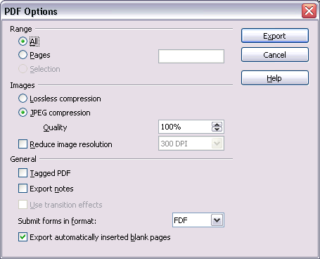Illustration 9: PDF Options Dialog in OOo 2.0.2

Adobe Acrobat 5
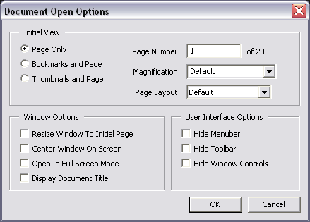Illustration 10: Document Options Dialog in Adobe Acrobat 5

Adobe Acrobat 7 – German Version
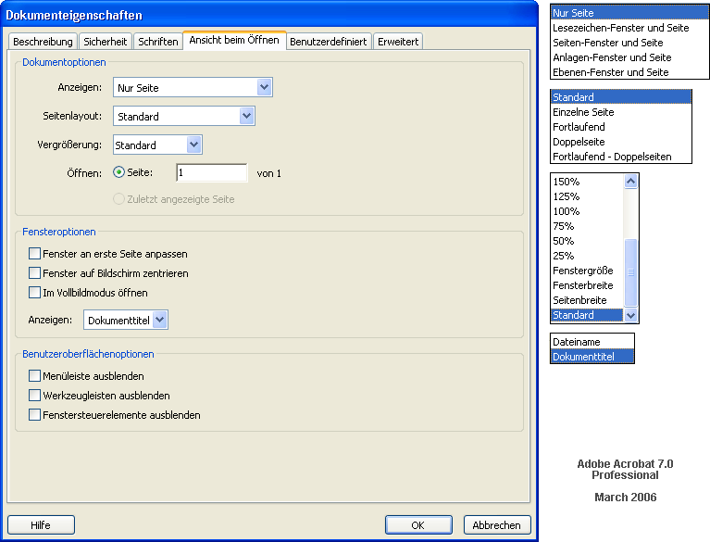Illustration 11: Document Properties Dialog of Adobe Acrobat 7 Professional

Document Change History
Rev. | Change | Initials | Date
1 | new spec and capture state of the patch as a starting point. | MMP | Mar 6, 2006
2 | completed i-Team | MMP | Mar 8, 2006
3 | added string tables for English  PL provided the configuration settings.  Mnemonics for English strings  removed Reset button  default values are defined in the string tables. | MMP | Mar 9, 2006
4 | Added German screen shot of Adobe Acrobat 7 to Competitive Analysis  Final proposal for English and German strings  “Main reading order for text” becomes a checkbox on the second tab.  Request for approval | MMP | Mar 10, 2006
5 | added latest screen shots; changed configuration too match new UI  word DirectionR2L should be changed to FirstPageOnLeft. | beppec56 | Mar 11, 2006
6 | approved by UFI, beppec56  Help button is bottom left  Changes in German strings “Benutzungs-” to “Benutzer-”  “First page is left” depends on CTL setting | MMP | Mar 13, 2006
7 | Help button is (and stays) bottom right | MMP | Mar 14, 2006
8 | review by Frank Loehmann  new default value for ExportNotes  UseTaggedPDF=true wouls increase the file size significantly. | MMP | Mar 15, 2006
9 | spec status change to “standard” | MMP | Mar 16, 2006
10 | test case URL added | MMP | Mar 30, 2006
11 | Incorporate beppec56's spec draft v1.1 for security settings  Adjust panel layout, terminology and interactive logic  Set Password dialog  German strings  Mnemonics for English and German strings | MMP | Jul 7, 2006
12 | added link toi Hasan's Test Description | MMP | Jul 31, 2006
13 | added new fields for bookmarks, form fields, zoom level and first page | PL | Oct 20, 2006
14 | Spec review by MMP, see tracked changes | MMP | Nov 6, 2006
15 | Add section of “past” PDF specifications and supporting documents below.  Quote general statement of PDF content in section 1.1 | MMP | Nov 13, 2006

Related PDF Specifications and Documents
PDF Export - UI specification v.1.0 , 29-Nov-2002, Ooo333 1.x / StarOffice 6.x
PDF Export - UI specification v.1.1 , 4-Nov-2003, OOo 1.1 / StarOffice 6.x
PDF Export Minutes, 28-Nov-2003
PDF Export 11-Oct-2005
Outline Style Font Quality for PDF Export
Acrobat7-Security.odg

File Menu

It seems that the jump to the named destination is correct only if the name is semantically correct to both environment (Internet and Acrobat). Changing the mapping should do the trick.
Acrobat Reader handles open bookmark levels “0” and “1” the same: the first level is visible

