Software Specification Document

OpenOffice.org / StarOffice
Product Registration

Specification Status
Last Change | Jun 4, 2008
Status
Abstract
Product registration is important to be able to get reliable numbers of the installed product base. OOo and SO users have different motivations to register themselves, therefore the registration dialogs are different for these two products. Furthermore a registration reminder is introduced using the online update notifyer.
i-Team Members
Role | First Name, Last Name, Initials | E-Mail Address
I-Team Lead | Frank Loehmann (FL) | frank.loehmannn@sun.com
Specification Author | Frank Loehmann (FL) | frank.loehmannn@sun.com
User Experience | Frank Loehmann (FL) | frank.loehmannn@sun.com
Development | Peter Burow (PB) | peter.burow@sun.com
Quality Assurance | Olaf Felka | olaf.felka@sun.com
Documentation | Uwe Fischer (UFI) | uwe.fischer@sun.com
Marketing | Erwin Tenhumberg | erwin.tenhumberg@sun.com
Program Manager | Martin Damboldt (MD)  Martin Hollmichel (MH) | martin.damboldt@sun.com  martin.hollmichel@sun.com

Contents
Abstract 1
i-Team Members 1
References and Reference Documents 3
Acronyms and Abbreviations 3
1 Detailed Specification 4
1.1 Registration Dialog 4
1.1.1 OpenOffice.org 4
1.1.2 StarOffice and Other Products 6
1.2 Registration Reminder 7
2 Migration 7
3 Configuration 7
4 File Format 7
5 Open Issues 7
Document Change History 8
6 Future Feature Specification 9
6.1 Registration Reminder 9
6.1.1 Reminder in Start Center 9
6.1.2 OpenOffice.org 9
6.1.3 StarOffice and Other Products 10

References and Reference Documents
Reference Document | Check | Location (URL)
Specification Process Entry Check |  | N/A
Product Requirement, RFE, issue [Required] |  | i86683
Product Concept Document |  | <Please enter location here>
Competitive Analysis |  | <Please enter location here>
IDL Specification |  | <Please enter location here>
Test Case Specification [Required] |  | http://www.openoffice.org/nonav/issues/showattachment.cgi/51932/StartUp_wizard.html
Software Specification Rules | N/A | N/A
Start-Center Specification |  | http://specs.openoffice.org/appwide/start_center/start_center.odt
Acronyms and Abbreviations
Acronym / Abbreviation | Definition
<WYSIWYG> | <What You See Is What You Get>

Detailed Specification
The following is implemented to improve number of registrations.

Registration Dialog
The registration promotion dialog is shown during the first start-up wizard. The wizard UI is not defined here.

OpenOffice.org
OOo uses the following registration UI in step 5 of the first start-up wizard.
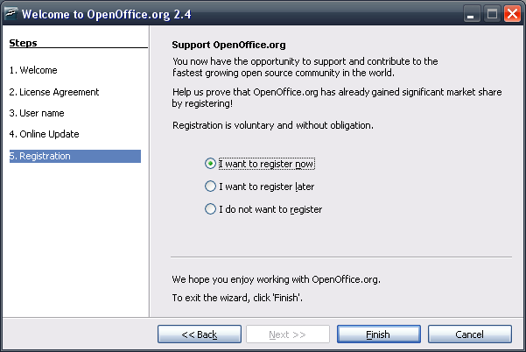Illustration 1: Registration dialog in first start-up wizard
- “Registration” - Dialog Properties |  | Comment
State: | Modal
Type: | Dialog
Closable: | Yes
Resizable: | No
Other:
Titel: | Welcome to %PRODUCTNAME %PRODUCTVERSION | EN-US
- “Support OOo Heading” - Text Properties |  | Comment
Label: | Support %PRODUCTNAME | EN-US
- “OOo Registration” - Text Properties |  | Comment
Label: | You now have the opportunity to support and contribute to the fastest growing open source community in the world.\n\nHelp us prove that %PRODUCTNAME has already gained significant market share by registering.\n\nRegistering is voluntary and without obligation. | EN-US
- “Register” - RadioButton Properties |  | Comment
Enabled: | Always
Disabled: | Never
Selected: | By default
RadioButton Label: | I want to register ~now | EN-US
- “Register” - RadioButton Properties |  | Comment
Enabled: | Always
Disabled: | Never
Selected: | -
RadioButton Label: | I want to register ~later | EN-US
- “Register” - RadioButton Properties |  | Comment
Enabled: | Always
Disabled: | Never
Selected: | -
RadioButton Label: | I do not want to ~register | EN-US
- “Registration Closing” - Text Properties |  | Comment
Label: | We hope you enjoy working with $PRODUCTNAME./n/nTo exit the wizard, click 'Finish'. | EN-US

StarOffice and Other Products
SO uses the following registration UI in step 5 of the first start-up wizard. Please see OOo section above for general UI element strings.
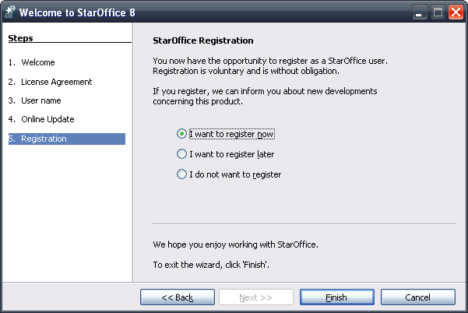Illustration 2: Registration dialog for StarOffice
- “SO Registration” - Text Properties |  | Comment
Label: | You now have the opportunity to register as a %PRODUCTNAME user. Registration is voluntary and is without obligation./n/nIf you register, we can inform you about new developments concerning this product. | EN-US

Registration Reminder
A reminder is shown 7 days after the installation data, if the user has chosen “I want to register later”. The dialog shows the registration tab page as a single dialog.
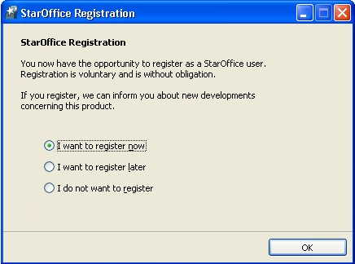Illustration 3: Registration dialog shown as a single dialog as a reminder

Migration
None

Configuration
PB?

File Format
PB?

Open Issues
Issue | Initials | Date
Registry key to turn off registration for enterprise customers | FL | February 29, 2008
Registration in a network installation (show reminder bubble then?) | FL | February 29, 2008
Registration URLs and CIDs | FL | February 29, 2008
Icon for registration for OOo reg. bubble and OOo graphic for setup needed | FL | February 29, 2008
Add reminder as a bubble | FL | March 04, 2008
Reminder dialog should provide Cancel button | FL/MT | 25.04.2008
Document Change History
Rev. | Change | Initials | Date
1 | Initial Specification | FL | February 12, 2008
2 | New notification bubble and dialogs added | FL | February 12, 2008
3 | Added version | FL | February 19, 2008
4 | Update dialog mock-ups and add setup section | FL | February 29, 2008
5 | Remove icon form registration dialog | FL | March 04, 2008
6 | Update registration dialog | FL | March 05, 2008
7 | Add open issue from MT | FL | April 25.04.2008
8 | String adjustment | FL | June 04, 2008

Future Feature Specification

Registration Reminder
The registration reminder uses the online update notification functionality. It is only shown if the online update notification is not shown.
The reminder shows up one week after the initial installation has been completed choosing I want to register later in the registration dialog. The bubble is shown for a period of 10 seconds after OpenOffice.org has been started. The reminder disappears if the the link has been executed once.
The Help menu entry for registration keeps untouched and is always enabled.
OpenOffice.org and StarOffice show a different reminder text.

Reminder in Start Center
The new start center contains a registration icon. Please see following specification for details about registration within this center.

OpenOffice.org
The following registration reminder is used for OOo.
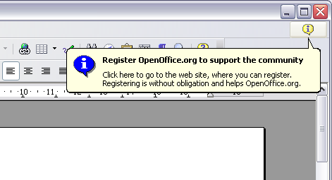Illustration 4: Registration reminder for OOo
- “OOo Registration Reminder” - Text Properties |  | Comment
Bold header: | Register %PRODUCTNAME to support the community | EN-US
Notice: | Click here to go to the web site, where you can register. Registering is without obligation and helps %PRODUCTNAME.
URL:

StarOffice and Other Products
The following registration reminder is used for SO and other OOo based products.
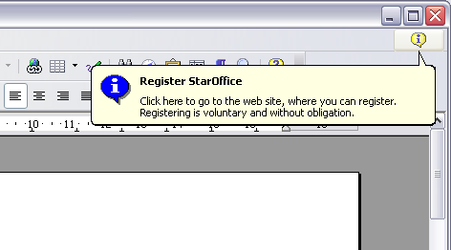Illustration 5: Registration reminder for SO
- “SO Registration Reminder” - Text Properties |  | Comment
Bolder header: | Register $PRODUCTNAME | EN-US
Notice: | Click here to go to the web site, where you can register. Registering is voluntary and without obligation.
URL:

http://specs.openoffice.org/appwide/start_center/start_center.odt

