Software Specification Document

OpenOffice Calc
Resizeable Margin on Page Preview

Specification Status
Last Change | February 12, 2007
Status
Abstract
According to the request of the to-do list in Calc OOo community, the feature is to add resizeable margins and scaling factor on page preview in Calc.
i-Team Members
Role | First Name, Last Name, Initials | E-Mail Address
Project Lead | Niklas Nebel | nn@openoffice.org
Specification Owner | Frank Loehmann (FL) | frank.loehmann@sunc.com
User Experience | Frank Loehmann (FL) | frank.loehmann@sunc.com
Development | Maoyonggang(maoyg)  Yunjingtao | maoyg@openoffice.org  yunjingtao@openoffice.org
Quality Assurance | Peter Junge | pj@openoffice.org
Documentation | maoyg | maoyg@openoffice.org

Contents
Abstract 1
i-Team Members 1
References and Reference Documents 3
Acronyms and Abbreviations 3
1 Detailed Specification 4
1.1 Reasons: 4
1.2 Page Preview 6
1.2.1 Margins hide 6
1.2.2 Margins show 7
1.2.3 Margins adjust 8
2 Migration 10
3 Configuration 10
4 File Format 10
5 Open Issues 10
Document Change History 10

References and Reference Documents
Reference Document | Check | Location (URL)
Specification Process Entry Check |  | N/A
Product Requirement,, RFE, issue (required) |  | 75673, 51656
Product Concept Document |  | <Please enter location here>
Competitive Analysis |  | <Please enter location here>
Test Case Specification (required) |  | Attached to 51656
Software Specification Rules | N/A | N/A
<Other, e.g. references to related specs>

Acronyms and Abbreviations
Acronym / Abbreviation | Definition

Detailed Specification

Reasons:
In OpenOffice.org 2.3, there was no resizeable margins on page preview. It was just a page. If you want to change margins of the page you have to change them through the page style dialog box. So it is very handy to have the margins of the page changed by dragging indicators(Part1.2). This feature would make the user get immediate feedback when changing this setting and she could see how the printout will look like(Part1.3).
Figures of the page preview without resizeable margins are shown as below:
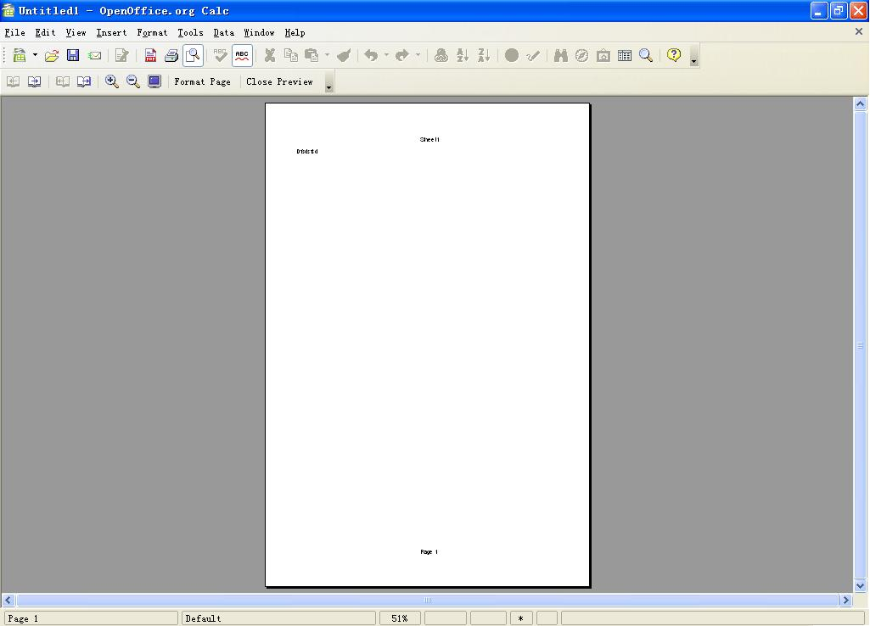Illustration 1: Screen shot of the page preview without resizeable margins

Illustration 2: Screen shot when zooming in

Page Preview

Margins hide
We will add a button “Margins” to the toolbar to show/hide margins .Default it is hidden.
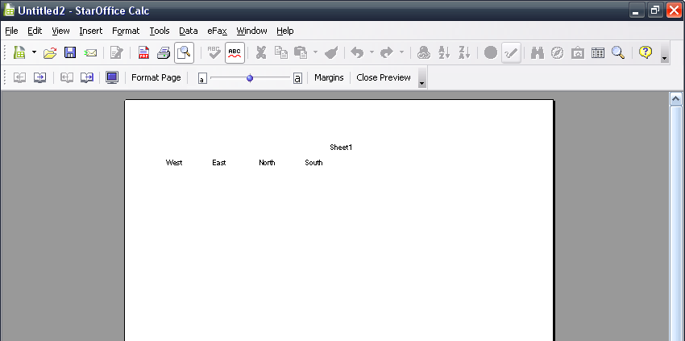Illustration 3: Page margins hide
- Margins” - Button Properties |  | Comment
Button Label: | Margins | EN-US

Margins show
When the page preview is clicked, the page will be shown on the screen. On this view, we add two lines for width and four for height.
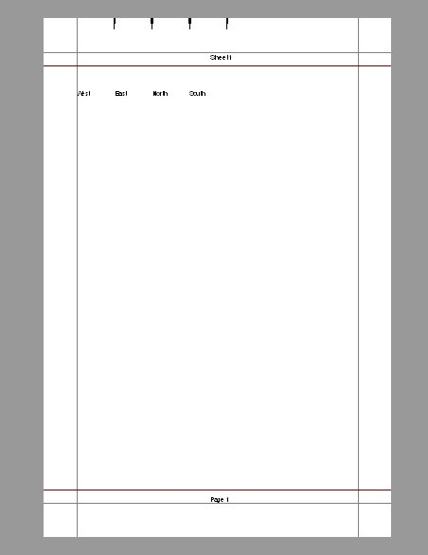Illustration 4: Page margins adjust

Margins adjust
Users can put the cursor on the line area and wait for the symbol to indicate it is available to drag the line to adjust margins of the page. The following is the figure of the new feature:
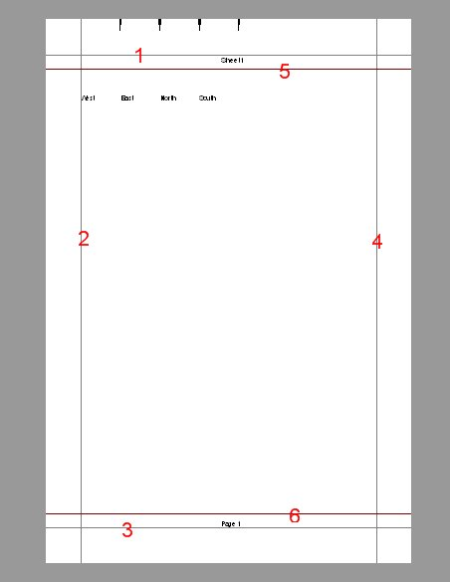

Table 1: User Interface elements of Figure 2-1
# | Type | Properties |  | Comment
1 |  | Control Properties  Features: To be dragged to resize the top margin of the page
1 |  | String English  N/A | String German  N/A
2 |  | Control Properties  Features: To be dragged to resize the left margin of the page
2 |  | String English  N/A | String German  N/A
3 |  | Control Properties  Features: To be dragged to resize the bottom margin of the page
3 |  | String English  N/A | String German  N/A
4 |  | Control Properties  Features: To be dragged to resize the right margin of the page
4 |  | String English  N/A | String German  N/A
5 |  | Control Properties  Features: To be dragged to resize the header height of the page |  | The line can adapt itself to fit the distance which is set between itself and the top margin line. It is the height of the header
5 |  | String English  N/A | String German  N/A
6 |  | Control Properties  Features: To be dragged to resize the footer height of the page |  | The line can adapt itself to fit the distance which is set between itself and the bottom margin line. It is the height of the footer
6 |  | String English  N/A | String German  N/A

1). We think that the minimal page margin values should not be negative,so the minimal value of the page margin should be 0. The reason is that the line is not allowed to move outside the paper size. Each margin can be reset but can't be beyond the border.
2). The feature on page margin will cancel the dialogs when the page margin cannot be further dragged. The solution is each margin(right, left, top or bottom) returns back to its last position.
3). Solutions to the overlaps of the right and left margin: Don't pop up a dialog and keep a certain space between lines.
4). Solutions to header height and footer height: They can overlap but they can't go over each other. It is similar as the function in MS excel, but not the same implementation. In excel, the style is not so strict. The user can even drag the page margin into the content area. In our new feature in Calc, the page margin can never be dragged in to the content area. Line 5 and 6 are in charge of the header and footer, and they always adjust itself due to the fixed height of header and footer .
5). When dragging the top margin, the distance between the top margin and the header height stands still. But when dragging the header height, the distance between them will change. The same things happens to the bottom and the footer height.
6). The Columns and hidden Columns should be considered.

Migration
Not applicable as this is a new feature

Configuration
This feature doesn't need to be stored in configuration path.

File Format
No change to the file format

Open Issues
Issue | Initials | Date

Document Change History
Rev. | Change | Initials | Date
1 | Finalization | FL | February 11, 2008
2 | Added link to test spec. | FL | February 12, 2008

