Software Specification Document

OpenOffice.org Calc
New Selection Visualization

Specification Status
Last Change | Feb 19, 2008
Status
Abstract
The selection visualization in spreadsheets is changed to be transparent. Furthermore the column headers get a glass effect in selection color to improve visibility.
i-Team Members
Role | First Name, Last Name, Initials | E-Mail Address
I-Team Lead | Niklas Nebel (NN) | niklas.nebel@sun.com
Specification Author | Frank Loehmann (FL) | frank.loehmann@sun.com
User Experience | Frank Loehmann (FL)  Christian Jansen (CJ) | frank.loehmann@sun.com  christian.jansen@sun.com
Development | Niklas Nebel (NN) | niklas.nebel@sun.com
Quality Assurance | Oliver Crämer (OC) | Oliver.craemer@sun.com
Documentation | Uwe Fischer (UFI) | uwe.fischer@sun.com

Contents
Abstract 1
i-Team Members 1
References and Reference Documents 3
Acronyms and Abbreviations 3
1 Detailed Specification 4
1.1 New Visualization for Selection and Column / Row Header 4
1.2 Visualization in High Contrast Mode (Accessibility) 5
1.3 Visualization for Remote Protocols (SunRay) 5
2 Migration 5
3 Configuration 5
4 File Format 5
5 Open Issues 6
Document Change History 6

References and Reference Documents
Reference Document | Check | Location (URL)
Specification Process Entry Check |  | N/A
Product Requirement, RFE, issue [Required] |  | 86069
Product Concept Document |  | <Please enter location here>
Competitive Analysis |  | <Please enter location here>
IDL Specification |  | <Please enter location here>
Test Case Specification [Required] |  | http://www.openoffice.org/issues/show_bug.cgi?id=86069  http://www.openoffice.org/nonav/issues/showattachment.cgi/51587/TCS_Calcselection.htm
Software Specification Rules | N/A | N/A
<Other, e.g. references to related specs>
Acronyms and Abbreviations
Acronym / Abbreviation | Definition
<WYSIWYG> | <What You See Is What You Get>

Detailed Specification

New Visualization for Selection and Column / Row Header
The translucent selection looks like shown in the following screenshot. Furthermore the row and column header show a glass effect and also use the systems selection color.
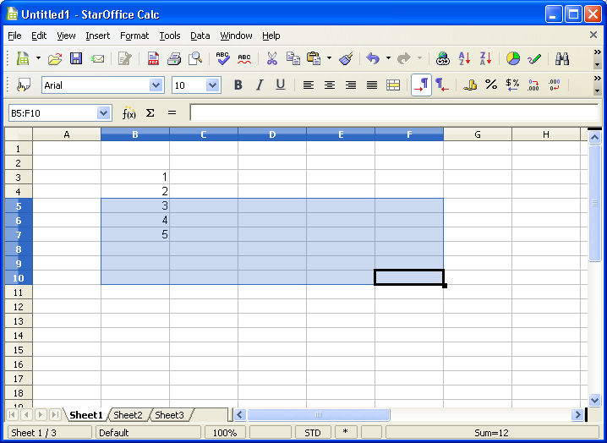Illustration 1: New transparent selection
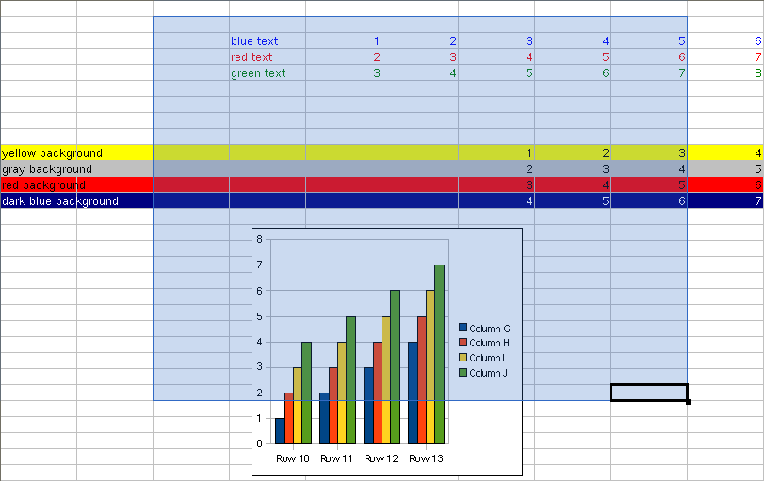Illustration 2: Translucent selection is painted above spreadsheet content

Visualization in High Contrast Mode (Accessibility)
In high contrast mode the the old inverting representation for the selection and cell cursor is used. Furthermore the row and column header are highlighted in the old way used for OOo 2.x to improve readability in high contrast mode.

Visualization for Remote Protocols (SunRay)
If a translucent selection is not supported by the system, the old inverting selection is used instead. The column and row header are painted in glass optic.

Migration
None.

Configuration
Uses selection colors defined in systems.

File Format
Not relevant.

Open Issues
Issue | Initials | Date
<State Issue here, State “None”, if all issues are solved> |  | <Format: Dec 31, 2000>
<...>

Document Change History
Rev. | Change | Initials | Date
1 | Initial specification | FL | February 13, 2008
2 | Finalization | FL | February 14, 2008
3 | 2nd Mock-up added | FL | February 18, 2008
4 | Standard | FL | February 19, 2008

