Software Specification Document

OpenOffice.org
Chart Wizard

Specification Status
Last Change | Oct 14, 2009
Status

Abstract
Bubble charts and filled net charts are available in addition now.
i-Team Members
Role | First Name, Last Name, Initials | E-Mail Address
I-Team Lead | Ingrid Halama (IHA) | iha@openoffice.org
Specification Author | Matthias Müller-Prove (MMP) | mprove@sun.com,
User Experience | Frank Loehmann (FL) | fl@openoffice.org
Development | Wei Zhao | weiz@openoffice.org
Quality Assurance | Thomas Klarhöfer (TK) | kla@openoffice.org
Documentation | Uwe Fischer (UFI) | ufi@openoffice.org
Test Automation | Helge Delfs (HDE) | hde@openoffice.org

Contents
Abstract 1
i-Team Members 1
References and Reference Documents 3
Acronyms and Abbreviations 3
1 Detailed Specification 4
1.1 Creating a new Chart from Data 4
1.1.1 In Calc 4
1.1.2 In Writer 4
1.2 Display the Chart Wizard 5
1.3 Live Preview 5
1.4 Dialog and Roadmap 5
1.5 Step 1 – Choose a chart type 7
1.5.1 Columns Chart 9
1.5.2 Bar Chart 11
1.5.3 Pie Chart 11
1.5.4 Area Chart 12
1.5.5 Line Chart 13
1.5.6 Smooth Line Properties Dialog 14
1.5.7 XY (Scatter) Chart 16
1.5.8 Bubble Chart 17
1.5.9 Net Chart 17
1.5.10 Stock Chart 18
1.5.11 Columns and Line Chart 19
1.6 Chart Type Dialog 20
1.7 Step 2 – Data Range 21
1.8 Step 3 – Data Series 22
1.9 Step 4 – Chart Elements 23
1.10 Sticky Settings 24
2 Migration 25
3 Configuration 25
4 File Format 25
5 Open Issues 25
5.1 Todos after SRC-Integration 25
5.2 After Release OOo 2.3 26
6 Document Change History 26

References and Reference Documents
Reference Document | Check | Location (URL)
Specification Process Entry Check |  | N/A
Product Requirement,, RFE, issue (required) |  | I20344 , i76728, i64689, 64752 ,
Product Concept Document |  | <Please enter location here>
Competitive Analysis |  | Competitive Analysis
Test Case Specification (required) |  | http://qa.openoffice.org/source/browse/qa/qatesttool/chart2/level1/ch2_lvl1_wizard.bas?rev=1.1.2.3&only_with_tag=cws_pj_chart2&view=log  TCS for Bubble Charts  TCS for Filled Net Charts
Software Specification Rules | N/A | N/A
Concepts for Wizards
Chart Menu Structure

Acronyms and Abbreviations
Acronym / Abbreviation | Definition
OOo | OpenOffice.org
MA (MAP) | The units which are used in this specification are Map AppFont (ma). It is the preferred unit when designing dialogs with the OpenOffice.org API. Map AppFont units are device and resolution independent. One Map AppFont unit is equal to one-eighth of the average character (Systemfont) height and a quart in width.
Spline | http://www.ibiblio.org/e-notes/Splines/Intro.htm
SRC-Integration | The milestone when the Chart CWS is integrated into the main source trunk SRC.

Detailed Specification
The Chart Wizard opens only if a chart is created using data from calc or writer. In other cases where charts are created without external input data the wizard does not open.

Creating a new Chart from Data
A chart can be created using existing data from spreadsheets in Calc or tables in Writer.

In Calc
After choosing the insert chart command in Calc, the current selection gets expanded to embrace all data cells of the minimal rectangular area – same as in OOo 1.1. Next, the chart is temporarily created at a default position using all default values of the Chart Wizard.
The default position of the chart preview adheres to the following constraints:
- The chart preview has a fixed size. 8cm width x 7cm height (same values as in OOo 2.0)
- The document is not scrolled to make the chart visible.
- A maximum amount of the chart preview is visible.
  - If the chart preview (number 1 above) is larger than the current view, then the top left corner of the chart preview is positioned top left in the visible view (topright/top right for right-to-left UI).
  - The position of the preview is always constrained by the size of the document, e.g. the chart preview can not be positioned higher than the A0 cell, or it can not overhang the right or lower edge of a document.
- The chart preview should be placed adjacent to the data range. Preferred location for western orientation is top-right. For right-to-left UI the preferred location in top-left.
If there is not enough space then it is allowed to overlap with the data range.
Comment: This means the chart preview is no longer 'adjacent' to the data range but still top-right, or top-left respectively.
- A maximum amount of data range remains visible.
These constraints are competing with each other. Therefore they are ordered by relevance. Most important is #1, then #2, and so forth.
Then the Chart Wizard is called.

In Writer
The current cell selection in a Writer table is used as input data for a new chart. The new chart is created
- above the table
- Aligned To Paragraph
- No Wrap
MMP, Future Issue: Wouldn't it be better to create the chart below the table?
Then the Chart Wizard is called.

Display the Chart Wizard
The Chart Wizard opens automatically for charts that display external data like in Calc or for tables in Writer,
The initial position of the Chart Wizard adheres to the following constraint:
- The Chart Wizard is completely visible on the screen.
- The Chart Wizard should have a minimal overlap with the chart preview.
- If possible, the Chart Wizard should be positioned directly + 12 MA below the chart preview.
  - 2nd attempt is above the chart
  - 3rd attempt is left from the chart (for LTR orientation; right for RTL orientation)
  - 4th attempt is the 4th unused direction
- For the other dimension (direction on screen),the wizard should be centered to the chart preview.
Chart preview and Wizard are presented to the user with at most 1 sec delay in between. If the time before the chart preview can be displayed exceeds 3 sec, a wait cursor is shown.
MMP. Comment: The timing constraints need to be addressed between SRC-Integration and Final Release.

Live Preview
The document serves as a live preview area for the new chart.
This means for Calc, than charts are always created on the current sheet.
Once the user presses the Finish button in the Chart Wizard the chart becomes permanent part of the document. If the user dismisses the wizard with Cancel the chart in the document is removed.

Dialog and Roadmap
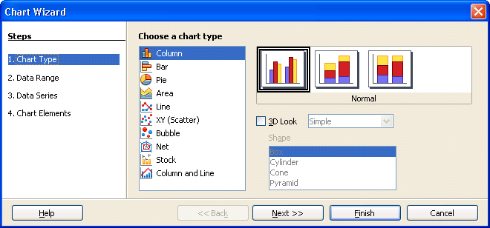Illustration 1: Chart Wizard

The title of the wizard is “Chart Wizard”.
The heading of the roadmap is “Steps”.
The roadmap has an active navigation [Concepts for Wizards, 4.3.1] with 4 steps:
- Chart Type
- Data Range
- Data Series
- Chart Elements

Table 1: User Interface elements of Figure Illustration 1
# | Type | Properties |  | Comment
<#> |  | Control Properties  State: modal  Closable: yes  Close Operation: same as Cancel  Is iconifiable: no  Is maximizable: no  Resizable: no  Always On Top: yes
<#> |  | String English  Chart Wizard | String German  Diagramm-Assistent
<#> | roadmap | Properties
<#> | roadmap | String English  Chart Type | String German  Diagrammtyp
<#> | roadmap | Properties
<#> | roadmap | String English  Data Range | String German  Datenbereich
<#> | roadmap | Properties
<#> | roadmap | String English  Data Series | String German  Datenreihen
<#> | roadmap | Properties
<#> | roadmap | String English  Chart Elements | String German  Diagrammelemente

The ordinal numbers for the roadmap (“1. “, “2. ”, etc) are inserted by the application.

Step 1 – Choose a chart type
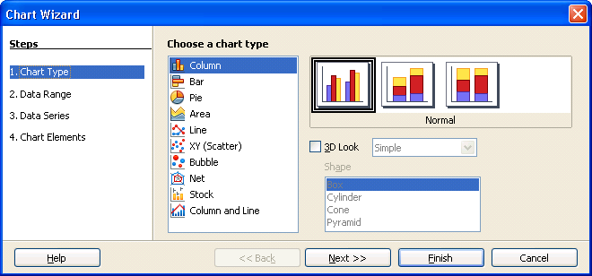Illustration 2: Chart Wizard step 1: Chart Type

The main chart types are, in this order:
- Column
- Bar
- Pie
- Area
- Line
- XY (Scatter)
- Bubble
- Net
- Stock
- Column and Line
At any time one item of the Chart type list is selected. By default, the first item is selected, i.e. a column chart / normal / 2D is created. By selecting another type the control area to the right pane changes accordingly to offer further variations of the selected chart type.
Table 2: User Interface elements of Illustration 2;
# | Type | Properties |  | Comment
1 |  | Properties
1 |  | String English  Choose a chart type | String German  Bitte wählen sie einen Diagrammtyp
2 |  | Properties
2 |  | String English  Column | String German  Säulen
3 |  | Properties
3 |  | String English  Bar | String German  Balken
4 |  | Properties
4 |  | String English  Pie | String German  Kreis
5 |  | Properties
5 |  | String English  Area | String German  Flächen
6 |  | Properties
6 |  | String English  Line | String German  Linien
7 |  | Properties
7 |  | String English  XY (Scatter) | String German  XY |  | “(Scatter)” is not translated for German
8 |  | Properties
8 |  | String English  Bubble | String German  Blasen
9 |  | Properties
9 |  | String English  Net | String German  Netz
10 |  | Properties
10 |  | String English  Stock | String German  Kurs
11 |  | Properties
11 |  | String English  Column and Line | String German  Säulen und Linien

Columns Chart
Illustration 3: Chart type: Column

Table 3: User Interface elements of Figure Illustration 3
# | Type | Properties |  | Comment
1 |  | Control Properties  Initially Checked: yes  TriState: no
1 |  | String English  Normal | String German  Normal
2 |  | Control Properties  Initially Checked: no  TriState: no
2 |  | String English  Stacked | String German  Gestapelt
3 |  | Control Properties  Initially Checked: no  TriState: no
3 |  | String English  Percent stacked | String German  Prozentual gestapelt
4 |  | Control Properties  Initially Checked: no  TriState: no  Visible: if and only if 3D Look (#5) is marked
4 |  | String English  Deep | String German  Tief
5 |  | Control Properties  Enabled: yes  Initially Checked: no  TriState: no
5 |  | String English  ~3D Look | String German  ~3D-Darstellung
6 |  | Control Properties  Editable: no  Enabled: if and only if 3D Look (#5 is marked)  Maximum Row Count: 2  Visible Row Count: 2  Item Selected: Realistic  Live preview of items: yes  TriState: yes
6 |  | String English  Simple | String German  Einfach
6 |  | Same as above
6 |  | String English  Realistic | String German  Realistisch
7 |  | Control Properties  Enabled: if and only if 3D Look (#5 is marked)
7 |  | String English  Shape | String German  Form
8 |  | Control Properties  Editable: no  Enabled: if and only if 3D Look (#5 is marked)  Maximum Row Count: 4  Visible Row Count: 4  Item Selected: 1  Enable Sorting by Drag & Drop: no  Live preview of items: yes  Item Selected: yes
8 |  | String English  Box | String German  Quader
8 |  | Same as above
8 |  | String English  Cylinder | String German  Zylinder
8 |  | Same as above
8 |  | String English  Cone | String German  Kegel
8 |  | Same as above
8 |  | String English  Pyramid | String German  Pyramiden

Bar Chart
Illustration 4: Chart type: Bar
The user interface elements are the same as for Column Charts (1.4.1 Columns Chart).

Pie Chart
Illustration 5: Chart type: Pie
3D Look and the the following combo box are the same as for Column Charts (1.4.1 Columns Chart). However, a shape control is not provided.

Table 4: User Interface elements of Figure Error: Reference source not found
# | Type | Properties |  | Comment
1 |  | Control Properties  Initially Checked: yes  TriState: no
1 |  | String English  Normal | String German  Normal
2 |  | Control Properties  Initially Checked: no  TriState: no
2 |  | String English  Exploded Pie Chart | String German  Explodiertes Kreisdiagramm
3 |  | Control Properties  Initially Checked: no  TriState: no
3 |  | String English  Donut | String German  Ringe
4 |  | Control Properties  Initially Checked: no  TriState: no
4 |  | String English  Exploded Donut Chart | String German  Explodiertes Ringdiagramm

Area Chart
Illustration 6: Chart type: Area
The user interface elements are the same as for Column Charts (1.4.1 Columns Chart). However, a shape control is not provided. And marking the 3D Look does not display a 4th chart icon.

Line Chart
Illustration 7: Chart type: Line
The Properties button is positioned adjacent to the check box control “Smooth lines”.

Table 5: User Interface elements of Figure Illustration 7
# | Type | Properties |  | Comment
1 |  | Control Properties  Initially Checked: yes  TriState: no  Function: marking this option unmarks the 3D Look control of the chart types above.
1 |  | String English  Points Only | String German  Nur Punkte
2 |  | Control Properties  Initially Checked: no  TriState: no  Function: marking this option unmarks the 3D Look control of the chart types above.
2 |  | String English  Points and Lines | String German  Punkte und Linien
3 |  | Control Properties  Initially Checked: no  TriState: no  Function: marking this option unmarks the 3D Look control of the chart types above.
3 |  | String English  Lines Only | String German  Nur Linien
4 |  | Control Properties  Initially Checked: no  TriState: no  Function: marking this option marks the 3D Look control of the chart types above.
4 |  | String English  3D Lines | String German  3D-Linien
5 |  | Control Properties  Enabled: yes  Initially Checked: no  TriState: no
5 |  | String English  ~Stack series | String German  ~Datenreihen stapeln
6 |  | Control Properties  Enabled: if and only if Stack series (#5) is marked  Initially Selected: yes
6 |  | String English  ~On top | String German  Ü~bereinander
7 |  | Control Properties  Enabled: if and only if Stack series (#5) is marked  Initially Selected: no
7 |  | String English  ~Percent | String German  ~Prozentual
8 |  | Control Properties  Enabled: yes  Initially Checked: no  TriState: no
8 |  | String English  S~mooth lines | String German  Ku~rvenglättung
9 |  | Control Properties  Icon: no  Enabled: yes  Function: if the Properties dialog is closed with OK then the Smooth Lines checkbox (#8) is marked. If the dialog is canceled the checkbox #8 remains unchanged.
9 |  | String English  P~roperties... | String German  ~Eigenschaften...

Smooth Line Properties Dialog
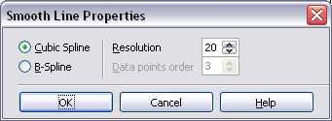Illustration 8: Smooth Line Properties dialog (Current layout)

Illustration 9: Smooth Lines dialog (mockup 11-Dec-2006)

Future todo: The dialog layout should be changed from illustration 8 to illustration 9 between.

Table 6: User Interface elements of Figure Illustration 9
# | Type | Properties |  | Comment
1 |  | Control Properties  State: modal  Closable: yes  Close Operation: cancel  Is iconifiable: no  Is maximizable: no  Resizable: no  Always On Top: yes
1 |  | String English  Smooth Lines | String German  Kurvenglättung
2 |  | Control Properties  Enabled: yes  Initially Selected: yes
2 |  | String English  ~Cubic spline | String German  ~Kubischer Spline
3 |  | Control Properties  Enabled: yes  Initially Selected: no
3 |  | String English  ~B-Spline | String German  ~B-Spline
4 |  | Control Properties  Editable: yes  Enabled: always  Drag Enabled: no  Minimum Value: 1  Maximum Value: 100  Start Value: 20  Steps: 1  Size: 3 digits
4 |  | String English  ~Resolution | String German  ~Auflösung
6 |  | Control Properties  Editable: yes  Enabled: if and only if B-Splines (#3) is marked  Drag Enabled: no  Minimum Value: 1  Maximum Value: 100  Start Value: 3  Steps: 1  Size: 3 digits
6 |  | String English  ~Data points order | String German  ~Ordnung für Stützpunkte

XY (Scatter) Chart
Illustration 10: Chart type: XY (Scatter)
Same as chart types above.
Future todo: The control for Smooth lines should be at the same position as the check box for Line and Net charts. The base line of the Properties button shall be the same as for the check box control left of it (it is 1 px too low.)

Table 7: User Interface elements of Figure Illustration 10
# | Type | Properties |  | Comment
1 |  | Control Properties  Enabled: yes  Initially Checked: no  TriState: no
1 |  | String English  ~Sort by X values | String German  ~Nach X-Werten sortieren

Bubble Chart
Illustration 11: Chart type: Bubble
Table 8: User Interface elements of Figure Illustration 11
# | Type | Properties |  | Comment
1 |  | Control Properties  Initially Checked: yes  TriState: no
1 |  | String English  Bubble Chart | String German  Blasendiagramm

Net Chart
Illustration 12: Chart type: Net

Except the most right sub type all other controls are already defined in the sections above
Table 9: User Interface elements of Figure Illustration 11
# | Type | Properties |  | Comment
1 |  | Control Properties  Initially Checked: no  TriState: no
1 |  | String English  Filled | String German  Gefüllt

Stock Chart
Illustration 13: Chart type: Stock
Table 10: User Interface elements of Figure Illustration 13
# | Type | Properties |  | Comment
1 |  | Control Properties  Initially Checked: yes  TriState: no
1 |  | String English  Stock Chart 1 | String German  Kursdiagramm 1
2 |  | Control Properties  Initially Checked: no  TriState: no
2 |  | String English  Stock Chart 2 | String German  Kursdiagramm 2
3 |  | Control Properties  Initially Checked: no  TriState: no
3 |  | String English  Stock Chart 3 | String German  Kursdiagramm 3
4 |  | Control Properties  Initially Checked: no  TriState: no
4 |  | String English  Stock Chart 4 | String German  Kursdigramm 4

MMP-1 Future Issue: Can we add an more information below the chart picker? How many datapoints are needed to generate the chart.

Columns and Line Chart
Illustration 14: Chart type: Column and Line
The spin field is positioned adjacent to the label “Number of lines”.

Table 11: User Interface elements of Figure Illustration 14
# | Type | Properties |  | Comment
1 |  | Control Properties  Initially Checked: yes  TriState: no
1 |  | String English  Columns and Lines | String German  Säulen und Linie
2 |  | Control Properties  Initially Checked: no  TriState: no
2 |  | String English  Stacked Columns and Lines | String German  Gestapelte Säulen und Linie
3 |  | Control Properties  Enabled: yes
3 |  | String English  ~Number of lines | String German  Anzahl der ~Linien
4 |  | Control Properties  Editable: yes  Enabled: yes  Drag Enabled: no  Minimum Value: 0  Maximum Value: if data series are taken from rows (step 2 of the Chart Wizard) then the maximum value is number of rows – i.  if data series are taken from columns then the maximum value is number of columns – i.  If the first cell contains the label THEN i is 2 ELSE i is 1.  Start Value: 0  Steps: 1
4 |  | String English | String German

Chart Type Dialog
The first step of the Chart Wizard can also be called stand alone. This is the Chart Type dialog:
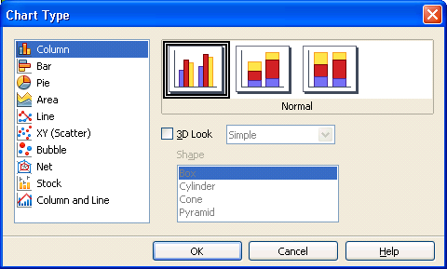Illustration 15: Chart Type Dialog

Table 11b: User Interface elements of Figure Illustration 15
# | Type | Properties |  | Comment
1 |  | Control Properties  State: modal  Closable: yes  Close Operation: same as cancel  Is iconifiable: no  Is maximizable: no  Resizable: no  Always On Top: yes  Special: dialog has live preview
1 |  | String English  Chart Type | String German  Diagrammtyp

Step 2 – Data Range
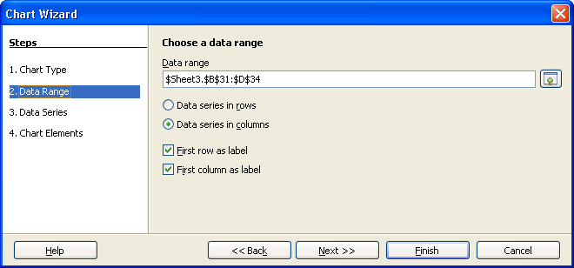Illustration 16: Chart Wizard Step 2: Data Range

Table 12: User Interface elements of Figure Illustration 16
# | Type | Properties |  | Comment
1 |  | Control Properties  Enabled: YES  Style: Bold
1 |  | String English  Choose a data range | String German  Wählen Sie den Datenbereich

All other controls are specified in Flexible Source-Range Selection

Step 3 – Data Series
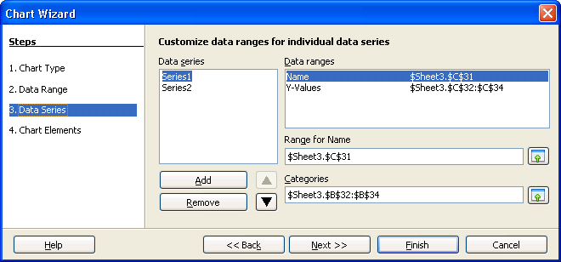Illustration 17: Chart Wizard Step 3: Data Series (mockup 14-Dec-2006)

Table 13: User Interface elements of Figure Illustration 17
# | Type | Properties |  | Comment
1 |  | Control Properties  Enabled: YES  Style: Bold
1 |  | String English  Customize data ranges for individual data series | String German  Wählen Sie spezielle Datenbereiche für die Datenreihen

All other controls are specified in Flexible Source-Range Selection

Step 4 – Chart Elements
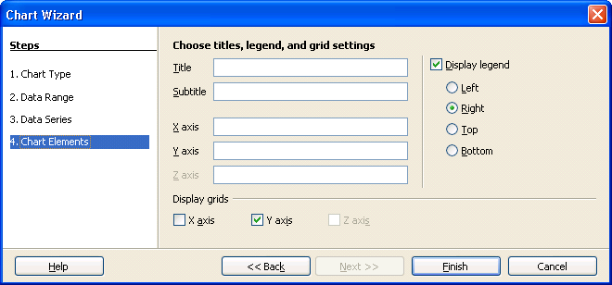Illustration 18: Chart Wizard Step 4: Chart Elements

Table 14: User Interface elements of Figure Illustration 18
# | Type | Properties |  | Comment
1 |  | Control Properties  Enabled: YES  Style: Bold
1 |  | Choose titles, legend, and grid settings | Wählen Sie Titel, Legenden- und Gittereinstellungen
2 |  | Control Properties  Enabled: yes  Initially Checked: yes  TriState: no
2 |  | String English  ~Display legend | String German  Legende ~anzeigen
3 |  | Control Properties  Enabled: if and only if check box #2 is marked  Initially Selected: no
3 |  | String English  ~Left | String German  ~Links
4 |  | Control Properties  Enabled: if and only if check box #2 is marked  Initially Selected: yes
4 |  | String English  ~Right | String German  ~Rechts
5 |  | Control Properties  Enabled: if and only if check box #2 is marked  Initially Selected: no
5 |  | String English  ~Top | String German  ~Oben
6 |  | Control Properties  Enabled: if and only if check box #2 is marked  Initially Selected: no
6 |  | String English  ~Bottom | String German  ~Unten
7 |  | Control Properties  Enabled: yes
7 |  | String English  Display grids | String German  Gitter anzeigen
8 |  | Control Properties  Enabled: if and only if chart has X axis  Initially Checked: depends on the chart type
8 |  | String English  X axis | String German  X-A~chse
9 |  | Control Properties  Enabled: if and only if chart has Y axis  Initially Checked: depends on the chart type
9 |  | String English  Y axis | String German  Y-Ac~hse
10 |  | Control Properties  Enabled: if and only if chart has Z axis  Initially Checked: no
10 |  | String English  Z axis | String German  Z-Ach~se

Title, Subtitle, X/Y/Z axis are specified in Chart Insert Title Dialog

Sticky Settings
Some settings are shared among different chart types. e.g. “3D Look” can be applied to columns, bars, area, lines, and xy-scatter plots. If any of those chart types is set to 3D and the user changes the chart type to another type, that also supports 3D then the 3D setting is set here as well.
The set of settings that show this “sticky” behavior are the ones that show up in more than one pane for the chart types.
- Normal / Stacked / Percent Stacked
  - Stacked Bar or Column chart map to Donut variation of Pie chart. But donut and exploded donut map back to normal for bar and column.
- 3D Look
- 3D Style
- Shape
- Smooth Lines
- Smooth Line Properties

Migration
n/a

Configuration
n/a

File Format
n/a

Open Issues

Todos after SRC-Integration
initial preview matching selected data range and chart type.
modeless Chart Wizard
visual feedback for Calc cells on used ranges
Inline Help for Stock Charts to explain the formatting of the data. Other chart type can benefit from this info texts as well.
Insert Object Pane: Legend position, Axis on/off
"sticky settings" for symbol/line settings
"sticky settings" for B-Splines

MMP Feb-27, 2007: Selection for Sub-Chart Type should be more pleasing. A thick black border looks quite outdated.

MMP Feb-27, 2007: Line and XY (Scatter) need the control to choose the 3D style once the 3D subtype is selected. Currently they can just be defined indirectly using the sticky settings for other panels.

After Release OOo 2.3
- If several charts are created for the same data range the location should not be the same. A small offset to the bottom right (## 16 * 16) is applied to the charts. For right-to-left UI the offset is to bottom left (-16 * 16).
User defined 3D schemata
MMP 14-Feb-07: The Wizard is not used for charts with internal data (Writer and Impress). Shall we provide some UI to use the wizard in these cases as well?
LH-1 Idea (Jan 2006): Introduce a first step with just thumbnails. To make it possible to create final charts with 2 clicks. Smooth Line Properties Dlg Redesign (Btns to the right)nalyses
CJ-1 RFE: User XYZ erstellt ein Chart und formatiert es nach seinem Geschmack.
Er erstellt ein weiteres Chart, das die gleichen Design-Attribute haben soll. Um das zu vereinfachen wäre es klasse, wenn User XYZ das schon bestehende Chart, in eine Art Custom Chart Format Gallery stecken könnte.
User XYZ könnte dann diese Formatvorlage auf das zweite Chart anwenden, und würde dadurch so einige Klicks sparen.

Document Change History
Rev. | Change | Initials | Date
1 | Followup specification document for Chart Wizard using the new spec template | MMP | Nov 15, 2006
2 | Specify step 1 with strings and behavior; German strings are TBD | MMP | Nov 17, 2006
3 | German strings | MMP | Nov 30, 2006
4 | New layout for Smooth Lines dialog, some string changes. | MMP | Dec 11, 2006
5 | Comments IHA-1 – IHA-8  New layout for step 2 and 3 | MMP | Dec 13, 2006
6 | String changes for step 3, string and layout changes for step 4  Created new document for Competitive Analysis  Chart Type Dialog | MMP | Dec 14, 2006
7 | Replace German “Tortendiagramm” by “Kreisdiagramm” | MMP | Feb 8, 2007
8 | Clean up of spec  exchange mockups with screenshots of milestone 11  Positioning of new Charts in Writer and Impress  Sticky settings  iTeam approval requested: Ingrid says OK. What about you Uwe and Thomas? | MMP | Feb 15, 2007
9 | CJ-1 RFE | MMP | Feb 19, 2007
10 | Incorporate Spec-Review from Christoph Noack | MMP | Feb 27, 2007
11 | In Calc, charts are always created on the current sheet. (row 69) | MMP | Apr 18, 2007
12 | Inserted link to testcase specification -> set to standard | IHA | May 10, 2007
13 | Added chart type bubble chart | IHA | Apr 22, 2009
14 | Add sub type 'filled net chart' |  | Jun 3, 2009
15 | Updated icon for filled net chart |  | Jun 11, 2009
16 | Added links to test case specification for bubble charts and filled net charts → set to standard again |  | Aug 24, 2009
17 | Changed abstract to suitable text for the 'what's new guide' | iha | Oct 14, 2009

