Andreas Bregas, 06/22/2006

Support of Non-Script actions in (Basic) dialogs
Inside the (Basic) Dialog Editor it's currently only possible to assign scripts to dialog/control events. This limitation both applies to the UI to assign events (only allowing to assign scripts provided by the scripting framework) as to the core that is only able to manage and call scripts when an event occurs. In the scope of the “GUI Extension” project it's necessary to support non-script actions allowing to use the dialogs for components developed in non-script languages, especially Java and C++.

Core
The mapping between control events and scripts is described by struct of type:
com.sun.star.script.ScriptEventDescriptor
On the one hand this struct describes the event by defining the listener type (member “ListenerType”, e.g. com.sun.star.awt.XTextListener) and the listener method (member “EventMethod”, e.g. textChanged). On the other hand the struct describes the script that should be executed when the event occurs. The script is specified by a type (member “ScriptType”, e.g. “Basic”) and the script code/name (member “ScriptCode”, e.g. “Standard.Module1.doit”).
Although the naming of the types and type members explicitely refer to Scripting and currently is only used to assign scripts provided by the Scripting Framework it seem appropriate to also use these types to describe event mappings to Non-Script targets.
To realise this, a new ScriptType like “Uno” has to be defined. ScriptCode has to specify which functionality or object's method has to be called. It makes sense to define a special URL scheme for this like the Script URLs used to address scripts. e.g.:
vnd.sun.star.UNO:<handler method name>
Example:
vnd.sun.star.UNO:handleMyEvent

But there is a general difference between addressing scripts and components. Scripts have a static character whereas for accessing components the component itself has to be known. So it's necessary to pass the object or objects somehow that should be called when an event occurs.
This could be done in different ways
- Pass the object(s) to the DialogProvider service while initalisation
- Pass the object(s) when instantiating a dialog object

Way 1 is easy to realize as the additional data can passed when calling createInstanceWith-Arguments(). But in this solution all dialogs created with this DialogProvider instance would refer to the same object. So passing the object for the creation of each dialog seems to be more logical.
This requires a new interface to be supported by the DialogProvider service that allows the creatation of dialogs with passing an additional interface (variant with only one handler object):

com::sun::star::awt {
interface XDialogProvider2: com::sun::star::uno::XInterface
{
com::sun::star::awt::XDialog createDialogWithHandler
(
[in] string URL,
[in] XInterface xHandler
)
raises ( com::sun::star::lang::IllegalArgumentException );
}
URL addresses the dialog as in XDialogProvider. xHandler is the interface that will be called to dispatch the Events that are generated by the dialog. xHandler can be implemented in two different ways. The first way: The component developer implements the special new interface com::sun:: star::awt::XDialogEventHandler:

com::sun::star::awt {
interface XDialogEventHandler: com::sun::star::uno::XInterface
{
bool callHandlerMethod
(
[in] com::sun::star::awt::XDialog xDialog,
[in] any Event,
[in] string MethodName
)
}

This is a generic handler interface and in case of an event the method callHandlerMethod is called with the method name provided in the vnd.sun.star.UNO URL.

The other way: If xHandler does not support the generic XEventHandler interface the methods the vnd.sun.star.UNO URLs refer to have to be implemented in interfaces provided by the component. The DialogProvider then will try to map the Events to methods using XIntrospection.
It has to be discussed which method signatures should be accepted. The easiest variant to implement would be to demand all methods to accept an XDialog and an any parameter like the XDialogEvent-Handler::callHandlerMethod method. But it would be easy to also support methods without any parameters. This makes sense for components that define all event handling logic just by naming the methods, e.g. handleOkButton( void ), handleDoitButton1( void ) etc. In this case additional information concerning the dialog or event are not necessary.

Example:
URL “vnd.sun.star.UNO:doit”
The event handling core inside the DialogProvider then would map this URL like this:
If the component supports XDialogEventHandler, it calls
xComponennt.callHandlerMethod( xDialog, aEvent, “doit” )
(if hasHandlerMethod() is realised, this is asked before, otherwise IllegalArgumentException has to be catched).
If the component does not support XDialogEventHandler or if the call to callHandlerMethod fails introspection is used to detect if one of the following methods is provided by one of the interfaces supported by the components:
void doit
(
[in] com::sun::star::awt::XDialog xDialog,
[in] any aEvent,
);
or
void doit( void );
The second method is only used if the first one is not available.

Simple components using dialogs can be realised very easily by supporting XDialogEventHandler as then no own interfaces have to be created. For complex components it could make more sense to define handler interfaces to avoid a huge switch/case blocks in XDialogEventHandler:: callHandlerMethod.

UI
DEPRECATED, now handled in spec document.
The UI is affected as it must be possible to also assign non scripts to control events. To achive this the Assign Macro - so far this name was correct - dialog has to be extended. Currently this dialog looks like this:

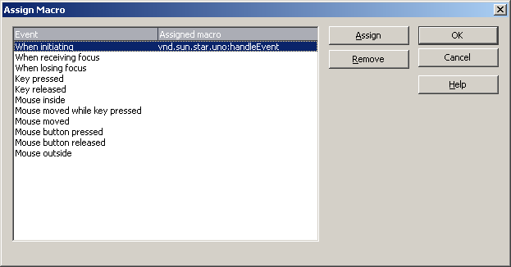

It has to be extended to also support the assignment of the new vnd.sun.star.UNO URLs. This can be done by adding a button for assigning UNO URLs. The new dialog could look like this (caption and “Assign” button text still has to be adapted, Event list may also be extended by a “type” column replacing the URL sceme part in the “Assigned macro” column):

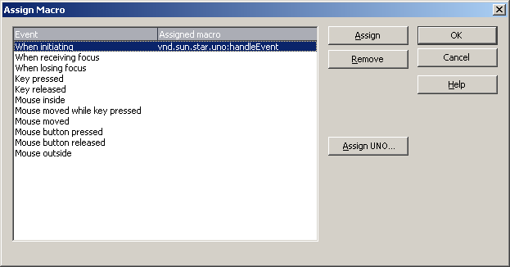

A problem here could be that this dialog is used in multiple contexts. It has to be ensured that the extension will only be active in the Dialog Editor context.
The “Assign UNO...” button could open a simple dialog allowing to type in the URL (mockup created with Dialog Editor):

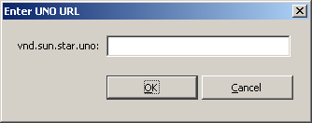

Another way could be to allow typing in the URL directly on the Assign Macro dialog by placing an edit filed near to the “Assign UNO...” button. This has to be discussed with with User Experience. Christian Jansen is yet involved.

