Software Specification Document

OpenOffice.org
Context Menus in Impress and Draw

Specification Status
Last Change | Aug 18, 2006
Status

Abstract
OOo 2.0.4. New context menu command for Impress and Draw to save images directly to the file system.
OOo 2.2. Separate context menu commands for Show Slide / Hide Slide in Slide Pane and Slide Sorter in Impress.

i-Team Members
Role | First Name, Last Name, Initials | E-Mail Address
Project Lead | Matthias Müller-Prove /MMP | mprove@sun.com,
Specification Owner | Matthias Müller-Prove /MMP | mprove@sun.com,
User Experience | Matthias Müller-Prove /MMP | mprove@sun.com,
Development | Christian Lippka /CL  Andre Fischer /AF | Christian.Lippka@Sun.COM,  andre.w.fischer@sun.com,
Quality Assurance | Wolfram Garten /WG  Christian Günther /CGU | Wolfram.Garten@Sun.COM,  christian.guenther@sun.com,
Documentation | Uwe Fischer /UFI | Uwe.Fischer@Sun.COM
Other roles

Contents
Abstract 1
i-Team Members 1
References and Reference Documents 3
Acronyms and Abbreviations and Terms 3
1 Detailed Specification 4
1.1 Context Menu for Bitmap Images in Impress and Draw 4
1.2 Context Menus in Slide Pane and Slide Sorter in Impress 6
1.2.1 Context Clicks on Slides, No Master Pages 6
1.2.2 Context Clicks on the Background, No Master Pages 6
1.2.3 Context Clicks on Slides, Active Master Page View 7
1.2.4 Context Clicks on the Background, Active Master Page View 7
1.3 Context Menus in Slide Pane and Slide Sorter in Draw 8
2 Migration 8
3 Configuration 8
4 File Format 8
5 Open Issues 8
6 Competitive Analysis 10
6.1 OpenOffice.org 2.0.2 10
6.1.1 Context Menu for Images 10
6.2 Microsoft Office PowerPoint 2003 11
7 Document Change History 12

References and Reference Documents
Reference Document | Check | Location (URL)
Specification Process Entry Check |  | N/A
Product Requirement,, RFE, issue (required) |  | i13816: Save As for images  OOo 2.2: i43547: Show/Hide Slide
Product Concept Document |  | <Please enter location here>
Competitive Analysis |  | Chapter 6
Test Case Specification (required) |  | <Please enter location here>
Software Specification Rules | N/A | N/A
Multi Pane GUI |  | http://specs.openoffice.org/impress/multipane/MultiPaneGUI.sxw
Slide Show Menu |  | http://specs.openoffice.org/impress/menus/SlideShowMenu.odt

Acronyms and Abbreviations and Terms
Acronym / Abbreviation | Definition
OOo | OpenOffice.org

Detailed Specification

Context Menu for Bitmap Images in Impress and Draw
comment
Position and Size... Moved up to be consistent with OOo's Format menu
Original Size This belongs to Position and Size.
Line...
Area...
Text...
Color Resolution > no longer part of the context menu and therefore no longer accessible in the user interface
---------------
Character...
Paragraph...
---------------
Alignment > Moved one position up to be consistent with Format menu in Writer
Arrange >
Flip >
Convert >
---------------
Name Object...
removed divider
Interaction... OO Impress only. Not in OO Draw
---------------
Edit Style...
---------------
Save as Picture... new command
---------------
Cut
Copy
Paste

Mnemonic characters are underlined above.
Table 1: User Interface elements of menu above
# | Type | Properties |  | Comment
<#> | = in fact a menu item = | Control Properties  Icon: no  Enabled: yes  Acc. Descrip.: <If needed specify text here>  Acc. Text: <If needed specify text here>  ToolTip Text: <If needed specify text here>
<#> | = in fact a menu item = | String English  ~Save as Picture... | String German  Als Grafik speichern...

Save as Picture command
For any image the context menu contains the “Save as Picture...” menu item. The following Save dialog offers to choose file name and format for the image. The default file format is the internal format of the image. If the user does not change this preselection than the images is not re-encoded -- just a copy of the internal image file is saved to disk.
Comment: The command File-Export always creates a new image file, i.e. a jpeg-images gets re-encoded, which results not in an optimal quality for the image.
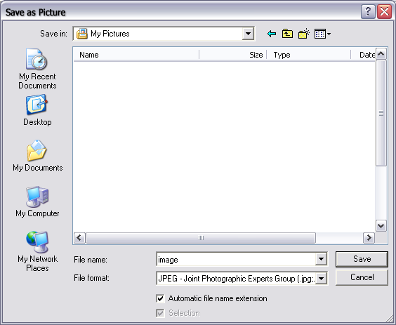Illustration 1: Save as Picture Dialog
The control “Selection” is marked and and disabled. It cannot be changed.

Table 2: User Interface elements of Illustration 3
# | Type | Properties |  | Comment
<#> |  | Control Properties  State: Modal  Closable: Yes  Close Operation: Cancel  Is iconifiable: No  Is maximizable: No  Resizable: Yes  Always On Top: Yes  ToolTip Text: <If needed specify text here>  Acc. Descrip.: <If needed specify text here>  Acc. Text: <If needed specify text here>  Other...: <If needed specify text here>
<#> |  | String English  Save as Picture | String German  Als Grafik speichern

Context Menus in Slide Pane and Slide Sorter in Impress
We have to distinguish between four cases. A click can either be on a slide or on the background. And the master page view can be active or not.

Context Clicks on Slides, No Master Pages
Master pages are not shown.
The slide for which the context menu is shown is referred to as current slide):
New Slide | Insert a new slide after the current slide.
Delete Slide | Delete the current slide. Show a confirmation dialog when the content of the slide is modified.
Rename Slide | Show the rename dialog for the current slide.
-----
Slide Design | Show the Slide Design dialog.
Slide Layout | Show the Slide Layout dialog.
------
Slide Transition... | Show the slide transition dialog.
Show Slide | Active and enabled menu item if current selection contains a hidden slide.  Action: set visible state for the current slide.
Hide Slide | Active and enabled menu item if current selection contains a visible slide.  Action: set hide state for the current slide.
-------- | Separator and entries for Cut, Copy, and Paste are appended automatically by the (SFX) system when appropriate.
Cut
Copy
Paste

OOo 2.1 / issue 43547 / Show Slide: The menu item “Hide Slide” changes to “Show Slide” if the slide is already hidden. If the current selection contains some slides hidden and some visible, then both menu items are active and enabled.
The menu items Show Slide and Hide Slide get the same menu icons as the corresponding menu commands.
- Menu icons for Show Slide and Hide Slide are provided by Stella.

Context Clicks on the Background, No Master Pages
Master pages are not shown.
New Slide | Insert a new slide after the last slide or insert a first slide when there is none.
----- | Separator and Paste entry are appended automatically by the (SFX) system when appropriate.
Paste

Entries for cut and copy are not necessary because there is no selection when the context menu is invoked for the background.
String list
Item | English | German | Comments
Menu item | ~New Slide | ~Neue Folie
Menu item | D~elete Slide | Folie ~löschen
Menu item | ~Rename Slide | Folie ~umbenennen
Menu item | Slide ~Design | ~Foliendesign
Menu item | Slide ~Layout | Folienlayout
Menu item | Slide ~Transition | Folienübergang
Menu item | ~Hide Slide | Folie ~ausblenden
Menu Item | ~Show Slide | Folie ~einblenden

Context Clicks on Slides, Active Master Page View
When the center pane in Impress shows the master page view then the Slide Pane shows master pages instead of slides. For this we need a modified context menu (that essentially just refers to master pages instead to slides.)
New Master | Insert a new master page.
Delete Master | Delete the currently selected master pages.
Rename Master | Show the rename dialog for the current master.
-----
Slide Design | Show the Slide Design dialog.
-------- | Separator and entries for Cut, Copy, and Paste are appended automatically by the (SFX) system when appropriate.
Cut
Copy
Paste

Context Clicks on the Background, Active Master Page View
Background menu (shown when no master is selected):
New Slide | Insert a new slide after the last slide or insert a first slide when there is none.
----- | Separator and Paste entry are appended automatically by the (SFX) system when appropriate.
Paste
Entries for cut and copy are not necessary because there is no selection when the context menu is shown.

Context Menus in Slide Pane and Slide Sorter in Draw
There are two context menus, one is displayed when the right mouse button is clicked in a page, the other one is displayed when the right mouse button is clicked on the background:
Page menu (the slide for which the context menu is shown is referred to as current page):
New Page | Insert a new page after the current page.
Delete Page | Delete the current page. Show a confirmation dialog when the content of the page is modified.
Rename Page | Show the rename dialog for the current page.
Entries for cut, copy, and paste are appended automatically when appropriate.
Background menu:
New Page | Insert a new page after the last page or insert a first page when there is none.
Entries for paste is appended automatically when appropriate. Entries for cut and copy are not necessary because there is no selection when the context menu is invoked for the background.
String list
Item | English | German | Comments
Menu item | ~New Page | Neue Seite
Menu item | D~elete Page | Seite ~löschen
Menu item | ~Rename Page | Seite ~umbenennen

Migration
n/a

Configuration
n/a

File Format
n/a

Open Issues
Issue | Initials | Date
desired consistency with pictures in Writer | FL | Mar 28, 2006
consistency with other context menus in Impress/Draw | MMP | Mar 28, 2006
This feature should be available for all kinds of objects, not just images | WG, FL | Mar 28, 2006
general context menu redesign for Impress/Draw, i.e. order of menu items for Psotion&Size, Alignment | MMP | Mar 30, 2006

Competitive Analysis

OpenOffice.org 2.0.2

Context Menu for Images
comment
Line...
Area...
Text...
Position and Size...
Original Size
Color Resolution >
---------------
Character...
Paragraph...
---------------
Arrange >
Alignment >
Flip >
Convert >
---------------
Name Object...
---------------
Interaction...
---------------
Edit Style...
---------------
Cut
Copy
Paste

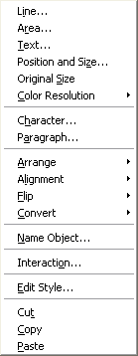Illustration 2: Context menu for image in OOo 2.0.2

Microsoft Office PowerPoint 2003
Microsoft Office PowerPoint 2003 provides a menu command “Save as Picture...”
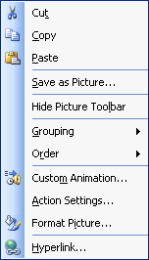Illustration 3: Context menu for image in MS PowerPoint 2003

Document Change History
Rev. | Change | Initials | Date
1 | 1st proposal for context menus for images in Impress and Draw | MMP | Mar 24, 2006
2 | Mnemonics defined. Mockup of Save dialog | MMP | Mar 27, 2006
3 | UX review by Frank Loehmann | MMP | Mar 28, 2006
4 | set spec status to standard | MMP | Mar 30, 2006
5 | new target OOo 2.0.4 | MMP | Apr 5, 2006
6 | move context menu definitions from Multi Pane GUI into this spec | MMP | Aug 18, 2006
7 | New target 2.2 | MMP | Oct 9, 2006

