Software Specification Document

Enhanced Caption in Writer
Enhanced Caption Dialog for Hungarian Language

Specification Status
Last Change | Nov 8, 2007
Status
Abstract
Hungarian language requires a reversed category and number order in captions for pictures, tables and the like. the default order looks like “Figure 1:” and for Hungarian it looks like “1. ábra:”. Therefore changes are needed to the Caption and the AutoCaption dialog.
i-Team Members
Role | First Name, Last Name, Initials | E-Mail Address
I-Team Lead | Oliver Specht | oliver.specht@sun.com
Specification Author | Kálmán, Szalai (KAMI_) | kami_openoffice.org
User Experience | Frank Loehmann (FL) | frank.loehmann@sun.com
Development | Oliver Specht (OS) | oliver.specht@sun.com
Quality Assurance | Éric Savary (E | eric.savary@sun.com
Documentation | Uwe Fischer (UFI) | uwe.fischer@sun.com

Contents
Abstract 1
i-Team Members 1
References and Reference Documents 3
Acronyms and Abbreviations 3
1 Detailed Specification 4
1.1 Required Caption Dialog Enhancements 4
1.1.1 Insert – Caption Dialog 4
1.1.2 Insert - Caption - Options Dialog 6
1.1.3 Insert – Caption – AutoCaption Dialog 6
1.1.4 Tools – Options – OpenOffice.org Writer – AutoCaption 8
2 Migration 9
3 Configuration 9
4 File Format 9
5 Open Issues 9
Document Change History 10

References and Reference Documents
Reference Document | Check | Location (URL)
Specification Process Entry Check |  | N/A
Product Requirement, RFE, issue [Required] |  | http://www.openoffice.org/issues/show_bug.cgi?id=61007
Product Concept Document |  | <Please enter location here>
Competitive Analysis |  | <Please enter location here>
IDL Specification |  | <Please enter location here>
Test Case Specification [Required] |  | <Please enter location here>
Software Specification Rules | N/A | N/A
Initial specification for the caption feature: |  | http://specs.openoffice.org/writer/caption_dialog/Writer_Caption_Dialog.sxw
Acronyms and Abbreviations
Acronym / Abbreviation | Definition
<WYSIWYG> | <What You See Is What You Get>

Detailed Specification
The current caption formatting parameters in the Writer are not enough at least for Hungarian language.
Let's look a real life example:
The Caption format looks like this “Figure 1:” in English. This formatting produces “ábra 1:” that is grammatically incorrect and look unprofessional in a Hungarian text. The correct formatting looks like this “1. ábra:”. Need options to add the placement of numbering and the characters after the number.
The current formatting options are:
category [number][separator]Caption text
We need an option to swap “number”ing and “category” text. Also we need an option to place a “.” (point) character after the numbering this is what I called “number separator”. To make the solution universal the “number separator” must be same input as “separator” - text filed. These changes are enough to provide this formatting options:
number[number separator] category[separator]Caption text
also the old formatting will look like this:
category [number][number separator][separator]Caption text

Required Caption Dialog Enhancements
The order of the caption fields: Numbering and Category depends on the new setting Caption order shown in the Caption - Options dialog and the AutoCaption dialogs. The order in the dialog reflects the order used for the caption in the document.

Insert – Caption Dialog
The default Caption dialog shows Category first for all languages except Hungarian. The Caption dialog looks like shown in Illustration 1 below and has not changed from OOo 2.3.
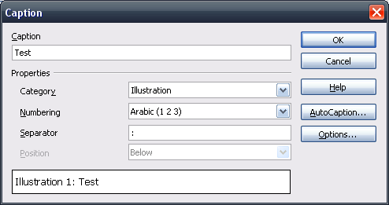Illustration 1: Insert - Caption dialog in the default setting Category first
In case the option Caption order is set to Numbering first the Numbering field is shown first followed by a new separator field. See following Illustration 2 for details.
Illustration 2: Insert - caption dialog - with activated support for Hungarian (Numbering First)

- “Numbering Separator” - TextField Properties |  | Comment
Enabled: | If Caption order drop down of the Options dialog is set to Numbering first.
Disabled: | If Caption order drop down of the Options dialog is set to Category first.
Read Only: | No
Initial String: | . | .[space]
String Preselected: | No
Caret Position: | 0
TextField Label: | Numbering separator |  | EN-US
TextField Label: | <Label in your native language> |  | e.g. DE

See also chapter 1.1.3 for string tables.

Insert - Caption - Options Dialog
The order setting is defaulted to Category first. If the value is set to Numbering first (like shown in the illustration below), the order of Numbering and Category field is changed like described above.
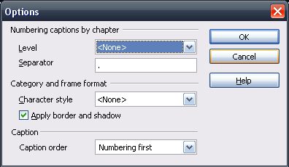Illustration 3: New option to define order used in captions
See chapter 1.1.3 for string tables.

Insert – Caption – AutoCaption Dialog
The AutoCaption dialog also gets a new Caption order drop down list box. The new Numbering separator edit field is shown in both cases, but it is disabled if the order is set to Category first. The following illustrations show both cases.
Illustration 4: AutoCaption dialog (Category first)
Illustration 5: Insert – Caption – AutoCaption Dialog (Numbering First)

“Caption order" - DropDown Listbox Properties |  | Comment
Enabled: | Always
Disabled: | Never
Max. Row Count: | 2
Rows Visible: | 2
Items: | Category first ;  Numbering first ;
Item Selected: | Depend on document language and the configuration bits that stores the defaults for every language.
Sorting by  Drag & Drop: | Disabled
DropDown  ListBox Label: | Caption order | EN-US

“Number separator” - TextField Properties |  | Comment
Enabled: | Caption order=="Numbering first"
Disabled: | Caption order=="Category first"
Read Only: | No
Initial String: | Depends on document language and the configuration bits that stores the defaults for every language.
String Preselected: | No
Caret Position: | 0
Characters Not Allowed: | (none)
Echo characters (Password Field) | (none)
Other: | <Specify Other Properties Here>
TextField Label: | Number separator |  | EN-US
TextField Label: | <Label in your native language> |  | e.g. DE

Tools – Options – OpenOffice.org Writer – AutoCaption
The AutoCaption dialog in Tools-Options behaves like the AutoCaption dialog described above. The following illustrations show the AutoCaption dialog plugged into the Tools-Options dialog.
Illustration 6: Tools - Options - OpenOffice.org - AutoCaption (Category first)
Illustration 7: Tools – Options – OpenOffice.org Writer – AutoCaption (Numbering First)

Migration
None.

Configuration
The boolean entry org.openoffice.Office/Writer/Insert/Caption/CaptionOrderNumberingFirst will be added to determine the order. Entries org.openoffice.Office/Writer/Insert/Caption/*/Settings/NumberingDelimiter will be added for all caption categories as string.

File Format
No file format changes are required.

Open Issues
Issue | Initials | Date
TODO: Search other languages that prefer “number[number separator] category[separator]Caption text” over “category [number][number separator][separator]Caption text” | KAMI_ | September 13, 2007
<...>

Document Change History
Rev. | Change | Initials | Date
1 | First draft of specification | KAMI_ | September 13, 2007
2 | Add mock-ups and did a spec. review | FL | October 04, 2007
3 | Small correction on mock-ups | FL | October 05, 2007
4 | Added configuration setting | OS | November 08, 2007

This is necessary because the filed is in the same dialog like the Caption order drop down.

