

Project-Management with

Gantt-Charts
OpenOffice.org 2.0 Calc

[Projekt-Management und Gantt-Diagramm mit OpenOffice.org 2.0 Calc and Comment créer un diagramme de Gantt avec OpenOffice.org]
[1.1]
First editions: [2005-06-06 and 2003-01-03]
First English edition: [2005-11-09]

Contents
Contents 1
Copyright and trademark information 2
Feedback 2
Acknowledgments 2
Modifications and updates 3
Overview 1
Starting the Process 2
Converting the simple bar-chart into a Gantt chart 5
Using the chart as a graphic in other applications 9
Extending Gantt charting for Project Management 11
About the macro 12
Example: Planning a relocation 13
Controlling the Project 17
Public Documentation License, Version 1.0 19

Copyright and trademark information
The contents of this Documentation are subject to the Public Documentation License, Version 1.0 (the "License"); you may only use this Documentation if you comply with the terms of this License. A copy of the License is available at:
http://www.openoffice.org/licenses/PDL.rtf
The Original Documentation is "Comment créer un diagramme de Gantt avec OpenOffice.org". The Initial Writer of the Original Documentation is Serge LE LOUARNE Copyright ©2003. All Rights Reserved.
(Initial Writer contact(s): serge.le_louarne@tiscali.fr.

Contributor(s): DIETMAR HILLER
Portions created by DIETMAR HILLER are Copyright © 2005. All Rights Reserved.
(Contributor contact(s): hillerd@tiscali.de.

Contributor(s): G. Roderick Singleton.
Portions created by G. Roderick Singleton are Copyright ©2005. All Rights Reserved.
(Contributor contact(s):grsingleton@openoffice.org .
Portions created by ______ are Copyright ©_________[insert year(s)]. All Rights Reserved. (Contributor contact(s):________________[insert hyperlink/alias]).
All trademarks within this guide belong to legitimate owners.
[Note: a copy of the PDL is included in this template and is also available at: http://www.openoffice.org/licenses/PDL.rtf.]

Feedback
Please direct any comments or suggestions about this document to:
grsingleton@openoffice.org

Acknowledgments
I wish to thank every member of the German and French Native Language Communities who are not mentioned but contributed to my being able to provide a translation.
To S. Schneider for fixing my errors and grammar.

Modifications and updates
Version | Date | Description of Change
[1.0] | [2005-11-09] | [grs: Initial edition issued for comment]
[1.1] | [2005-11-12] | [ss: Proofed edition issued for publication]

Overview
Gantt Charts are a way to graphically show progress of a project. Management of a project is made easier if it is viewed as small manageable items where the dependencies are visually illustrated, parallel processes are discovered, the overall processing time determined and progress tracked. The tasks of a project can be quite complex and dependent on each other. With a project management tool, such as a Gantt chart,all subtasks of a task can be viewed graphically.
In this document a relocation-process to another city is used for all examples and is based upon the accompanying Calc template, .pjm_template_english.ots which may be downloaded from http://documentation.openoffice.org/HOW_TO/
Illustration 1: The finished example
In illustration 1, the subtasks of the relocation-process appear on the y-axis, and the time line on the x-axis. The bars show when a task should start and when it will be finished. Blue bars show tasks which have been completed. Yellow bars show work which still must be done.

Starting the Process
To chart a project, all the sub-tasks must first be collected in a spreadsheet. In this simple example there is the name of the task, the start-date and the duration in calendar days:
Illustration 2: Task list
This simplified project consists of eight subtasks “Task 1” to “Task 8”.
Next, begin creating the chart by selecting Insert—Chart:
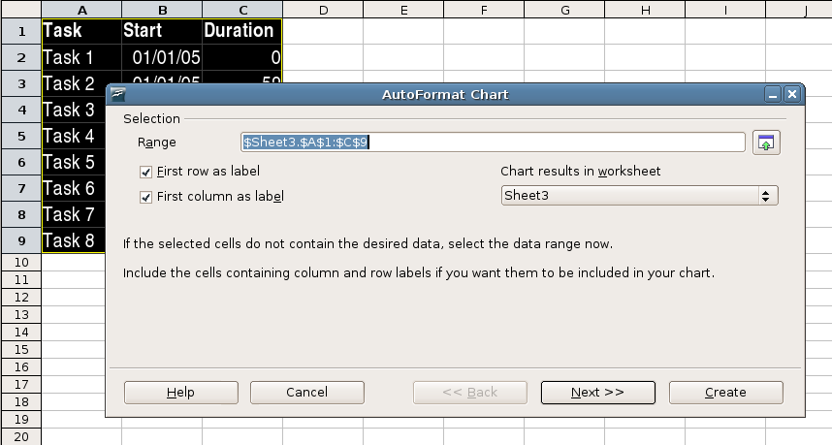Illustration 3: Create the chart
From the dialogue “AutoFormat Chart” define the selection range. Neither the first row (containing the column label) nor the first column (containing the task name) should be included as data.

Click “Next >>” , and choose the Chart type:

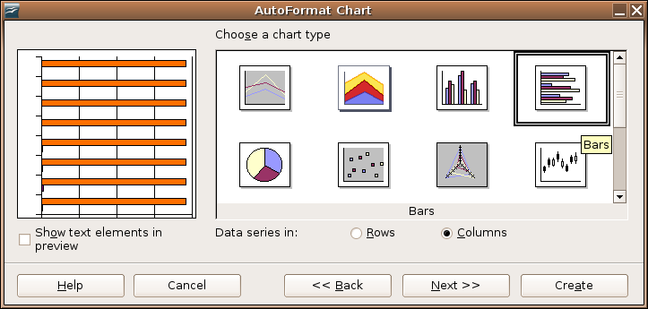Illustration 4: Choose chart type

Choose the horizontal bar-chart and click “Columns” to indicate that the data are arranged in columnar form.
Note: This changes the assignment of the axis in OpenOffice.org Calc. Now the horizontal axis is called “Y” and the vertical axis is called “X”.
Click “Next >>” and choose the variant “Stacked”:
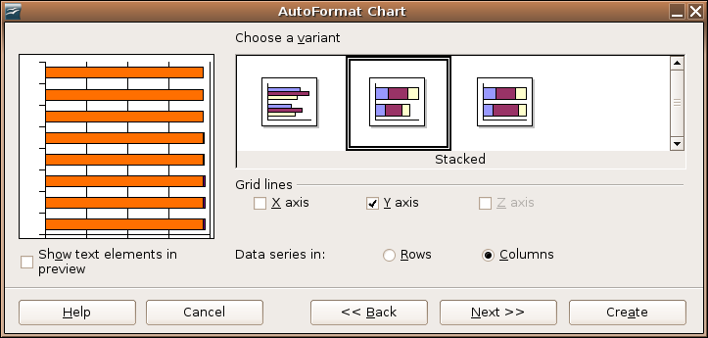Illustration 5: Create chart with stacked bars

Click “Next >>” once again and enter chart and axis titles:
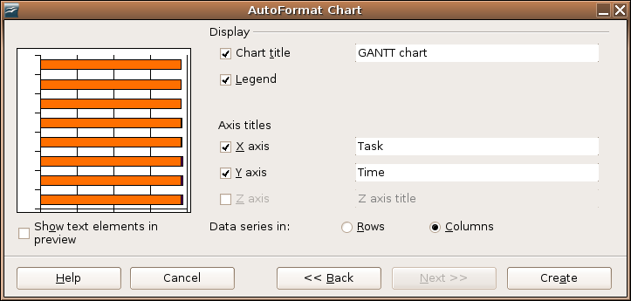Illustration 6: Adapt chart labeling

The first Gantt Chart appears as follows:
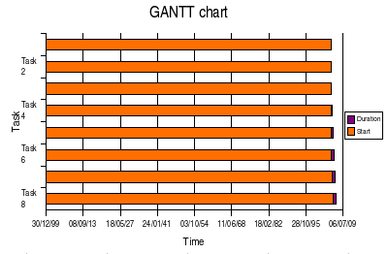Illustration 7: Bar chart

The task names are on the vertical axis (“Task 1” to “Task 8”) and the time line is on the horizontal axis.

Converting the simple bar-chart into a Gantt chart
In order to edit the properties of an element in the diagram,. double-click the chart to select it. Next, right-click to open the context menu and gain access to the chart properties:

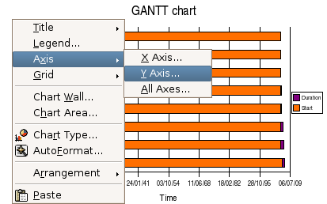Illustration 8: Edit diagram properties
Note: Ensure that no element in the diagram is selected, because otherwise the axis-properties can not be edited
Select the y-axis, which now is the horizontal time line. (One could also select the horizontal axis using a left-click then right-click to open the context menu and finally choose Object Properties ... to format this axis.)
Set the Minimum to the real start-date, In this example this is 01/01/05. Furthermore the axis should get the start date, so check the checkbox “Automatic” in the line “Axis at”:
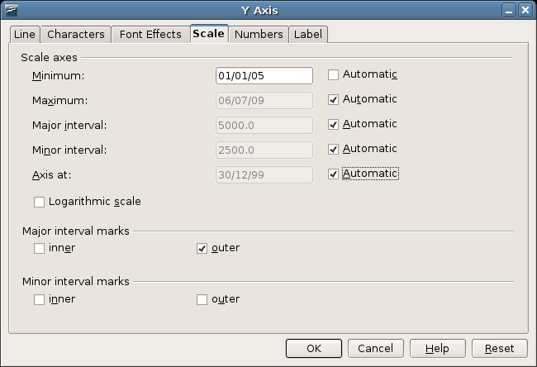Illustration 9: Adjust the time line
This produces a chart as follows:
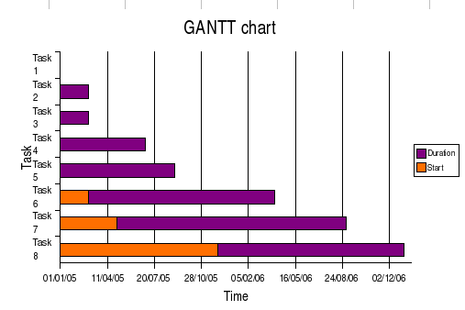Illustration 10: Gantt chart

The orange bar symbolizes the time up to the start of the task. This bar should be made invisible. For this select the orange bar with a left-click, and then open its Object Properties after a right click.

Under the tab “Borders” choose Style – Invisible, and under the tab “Area” choose Fill – None. Now the chart presents itself as follows:
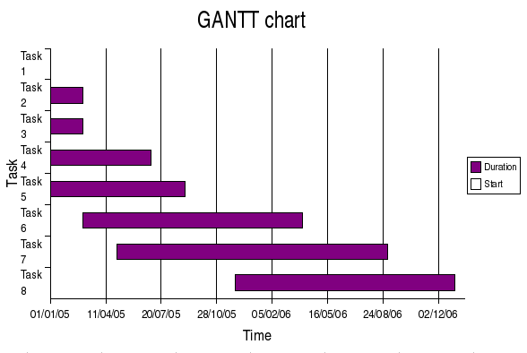Illustration 11: The completed Gantt chart

Using the chart as a graphic in other applications
To use the Gantt-chart as a picture in another application, save the whole Calc document as HTML. This generates not only the HTML-file, but also a jpeg-file containing the chart which can then be included in other documents, such as anOpenOffice.org impress presentation.
Remember to give the graphic a more descriptive name than, the the name suggested when the document is exported to HTML so that it can be found easily later

Extending Gantt charting for Project Management
In order to manage a project, still more information is needed. The progress of any task should be tracked as a percentage of the task and displayed in the chart, and the dependencies of the subtasks should also be documented. Furthermore the start-date should be determined automatically based on these dependencies.
To be able to create such a plan easily, a template was made by the German Native Language Community ( http://de.openoffice.org/ ) called pjm_template.ots.
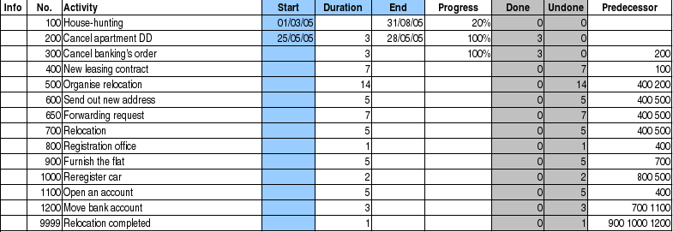Illustration 12: Calc template pjm_template.ots
The current version of Gantt.zip contains the example spreadsheet and the spreadsheet itself can be downloaded from
http://documentation.openoffice.org/HOW_TO/spreadsheet/pjm_template.ots
Note: This template uses macros and upon opening displays a security warning. Therefore, macros must be enabled to use the file.
The file, created from the template, contains the following columns:
- “Info” - Information about the progress of the task
- “No.” - unique number of the task. It is recommended to count in intervals of 100, to be able to add tasks later on
- “Activity” - description of the task
- “Start” - start-date of the task
- “Duration” - planned or actual duration of the task in calendar days
- “End” - end-date of the task. This gets calculated based on the start-date and duration.
- “Progress” in percentage
- “Done” - Duration * progress
- “Undone” - expected time remaining: Duration - Done
- “Predecessor” - List of tasks, which have to be completed, before this task can start. Separation is made by spaces.
The column titles in the first row can be labeled freely, but the columns must not change their position.
Some columns have a colored background:
- gray: these columns contain formulas, which are calculated automatically
- light blue: these columns can be edited manually, they can possibly be changed by the macro.
It is recommended to use the last row for the end of the project. Thus new tasks, which are inserted above, are displayed in the chart automatically.

About the macro
The macro is named “update” and is written in OpenOffice.org BASIC. The way it works follows this sequence:
- Add duration and end-date, if they are missing
- For each row of the table
  - Where the task has not yet started (Progress <= 0)
- Search for rows, whose number corresponds with the value in the column “Predecessor”. For those not familiar with project management terms, a predecessor is an activity that must be completed (or be partially completed) before a specified activity can begin.( See
http://www.apm.org.uk/page.asp?categoryID=4&subCategoryID=29&pageID=0 for definitions. )
    - Determine latest possible end-date of these rows
    - Set the successor start-date to this end-date
- Where the task is finished (Progress = 100%)
  - Determine duration from start-date and end-date
- Illustrate information of task
The meaning of this list of steps is described later on in this document.
The macro expects that the first row contains the headlines, the tasks start in row 2 and the columns are in the same place as in the example. Additional columns (for comments or some other purpose) must be located at the end.
Note: The maximum number of predecessors is limited to 9.

Example: Planning a relocation
This section describes the process of relocating from one city to another city and is based upon the template, pjm_template.ots.
The first step is to create a list with all subtasks:
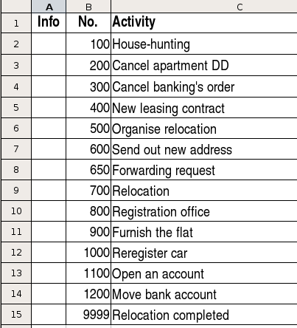Illustration 13: List of subtasks

In preparing the set of tasks, getting mail forwarded was missed. So we inserted the activity “Forwarding request” in row 8 after the fact. Therefore this activity has the number 650. Inserting a row does not automatically copy any formulae, thus all the formulae must be copied to each cell in the new row manually.
Next insert the start-date for the not-dependent tasks, as well as duration and expected end-date:
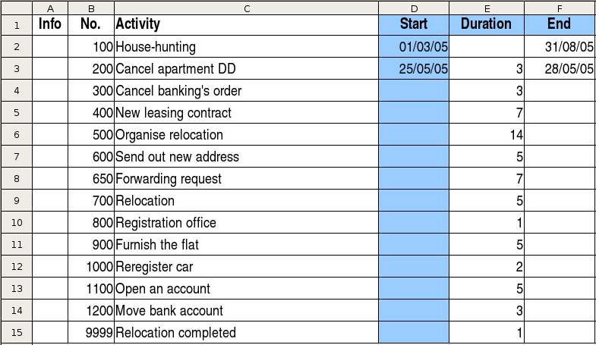Illustration 14: Insert start- and end-date

House-hunting starts on 01/03 and should be finished by 31/08. For all the other tasks the duration is given.
Now, define the dependencies of the tasks. The relocation (700) for example can not start before the new leasing contract is signed (400) and the relocation is organized (500). The tasks 300-9999 have no dependencies, thus there are no start-dates for these tasks.
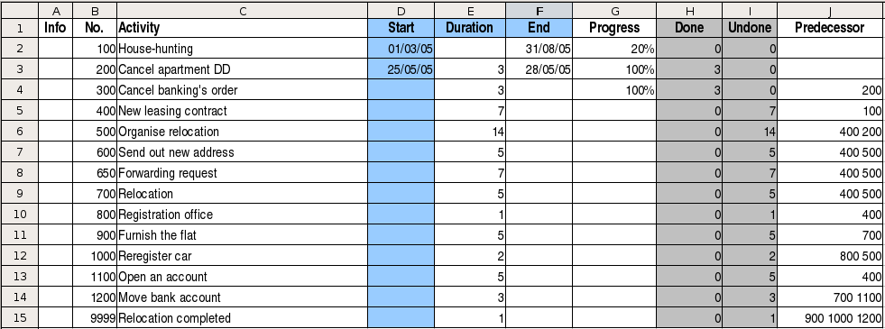Illustration 15: Define dependencies
Next insert the start-date for the not-dependent tasks, as well as duration and expected end-date:

Illustration 16: Insert start- and end-date

House-hunting starts on 01/03 and should be finished by 31/08. For all the other tasks the duration is given.
Now define the dependencies of the tasks. For example, relocation (700) can not start before the new leasing contract is signed (400) and relocation is organized (500). The tasks 300-9999 have no dependencies, thus there are no start-dates for these tasks.
Illustration 17: Define dependencies

As 20% of house-hunting are already done, and the current apartment is already canceled, the progress is 20% and 100% respectively.
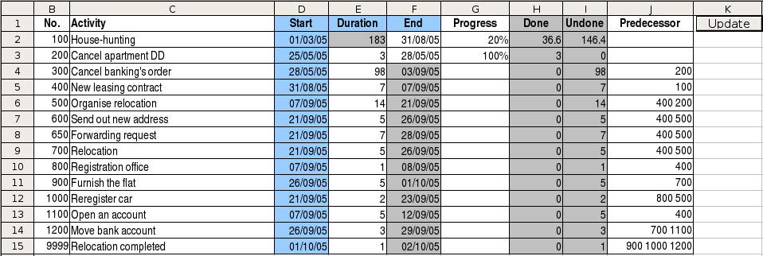Illustration 18: Calculated duration
At this point call the macro by clicking on the button “Update”. The duration and end-dates are calculated, and the column start is completed.
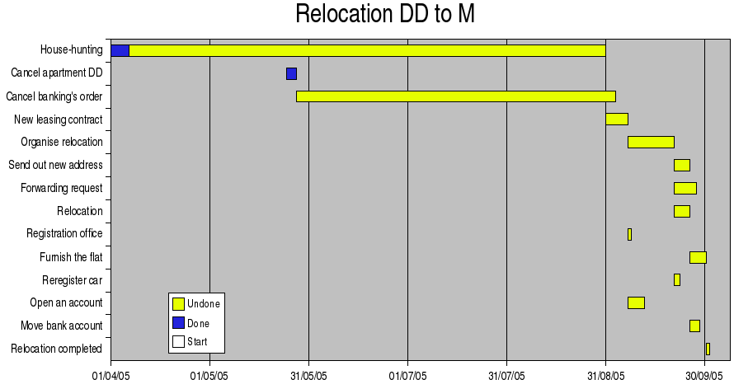Illustration 19: The appropriate chart
The organization of the relocation, the registration at the office and the opening of an account can be done simultaneously. On the other hand the bank account can not be moved immediately, because the current apartment is not yet relocated.

Controlling the Project
During any project, start by implementing several subtasks.
To begin a subtask, insert the start date in the column “Start”. Set the progress to a value greater than zero (1% e.g.), so that “Update” will no longer change this date.

If a task is completed, insert the real End-date, delete the duration and set the progress to 100%. When calling “Update” the next time, the required duration will be calculated.
After each change in the table,invoke the macro ”Update” to update the table accordingly.
The “Info” column shows the current status of the project:
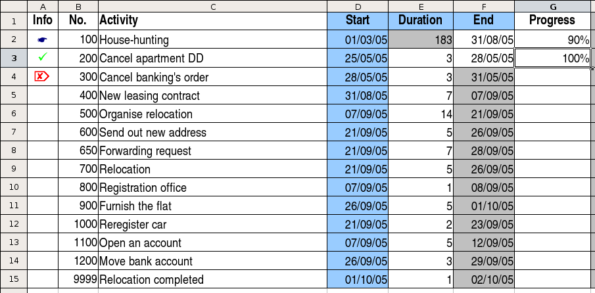Illustration 20: Table during project-controlling
 | House-hunting has begun and is on schedule according to the progress
 | The apartment has already been canceled, the task is completed.
 | Cancelling the bank's order is due and not on schedule, this means, that the end-date is prior to the current date.
 | All the other tasks are not due yet, they are not marked.

Public Documentation License, Version 1.0
1.0 DEFINITIONS.
1.1. "Commercial Use" means distribution or otherwise making the Documentation available to a third party.
1.2. "Contributor" means a person or entity who creates or contributes to the creation of Modifications.
1.3. "Documentation" means the Original Documentation or Modifications or the combination of the Original Documentation and Modifications, in each case including portions thereof.
1.4. "Electronic Distribution Mechanism" means a mechanism generally accepted for the electronic transfer of data.
1.5. "Initial Writer" means the individual or entity identified as the Initial Writer in the notice required by the Appendix.
1.6. "Larger Work" means a work which combines Documentation or portions thereof with documentation or other writings not governed by the terms of this License.
1.7. "License" means this document.
1.8. "Modifications" means any addition to or deletion from the substance or structure of either the Original Documentation or any previous Modifications, such as a translation, abridgment, condensation, or any other form in which the Original Documentation or previous Modifications may be recast, transformed or adapted. A work consisting of editorial revisions, annotations, elaborations, and other modifications which, as a whole represent an original work of authorship, is a Modification. For example, when Documentation is released as a series of documents, a Modification is:
A. Any addition to or deletion from the contents of the Original Documentation or previous Modifications.
B. Any new documentation that contains any part of the Original Documentation or previous Modifications.
1.9. "Original Documentation" means documentation described as Original Documentation in the notice required by the Appendix, and which, at the time of its release under this License is not already Documentation governed by this License.
1.10. "Editable Form" means the preferred form of the Documentation for making Modifications to it. The Documentation can be in an electronic, compressed or archival form, provided the appropriate decompression or de-archiving software is widely available for no charge.
1.11. "You" (or "Your") means an individual or a legal entity exercising rights under, and complying with all of the terms of this License or a future version of this License issued under Section 5.0 ("Versions of the License"). For legal entities, "You" includes any entity which controls, is controlled by, or is under common control with You. For purposes of this definition, "control" means (a) the power, direct or indirect, to cause the direction or management of such entity, whether by contract or otherwise, or (b) ownership of more than fifty percent (50%) of the outstanding shares or beneficial ownership of such entity.
2.0 LICENSE GRANTS.
2.1 Initial Writer Grant.
The Initial Writer hereby grants You a world-wide, royalty-free, non-exclusive license to use, reproduce, prepare Modifications of, compile, publicly perform, publicly display, demonstrate, market, disclose and distribute the Documentation in any form, on any media or via any Electronic Distribution Mechanism or other method now known or later discovered, and to sublicense the foregoing rights to third parties through multiple tiers of sublicensees in accordance with the terms of this License.
The license rights granted in this Section 2.1 ("Initial Writer Grant") are effective on the date Initial Writer first distributes Original Documentation under the terms of this License.
2.2. Contributor Grant.
Each Contributor hereby grants You a world-wide, royalty-free, non-exclusive license to use, reproduce, prepare Modifications of, compile, publicly perform, publicly display, demonstrate, market, disclose and distribute the Documentation in any form, on any media or via any Electronic Distribution Mechanism or other method now known or later discovered, and to sublicense the foregoing rights to third parties through multiple tiers of sublicensees in accordance with the terms of this License.
The license rights granted in this Section 2.2 ("Contributor Grant") are effective on the date Contributor first makes Commercial Use of the Documentation.
3.0 DISTRIBUTION OBLIGATIONS.
3.1. Application of License.
The Modifications which You create or to which You contribute are governed by the terms of this License, including without limitation Section 2.2 ("Contributor Grant"). The Documentation may be distributed only under the terms of this License or a future version of this License released in accordance with Section 5.0 ("Versions of the License"), and You must include a copy of this License with every copy of the Documentation You distribute. You may not offer or impose any terms that alter or restrict the applicable version of this License or the recipients' rights hereunder. However, You may include an additional document offering the additional rights described in Section 3.5 ("Required Notices").
3.2. Availability of Documentation.
Any Modification which You create or to which You contribute must be made available publicly in Editable Form under the terms of this License via a fixed medium or an accepted Electronic Distribution Mechanism.
3.3. Description of Modifications.
All Documentation to which You contribute must identify the changes You made to create that Documentation and the date of any change. You must include a prominent statement that the Modification is derived, directly or indirectly, from Original Documentation provided by the Initial Writer and include the name of the Initial Writer in the Documentation or via an electronic link that describes the origin or ownership of the Documentation. The foregoing change documentation may be created by using an electronic program that automatically tracks changes to the Documentation, and such changes must be available publicly for at least five years following release of the changed Documentation.
3.4. Intellectual Property Matters.
Contributor represents that Contributor believes that Contributor's Modifications are Contributor's original creation(s) and/or Contributor has sufficient rights to grant the rights conveyed by this License.
3.5. Required Notices.
You must duplicate the notice in the Appendix in each file of the Documentation. If it is not possible to put such notice in a particular Documentation file due to its structure, then You must include such notice in a location (such as a relevant directory) where a reader would be likely to look for such a notice, for example, via a hyperlink in each file of the Documentation that takes the reader to a page that describes the origin and ownership of the Documentation. If You created one or more Modification(s) You may add your name as a Contributor to the notice described in the Appendix.
You must also duplicate this License in any Documentation file (or with a hyperlink in each file of the Documentation) where You describe recipients' rights or ownership rights.
You may choose to offer, and to charge a fee for, warranty, support, indemnity or liability obligations to one or more recipients of Documentation. However, You may do so only on Your own behalf, and not on behalf of the Initial Writer or any Contributor. You must make it absolutely clear than any such warranty, support, indemnity or liability obligation is offered by You alone, and You hereby agree to indemnify the Initial Writer and every Contributor for any liability incurred by the Initial Writer or such Contributor as a result of warranty, support, indemnity or liability terms You offer.
3.6. Larger Works.
You may create a Larger Work by combining Documentation with other documents not governed by the terms of this License and distribute the Larger Work as a single product. In such a case, You must make sure the requirements of this License are fulfilled for the Documentation.
4.0 APPLICATION OF THIS LICENSE.
This License applies to Documentation to which the Initial Writer has attached this License and the notice in the Appendix.
5.0 VERSIONS OF THE LICENSE.
5.1. New Versions.
Initial Writer may publish revised and/or new versions of the License from time to time. Each version will be given a distinguishing version number.
5.2. Effect of New Versions.
Once Documentation has been published under a particular version of the License, You may always continue to use it under the terms of that version. You may also choose to use such Documentation under the terms of any subsequent version of the License published by______________________ [Insert name of the foundation, company, Initial Writer, or whoever may modify this License]. No one other than ________________________[Insert name of the foundation, company, Initial Writer, or whoever may modify this License] has the right to modify the terms of this License. Filling in the name of the Initial Writer, Original Documentation or Contributor in the notice described in the Appendix shall not be deemed to be Modifications of this License.
6.0 DISCLAIMER OF WARRANTY.
DOCUMENTATION IS PROVIDED UNDER THIS LICENSE ON AN "AS IS'' BASIS, WITHOUT WARRANTY OF ANY KIND, EITHER EXPRESSED OR IMPLIED, INCLUDING, WITHOUT LIMITATION, WARRANTIES THAT THE DOCUMENTATION IS FREE OF DEFECTS, MERCHANTABLE, FIT FOR A PARTICULAR PURPOSE OR NON-INFRINGING. THE ENTIRE RISK AS TO THE QUALITY, ACCURACY, AND PERFORMANCE OF THE DOCUMENTATION IS WITH YOU. SHOULD ANY DOCUMENTATION PROVE DEFECTIVE IN ANY RESPECT, YOU (NOT THE INITIAL WRITER OR ANY OTHER CONTRIBUTOR) ASSUME THE COST OF ANY NECESSARY SERVICING, REPAIR OR CORRECTION. THIS DISCLAIMER OF WARRANTY CONSTITUTES AN ESSENTIAL PART OF THIS LICENSE. NO USE OF ANY DOCUMENTATION IS AUTHORIZED HEREUNDER EXCEPT UNDER THIS DISCLAIMER.
7.0 TERMINATION.
This License and the rights granted hereunder will terminate automatically if You fail to comply with terms herein and fail to cure such breach within 30 days of becoming aware of the breach. All sublicenses to the Documentation which are properly granted shall survive any termination of this License. Provisions which, by their nature, must remain in effect beyond the termination of this License shall survive.
8.0 LIMITATION OF LIABILITY.
UNDER NO CIRCUMSTANCES AND UNDER NO LEGAL THEORY, WHETHER IN TORT (INCLUDING NEGLIGENCE), CONTRACT, OR OTHERWISE, SHALL THE INITIAL WRITER, ANY OTHER CONTRIBUTOR, OR ANY DISTRIBUTOR OF DOCUMENTATION, OR ANY SUPPLIER OF ANY OF SUCH PARTIES, BE LIABLE TO ANY PERSON FOR ANY DIRECT, INDIRECT, SPECIAL, INCIDENTAL, OR CONSEQUENTIAL DAMAGES OF ANY CHARACTER INCLUDING, WITHOUT LIMITATION, DAMAGES FOR LOSS OF GOODWILL, WORK STOPPAGE, COMPUTER FAILURE OR MALFUNCTION, OR ANY AND ALL OTHER DAMAGES OR LOSSES ARISING OUT OF OR RELATING TO THE USE OF THE DOCUMENTATION, EVEN IF SUCH PARTY SHALL HAVE BEEN INFORMED OF THE POSSIBILITY OF SUCH DAMAGES.
9.0 U.S. GOVERNMENT END USERS.
If Documentation is being acquired by or on behalf of the U.S. Government or by a U.S. Government prime contractor or subcontractor (at any tier), then the Government's rights in Documentation will be only as set forth in this Agreement; this is in accordance with 48 CFR 227.7201 through 227.7202-4 (for Department of Defense (DOD) acquisitions) and with 48 CFR 2.101 and 12.212 (for non-DOD acquisitions).
10.0 MISCELLANEOUS.
This License represents the complete agreement concerning the subject matter hereof. If any provision of this License is held to be unenforceable, such provision shall be reformed only to the extent necessary to make it enforceable. This License shall be governed by California law, excluding its conflict-of-law provisions. With respect to disputes or any litigation relating to this License, the losing party is responsible for costs, including without limitation, court costs and reasonable attorneys' fees and expenses. The application of the United Nations Convention on Contracts for the International Sale of Goods is expressly excluded. Any law or regulation which provides that the language of a contract shall be construed against the drafter shall not apply to this License.
Appendix
Public Documentation License Notice
The contents of this Documentation are subject to the Public Documentation License Version 1.0 (the "License"); you may only use this Documentation if you comply with the terms of this License. A copy of the License is available at http://www.openoffice.org/licenses/PDL.rtf.
The Original Documentation is _________________. The Initial Writer of the Original Documentation is ______________________ (C) ____. All Rights Reserved. (Initial Writer contact(s):_______________[Insert hyperlink/alias].)
Contributor(s): ______________________________________.
Portions created by ______ are Copyright (C)_________[Insert year(s)]. All Rights Reserved. (Contributor contact(s):________________[Insert hyperlink/alias]).
Note: The text of this Appendix may differ slightly from the text of the notices in the files of the Original Documentation. You should use the text of this Appendix rather than the text found in the Original Documentation for Your Modifications.

