Software Specification Document

OpenOffice.org
Thesaurus

Specification Status
Last Change | Feb 22, 2010
Status
Abstract
The Thesaurus functionality has been reworked to make it more attractive and improve the usability. Therefore a new contextual menu item has been added to provide a list of synonyms for the current word.
i-Team Members
Role | First Name, Last Name, Initials | E-Mail Address
I-Team Lead | Frank Loehmann (FL) | frank.loehmann@sun.com
Specification Author | Frank Loehmann (FL) | frank.loehmann@sun.com
User Experience | Frank Loehmann (FL) | frank.loehmann@sun.com
Development | Thomas Lange (TL) | thomas.lange@sun.com
Quality Assurance | Stefan Baltzer (SBA) | Stefa.baltzer@sun.com
Accessibility | Stefan Baltzer (SBA) | Stefa.baltzer@sun.com
Documentation | Uwe Fischer (UFI) | Uwe.fischer@sun.com

Contents
Abstract 1
i-Team Members 1
References and Reference Documents 3
Acronyms and Abbreviations 3
1 Detailed Specification 4
1.1 Thesaurus Dialog 4
1.1.1 Dialog Without Branding (Default) 4
1.1.2 With Branding 6
1.2 Context Menu in Text 6
1.2.1 In Case of Synonyms Found 7
1.2.2 In Case of no Synonyms Found 8
1.2.3 Branding 8
2 Accessibility 8
3 Migration 9
4 Configuration 9
5 File Format 9
6 Open Issues 9
Document Change History 9

References and Reference Documents
Reference Document | Check | Location (URL)
Specification Process Entry Check |  | N/A
Product Requirement, RFE, issue [Required] |  | N/A
Accessibility Check [Required] |  | See section 2 Accessibility below
Product Concept Document |  | <Please enter location here>
Competitive Analysis |  | <Please enter location here>
IDL Specification |  | <Please enter location here>
Test Case Specification [Required] |  | <Please enter location here>
Software Specification Rules | N/A | N/A
<Other, e.g. references to related specs>
Acronyms and Abbreviations
Acronym / Abbreviation | Definition
<WYSIWYG> | <What You See Is What You Get>

Detailed Specification

Thesaurus Dialog
The following dialog replaces the current one.
If dialog is called via Tools-Language-Thesaurus menu entry, the current word (selection or cursor position) will be shown in the Current word field. Synonyms for that word will be shown in the Alternatives list box below. As long as no alternative has been selected, the Replace button is disabled.
User can:
- select a synonym in the Alternatives list box (except the bold headings) and press Replace to close the dialog and replace the word in the text.
- set the language to be used to look up the word. Therefore the Language button offers a list of all supported languages for the thesaurus.
- double-click an entry (except the bold headings) to look up this alternative or she can change the word in Current word and look up the same manually (look up processed automatic by timer).
Other:
- The Back button (arrow left) will go back to the previous word.
- Dialog title shows currently used language for look up.
- Alternatives list box shows message if no alternative was found.
- Cancel button closes the dialog and withdraws all changes made in the dialog.

Dialog Without Branding (Default)
The following dialog appears, if the word 'light' was selected when Thesaurus dialog was called.

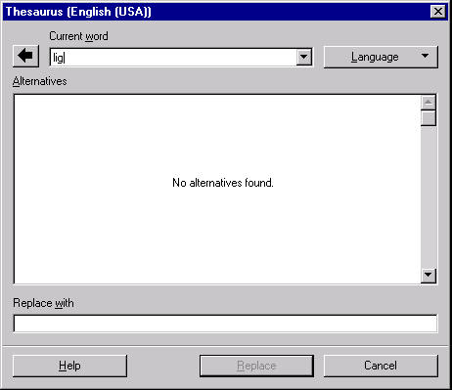Illustration 1: Text shown if no alternative was found for current text
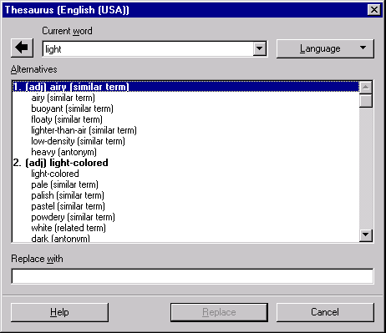Illustration 2: Thesaurus dialog without branding

With Branding
The Thesaurus dialog can show a banner (same height as in the spelling dialog) on top of the dialog. This allows third party vendors to make own offerings. The banner is only shown for supported languages, all other show an OpenOffice.org banner.
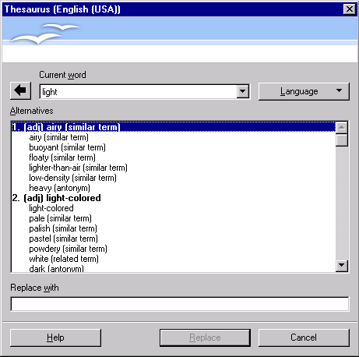Illustration 3: Thesaurus dialog showing the default OOo branding.

Context Menu in Text
The context menu for text without spelling or grammar issues shows a Synonyms entry.

In Case of Synonyms Found
If selected the Synonym entry shows a sub menu with Synonyms and an entry to call the Thesaurus dialog at the end.
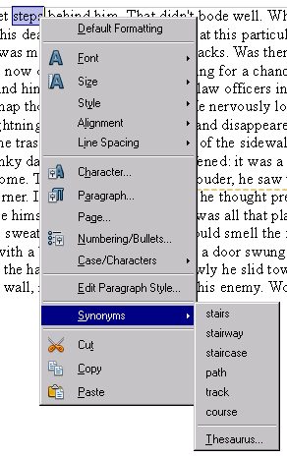

In Case of no Synonyms Found
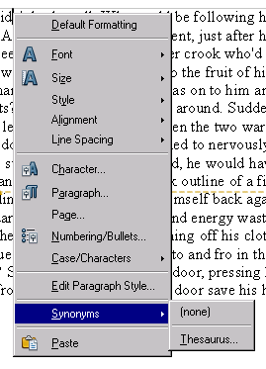

Branding
The context menus could show a branding icon in front of a synonym. (like for spelling)

Accessibility
Accessibility is the responsibility of the I-Team, beginning with UX, DEV and QA, to ensure that the following requirements are fulfilled:
- Is the feature fully keyboard accessible?
(Ex: “I can go everywhere and use every function using the keyboard only”)
Yes
- Have I specified visual alternatives for the case that the specified feature includes audio as output?
N/A
- Are text alternatives for all icons and graphics available?
<Start typing here>
- Don't provide important information in colors alone
(Ex: marking important information hard coded in red)
We do use system colors for selection in list box.
- Does the specified feature respect system settings for font, size, and color for all windows and user interface elements?
<Start typing here>
- Have I ensured that flash rates do not exceed 2 hertz for blinking text, objects, or other elements? In any case, try to avoid flashing UI elements
Yes.
- Ensure that assistive technology(AT) (like ZoomText or Orca) is able to read everything.
<Start typing here>

Migration
N/A, new dialog.

Configuration
None.

File Format
N/A

Open Issues
Issue | Initials | Date
<State Issue here, State “None”, if all issues are solved> |  | <Format: Dec 31, 2000>
<...> |  | <Format: Dec 31, 2000>

Document Change History
Rev. | Change | Initials | Date
1 | Initial specification | FL | February 9, 2010
2 | Remove Look up button | FL | February 22, 2010
3 |  |  | <Format: Dec 31, 2000>
<...> |  |  | <Format: Dec 31, 2000>

