Optional Hardware Acceleration
OpenOffice.org 2.0.3, StarOffice 8 PU3

Document - ID | Specification Owner | Last Change | Status
 | Matthias Müller-Prove | Apr 12, 2006 | final
Conforms to | OpenOffice.org Specification Workflow v0.1, Aug 2003
Applies to | Impress
Task ID(s) | i59119, i53104
Category | Enhancement

Abstract
OpenOffice.org 2.0.3 supports a hardware acceleration for rendering of presentations in Impress. An additional component is needed to enable the platform specific acceleration. Furthermore, graphic card drivers are 3rd-party products, which OpenOffice.org does not have any influence on. Additionally, there is a potential for bugs in those drivers, which can be unveiled by using OpenOffice.org. Since such problems can make OpenOffice.org presentations potentially unusable, we introduce an option which allows the user to disable the hardware acceleration support.

i-Team Members (The specification owner is part of the i-Team)
 | Name | E-mail Address
User Experience | Matthias Müller-Prove | mprove@sun.com,
Development | Thorsten Behrens | Thorsten.Behrens@Sun.COM,
Quality Assurance | Christian Günther | christian.guenther@sun.com,
Documentation | Uwe Fischer | uwe.fischer@sun.com

Approved for Implementation
 | Approved by | Date
User Experience | Matthias Müller-Prove | 12/13/05
Development | Thorsten Behrens | 12/12/05
Quality Assurance | Christian Günther | 12/13/05
Documentation | Uwe Fischer | 12/12/05
String Review | n/a | n/a

Document Change History
Rev. Level | Change | Initials | Date
 | follow up spec to Sun internal spec: "Controlling the usage of DirectX" by Frank Schönheit | MMP | 12/12/05
1.0 | Spec approved;  section 5.1 SO Config needs to be clarified with Jörg Barfurth | MMP | 12/13/05
 | new target is OOo 2.0.3 | MMP | 01/17/06

Contents
Glossary 1
1 Motivation 1
2 User Scenarios 1
3 Dependencies 1
3.1 Technical Dependencies 1
4 Competitive Analysis 1
4.1 StarOffice 8 1
5 Detailed Specification 2
6 Notes 3
7 References 3

Glossary
Term | Description
VCL | VCL is OpenOffice.org's platform-independent graphics library

Motivation
Graphics drivers are 3rd party products, and like every software product, they tend to have bugs. In the worst case, such bugs can prevent OpenOffice.org from displaying screen presentations, when using acceleration engines.
To give the user a fallback in such a case, she needs an option to disable hardware acceleration usage in OpenOffice.org.

User Scenarios
The user owns a high-end graphics card, with brand-new drivers. Playing full-screen presentations in OpenOffice.org shows artifacts of several severity, in the worst case, the presentations cannot be reasonably played at all.
The user then disables hardware acceleration support in OpenOffice.org by using the respective setting in Tools|Options.

Dependencies

Technical Dependencies
The presentation engine must support a precedence of rendering engines to use. This is already implemented.

Competitive Analysis

StarOffice 8
The Tools>StarOffice>View panel of StarOffice 8 for Windows:
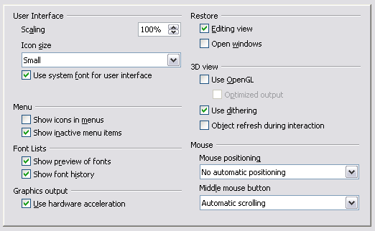Illustration 4.1: Option>OpenOffice.org>View for StarOffice 8

Detailed Specification
OpenOffice.org 2.0.2 will add a Boolean setting to Tools|Options|OpenOffice.org|View, as shown in Illustration 5.1.

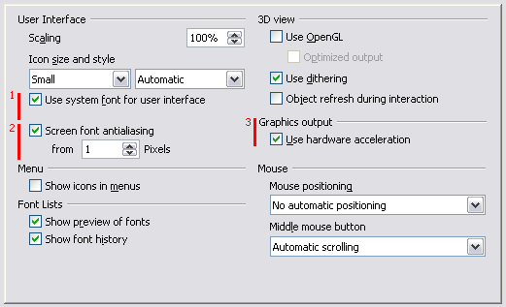Illustration 5.1.: Option>OpenOffice.org>View for OOo 2.0.2
Remark 1: The check box “Use system font for user interface” needs some more vertical space for some localized versions. Esp. the German localization needs 2 rows of text.
Remark 2: The section for “Screen font antialiasing” is only visible on Unix,
Remark 3: The section for the “Graphics output” is only visible if the system supports hardware acceleration.
Three check boxes are no longer part of the panel.
- “Show inactive menu items”. The default is on since OOo 1.1. Now it is no longer possible to hide deactive menu items.
- “Restore: Editing view”. cf. i53104. and the specification Open Document Behavior
- “Restore: Open windows”. This options was already unused. It can be removed without further ado.
The sections for “Menu” on the left and “Mouse” on the right start at the same height.
Comment: The section for ”Icon size and style” is defined in Icon Theme Switching.

String list
Item | English | German | Comments
Fixed Line | Graphics output | Grafikausgabe | Same as in OOo 2.0
Check Box | Use hardware acceleration | Hardwarebeschleunigung verwenden | Same as in OOo 2.0

When the check box “Use hardware acceleration” is marked, presentations on Windows will try to make use of platform specific acceleration, if present on the system and OOo. If the check box is not marked, presentations will use the internal, VCL-based rendering engine, which is slower in displaying the graphics, but more robust.
The default value for this option is enabled (check box is marked).

Migration
The option “Show inactive menu items” is no longer part of the dialog. The corresponding configuration setting is no longer needed. Inactive menu items are always visible.

SO Config
TBD ##

Notes
The page where we added the “Use hardware acceleration” setting already contains a Boolean option “Use OpenGL”, which certainly also denotes some kind of hardware acceleration.
Due to the fact that the 3D set of options will (likely) be removed for OOo3, we decided to go with the string that is more general and can cover all types of hardware acceleration. that may also be added in OOo3. That way, this option will still continue to exist even after the 3D options are removed from the page.

References
- Controlling the usage of DirectX. Spec for StarOffice 8 by Frank Schönheit. http://so-doc/Teams/Development/Draw_Impress/Documents/specifications/documents.inv/directx_rendering.sxw
- Open Document Behavior. Spec for OOo 2.0x by MMP. http://specs.openoffice.org/appwide/open_doc_behavior/OpenDocumentBehavior.sxw
- Icon Theme Switching http://specs.openoffice.org/ui_in_general/icons/icon-theme-switching.sxw

