Software Specification Document

OpenOffice.org Writer
Spelling and Grammar Checking

Specification Status
Last Change | Oct 24, 2008
Status
Abstract
Grammar checking is now available in OpenOffice.org Writer. Therefore the former Spelling dialog gets extended to handle grammar checking too. The dialog is now also able to show a vendor logo as a bitmap and name in the dialog title.
i-Team Members
Role | First Name, Last Name, Initials | E-Mail Address
I-Team Lead | Mathias Bauer (MBA) | mathias.bauer@sun.com
Specification Author | Frank Loehmann (FL) | frank.loehmann@sun.com
User Experience | Frank Loehmann (FL) | frank.loehmann@sun.com
Development | Thomas Lange (TL) | thomas.lange@sun.com
Quality Assurance | Stefan Baltzer (SBA) | stefan.baltzer@sun.com
Documentation | Uwe Fischer (UFI) | uwe.fischer@sun.com

Contents
Abstract 1
i-Team Members 1
References and Reference Documents 3
Acronyms and Abbreviations 3
1 Detailed Specification 4
1.1 Standard Toolbar 4
1.2 Context Menu 4
1.2.1 Spellchecking Context Menu 4
1.2.2 Grammar Context Menu 5
1.3 Tools Menu Entry 6
1.3.1 Writer 6
1.3.2 Calc, Draw and Impress 6
1.4 Spelling and Grammar Dialog 7
1.4.1 Writer 7
1.4.1.1 Spelling Function 7
1.4.1.2 Grammar Function 8
1.4.2 Vendor Logo in Spelling and Grammar Dialog 9
1.5 Calc, Draw and Impress 10
1.6 Writing Aids Dialog 11
1.6.1 Options Dialog 11
1.7 Edit Modules Dialog 12
1.8 Appearance Options (OOo 3.1) 13
2 Migration 14
3 Configuration 14
4 File Format 14
5 Open Issues 14
Document Change History 14

References and Reference Documents
Reference Document | Check | Location (URL)
Specification Process Entry Check |  | N/A
Product Requirement, RFE, issue [Required] |  | 90144
Product Concept Document |  | <Please enter location here>
Competitive Analysis |  | <Please enter location here>
IDL Specification |  | <Please enter location here>
Test Case Specification [Required] |  | <Please enter location here>
Software Specification Rules | N/A | N/A
Spelling Dialog Specification |  | http://specs.openoffice.org/appwide/linguistic/Spellcheckdialog.sxw
Acronyms and Abbreviations
Acronym / Abbreviation | Definition
<WYSIWYG> | <What You See Is What You Get>

Detailed Specification

Standard Toolbar
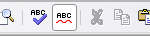Illustration 1: AutoSpellcheck
The Check as you type (or AutoSpellcheck) button in the Standard toolbar turns the Check spelling as you type options on/off. If Check Grammar as you type option is enabled in in Tools-Options-Language-Language Settings-Writing Aids, which is the default, the automatic grammar checker is being enabled and disabled as well.

- “Check Spelling as you type” - Button Properties |  | Comment
Enabled: | If a spellchecker is installed.
Disabled: | If no spellchecker is installed.
Press: | Turns on spelling as you type for current document. Shows/Hides grammar checking visualization as well.
Button Label: | Check as you type | EN-US

Context Menu

Spellchecking Context Menu
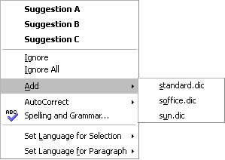Illustration 2: Context menu for a misspelled word
- “Spelling” - Context Menu Properties |  |  |  | Comment
Menu Title: |  |  |  | EN-US
Menu Position: | 1
Menu Items:
Items | Sub Items | KBD Shortcuts | Icon | Comment
<List of Suggestions> |  |  |  | Shown bold
Ignore |  |  |  | Ignore attribute is kept for runtime of a document. So marked text is not being checked anymore. A modification of a sentence withdraws the attribute. Furthermore a recheck of the document can be forced by API.
Ignore All
Add | <List of Custom Dictionaries>
AutoCorrect | <List of AutoCorrect Suggestions>
Spelling and Grammar... |  | F7 |  | Calls the Spelling and Grammar dialog.
Set Language for Selection | <Language List>
Set Language for Paragraph | <Language List>

Grammar Context Menu
The context menu for grammar mistakes shows a hint and an optional suggestions for correction(s).
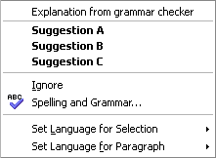Illustration 3: Context menu for grammar error

- “Grammar” - Context Menu Properties |  |  |  | Comment
Menu Title: |  |  |  | EN-US
Menu Position: | 1
Menu Items:
Items | Sub Items | KBD Shortcuts | Icon | Comment
<Grammar Explanation>
<Grammar Suggestion> |  |  |  | Optional. Shown bold.
Ignore
Spelling and Grammar... |  | F7 |  | Calls the Spelling and Grammar dialog.
Set Language for Selection | <Language List>
Set Language for Paragraph | <Language List>

Tools Menu Entry

Writer
The main menu entries in Writer, Calc, Draw and Impress change from Spellcheck to Spelling or Spelling and Grammar if a grammar checker is installed and active.
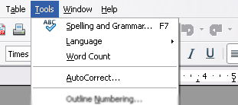Illustration 4: New Spelling & Grammar entry in Writer
- “Spelling and Grammar” - Menu Properties |  |  |  | Comment
Menu Title: | Tools |  |  | EN-US
Menu Position: | 1
Menu Items:
Items | Sub Items | KBD Shortcuts | Icon | Comment
Spelling and Grammar... |  | F7 |  | Calls the Spelling and Grammar dialog.
Spelling... |  | F7 |  | Calls the Spelling dialog

Calc, Draw and Impress
The menu entry is changed to match the new one in Writer.
- “Spelling” - Menu Properties |  |  |  | Comment
Menu Title: | Tools |  |  | EN-US
Menu Position: | 1
Menu Items:
Items | Sub Items | KBD Shortcuts | Icon | Comment
Spelling... |  | F7 |  | Calls the Spelling dialog.

Spelling and Grammar Dialog

Writer
The former Spelling dialog gets extended to cover grammar checking as well. Therefore a new checkbox control has been added to enable/disable grammar checking. The check box is only shown, if a grammar module has been installed as an extension. Furthermore the dialog layout got slightly adjusted.
Note: All not explicitly listed strings are left unchanged and can be found in Spelling dialog specification¹.

Spelling Function
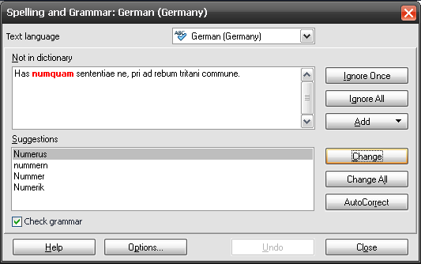Illustration 5: Spelling and Grammar dialog
Note: The AutoCorrect button is shown in Writer only.
- “Spelling and Grammar” - Dialog |  | Comment
State: | Modeless
Type: | Dialog
Closable: | Yes
Resizable: | No
Titel: | Spelling: $LANGUAGE ($LOCATION) | EN-US
Titel: | Spelling and Grammar: $LANGUAGE ($LOCATION) | EN-US (Grammar checker installed and active)
- “Text language” - DropDown Listbox Properties |  | Comment
Enabled: | In spelling mode of dialog
Disabled: | In grammar mode of dialog
Rows Visible: | 5
Items: | - <Item #1 EN-US> ; <Additional Language (Optional)>  - <Item #2 EN-US> ; <Additional Language (Optional)>
Item Selected: | <current text language>
DropDown  ListBox Label: | Text language |  | EN-US
DropDown  ListBox Label: | Textsprache |  | DE
- “Check Grammar” - CheckBox Properties |  | Comment
Enabled: | If a grammar module has been installed.
Disabled: | If no grammar module has been installed.
Tri-State: | --
Checked: | If check grammar as you type option is active (default).
CheckBox Label: | Check ~grammar | EN-US

Grammar Function
The grammar function requires an installed grammar checking module.
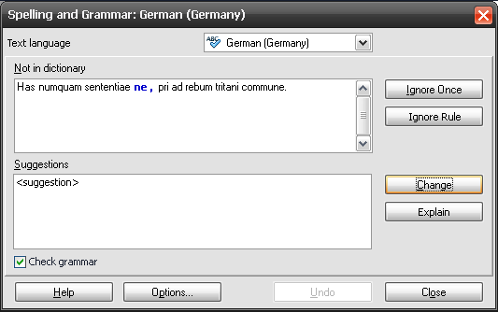Illustration 6: Grammar check and suggestion in progress
Hidden controls in grammar mode:
- Change All and
- AutoCorrect buttons
New buttons in grammar mode:
- “Ignore Rule” - Button Properties |  | Comment
Enabled: | If grammar check makes a suggestion
Disabled: | In spelling mode
Press: | Does not use current grammar rule for runtime of office
Button Label: | Ignore Rule | EN-US
- “Explain” - Button Properties |  | Comment
Enabled: | If grammar check makes a suggestion and offers an explanation.
Disabled: | In spelling mode
Press: | Help with extended help for the suggested change comes up
Button Label: | Explain | EN-US

Vendor Logo in Spelling and Grammar Dialog
The new Spelling and Grammar dialog is able to display a vendor bitmap (527*44 Pixel) on top of the dialog and a vendor name in the dialog title. The dialog height increases automatically if a bitmap is shown. Visibility of the logo and the dialog extension depends on the language chosen. In all other cases a fall back logo is shown to avoid resizing of the dialog.
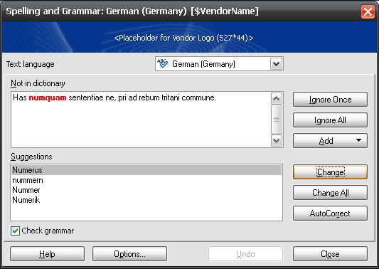Illustration 7: Dialog is able to show a vendor logo and name depending on the language chosen.
- “Spelling and Grammar” - Dialog |  | Comment
State: | Modeless
Type: | Dialog
Closable: | Yes
Resizable: | No
Titel: | Spelling and Grammar: $LANGUAGE ($LOCATION) [$VendorName] | EN-US
 | Spelling: $LANGUAGE ($LOCATION) [$VendorName] | EN-US  No grammar checker installed.

Calc, Draw and Impress
The general dialog layout changes to the one used in Writer. Grammar checking option is not shown in Calc, Draw and Impress.
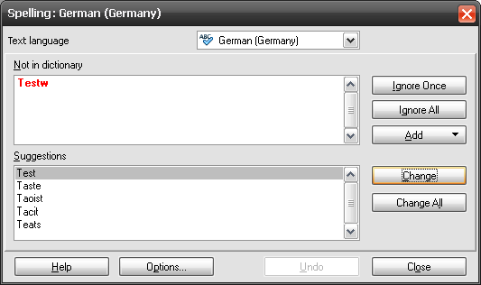Illustration 8: New Spelling dialog layout in Calc, Draw and Impress
- “Spelling” - Dialog |  | Comment
State: | Modeless
Type: | Dialog
Closable: | Yes
Resizable: | No
Titel: | Spelling: $LANGUAGE ($LOCATION) | EN-US. Grammar checker not available for Draw, Impress and Calc.

Writing Aids Dialog
The following dialog gets called if the Options button gets clicked in the Spelling and Grammar dialog. The dialog shows new options regarding grammar checking.

Options Dialog
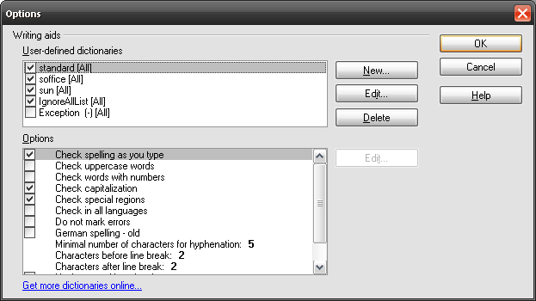Illustration 9: Writing aids Options dialog
Removed items:
- Remove Old German spelling from Options list box
- Remove Check in all languages from Options list box
- Remove Do not mark errors from Options list box
Added Items:
- “Options” - Dialog Properties |  | Comment
State: | Modal
Type: | Dialog
Closable: | Yes
Resizable: | No
Titel: | Options | EN-US
- Grammar” - CheckBox Properties |  | Comment
Enabled: | If grammar checker is installed.
Disabled: | If no grammar checker is installed.
Tri-State: | -
Checked: | By default
CheckBox Label: | Check grammar as you type | EN-US

Edit Modules Dialog
The Edit Modules dialog can be called by the Edit button in the Tools-Options-Language Settings-Writing Aids-Available Language Modules.
Note: Only one grammar checking module per language is allowed, but multiple spellchecker per language.

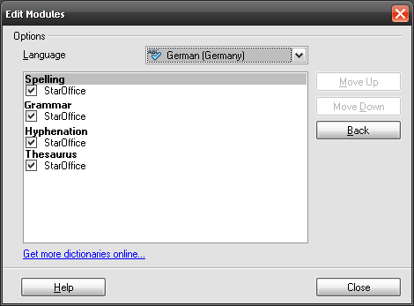Illustration 10: Edit Modules Dialog

Appearance Options (OOo 3.1)
The Appearance tab page shows a new element to define the color used for grammar check highlighting in the document.
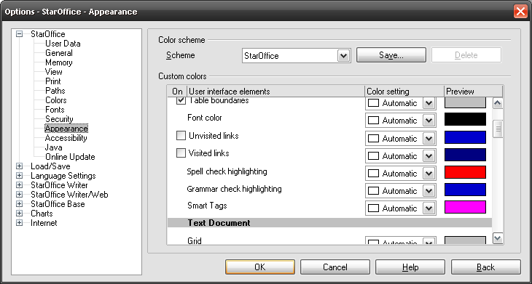Illustration 11: Tools-Options-Appearance tab page with new element for grammar checking
- “Appearance” - Dialog Properties |  | Comment
State: | Modal
Type: | Dialog
Closable: | Yes
Resizable: | No
Titel: | Options - $PRODUCTNAME - Appearance | EN-US (already present string)
- “Spelling” - DropDown Listbox Properties |  | Comment
Enabled: | Always
Disabled: | Never
Rows Visible: | 5
Items: | <Color list>
Item Selected: | “Light red”
DropDown  ListBox Label: | Spell check highlighting | EN-US
- “Grammar” - DropDown Listbox Properties |  | Comment
Enabled: | Always
Disabled: | Never
Rows Visible: | 5
Items: | <Color list>
Item Selected: | “Blue 3”
DropDown  ListBox Label: | Grammar check highlighting | EN-US

Migration
None.

Configuration
@TL?

File Format
@TL?

Open Issues

Issue | Initials | Date
Remove AutoSpellcheck button from Standard Toolbar? | FL | June 4, 2008
Change string “AutoSpellcheck” for button from Standard Toolbar if it does not get removed. | FL | June 4, 2008
Get new icon for ABC button from STS. Do we need this button at all? | FL | July 7, 2008
Grammar check in Dialog needs Tooltip | FL | August 12, 2008
Grammar check highlighting for spaces needs to be reworked. | FL | August 12, 2008
Do we need a new spelling toolbar with a “Recheck Document” button. | FL | October 20, 2008
Document Change History
Rev. | Change | Initials | Date
1 | Initial specification | FL | May 21, 2008
2 | Add some string tables and mock-ups | FL | May 22, 2008
3 | Add Appearance options | FL | May 22, 2008
4 | Remove some options from Writing aids options | FL | May 23, 2008
5 | Working on grammar mode | FL | May 26, 2008
6 | Working on comments from TL | FL | May 28, 2008
7 | Change dialog layout for Calc, Draw and Impress to new layout | FL | May 29, 2008
8 | Add AutoSpellcheck behavior for Standard toolbar | FL | June 4, 2008
9 | Add new context menus for grammar checking | FL | June 24, 2008
10 | Small corrections for upcoming release | FL | August 4, 2008
11 | Add new features for upcoming release | FL | August 5, 2008
12 | Rework of some details in mock-ups according to iTeam meeting | FL | August 12, 2008
13 | Remove Recheck document button. Use old dialog layout (buttons on the right). Change the string “dictionary language” into “Text language”. | FL | October 20, 2008
14 | Working on comments from TL | FL | October 24, 2008

See specification: http://specs.openoffice.org/appwide/linguistic/Spellcheckdialog.sxw

