Software Specification Document

OpenOffice.org 2.0.4 and higher
OpenOffice.org NetBeans Integration: Client wizard

Specification Status
Last Change | Mar 1, 2007
Status

Abstract
The intention of the OpenOffice.org NetBeans Integration: Client wizard is to simplify the development of OpenOffice.org extensions as well as the general development for or with the OpenOffice.org API. Modern IDE's provide a lot of useful tools to make the daily work for developers easier. Especially recurring tasks or some kind of templates/wizards are often used to provide special support inside an IDE. And exactly here should the OpenOffice.org NetBeans Integration: Client wizard provide some useful extensions to the NeBeans IDE to speed up the initial start working with the OpenOffice API. The plan is to provide wizards for various tasks and new project types as well as the support of scripting support from within the IDE. General support for UNOIDL and other office specific file types like *.xcu, *.oxt.

i-Team Members
Role | First Name, Last Name, Initials | E-Mail Address
Project Lead | Jürgen Schmidt (jsc) | juergen.schmidt@sun.com
Specification Owner | Jürgen Schmidt (jsc) | juergen.schmidt@sun.com
User Experience
Development | Steffen Grund (sg) | steffen.grund@sun.com
Quality Assurance | Thorsten Bosbach (tbo) | thorsten.bosbach@sun.com
Documentation
Other roles
Based on a verbal agreement between Lutz Höger and Jürgen Schmidt, we decided that a team member of the office user experience team isn't necessary because this specification is off topic of normal office features and address developers only and provides an integration in an external application (NetBeans IDE).

Contents
Abstract 1
i-Team Members 1
References and Reference Documents 3
Acronyms and Abbreviations 3
1 Detailed Specification 4
1.1 OpenOffice.org Simple UNO Client Application Project Type 4
2 Migration 10
3 Configuration 11
4 File Format 11
5 Open Issues 11
Document Change History 11

References and Reference Documents
Reference Document | Check | Location (URL)
Specification Process Entry Check |  | N/A
Product Requirement,, RFE, issue (required) |  | <Please enter location here>
Product Concept Document |  | <Please enter location here>
Competitive Analysis |  | <Please enter location here>
Test Case Specification (required) |  | <Please enter location here>
Software Specification Rules | N/A | N/A
<Other, e.g. references to related specs>

Acronyms and Abbreviations
Acronym / Abbreviation | Definition
SDK | Software Development Kit
Add-in | Specialized component type supporting Calc built-in functions
deploy/deployment | Means the installation of office extension packages into an office installation
nbm | NetBeans module/plugin, comparable with an office extensions package, means a plugin extending the base functionality of NetBeans with some new functions.
UNOIDL
simple UNO bootstrap feature | link zu erklärung

Detailed Specification
This project type will create an adapted J2SE client application project with additional support of the simple UNO bootstrap feature. Means an adapted manifest file to support the bootstrap feature and bundling of some precompiled bootstrap glue code with the client application jar.

OpenOffice.org Simple UNO Client Application Project Type
The OpenOffice.org Simple Client Application wizard creates a new J2SE project with office API support, means the office library is added to the project to provide code completion and context sensitive help for the office API. The generated main function contains some code to bootstrap an UNO environment and returns the remote office context object of the default office installation on the system. This works only if a default installation of the office was made and the soffice binary in the <office>/program directory is in the path (at least reachable over a symbolic links).
That means we can only guaranty that this feature works if the office installation is either a StarOffice or a Sun build OpenOffice.org. Some Linux distributions change or modify the startup scripts and that can have negative impact on this feature.
The simply UNO bootstrap feature supports some fallback strategies which are not further discussed here because they are not part of this integration, if you are interested you can get more information about the bootstrap feature in the Developer's Guide - Professional UNO - Transparent Use of Office UNO Components.
The project builds a customized jar file containing special UNO bootstrap classes from the office SDK + special manifest entries to support the simply UNO bootstrap feature. That enables the application jar to run without any further prepared environment but having full access to the office API to control the office process. The bootstrap features prepares a customized classloader to support the office API and establish a named pipe connection to an already running office process or if necessary a new started office process.
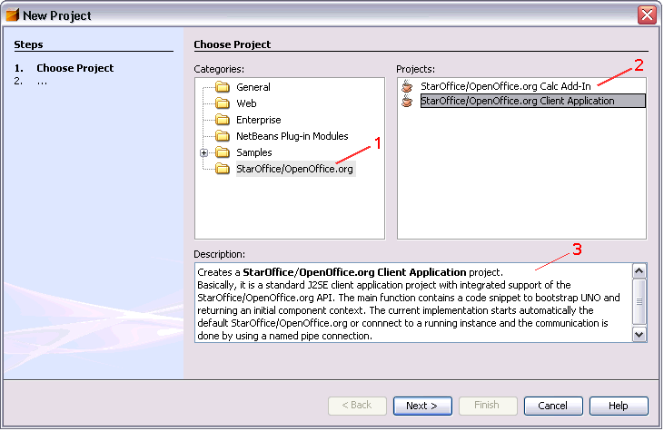Figure 1: New Project Dialog – Choose Project Tab

The new project Dialog (Figure 1) can be reached by choosing File -> New Project...
Table 1: User Interface elements of Figure 1
# | Type | Properties |  | Comment
1 |  | Control Properties  Enabled: Yes
1 |  | String English  StarOffice/OpenOffice.org | String German  <Enter String Here>
2 |  | Control Properties  Enabled: Yes  Visible Row Count: 2+  Item Selected: not specified,  Enable Sorting by DnD: No  A11Y Text: <If needed specify text here> |  |  | The selection depends on the last selection and is not specific to this project category.
2 |  | String English  - StarOffice/OpenOffice.org Calc Add-In  - StarOffice/OpenOffice.org Client Application | String German  <Enter String Here> |  | Specialized icons for the new project types is planned, see i69763
3 |  | Control Properties  Enabled: Yes  Editable: No  Linewrap: On  Display Hori. Scrollbar: Never  Display Vert. Scrollbar: As Needed  Initial Text Inside Field: depends on selection of #2 |  |  | This TextArea shows a short description of the selected project type and depends on the section in the listbox #2 above.
3 |  | String English  Project Type Calc Add-In:  Creates a <b>StarOffice/OpenOffice.org Calc Add-In</b> project.<br>  Calc Add-Ins are specialized office extensions which extends <b>StarOffice/OpenOffice.org</b> functionality with new built-in <b>Calc Add-In</b> functions. This functions are usable directly over the normal user interface of the Spreadsheet application in StarOffice/OpenOffice.org.<br>  A wizard collects information about new Calc Add-In functions and creates a new extended J2SE class library project, generates <b>Uno IDL</b> files and a Java skeleton source file which default implement the new Add-In functions.  Project Type Client Application:  Creates a <b>StarOffice/OpenOffice.org Client Application</b> project.<br>  Basically, it is a standard J2SE client application project with integrated support of the StarOffice/OpenOffice.org API. The main function contains a code snippet to bootstrap UNO and returning an initial component context. The current implementation starts automatically the default StarOffice/OpenOffice.org or connect to a running instance and the communication is done by using a named pipe connection. | String German  <Enter String Here>

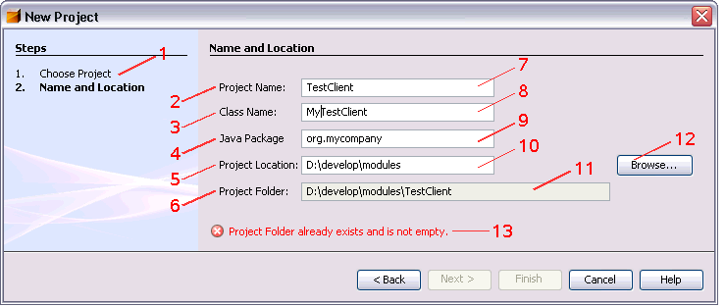Figure 2: New Project Dialog – StarOffice/OpenOffice.org Client Application Project Tab

Table 2: User Interface elements of Figure 2
# | Type | Properties |  | Comment
1 |  | Control Properties  Features: TextArea showing the wizard steps and highlight the currently active wizard pane/step
1 |  | String English  - Choose Project  - Name and Location | String German  <Enter String Here>
2 |  | Control Properties  Enabled: Yes
2 |  | String English  Project Name: | String German  <Enter String Here>
3 |  | Control Properties  Enabled: <Yes/No>
3 |  | String English  Class Name: | String German  <Enter String Here>
4 |  | Control Properties  Enabled: <Yes/No>
4 |  | String English  Java Package | String German  <Enter String Here>
5 |  | Control Properties  Enabled: <Yes/No>
5 |  | String English  Project Location | String German  <Enter String Here>
6 |  | Control Properties  Enabled: <Yes/No>
6 |  | String English  Project Folder | String German  <Enter String Here>
7 |  | Control Properties  Enabled: Yes  Editable: Yes  Initial Text Inside Field: OfficeUNOClientApp  Drag Enabled: No  Initial Caret Position: 18  Characters Allowed: <All Charcters>  Characters not Allowed: <Specify not allowed characteres here>  Selection Starts: 0  Selection Ends: 18  Selected Text: OfficeUNOClientApp  ToolTip Text: the name of the new created project (used as project folder name as well) |  | The suggested Project name is initially selected because changes are expected.
7 |  | String English  - | String German  <Enter String Here>
8 |  | Control Properties  Enabled: Yes  Editable: Yes  Initial Text Inside Field: OfficeUNOClientApp  Drag Enabled: No  Initial Caret Position: 18  Characters Allowed: <All Charcters>  Characters not Allowed: <Specify not allowed characteres here>  ToolTip Text: the name of the class, it is set as main class |  | This text field depends on text field #7 as long as it is changed the first time.
8 |  | String English  - | String German  <Enter String Here>
9 |  | Control Properties  Enabled: Yes  Editable: Yes  Initial Text Inside Field: -  Drag Enabled: No  Initial Caret Position: 0  Characters Allowed: <All Charcters>  Characters not Allowed: <Specify not allowed characteres here>  ToolTip Text: the name of the Java package
9 |  | String English  <Enter String Here> | String German  <Enter String Here>
10 |  | Control Properties  Enabled: Yes  Editable: Yes  Initial Text Inside Field: last specified directory  Drag Enabled: No  Initial Caret Position: <Specify position; e.g. 0>  Characters Allowed: <All Charcters>  Characters not Allowed: <Specify not allowed characteres here>  ToolTip Text: path to the directory where the project will be created |  | The initial location is the last selected location (NetBeans default)
10 |  | String English  <Enter String Here> | String German  <Enter String Here>
11 |  | Control Properties  Enabled: No  Editable: No  Initial Text Inside Field: #10<pathseparator>#7  Drag Enabled: No  ToolTip Text: showing the final destination folder of the new project |  | Textfield showing the final destination folder, the project location of #10 + path separator + the project name in #7
11 |  | String English  <Enter String Here> | String German  <Enter String Here>
12 |  | Control Properties  Enabled: Yes  Icon: No  Resizeable: No  Has Menu: No  ToolTipText: opens a file picker to select a folder where the project will be created
12 |  | String English  <Enter String Here> | String German  <Enter String Here>
13 |  | Control Properties  Enabled: Yes  Editable: No  Linewrap: Off  Maximum Row Count: 1  Visible Row Count: 1  Display Hori. Scrollbar: Never  Display Vert. Scrollbar: Never  Initial Text Inside Field: -  Drag Enabled: No |  | Text Area showing configuration errors. The error message depends on the selected text field, either an project name or project location error is shown.
13 |  | String English  - Project Name is not a valid folder name  - Class Name is not a valid class name  - Package is not a valid name  - Project Folder already exists and is not empty  - Project folder is not a valid path | String German  <Enter String Here> | Error condition:  - when the project nasme texfield is empty  - when the class name is empty or is n valid java class name, e.g. Name starting with a number  - when the package name is empty (do don't allow empty packages) or the package start with a number  - The project folder is implicitly generated from the project name. The error appears when the folder (location + project name) already exists  - when the specified project location path is invalid

Table 3: Tab order of Figure 2
Tab Order | Comment
#7, #8, #9, #10, #12

Migration
No migration involved.

Configuration
<Start typing here ----- If this part is irrelevant state a reason for its absence!>

File Format
No file format changes currently but this can change and this section gets reused later when scripting capabilities are specified in detail because scripts can be part of documents and in fact of this part of a zip document container package.

Open Issues
Issue | Initials | Date
wizard for new IDL type definitions I69757 | sg | <Format: Dec 31, 2000>
general UNO component wizard I69758 | sg
uno-skeletonmaker support for add-on components i69760 | jsc
wizard for Add-On components i69761 | sg
debug support for UNO components in NetBeans i69762 | jsc
prepare/design new icons for UNO components in NetBeans i69763 | jsc
improve UNOIDL editor -> syntax highlighting i69781 | sg

Document Change History
Rev. | Change | Initials | Date
1 | Integrate feedback from TBO | jsc | Sep 22, 2006
2 | Separated this file from general specification. | sg | Mar 1, 2007
3
<...>

