Software Specification Document

OpenOffice.org
Java GUI Installer for OpenOffice.org

Specification Status
Last Change
Status

Abstract
The OpenOffice.org 1.x versions were delivered with an installer, that offered a graphical wizard for the installation process. This wizard could no longer be used after the introduction of native installers with OpenOffice.org 2.0. For Windows the Windows Installer service offers an installation wizard. But for all other platforms, there was no more graphical user interface (GUI) available during the installation process. For Linux and Solaris only command line tools are available to intall the RPMs or the Solaris packages.
Using an installer programmed in Java offers the ability to create one installer, that can be used on any platform. It is only required, that Java is available for this platform and installed on the computer. The first version of this new Java GUI installer for OpenOffice.org offers the installation of Linux RPMs and Solaris Packages. The Java Installer offers the following advantages:
- GUI installation wizard. No knowledge of command line tools required.
- Installation with user privileges possible.
- Open source code.
- Automatically uses system installation database. Support of native installers.
- Easily expandable to other platforms than Linux and Solaris.

i-Team Members
Role | First Name, Last Name, Initials | E-Mail Address
Project Lead | Ingo Schmidt, IS | Ingo.Schmidt@sun.com
Specification Owner | Ingo Schmidt, IS | Ingo.Schmidt@sun.com
User Experience | Bettina Haberer, BH | Bettina.Haberer@sun.com
Development | Ingo Schmidt, IS | Ingo.Schmidt@sun.com
Quality Assurance | Olaf Felka, OF | Olaf.Felka@sun.com
Documentation | Uwe Fischer, UFI | Uwe.Fischer@sun.com
Other roles | <First Name, Last Name (Initials)> | <User@openoffice.org>
<State reason here, if one role is not represented in i-Team.>

Contents
Abstract 1
i-Team Members 1
References and Reference Documents 4
Acronyms and Abbreviations 4
1 Installation Wizard / Uninstallation Wizard details 5
1.1 Installation 5
1.1.1 The help window on the welcome page 7
1.1.2 Path with packages not found 10
1.1.3 Wrong package format 10
1.1.4 Newer installation found (with root privileges) 11
1.1.5 Older installation found (with root privileges) 12
1.1.6 Solaris: Installation with user privileges without getuid.so 13
1.2 The license page of the installation wizard 14
1.2.1 The help text of the license page 17
1.3 Selection of the installation directory 18
1.3.1 The help text of the “Select installation directory” dialog 20
1.3.2 Browsing for the installation directory 21
1.3.3 Create the new directory 21
1.3.4 Directory creation failed 22
22
1.3.5 Missing write privileges inside selected directory 22
1.3.6 An installed product was found (only for installation with root privileges) 23
1.3.7 Selecting the directory ( installation on Solaris with user privileges) 26
1.3.8 Newer version already installed (user privileges) 28
1.3.9 Older version already installed (user privileges) 29
1.4 Type of installation 31
1.4.1 The help text about selection of the installation type 32
1.5 Selection of components for installation 33
1.5.1 The help text of the “Select Components” dialog 37
1.5.2 No components have been selected 38
1.6 The “Ready to Install” page 39
1.6.1 The help text of the “Ready to Install” dialog 41
1.7 The “Installing ...” dialog 42
1.7.1 The help text of the 'Installing...' dialog 43
1.7.2 Message box at aborting the installation 44
1.8 The dialog “Installation Completed Successfully” 44
1.9 The dialog “Installation Completed with Abort” 48
1.10 The “Installation Completed with an Error” dialog 50
1.11 Uninstallation, the “Uninstall Welcome” dialog 52
1.11.1 The help text of the “Uninstallation Welcome” dialog 53
1.11.2 Wrong privileges for uninstallation 55
1.12 Selection of the uninstallation type 56
1.12.1 Help text of the “Choose Uninstallation Type” dialog 58
1.13 The dialog “Select Components for Uninstallation” 59
1.13.1 The help text of the “Select Components for Uninstallation” dialog 60
1.13.2 No components selected for uninstallation 61
1.14 The “Ready to Remove” dialog 63
1.14.1 The help text of the “Ready to Remove” dialog 64
1.15 The “Uninstalling ...” dialog 65
1.15.1 The help text available at the “Uninstalling ...” dialog 67
1.15.2 Aborting the uninstallation 67
1.16 The “Uninstallation Completed with Abort” dialog 68
1.17 The “Uninstallation Completed with Success” dialog 70
1.18 The “Uninstallation Completed with Error” dialog 73
1.19 Additional dialogs, that are not in special order of the installation/uninstallation wizard 75
1.19.1 The “Exit” dialog in Installation Wizard 75
1.19.2 The “Exit” dialog in Uninstallation Wizard 76
1.19.3 The “Missing File” dialog 77
1.19.4 The dialog “Not Enough Disc Space” 77
1.20 Structure of installation set 79
1.21 Place of local database in user installation 79
1.22 Special module settings in Custom setup 79
1.23 Shell script “setup” 80
2 Migration 80
3 Configuration 80
4 Open Issues 80
Document Change History 80

References and Reference Documents
Reference Document | Check | Location (URL)
Specification Process Entry Check |  | N/A
i65425
Product Concept Document |  | <Please enter location here>
Competitive Analysis |  | <Please enter location here>
Test Case Specification (required) |  | @ Olaf: Bitte Test Case Spec hier verlinken
Software Specification Rules | N/A | N/A
<Other, e.g. references to related specs>

Acronyms and Abbreviations
Acronym / Abbreviation | Definition
<WYSIWYG> | <What You See Is What You Get>

Installation Wizard / Uninstallation Wizard details

This section contains all dialogs, that are available in the wizard for installation and deinstallation. The dialogs are ordered as they appear in the wizard, first the installation process, then the deinstallation process. If a dialog has more than one successor, they all are listed directly behind the direct predecessor.

Installation
The first dialog in Installation Wizard is the “Welcome Page”.

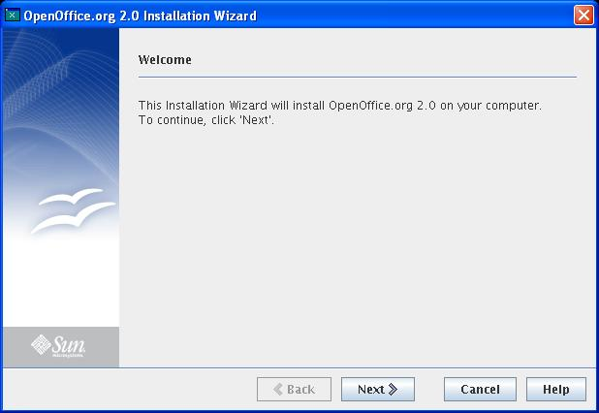Figure 1.1: The welcome page of the Installation Wizard
Note: One more string appears at the bottom of the dialog, if the installation is done without root privileges (STRING_PROLOGUE4).

Table <Table Number>: User Interface elements of Figure <Figure Number>
# | Type | Properties |  | Comment
<#> |  | Control Properties  Enabled: yes
<#> |  | ${PRODUCT_FULLNAME} Installation Wizard | ${PRODUCT_FULLNAME} Installationsassistent |  | STRING_APPLICATIONTITLE
<#> |  | Control Properties  Enabled: yes
<#> |  | String English  Welcome | String German  Willkommen |  | STRING_PROLOGUE1
<#> |  | Control Properties  Enabled: yes
<#> |  | String English  This Installation Wizard will install ${PRODUCT_FULLNAME} on your computer. | String German  Der Installationsassistent wird ${PRODUCT_FULLNAME} auf Ihrem Computer installieren. |  | STRING_PROLOGUE2
<#> |  | Control Properties  Enabled: yes
<#> |  | String English  To continue, click 'Next'. | String German  Klicken Sie auf 'Weiter', um fortzufahren. |  | STRING_PROLOGUE3
 |  | This string appears only in installations with user privileges
 |  | String English  "Note: This installation will be done without root privileges. Therefore you will have a reduced functionality (Java Runtime Environment (JRE) not installable, system integration not possible).\nClick 'Cancel' and change your privileges to root privileges, if you want to use the complete functionality." | String German  Hinweis. Diese Installation wird ohne Administrator Rechte ausgeführt. Deshalb haben Sie nur eingeschränkte Funktionalität verfügbar (Java Runtime Environment (JRE) nicht installierbar, System Integration nicht möglich).\nKlicken Sie auf 'Abbrechen' und ändern Sie Ihre Rechte auf Administrator Rechte, wenn Sie die vollständige Funktionalität nutzen möchten. |  | STRING_PROLOGUE4
<#> |  | Control Properties  Enabled: no
<#> |  | String English  Back | String German  Zurück |  | STRING_PREVIOUS
<#> |  | Control Properties  Enabled: <Yes/No>
<#> |  | String English  Next | String German  Weiter |  | STRING_NEXT
<#> |  | Control Properties  Enabled: <Yes/No>
<#> |  | String English  Cancel | String German  Abbrechen |  | STRING_CANCEL
<#> |  | Control Properties  Enabled: Yes  Icon: <Yes/No>  Resizeable: <Yes/No>  Has Menu: <Yes/No>  Menu Items: <Specify Items Here>  ToolTipText: <Specify Text Here>
<#> |  | String English  Help | String German  Hilfe |  | STRING_HELP

The help window on the welcome page

Pressing the “Help”-Button on the “Welcome”-Dialog, the following “Help”-dialog appears.
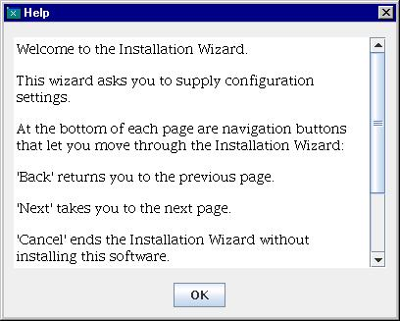Figure 1.2: Help content of the welcome page.

Table <Table Number>: User Interface elements of Figure <Figure Number>
# | Type | Properties |  | Comment
<#> |  | Control Properties  Enabled: <Yes/No>
<#> |  |  | Help | Hilfe | STRING_HELP
<#> |  | Control Properties  Enabled: <Yes/No>
<#> |  |  | String English  Welcome to the Installation Wizard.<p>This wizard asks you to supply configuration settings.<p>At the bottom of each page are navigation buttons that let you move through the Installation Wizard: | String German  Willkommen beim Installationsassistenten.<p>Auf jeder Seite befinden sich im unteren Teil Navigationschaltflächen, die Sie durch den Assistenten führen: | STRING_PROLOGUE_1
<#> |  | Control Properties  Enabled: No
<#> |  |  | String English  'Back' returns you to the previous page. | String German  'Zurück' führt Sie zu der vorigen Seite. | STRING_PROLOGUE_2
<#> |  | Control Properties  Enabled: No
<#> |  |  | String English  'Next' takes you to the next page. | String German  'Weiter' führt Sie zu der nächsten Seite. | STRING_PROLOGUE_3
<#> |  | Control Properties  Enabled: No
<#> |  |  | String English  'Cancel' ends the Installation Wizard without installing this software. | String German  'Abbrechen' bricht den Installionsassistenten ab ohne diese Software zu installieren. | STRING_PROLOGUE_4
<#> |  | Control Properties  Enabled: No
<#> |  |  | String English  'Help' displays the Help with further information about the page currently displayed. | String German  'Hilfe' zeigt die Hilfeseite mit weiteren Informationen zu der aktuellen Seite. | STRING_PROLOGUE_5
<#> |  | Control Properties  Enabled: No
<#> |  |  | String English  'OK' exits the Help page and returns you to the Installation Wizard. | String German  'OK' schließt die Hilfeseite und führt Sie zum Installionsassistent zurück. | STRING_PROLOGUE_6
<#> |  | Control Properties  Enabled: Yes  Icon:  Resizeable:  Has Menu:  Menu Items:  ToolTipText:
<#> |  |  | String English  OK | String German  OK | STRING_OK

In the following descriptions of help windows only the strings are specified, as the dialog itself keeps the same.
The help content is hold as dynamic HTML page.

Path with packages not found

If the installer detects, that the path, in which the installation packages have to be located, does not exist, the following error message appears. This leads to an abort of the installation process. The directory name is defined in the file <installset_root>/installdata/xpd/setup.xpd, the xml file, that contains global settings of the installation. This directory has to exist in the root of the installation set. For Linux the direcotory name is “RPMS”, for Solaris it is “packages”.

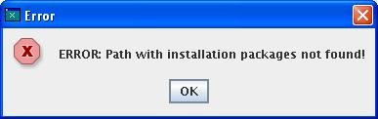Figure 1.3: Error message path not found

# | Type | Properties |  | Comment
<#>
<#> |  | Error | Fehler | STRING_ERROR
<#> |  | Properties
<#> |  | String English  ERROR: Path with installation packages not found! | String German  Fehler: Pfad mit Installationspaketen nicht gefunden! | STRING_INSTALLATIONONGOING_PACKAGEPATH_NOT_FOUND
<#> |  | Control Properties  Enabled: YES  Icon: <Yes/No>  Resizeable: <Yes/No>  Has Menu: <Yes/No>  Menu Items: <Specify Items Here>  ToolTipText: <Specify Text Here>
<#> |  | String English  OK | String German  OK | STRING_OK

Wrong package format
Currently not all package formats are supported for all platforms. In the beginning only the package format “rpm” is supported for Linux and “pkg” is supported for Solaris platforms. The package format of an installation set is defined in <installset_root>/installdata/xpd/setup.xpd. At the beginning of the installation, the installer compares, that the package format is supported by the current operating system. If this check fails, the following error message appears. This error leads to an immediate abort of installation.
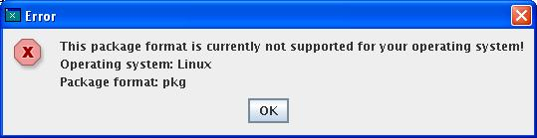Figure 1.4: Error message wrong package format

# | Type | Properties |  | Comment
<#> |  | Control Properties  Enabled: No
<#> |  | Error | Fehler |  | STRING_ERROR
<#> |  | Control Properties  Enabled: No
<#> |  | String English  This package format is currently not supported for your operating system! | String German  Dieses Paketformat wird momentan für Ihr Betriebssystem nicht unterstützt! |  | STRING_PACKAGEFORMAT_NOT_SUPPORTED
<#> |  | Control Properties  Enabled: No
<#> |  | String English  Operating system | String German  Betriebssystem |  | STRING_OPERATING_SYSTEM
<#> |  | Control Properties  Enabled: No
<#> |  | String English  Package format | String German  Paketformat |  | STRING_PACKAGEFORMAT
<#> |  | Control Properties  Enabled: Yes  Icon: <Yes/No>  Resizeable: <Yes/No>  Has Menu: <Yes/No>  Menu Items: <Specify Items Here>  ToolTipText: <Specify Text Here>
<#> |  | String English  OK | String German  OK |  | STRING_OK

Newer installation found (with root privileges)
If the installation is executed with root privileges, the system installation database can be checked, if a newer version of this product is already installed (for installations with user privileges this can only be controlled, after the installation directory is determined). If a newer version is found, the following message appears, that leads to an immediate end of the installation.
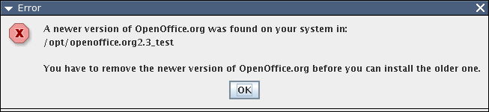
Figure 1.5: Error message newer version found

Table <Table Number>: User Interface elements of Figure <Figure Number>
# | Type | Properties |  | Comment
<#> |  | Control Properties  Enabled: No
<#> |  | Error | Fehler |  | STRING_ERROR
<#> |  | Control Properties  Enabled: No
<#> |  | String English  A newer version of ${PRODUCT_NAME} was found on your system in: | String German  Auf Ihrem System wurde eine neuere Version von ${PRODUCT_NAME} gefunden. Sie befindet sich in dem Ordner: |  | STRING_NEWER_VERSION_INSTALLED_FOUND
<#> |  | Control Properties  Enabled: No
<#> |  | String English  You have to remove the newer version of ${PRODUCT_NAME} before you can install the older one. | String German  Bevor Sie eine ältere Version von ${PRODUCT_NAME} installieren können, müssen Sie zuerst die neuere Version entfernen. |  | STRING_NEWER_VERSION_INSTALLED_REMOVE
<#> |  | Control Properties  Enabled: Yes  Icon: <Yes/No>  Resizeable: <Yes/No>  Has Menu: <Yes/No>  Menu Items: <Specify Items Here>  ToolTipText: <Specify Text Here>
<#> |  | String English  OK | String German  OK |  | STRING_OK

Older installation found (with root privileges)
If the installation is executed with root privileges, the system installation database can be checked, if an older version of this product is already installed (for installations with user privileges this can only be controlled, after the installation directory is determined). If an older version is found AND an update is not allowed for this product (setup.xpd: dontupdate is true), the message like in figure 1.5 appears with a text, that is a little bit changed. After pressing “Ok”, the installation is terminated

Table <Table Number>: User Interface elements of Figure <Figure Number>
# | Type | Properties |  | Comment
<#> |  | Control Properties  Enabled: No
<#> |  | Error | Fehler |  | STRING_ERROR
<#> |  | Control Properties  Enabled: No
<#> |  | String English  An older version of ${PRODUCT_NAME} was found on your system in: | String German  Auf Ihrem System wurde eine ältere von ${PRODUCT_NAME} gefunden. Sie befindet sich in dem Ordner: |  | STRING_OLDER_VERSION_INSTALLED_FOUND
<#> |  | Control Properties  Enabled: No
<#> |  | String English  You have to remove the older version of ${PRODUCT_NAME} before you can install the newer one. | String German  Bevor Sie eine neuere Version von ${PRODUCT_NAME} installieren können, müssen Sie zuerst die ältere Version entfernen. |  | STRING_OLDER_VERSION_INSTALLED_REMOVE
<#> |  | Control Properties  Enabled: Yes  Icon: <Yes/No>  Resizeable: <Yes/No>  Has Menu: <Yes/No>  Menu Items: <Specify Items Here>  ToolTipText: <Specify Text Here>
<#> |  | String English  OK | String German  OK |  | STRING_OK

Solaris: Installation with user privileges without getuid.so
On Solaris platform, it is required, that a file getuid.so exists, if the installation shall be executed with user privileges. For installations with root privileges this file is not required. Officially we do not want to support the Solaris installation with user privileges. But as workaround this file can be made available. If the file is not found, the installation with user privileges cannot succeed and the following error message appears:
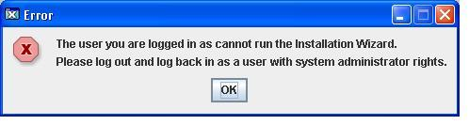
Figure 1.6: Error message: Solaris installation with user privileges

# | Type | Properties |  | Comment
<#> |  | Control Properties  Enabled: No
<#> |  | Error | Fehler |  | STRING_ERROR
<#> |  | Control Properties  Enabled: No
<#> |  | String English  The user you are logged in as cannot run the Installation Wizard. | String German  Sie sind unter einem Benutzernamen angemeldet, der nicht die nötigen Rechte hat, um den Installationsassistenten auszuführen. |  | STRING_ROOT_PRIVILEGES_REQUIRED_1
<#> |  | Control Properties  Enabled: No
<#> |  | String English  Please log out and log back in as a user with system administrator rights. | String German  Bitte melden Sie sich ab, dann melden Sie sich als Benutzer mit Administratorrechten wieder an. |  | STRING_ROOT_PRIVILEGES_REQUIRED_2
<#> |  | Control Properties  Enabled: Yes  Icon: <Yes/No>  Resizeable: <Yes/No>  Has Menu: <Yes/No>  Menu Items: <Specify Items Here>  ToolTipText: <Specify Text Here>
<#> |  | String English  OK | String German  OK |  | STRING_OK

The license page of the installation wizard
After the “Welcome”-Dialog the “License”-Dialog appears. As the name says, the user has to accept the license in this dialog. If he does not accept it, the installation process is aborted.

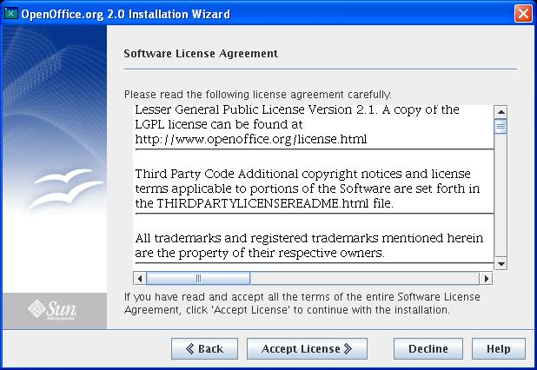Figure 1.7: The license page of the installation wizard.

# | Type | Properties |  | Comment
<#>
<#> |  | ${PRODUCT_FULLNAME} Installation Wizard | ${PRODUCT_FULLNAME} Installationsassistent |  | STRING_APPLICATIONTITLE
<#> |  | Properties
<#> |  | String English  Software License Agreement | String German  Lizenzvereinbarung |  | STRING_ACCEPTLICENSE1
<#> |  | Properties
<#> |  | String English  Please read the following license agreement carefully. | String German  Bitte lesen Sie die nachfolgende Lizenzvereinbarung sorgfältig durch. |  | STRING_ACCEPTLICENSE2
<#> |  | Properties
<#> |  | String English  If you have read and accept all the terms of the entire Software License Agreement, click 'Accept License' to continue with the installation. | String German  Klicken Sie auf 'Lizenz akzeptieren', um zu bestätigen, dass Sie den gesamten Inhalt der Lizenzvereinbarung gelesen und akzeptiert haben. Danach können Sie mit der Installation fortfahren. |  | STRING_ACCEPTLICENSE3
<#> |  | Control Properties  Enabled: Yes  Icon: <Yes/No>  Resizeable: <Yes/No>  Has Menu: <Yes/No>  Menu Items: <Specify Items Here>  ToolTipText: <Specify Text Here>
<#> |  | String English  Back | String German  Zurück |  | STRING_PREVIOUS
<#> |  | Control Properties  Enabled: Yes  Icon: <Yes/No>  Resizeable: <Yes/No>  Has Menu: <Yes/No>  Menu Items: <Specify Items Here>  ToolTipText: <Specify Text Here>
<#> |  | String English  Accept License | String German  Lizenz akzeptieren |  | STRING_ACCEPTLICENSE
<#> |  | Control Properties  Enabled: Yes  Icon: <Yes/No>  Resizeable: <Yes/No>  Has Menu: <Yes/No>  Menu Items: <Specify Items Here>  ToolTipText: <Specify Text Here>
<#> |  | String English  Decline | String German  Ablehnen |  | STRING_DECLINE
<#> |  | Control Properties  Enabled: Yes  Icon: <Yes/No>  Resizeable: <Yes/No>  Has Menu: <Yes/No>  Menu Items: <Specify Items Here>  ToolTipText: <Specify Text Here>
<#> |  | String English  Help | String German  Hilfe |  | STRING_HELP

The help text of the license page

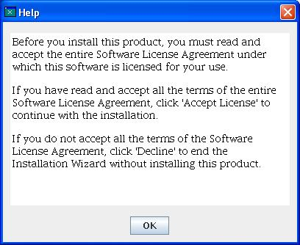Figure 1.8: Help window for license agreement

Table <Table Number>: User Interface elements of Figure <Figure Number>
# | Type | Properties |  | Comment
<#> |  | Control Properties  Enabled: No
<#> |  | Help | Hilfe |  | STRING_HELP

<#> |  | Control Properties  Enabled: No
<#> |  | String English  Before you install this product, you must read and accept the entire Software License Agreement under which this software is licensed for your use. | String German  Bevor Sie dieses Produkt installieren, müssen Sie die gesamte Lizenzvereinbarung lesen und akzeptieren. | STRING_ACCEPTLICENSE_1
<#> |  | Control Properties  Enabled: No
<#> |  | String English  If you have read and accept all the terms of the entire Software License Agreement, click 'Accept License' to continue with the installation. | String German  Klicken Sie 'Lizenz akzeptieren', um zu bestätigen, dass Sie den gesamten Inhalt der Lizenzvereinbarung gelesen und akzeptiert haben. Danach können Sie mit der Installation fortfahren. | STRING_ACCEPTLICENSE_2
<#> |  | Control Properties  Enabled: <Yes/No>
<#> |  | String English  If you do not accept all the terms of the Software License Agreement, click 'Decline' to end the Installation Wizard without installing this product. | String German  Falls Sie die Lizenzvereinbarung nicht akzeptieren, klicken Sie auf 'Ablehnen'. Die Installation dieses Produktes wird in diesem Fall beendet. | STRING_ACCEPTLICENSE_3

Selection of the installation directory
After accepting the license, the third dialog is the “Installation Directory”-Dialog, in which the installer can determine, where the product shall be installed. The default directory is defined in the installationset in the file “installdata/xpd/setup.xpd” with tag <defaultdir>.
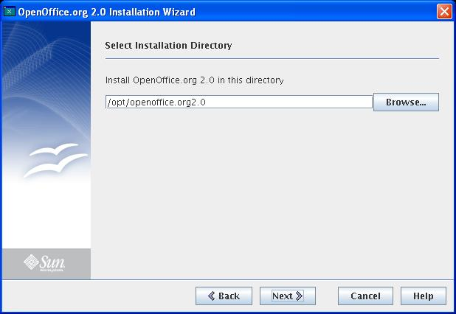Figure 1.9: The select installation directory page.

# | Type | Properties |  | Comment
<#>
<#> |  | Select Installation Directory | Wählen Sie das Installationsverzeichnis |  | STRING_CHOOSEDIRECTORY1
<#> |  | Properties
<#> |  | String English  Install ${PRODUCT_FULLNAME} in this directory | String German  ${PRODUCT_FULLNAME} installieren nach |  | STRING_CHOOSEDIRECTORY2
<#> |  | Properties
<#> |  | String English  Browse... | String German  Durchsuchen... |  | STRING_CHOOSEDIRECTORY3

The help text of the “Select installation directory” dialog

Figure 1.10

Table <Table Number>: User Interface elements of Figure <Figure Number>
# | Type | Properties |  | Comment
<#> |  | Control Properties  Enabled: Yes
<#> |  | It is recommended that you install this product in the directory suggested by this Installation Wizard. <p>To choose a different location, click 'Browse...' or specify the full path of the directory to use in the text box below. <p>If this product is already installed, you cannot change the destination directory. | Es wird empfohlen, dass Sie dieses Produkt in dem von diesem Installationsassistenten vorgeschlagenen Verzeichnis, installieren. Um ein anderes Installationsverzeichnis anzugeben klicken Sie auf 'Durchsuchen...'. <p>Wenn dieses Produkt bereits installiert ist, können Sie das Zielverzeichnis nicht verändern. |  | STRING_CHOOSEDIRECTORY_1

Browsing for the installation directory

If the “Browse”-Button is pressed, the standard Java dialog is started, in which the installation directory can be selected. This dialog is only shown here, but it is not customized from the installation wizard

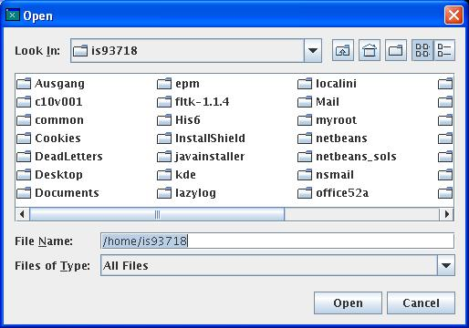Figure 1.11: Selecting another directory for the installation

Create the new directory

If the selected directory does not exist, a MessageBox appears, that informs the user about this. The user can decide to create the directory now. If he does not want to do so, he returns to the “Select installation directory”- dialog.
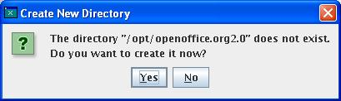Figure 1.12: Message box

# | Type | Properties |  | Comment
<#>
<#> |  | Create New Directory | Neues Verzeichnis anlegen |  | STRING_CHOOSEDIRECTORY4_QUESTION_TITLE
<#> |  | Properties
<#> |  | String English  The directory "${DIR}" does not exist.\nDo you want to create it now? | String German  Das Verzeichnis "${DIR}" existiert nicht.\nSoll das Verzeichnis jetzt angelegt werden? |  | STRING_CHOOSEDIRECTORY5_QUESTION_MESSAGE

Directory creation failed
Sometimes the user is not able to create the selected directory. The most important reason is missing write privileges in the selected directory. But network problems may also be possible. The user is informed about this and returns to the “Select installation directory”-dialog.
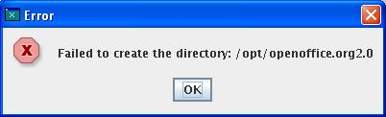Figure 1.13: Error message: Directory could not get created.

# | Type | Properties |  | Comment
<#>
<#> |  | Error | Fehler |  | STRING_ERROR
<#> |  | Properties
<#> |  | String English  Failed to create the directory | String German  Das Verzeichnis konnte nicht angelegt werden |  | STRING_CHOOSEDIRECTORY_NO_SUCCESS

Missing write privileges inside selected directory
It is possible, that the selected directory already exists. In this case, the installer checks, whether the user can create an empty directory inside the selected directory. If this fails the user is informed about this. Pressing the “OK”-button the user returns to the “Select installation directory”- dialog.

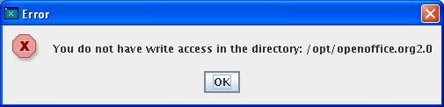Figure 1.14: Error message: Missing write privileges

# | Type | Properties |  | Comment
<#>
<#> |  | Error | Fehler |  | STRING_ERROR
<#> |  | Properties
<#> |  | String English  You do not have write access in the directory | String German  Sie haben keinen Schreibzugriff auf das Verzeichnis |  | STRING_CHOOSEDIRECTORY_NO_WRITE_ACCESS

An installed product was found (only for installation with root privileges)

If this installation is done with root privileges, it was already checked in the system installation database, if the product is already installed. If the installed product is not newer (than the installation was aborted in the “Welcome”-dialog), the destination directory cannot be selected. It has to be used that directory, in which the product is already installed. This is important for update mode and for maintenance mode:

Update Mode: The installed product is older. The user is informed, that an older product was found in the listed directory. This directory cannot be changed. The new installation updates all packages that were found in the system installation database.
Maintenance Mode: The installed product has the same version as the product of this installation set. In this case it is only possible to add new feature to the already installed product. The presented directory cannot be changed. The following dialog is the module selection dialog, in which all modules, that are already installed, cannot be checked for installation.

Figure 1.15: The directory already exists, an older product was found

Figure 1.16: The directory already exists, an older product was found

# | Type | Properties |  | Comment
<#>
<#> |  | Update the Installed Version | Aktualisieren der installierten Version |  | STRING_CHOOSEDIRECTORY1_UPDATE
<#> |  | Properties
<#> |  | String English  Adding Components to the Installed Version | String German  Komponenten zur installierten Version hinzufügen. |  | STRING_CHOOSEDIRECTORY1_MAINTAIN
<#> |  | Properties
<#> |  | String English  Install ${PRODUCT_FULLNAME} in this directory | String German  ${PRODUCT_FULLNAME} installieren nach: |  | STRING_CHOOSEDIRECTORY2
<#> |  | Properties
<#> |  | String English  Browse... | String German  Durchsuchen... |  | STRING_CHOOSEDIRECTORY3

Selecting the directory ( installation on Solaris with user privileges)

This is a special case, that is not officially supported. To be able to make this kind of installation, it is required that the file “getuid.so” was added to the installation set. In an installation executed with user privileges the directory root is shifted to a directory, in which the user has write-privileges. Additionally it is possible to change the variable part of the “standard”-installation directory. The latter is for example “/opt/openoffice.org 2.0” for an OpenOffice.org 2.0 installation set. As new root the user might select “/home/abc/shifted_solaris_root”. If there was only one directory path in this dialog, the user could choose something like:
“/home/abc/shifted_root/abc_installations/test/opt/myOffice”.
Then it would not be clear, which part of the directory is the new directory root, and which part is the relocatable part of the path. Therefore it is required, that both directories have to be defined independent from each other.
But as already mentioned, this is only important for installations on Solaris OS with user privileges. And this is officially not supported. It is only included as workaround, to be able to install the product for testing or development reasons.

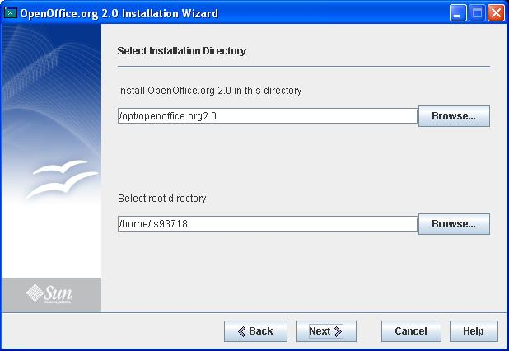Figure 1.17: Directory selection on Solaris

# | Type | Properties |  | Comment
<#>
<#> |  | Select Installation Directory | Wählen Sie das Installationsverzeichnis |  | STRING_CHOOSEDIRECTORY1
<#> |  | Properties
<#> |  | String English  Install ${PRODUCT_FULLNAME} in this directory | String German  ${PRODUCT_FULLNAME} installieren nach: |  | STRING_CHOOSEDIRECTORY2
<#> |  | Properties
<#> |  | String English  Select root directory | String German  Wählen Sie das Root-Verzeichnis aus |  | STRING_CHOOSEDIRECTORY6
<#> |  | Properties
<#> |  | String English  Browse... | String German  Durchsuchen... |  | STRING_CHOOSEDIRECTORY3

Newer version already installed (user privileges)

In an installation with root privileges, at the beginning of the installation the system installation database is checked for already installed products. In an installation with user privileges the location of the installation database is only known, after the destination directory is determined. This is the case, when the user presses the “Next”-button in the “Select installation directory”-dialog. On Linux OS the database for installations with user privileges is named “.RPM_OFFICE_DATABASE”. This database is located in the parent directory of the office root. Example: Installation directory is “/home/abc/opt/openoffice.org2.0”, then the database is located in “/home/abc/opt”. Attention: If you want to install an OOo 2.1 into the directory “/home/abc/opt/openoffice.org2.1”, it uses the same database. This is probably not what you want.
On Solaris the installation database is located in the shifted root. Several directories like “var” or “opt” are created in the shifted root directory. The “var” directory contains the information about the products, that are installed below the shifted root directory.

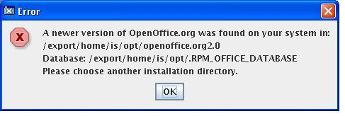Figure 1.18: Newer version found (user privileges)

Table <Table Number>: User Interface elements of Figure <Figure Number>
# | Type | Properties |  | Comment
<#> |  | Control Properties  Enabled: <Yes/No>
<#> |  | Error | Fehler |  | STRING_ERROR
<#> |  | Control Properties  Enabled: <Yes/No>
<#> |  | String English  A newer version of ${PRODUCT_NAME} was found on your system in: | String German  Auf Ihrem System wurde eine neuere Version von ${PRODUCT_NAME} gefunden. Sie befindet sich in dem Ordner: |  | STRING_NEWER_VERSION_INSTALLED_FOUND
<#> |  | Control Properties  Enabled: <Yes/No>
<#> |  | String English  Database | String German  Datenbank |  | STRING_NEWER_VERSION_DATABASE
<#> |  | Control Properties  Enabled: <Yes/No>
<#> |  | String English  Please choose another installation directory. | String German  Bitte wählen Sie ein anderes Installationsverzeichnis. |  | STRING_NEWER_VERSION_TIP

Older version already installed (user privileges)

In an installation with root privileges, at the beginning of the installation the system installation database is checked for already installed products. In an installation with user privileges the location of the installation database is only known, after the destination directory is determined. This is the case, when the user presses the “Next”-button in the “Select installation directory”-dialog. On Linux OS the database for installations with user privileges is named “.RPM_OFFICE_DATABASE”. This database is located in the parent directory of the office root. Example: Installation directory is “/home/abc/opt/openoffice.org2.0”, then the database is located in “/home/abc/opt”. Attention: If you want to install an OOo 2.1 into the directory “/home/abc/opt/openoffice.org2.1”, it uses the same database. This is probably not what you want.
On Solaris the installation database is located in the shifted root. Several directories like “var” or “opt” are created in the shifted root directory. The “var” directory contains the information about the products, that are installed below the shifted root directory.
If an older installation is found AND the update for the product is not allowed (setup.xpd: dontupdate is true) the user is informed about the existing installation. The dialog is very similar to the dialog in figure 1.18 and has only some very slightly changed strings. After this dialog, the user can choose a new installation directory.

Table <Table Number>: User Interface elements of Figure <Figure Number>
# | Type | Properties |  | Comment
<#> |  | Control Properties  Enabled: <Yes/No>
<#> |  | Error | Fehler |  | STRING_ERROR
<#> |  | Control Properties  Enabled: <Yes/No>
<#> |  | String English  An older version of ${PRODUCT_NAME} was found on your system in: | String German  Auf Ihrem System wurde eine ältere Version von ${PRODUCT_NAME} gefunden. Sie befindet sich in dem Ordner: |  | STRING_OLDER_VERSION_INSTALLED_FOUND
<#> |  | Control Properties  Enabled: <Yes/No>
<#> |  | String English  Database | String German  Datenbank |  | STRING_NEWER_VERSION_DATABASE
<#> |  | Control Properties  Enabled: <Yes/No>
<#> |  | String English  Please choose another installation directory. | String German  Bitte wählen Sie ein anderes Installationsverzeichnis. |  | STRING_NEWER_VERSION_TIP

Type of installation

After the installation directory is defined, the user can decide, whether he wants to make a “Typical” or a “Custom” installation.
Attention: This dialog does not appear in update mode or in maintenance mode. In update mode (an older version is installed), those packages are selected for installation, that are already installed. The type “Custom” cannot be allowed, to avoid the mixture of incompatible components. In maintenance mode (the same version is already installed) the user is forced to make a “Custom” installation, in which the packages, that are already installed, cannot be selected or deselected.

Figure 1.19: Selection of the installation type.

# | Type | Properties |  | Comment
<#>
<#> |  | Select the Type of Installation | Wählen Sie den Installationstyp |  | STRING_CHOOSEINSTALLATIONTYPE1
<#> |  | Properties
<#> |  | String English  Select the type of installation that best suits your needs: | String German  Wählen Sie den Installationstyp, der Ihren Erfordernissen am besten entspricht: |  | STRING_CHOOSEINSTALLATIONTYPE2
<#> |  | Properties
<#> |  | String English  Select the Type of Installation | String German  Wählen Sie den Installationstyp |  | STRING_CHOOSEINSTALLATIONTYPE3
<#> |  | Properties
<#> |  | String English  Typical | String German  Standard |  | STRING_CHOOSEINSTALLATIONTYPE6
<#> |  | Properties
<#> |  | String English  Custom | String German  Angepasst |  | STRING_CHOOSEINSTALLATIONTYPE7
<#> |  | Properties
<#> |  | String English  The main components will be installed. Recommended for most users. | String German  Die wichtigsten Komponenten werden installiert. Empfohlen für die meisten Anwender. |  | STRING_CHOOSEINSTALLATIONTYPE4
<#> |  | Properties
<#> |  | String English  You choose the components you want to install and where they are stored. Recommended for advanced users. | String German  Wählen Sie aus, welche Komponenten installiert werden sollen und wo diese gespeichert werden sollen. Empfohlen für erfahrene Anwender. |  | STRING_CHOOSEINSTALLATIONTYPE5

The help text about selection of the installation type

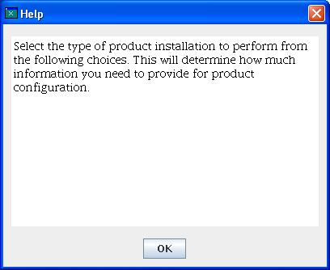Figure 1.20: Help of the installation type page.

# | Type | Properties |  | Comment
<#>
<#> |  | Help | Hilfe |  | STRING_HELP
<#> |  | Properties
<#> |  | String English  Select the type of product installation to perform from the following choices. This will determine how much information you need to provide for product configuration. | String German  Wählen Sie aus den folgenden Optionen den Installationstyp, der Ihren Erfordernissen am Besten entspricht. |  | STRING_CHOOSEINSTALLATIONTYPE_1

Selection of components for installation
If the user decides to make a “Custom” installation, the following “Select components”-dialog appears. This dialog appears automatically directly after the “Choose Directory” dialog, if the same version of this product was found on the system -> Maintenance Mode. In this maintenance mode, only those components can be selected, that are not already installed on the system.
Additionally there is always a global check of the components that are listed in this dialog. It can be possible that the main product, for example OOo, is not installed on this system. Therefore this is not a maintenance and not an update mode. But parts of the installation can already be installed, for example the JRE that is added to the OOo. Then it must be known, in which version the JRE is already installed and in which version it is part of this installation set. If the installed JRE is newer or in the same version, the JRE component cannot be selected for installation (the arrow is white, no color). If the installed JRE is older, the JRE component can be selected.
This version check is executed for all components that are part of the installation set..

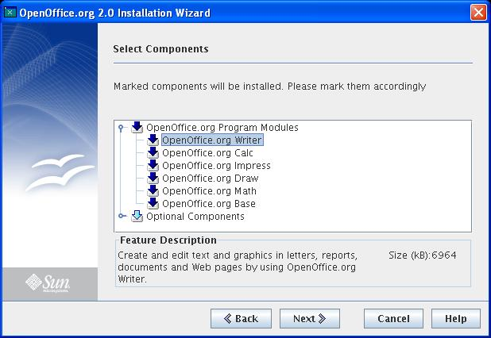Figure 1.21: The available components (no already installed version found)

Figure 1.22: The available components (Maintenance Mode, the product is already installed)

# | Type | Properties |  | Comment
<#>
<#> |  | Select Components | Wählen Sie die Komponenten |  | STRING_CHOOSECOMPONENTS1  (Only standard mode)
<#> |  | Properties
<#> |  | String English  Select Additional Components | String German  Wählen Sie zusätzliche Komponenten |  | STRING_CHOOSECOMPONENTS1_MAINTAIN  (Only maintenance mode)
<#> |  | Properties
<#> |  | String English  Marked components will be installed. Please mark them accordingly | String German  Die markierten Komponenten werden installiert. Bitte markieren Sie die Komponenten entsprechend. |  | STRING_CHOOSECOMPONENTS2
<#> |  | Properties
<#> |  | String English  Feature Description | String German  Modulbeschreibung |  | STRING_CHOOSECOMPONENTS3
<#> |  | Properties
<#> |  | String English  Size (kB): | String German  Größe (kB): |  | STRING_CHOOSECOMPONENTS4

The help text of the “Select Components” dialog

Figure 1.23: Help text available on the page 'Select Components'

# | Type | Properties |  | Comment
<#>
<#> |  | Help | Hilfe |  | STRING_HELP
<#> |  | Properties
<#> |  | String English  Components marked in color will be installed. Click the icon of a component to mark or unmark the component.<p>All already installed components cannot be selected for installation. | String German  Farblich markierte Komponenten werden installiert. Klicken Sie auf das Symbol einer Komponente, um die Markierung zu setzen oder zu entfernen.<p>Alle bereits installierten Komponenten können nicht für die Installation ausgewählt werden. |  | STRING_CHOOSECOMPONENTS_1

No components have been selected
After pressing the “Next”-button of the “Choose Components” dialog, it is controlled, whether components were chosen for installation. If no component is found, the user is informed about this with the following dialog. After confirming this info, the wizard returns to the “Choose Components”-dialog.

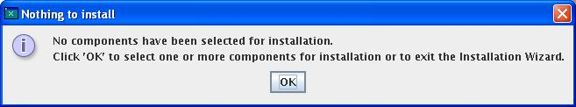Figure 1.24: Info box

# | Type | Properties |  | Comment
<#>
<#> |  | Nothing to install | Nichts wird installiert |  | STRING_NOTHING_TO_INSTALL
<#> |  | Properties
<#> |  | String English  No components have been selected for installation. | String German  Es wurden keine Komponenten für die Installation ausgewählt. |  | STRING_NO_COMPONENTS_SELECTED_1

Control Properties
Enabled: <Yes/No>
 |  | String English  Click 'OK' to select one or more components for installation or to exit the Installation Wizard. | String German  Klicken Sie auf 'OK', um eine oder mehrere Komponenten für die Installation auszuwählen oder den Installationsassistenten zu beenden. | STRING_NO_COMPONENTS_SELECTED_2

The “Ready to Install” page

The final dialog before the installation starts is the “Ready to Install” dialog. This dialog is reached from:
- the “Select Components”-dialog
- the “Choose Installation Type”-dialog, if “Typical” was choosen
- the “Choose Installation Directory” -dialog, if this is the update mode -> an older version is already installed

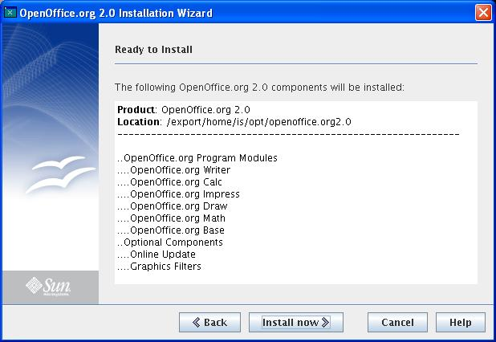Figure 1.25: Listing the selected components for installation (not update mode)

Figure 1.26: Listing the selected components for installation (Update Mode, an older version was found)

# | Type | Properties |  | Comment
<#>
<#> |  | Ready to Install | Bereit zum Installieren | STRING_INSTALLATIONIMMINENT1  (not in update mode)
<#> |  | Properties
<#> |  | String English  Ready to Update | String German  Bereit zum Aktualisieren | STRING_INSTALLATIONIMMINENT1_UPDATE  (only in update mode)
<#> |  | Properties
<#> |  | String English  The following ${PRODUCT_FULLNAME} components will be installed: | String German  Die folgenden ${PRODUCT_FULLNAME} Komponenten werden installiert: | STRING_INSTALLATIONIMMINENT2
<#> |  | Properties
<#> |  | String English  Install now | String German  Installation beginnen | STRING_INSTALL

The help text of the “Ready to Install” dialog

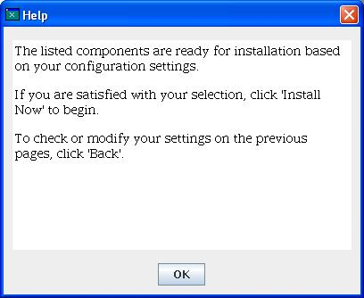Figure 1.27: Help string

# | Type | Properties |  | Comment
<#>
<#> |  | Help | Hilfe |  | STRING_HELP
<#> |  | Properties
<#> |  | String English  The listed components are ready for installation based on your configuration settings. <p>If you are satisfied with your selection, click 'Install Now' to begin. <p>To check or modify your settings on the previous pages, click 'Back'. | String German  Die aufgelisteten Komponenten werden, basierend auf Ihren Konfigurationseinstellungen installiert. <p>Klicken Sie auf 'Installation beginnen', um mit der Installation zu beginnen. <p>Wenn Sie Änderungen an der Auswahl der zu installierenden Komponenten vornehmen möchten, klicken Sie auf 'Zurück'. |  | STRING_INSTALLATIONIMMINENT_1

The “Installing ...” dialog
When the installation starts, the “Installing ...” dialog appears. A progress bar informs the user about the status of installation. The displayed value is the percentage of the number of already installed packages to the number of packages that shall be installed.

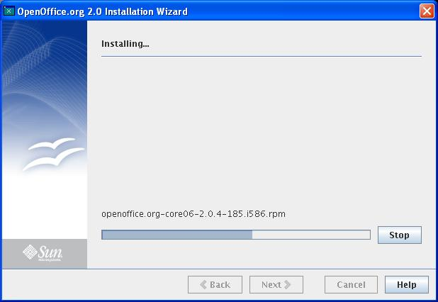Figure 1.28: The installation process

# | Type | Properties |  | Comment
<#>
<#> |  | Installing... | Installieren... |  | STRING_INSTALLATIONONGOING1
<#> |  | Properties
<#> |  | String English  Stop | String German  Stopp |  | STRING_INSTALLATIONONGOING3
<#> |  | Properties
<#> |  | String English  <Enter String Here> | String German  <Enter String Here>

The help text of the 'Installing...' dialog

Figure 1.29: The help string

# | Type | Properties |  | Comment
<#>
<#> |  | Help | Hilfe |  | STRING_HELP
<#> |  | Properties
<#> |  | String English  This page indicates the progress of the installation with the aid of a progress bar. To abort the installation process, click 'Stop'. | String German  Diese Seite informiert Sie über den Fortschritt der Installation. Um die Installation abzubrechen, klicken Sie auf 'Stopp'. |  | STRING_INSTALLATIONONGOING_1

Message box at aborting the installation
On the “Installing ...” dialog the user can press a button to stop the installation. Of course it is necessary, to confirm this. If the user confirms the abort, a process is started, in which the packages, that were installed, will be removed again.

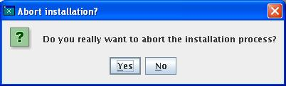Figure 1.30: Message box

# | Type | Properties |  | Comment
<#>
<#> |  | Abort installation? | Installation abbrrechen? |  | STRING_STOP_DIALOG_TITLE
<#> |  | Properties
<#> |  | String English  Do you really want to abort the installation process? | String German  Möchten Sie den Installationsassistenten wirklich beenden? |  | STRING_STOP_DIALOG

The dialog “Installation Completed Successfully”

The last dialog of the installation wizard is the dialog, in which the user is informed about the status of the installation. Currently there are three possible versions of this dialog:
- the installation was successful
- the installation was aborted
- during the installation an error occurred
If the installation was successful, the following dialog appears. The other two version are presented in the following sections.

Figure 1.31: Successful installation

# | Type | Properties |  | Comment
<#>
<#> |  | Installation Completed | Installation abgeschlossen |  | STRING_INSTALLATIONCOMPLETED1
<#> |  | Properties
<#> |  | String English  The Installation Wizard has successfully installed ${PRODUCT_FULLNAME} on your computer. | String German  Der Installationsassistent hat ${PRODUCT_FULLNAME} erfolgreich auf Ihrem Computer installiert. |  | STRING_INSTALLATIONCOMPLETED2
<#> |  | Properties
<#> |  | String English  Click 'Finish' to exit the Wizard. | String German  Klicken Sie auf 'Beenden' um den Installationsassistenten zu verlassen. |  | STRING_INSTALLATIONCOMPLETED3
<#> |  | Properties
<#> |  | String English  Details... | String German  Details... |  | STRING_INSTALLATIONCOMPLETED_BUTTON
<#> |  | Properties
<#> |  | String English  Finish | String German  Beenden |  | STRING_FINISH

The final dialog always contains a “Details ...” button. Pressing this button, the user will be informed about several processes of the installation. Currently especially the analysis of the system installation database is logged and the calls, that are required for the installation of the packages. This dialog is especially important, if an error occurred during installation process.

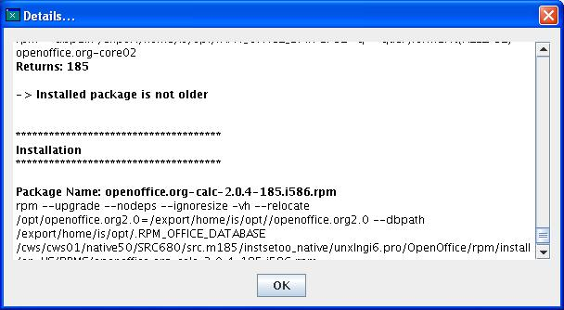Figure 1.32

The dialog “Installation Completed with Abort”
The second scenario for the last dialog of the installation wizard, is the abort of the installation. After confirming the abort information, all installed packages should be deinstalled again. Of course more information can be obtained by pressing the “Details ...” button.

Figure 1.33: Installation wizard after abort.

# | Type | Properties |  | Comment
<#>
<#> |  | Installation Aborted | Installation abgebrochen |  | STRING_INSTALLATIONCOMPLETED1_ABORT
<#> |  | Properties
<#> |  | String English  The Installation Wizard was aborted. ${PRODUCT_NAME} is not installed on your computer. | String German  Der Installationsassistent wurde beendet. ${PRODUCT_NAME} wurde auf Ihrem Computer nicht installiert. |  | STRING_INSTALLATIONCOMPLETED2_ABORT
<#> |  | Properties
<#> |  | String English  Click 'Finish' to exit the Wizard. | String German  Klicken Sie auf 'Beenden' um den Installationsassistenten zu verlassen. |  | STRING_INSTALLATIONCOMPLETED3
<#> |  | Properties
<#> |  | String English  Details... | String German  Details... |  | STRING_INSTALLATIONCOMPLETED_BUTTON
<#> |  | Properties
<#> |  | String English  Finish | String German  Beenden |  | STRING_FINISH

The “Installation Completed with an Error” dialog
The third scenario of the final installation wizard dialog, is the error scenario. The product could not be installed successfully. An error occurred during the installation process. More information is available, if the “Details ...” button is pressed.

Figure 1.34: Error at the installation

# | Type | Properties |  | Comment
<#>
<#> |  | Installation Failed | Installation fehlerhaft |  | STRING_INSTALLATIONCOMPLETED1_ERROR
<#> |  | Properties
<#> |  | String English  An error has occured. Thus the Installation Wizard could not install ${PRODUCT_NAME} on your computer successfully. Click 'Details...' for more information. | String German  Ein Fehler ist aufgetreten. Daher konnte der Installationsassistent ${PRODUCT_NAME} nicht erfolgreich auf Ihrem Computer installieren. Klicken Sie 'Details..' für nähere Informationen. |  | STRING_INSTALLATIONCOMPLETED2_ERROR
<#> |  | Properties
<#> |  | String English  Click 'Finish' to exit the Wizard. | String German  Klicken Sie auf 'Beenden' um den Installationsassistenten zu verlassen. |  | STRING_INSTALLATIONCOMPLETED3
<#> |  | Properties
<#> |  | String English  Details... | String German  Details... |  | STRING_INSTALLATIONCOMPLETED_BUTTON
<#> |  | Properties
<#> |  | String English  Finish | String German  Beenden |  | STRING_FINISH

Uninstallation, the “Uninstall Welcome” dialog

The second wizard of this Java installer is the “Uninstallation Wizard”. Until now, only the dialogs of the “Installation Wizard” were presented. This and the following sections describe the dialogs of the “Uninstallation Wizard”. This wizard is started by using the “setup” that is located in the installed product, after the installation has finished. There are two reasons for using this wizard:
- complete removal of this product
- removal of selected components of this product
It is not possible, to install additional components to the installed product. The packages are not available to this wizard. For adding new components it is required to start the setup from the original installation set, not the setup from the installed product.

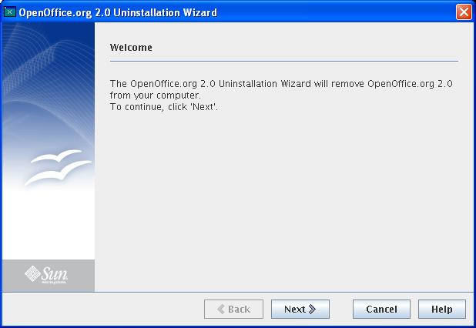Figure 1.35: The uninstallation page

# | Type | Properties |  | Comment
<#>
${PRODUCT_FULLNAME} Uninstallation Wizard | ${PRODUCT_FULLNAME} Deinstallationsassistent |  | STRING_APPLICATIONTITLEUNINSTALLATION
<#> |  | Properties
<#> |  |  | String English  Welcome | String German  Willkommen | STRING_PROLOGUE1
<#> |  | Properties
<#> |  |  | String English  The ${PRODUCT_FULLNAME} Uninstallation Wizard will remove ${PRODUCT_FULLNAME} from your computer. | String German  Der Deinstallationsassistent wird ${PRODUCT_FULLNAME} von Ihrem Computer entfernen. | STRING_UNINSTALLATIONPROLOGUE2
<#> |  | Properties
<#> |  |  | String English  To continue, click 'Next'. | String German  Klicken Sie auf 'Weiter', um fortzufahren. | STRING_PROLOGUE3

The help text of the “Uninstallation Welcome” dialog

Figure 1.36: Help content of the welcome page for uninstallation.

# | Type | Properties |  | Comment
<#>
<#> |  | Help | Hilfe |  | STRING_HELP
<#> |  | Properties
<#> |  | String English  Welcome to the Uninstallation Wizard.<p>This wizard asks you to supply configuration settings.<p>At the bottom of each page are navigation buttons that let you move through the Uninstallation Wizard: | String German  Willkommen beim Deinstallationsassistenten.<p>Auf jeder Seite befinden sich im unteren Teil Navigationschaltflächen, die Sie durch den Assistenten führen: |  | STRING_UNINSTALLATIONPROLOGUE_1

<#> |  | Control Properties  Enabled: <Yes/No>
<#> |  | String English  'Back' returns you to the previous page. | String German  'Zurück' führt Sie zu der vorigen Seite. | STRING_UNINSTALLATIONPROLOGUE_2

Control Properties
Enabled: <Yes/No>
 |  | String English  'Next' takes you to the next page. | String German  'Weiter' führt Sie zu der nächsten Seite. | STRING_UNINSTALLATIONPROLOGUE_3
<#> |  | Control Properties  Enabled: <Yes/No>
<#> |  | String English  'Cancel' ends the Uninstallation Wizard without removing this software. | String German  'Abbrechen' bricht den Deinstallionsassistenten ab ohne diese Software zu entfernen. | STRING_UNINSTALLATIONPROLOGUE_4
<#> |  | Control Properties  Enabled: <Yes/No>
<#> |  | String English  'Help' displays the Help with further information about the page currently displayed. | String German  'Hilfe' zeigt die Hilfeseite mit weiteren Informationen zu der aktuellen Seite. | STRING_UNINSTALLATIONPROLOGUE_5
<#> |  | Control Properties  Enabled: <Yes/No>
<#> |  | String English  'OK' exits the Help page and returns you to the Uninstallation Wizard. | String German  'OK' schließt die Hilfeseite und führt Sie zum Deinstallionsassistenten zurück. | STRING_UNINSTALLATIONPROLOGUE_6

Wrong privileges for uninstallation
If the installation was done with user privileges, it is necessary, that this uninstallation is also done with user privileges. The same is important for installations with root privileges. Therefore it is checked at the beginning of the uninstallation, if this privileges fit together. If not, the uninstallation is aborted with the following error messages.
First : Install with user privileges, uninstall with root privileges.

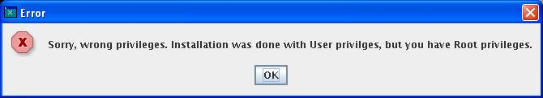Figure 1.37

# | Type | Properties |  | Comment
<#>
<#> |  | Error | Fehler |  | STRING_ERROR
<#> |  | Properties
<#> |  | String English  Sorry, wrong privileges. Installation was done with User privilges, but you have Root privileges. | String German  Es wurden die falschen Rechte benutzt. Die Installation wurde mit User-Rechten gestartet, aber Sie haben Root-Rechte. |  | STRING_UNINSTALLATION_PROLOGUE_WRONG_PRIVILEGES_CURRENT_ROOT

Second:: Install with root privileges, uninstall with user privileges.

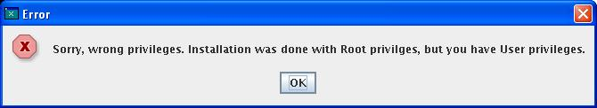Figure 1.38

# | Type | Properties |  | Comment
<#>
<#> |  | Error | Fehler |  | STRING_ERROR
<#> |  | Properties
<#> |  | String English  Sorry, wrong privileges. Installation was done with Root privilges, but you have User privileges. | String German  Es wurden die falschen Rechte benutzt. Die Installation wurde mit Root-Rechten gestartet, aber Sie haben User-Rechte. |  | STRING_UNINSTALLATION_PROLOGUE_WRONG_PRIVILEGES_CURRENT_USER

Selection of the uninstallation type
In the “Select Uninstallation Type” dialog, the user can choose between a complete uninstallation or a partial uninstallation. If the user selects “Partial”, he can achieve a “Complete” uninstallation, if he selects all offered components in the following “Choose components” dialog.
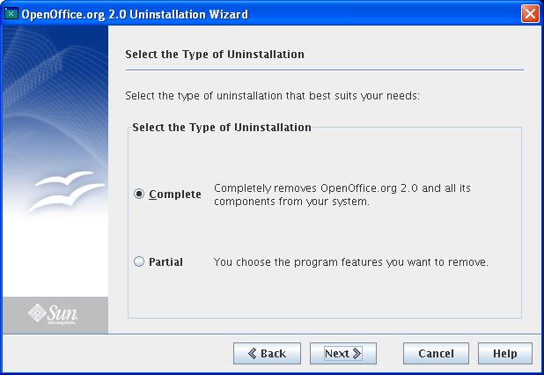Figure 1.39

# | Type | Properties |  | Comment
<#>
<#> |  | Select the Type of Uninstallation | Wählen Sie den Deinstallationstyp |  | STRING_CHOOSEUNINSTALLATIONTYPE1
<#> |  | Properties
<#> |  | String English  Select the type of uninstallation that best suits your needs: | String German  Wählen Sie den Deinstallationstyp, der Ihren Erfordernissen am besten entspricht: |  | STRING_CHOOSEUNINSTALLATIONTYPE2
<#> |  | Properties
<#> |  | String English  Partial | String German  Teilweise |  | STRING_CHOOSEUNINSTALLATIONTYPE3
<#> |  | Properties
<#> |  | String English  You choose the program features you want to remove. | String German  Sie wählen die Komponenten, die entfernt werden sollen. |  | STRING_CHOOSEUNINSTALLATIONTYPE5
<#> |  | Properties
<#> |  | String English  Complete | String German  Vollständig |  | STRING_CHOOSEUNINSTALLATIONTYPE6
<#> |  | Properties
<#> |  | String English  Completely removes ${PRODUCT_FULLNAME} and all its components from your system. | String German  Diese Option entfernt ${PRODUCT_FULLNAME} mit all seinen Komponenten von Ihrem System. |  | STRING_CHOOSEUNINSTALLATIONTYPE4

Help text of the “Choose Uninstallation Type” dialog

Figure 1.40

# | Type | Properties |  | Comment
<#>
<#> |  | Help | Hilfe |  | STRING_HELP
<#> |  | Properties
<#> |  | String English  Complete: This will remove all installed components of your version.<p>Partial: This removes only the components you will choose out of the components list. | String German  Vollständig: Alle Komponenten werden entfernt. <p>Teilweise: Die in der Komponentenliste ausgewählten Komponenten werden vom System entfernt. |  | STRING_CHOOSEUNINSTALLATIONTYPE_1

The dialog “Select Components for Uninstallation”
After selecting “Partial” in the “Choose Uninstallation Type” dialog, the “Select Components for Uninstallation” dialog appears. In this dialog the user decides, which components will be removed. If all components are chosen, the product will be removed completely (including the many hidden components).

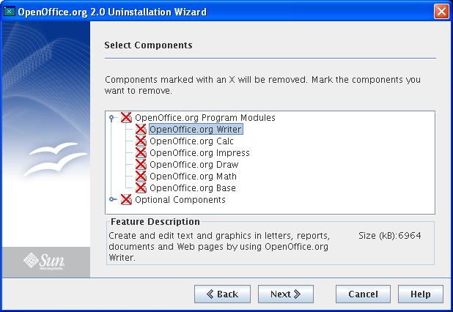Figure 1.41: Selecting the components.

# | Type | Properties |  | Comment
<#>
<#> |  | Select Components | Wählen Sie die Komponenten |  | STRING_CHOOSECOMPONENTS1
<#> |  | Properties
<#> |  | String English  Components marked with an X will be removed. Mark the components you want to remove. | String German  Komponenten gekennzeichnet durch ein X werden entfernt. Markieren Sie die Komponenten, die Sie entfernen möchten. |  | STRING_CHOOSEUNINSTALLATIONCOMPONENTS2]
<#> |  | Properties
<#> |  | String English  Feature Description | String German  Modulbeschreibung |  | STRING_CHOOSECOMPONENTS3
<#> |  | Properties
<#> |  | String English  Size (kB): | String German  Größe (kB): |  | STRING_CHOOSECOMPONENTS4

The help text of the “Select Components for Uninstallation” dialog

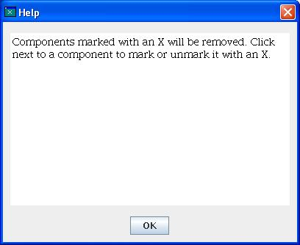Figure 1.42

# | Type | Properties |  | Comment
<#>
<#> |  | Help | Hilfe |  | STRING_HELP
<#> |  | Properties
<#> |  | String English  Components marked with an X will be removed. Click next to a component to mark or unmark it with an X. | String German  Die mit einem X markierten Komponenten werden entfernt. Klicken Sie auf das Symbol einer Komponente, um die X-Markierung zu setzen oder zu entfernen. |  | STRING_CHOOSEUNINSTALLATIONCOMPONENTS_1

No components selected for uninstallation
If no components were chosen for uninstallation in the “Select Components for Uninstallation” dialog, the user is informed about this with the following dialog. After pressing the “Ok” button, the wizard returns to the “Select Components for Uninstallation” dialog.

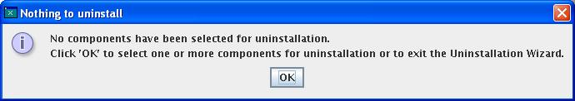Figure 1.43: Info box

# | Type | Properties |  | Comment
<#>
<#> |  | Nothing to uninstall | Nichts wird entfernt |  | STRING_NOTHING_TO_UNINSTALL
<#> |  | Properties
<#> |  | String English  No components have been selected for uninstallation. | String German  Es wurden keine Komponenten zum entfernen ausgewählt. |  | STRING_NO_UNINSTALLCOMPONENTS_SELECTED_1
<#> |  | Control Properties  Enabled: <Yes/No>
<#> |  | String English  Click 'OK' to select one or more components for uninstallation or to exit the Uninstallation Wizard. | String German  Klicken Sie auf 'OK', um eine oder mehrere Komponenten für die Deinstallation auszuwählen oder den Deinstallationsassistenten zu beenden. |  | STRING_NO_UNINSTALLCOMPONENTS_SELECTED_2

The “Ready to Remove” dialog
The final dialog before uninstallation starts is the “Ready to Remove” dialog. This dialog can be achieved on two different ways:
- after selecting “Complete” in the “Choose Uninstallation Type” dialog
- after the “Select Components for Uninstallation” dialog

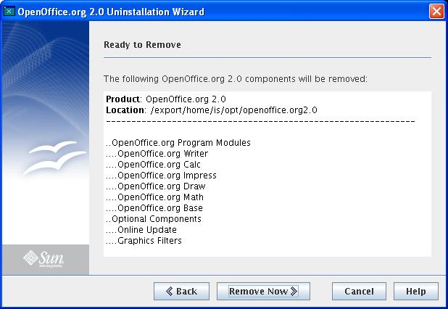Figure 1.44

# | Type | Properties |  | Comment
<#>
<#> |  | Ready to Remove | Bereit zum Entfernen |  | STRING_UNINSTALLATIONIMMINENT1
<#> |  | Properties
<#> |  | String English  The following ${PRODUCT_FULLNAME} components will be removed: | String German  Die folgenden ${PRODUCT_FULLNAME} Komponenten werden von Ihrem System entfernt: |  | STRING_UNINSTALLATIONIMMINENT2
<#> |  | Properties
<#> |  | String English  Remove Now | String German  Komponenten entfernen |  | STRING_UNINSTALL

The help text of the “Ready to Remove” dialog

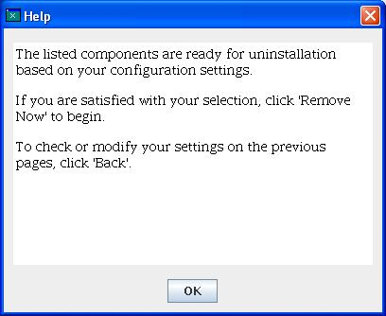Figure 1.45

# | Type | Properties |  | Comment
<#>
<#> |  | Help | Hilfe |  | STRING_HELP
<#> |  | Properties
<#> |  | String English  The listed components are ready for uninstallation based on your configuration settings. <p>If you are satisfied with your selection, click 'Remove Now' to begin. <p>To check or modify your settings on the previous pages, click 'Back'. | String German  Die aufgelisteten Komponenten werden, basierend auf Ihren Konfigurationseinstellungen, entfernt. <p>Klicken Sie auf 'Komponenten entfernen', um mit der Deinstallation zu beginnen. <p>Klicken Sie auf 'Zurück', wenn Sie Ihre Einstellungen überprüfen oder ändern möchten. |  | STRING_UNINSTALLATIONIMMINENT_1

The “Uninstalling ...” dialog

During uninstallation the user is informed about the status of uninstallation in the “Uninstalling ...” dialog. A progress bar, informs the user about the percentage of already uninstalled packages. A “Stop” button is also available. Unfortunately it is not possible to restore packages, that are already uninstalled, if the “Stop” button is pressed. This requires the installation set, in which the packages for installation are located.

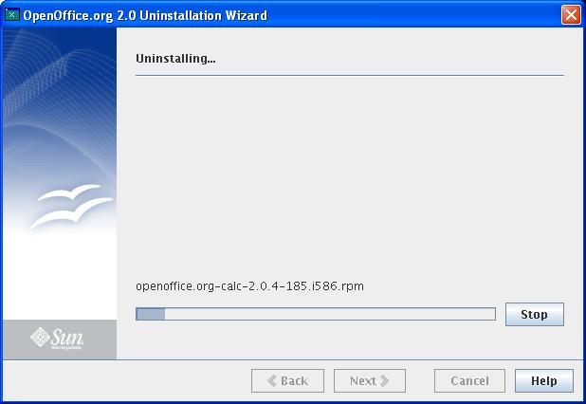Figure 1.46

# | Type | Properties |  | Comment
<#>
<#> |  | Uninstalling... | Entfernen... |  | STRING_UNINSTALLATIONONGOING1
<#> |  | Properties
<#> |  | String English  Stop | String German  Stopp |  | STRING_INSTALLATIONONGOING3

The help text available at the “Uninstalling ...” dialog
Figure 1.47

# | Type | Properties |  | Comment
<#>
<#> |  | Help | Hilfe |  | STRING_HELP
<#> |  | Properties
<#> |  | String English  This page indicates the progress of the uninstallation with the aid of a progress bar. To abort the uninstallation, click 'Stop'. | String German  Diese Seite informiert Sie über den Fortschritt der Deinstallation. Um die Deinstallation abzubrechen, klicken Sie auf 'Stopp'. |  | STRING_UNINSTALLATIONONGOING_1

Aborting the uninstallation
After pressing the “Stop” button on the “Uninstalling ...” dialog, the user has to confirm this abort of uninstallation. Therefore the following dialog appears:

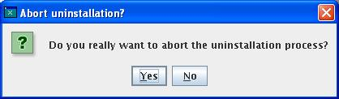Figure 1.48

# | Type | Properties |  | Comment
<#>
<#> |  | Abort uninstallation? | Deinstallation abbrechen? |  | STRING_STOP_DIALOG_TITLE_UNINSTALLATION
<#> |  | Properties
<#> |  | String English  Do you really want to abort the uninstallation process? | String German  Möchten Sie den Deinstallationsassistenten wirklich beenden? |  | STRING_STOP_DIALOG_UNINSTALLATION

The “Uninstallation Completed with Abort” dialog
There are different scenarios for the final dialog of the “Uninstallation Wizard”:
- the uninstallation was successful
- the uninstallation was aborted
- an error occurred during uninstallation

The following dialog represents the scenario, that the “Stop” button was pressed in the “Uninstalling ...” dialog. The button “Details ...” leads to an info dialog, in which more information is available about the system installation database and the process of uninstallation. Nevertheless it is not possible to restore packages, that were already removed before the “Stop” button was pressed. Therefore the product remains in an unclear status.
Figure 1.49

Table <Table Number>: User Interface elements of Figure <Figure Number>
# | Type | Properties |  | Comment
<#> |  | Control Properties  Enabled: <Yes/No>
<#> |  | Uninstallation Aborted | Deinstallation abgebrochen |  | STRING_UNINSTALLATIONCOMPLETED1_ABORT
<#> |  | Control Properties  Enabled: <Yes/No>
<#> |  | String English  The Uninstallation Wizard was aborted before completely removing ${PRODUCT_NAME} from your computer. | String German  Der Deinstallationsassistent wurde beendet, bevor ${PRODUCT_NAME} vollständig von Ihrem Computer entfernt wurde. |  | STRING_UNINSTALLATIONCOMPLETED2_ABORT
<#> |  | Control Properties  Enabled: <Yes/No>
<#> |  | String English  Click 'Finish' to exit the Wizard. | String German  Klicken Sie auf 'Beenden' um den Installationsassistenten zu verlassen. |  | STRING_INSTALLATIONCOMPLETED3
<#> |  | Properties
<#> |  | String English  Details... | String German  Details... |  | STRING_INSTALLATIONCOMPLETED_BUTTON
<#> |  | Control Properties  Enabled: <Yes/No>
<#> |  | String English  Finish | String German  Beenden |  | STRING_FINISH

The “Uninstallation Completed with Success” dialog
If the uninstallation is finished successfully the final dialog contains the “success message”.

Figure 1.50

# | Type | Properties |  | Comment
<#>
<#> |  | Uninstallation Completed | Deinstallation abgeschlossen |  | STRING_UNINSTALLATIONCOMPLETED1
<#> |  | Properties
<#> |  | String English  The Uninstallation Wizard has successfully removed ${PRODUCT_FULLNAME} from your computer. | String German  Der Deinstallationsassistent hat ${PRODUCT_FULLNAME} erfolgreich von Ihrem Computer entfernt. |  | STRING_UNINSTALLATIONCOMPLETED2
<#> |  | Properties
<#> |  | String English  Click 'Finish' to exit the Wizard. | String German  Klicken Sie auf 'Beenden' um den Installationsassistenten zu verlassen. |  | STRING_INSTALLATIONCOMPLETED3
<#> |  | Properties
<#> |  | String English  Details... | String German  Details... |  | STRING_INSTALLATIONCOMPLETED_BUTTON
<#> |  | Properties
<#> |  | String English  Finish | String German  Beenden |  | STRING_FINISH

The “Uninstallation Completed with Error” dialog
If an error occurred during uninstallation, the dialog “Uninstallation Completed with Error” dialog appears. In this case it is especially important to make use of the “Details ...” button, which opens a dialog, that presents additional information about the uninstallation process.

Figure 1.51

# | Type | Properties |  | Comment
<#>
<#> |  | Uninstallation Failed | Deinstallation fehlerhaft | STRING_UNINSTALLATIONCOMPLETED1_ERROR
<#> |  | Properties
<#> |  | String English  An error has occured. Thus the Uninstallation Wizard could not remove ${PRODUCT_NAME} from your computer successfully. Click 'Details...' for more information. | String German  Ein Fehler ist aufgetreten. Daher konnte der Deinstallationsassistent ${PRODUCT_NAME} nicht erfolgreich von Ihrem Computer entfernen. Klicken Sie 'Details..' für nähere Informationen. | STRING_UNINSTALLATIONCOMPLETED2_ERROR
<#> |  | Properties
<#> |  | String English  Click 'Finish' to exit the Wizard. | String German  Klicken Sie auf 'Beenden' um den Installationsassistenten zu verlassen. | STRING_INSTALLATIONCOMPLETED3
<#> |  | Properties
<#> |  | String English  Details... | String German  Details... | STRING_INSTALLATIONCOMPLETED_BUTTON
<#> |  | Properties
<#> |  | String English  Finish | String German  Beenden | STRING_FINISH

Pressing the button “Details ...” on the final dialog of the uninstallation wizards leads to the “Details” dialog, that contains the logging information, that was collected during uninstallation process. This is information about the analysis of the system installation database and information about the calls, that were used to remove the packages.

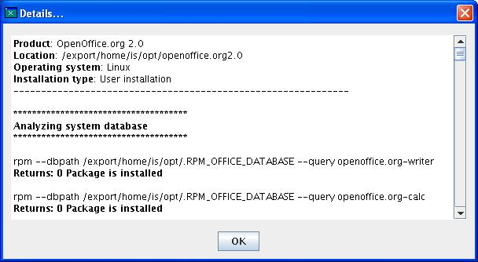Figure 1.52
# | Type | Properties |  | Comment
<#>
<#> |  | Details... | Details... |  | STRING_INSTALLATIONCOMPLETED_BUTTON

Additional dialogs, that are not in special order of the installation/uninstallation wizard

There are several dialogs, that do not fit into the order of the installation wizard or the uninstallation wizard. This dialogs shall be presented now.

The “Exit” dialog in Installation Wizard
If the “Cancel” button is pressed during installation, the following dialog appears. If the user confirms the exit, the installation wizard aborts.

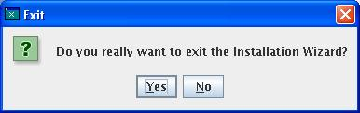Figure 1.53

# | Type | Properties |  | Comment
<#>
<#> |  | Exit | Beenden |  | STRING_CANCEL_DIALOG_TITLE
<#> |  | Properties
<#> |  | String English  Do you really want to exit the Installation Wizard? | String German  Möchten Sie den Installationsassistenten wirklich beenden? |  | STRING_CANCEL_DIALOG

The “Exit” dialog in Uninstallation Wizard
If the “Cancel” button is pressed during uninstallation, the following dialog appears. If the user confirms the exit, the uninstallation wizard aborts.

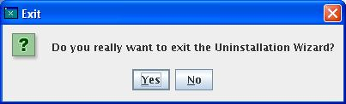Figure 1.54

# | Type | Properties |  | Comment
<#>
<#> |  | Exit | Beenden |  | STRING_CANCEL_DIALOG_TITLE
<#> |  | Properties
<#> |  | String English  Do you really want to exit the Uninstallation Wizard? | String German  Möchten Sie den Deinstallationsassistenten wirklich beenden? |  | STRING_CANCEL_DIALOG_UNINSTALLATION

The “Missing File” dialog
If during the installation process a package cannot be found, the following dialog appears, that informs the user about the missing file. If a package is described in a xpd file, but it is not available in the package directory, there are two possibilities:
1. If the package belongs to a selectable module, the module will be marked as not-selectable.
2. If the package is a root package, that is absolutely necessary for a successful installation, there error message below appears. This leads to an abort of the installation.
There is also one more possibility, in which the following Error-MessageBox appears: At the start of the Wizard the existence of the packages is checked. If a package is found at that time, but is no longer available, when the package shall be installed (using rpm or pkgadd), then the Error-MessageBox must appear. But this requires that the package is removed between start of the Java GUI Installation Wizard and real installation of the package.

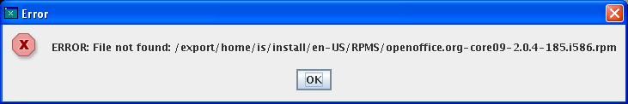Figure 1.55

# | Type | Properties |  | Comment
<#>
<#> |  | Error | Fehler |  | STRING_ERROR
<#> |  | Properties
<#> |  | String English  Error: File not found | String German  Fehler: Datei nicht gefunden |  | STRING_FILE_NOT_FOUND

The dialog “Not Enough Disc Space”
The dialog “Not enough disc space” appears, if there is not enough disc space available to install all selected components. This can be calculated after the “Choose Components” dialog or after the “Select Installation Type” dialog, if “Typical” was selected. In Update Mode (an older version was found) it is not calculated, because existing packages will be replaced.
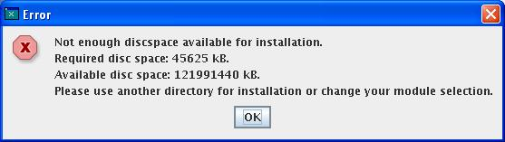Figure 1.56

# | Type | Properties |  | Comment
<#>
<#> |  | Error | Fehler |  | STRING_ERROR
<#> |  | Properties
<#> |  | String English  Not enough discspace available for installation. | String German  Nicht genügend Speicherplatz für die Installation vorhanden. |  | STRING_DISCSPACE_INSUFFICIENT
<#> |  | Control Properties  Enabled: <Yes/No>
<#> |  | String English  Required disc space | String German  Erforderlicher Speicherplatz |  | STRING_DISCSPACE_REQUIRED
<#> |  | Properties
<#> |  | String English  Available disc space | String German  Verfügbarer Speicherplatz |  | STRING_DISCSPACE_AVAILABLE
<#> |  | Control Properties  Enabled: <Yes/No>
<#> |  | String English  Please use another directory for installation or change your module selection. | String German  Bitte wählen Sie ein anderes Installationsverzeichnis oder ändern Sie die Modulauswahl. |  | STRING_DISCSPACE_TIP

Structure of installation set

Installation:

The executable “setup” and the Java file “JavaSetup.jar” are located in the root of the installation set. There are also four directories:
“RPMS” or “packages” in which the native installation packages are located (the directory name is defined in the setup.xpd).
“readmes” with readme files
“licenses” with license files
-> This is identical with StarOffice installation sets (except “JavaSetup.jar” instead of “install.class”)
“installdata”, that contains the information about the installation process. Again there are three subdirectories (four subdirectories on Solaris):
html: Contains help files and license files.
images: Contains the gif file, that is used by the GUI installer.
xpd: Contains the package description files.
getuid (Solaris only): contains the file getuid.so, that is used for Solaris user installations.

Uninstallation:

The “setup” for uninstallation is located next to the program-directory. There also has to be the jar-File “JavaSetup.jar”. Information for the uninstallation process is located in the directory “uninstalldata” next to the program-directory.
This directory “uninstalldata” contains the subdirectories:
html: Contains help files and license files.
images: Contains the gif file, that is used by the GUI installer.
xpd: Contains the package description files.
getuid.so (Solaris user installation only): is the file, that is used for Solaris user installations.
Additionally there are files in the directory “uninstalldata”, that contain information about the installation process (location of installation set, privileges of installer, ...), about the installed packages and the admin files for Solaris installations.

Place of local database in user installation

Linux:
The database file .RPM_OFFICE_DATABASE is always created in the parent directory of the installation directory. Example:
Installation to: /home/ab/test/opt/openoffice.org2.0
Database path: /home/ab/test/opt/.RPM_OFFICE_DATABASE

Solaris:
In a Solaris user installation the user has to define the new installation root. There are several directories created below this root. One of this directories is the “/var/sadm” directory, that contains the local installation database.

Special module settings in Custom setup

Modules are shown without color and are therefore not selectable, if:
- The module is described in a xpd file, but the package (RPM) does not exist.
- The package is already installed in the same or in a higher version.

If a module is flagged that it is not installed in a user installation (System integration), it is not visible in the module selection of the Custom setup.

Shell script “setup”

The shell script offers the following functionality:

Optional parameter “-j” to define a special Java Runtime Environment
Optional parameter “-h” to show a very short help

Some not translated messages are shown in the shell, if a problem occurs ($0 is the name of the program, in this case “setup”):

The displayed help:
"Usage: $0 [ -j <java_runtime> ]"

Error codes and messages
1: "Error: Platform $platform not supported for Java Runtime Environment (JRE) installation."
2: "Error: Invalid java runtime $java_runtime, file does not exist."
3: "Error: Invalid java runtime $java_runtime, not an executable file."
4: "Error: Java Runtime Environment (JRE) not found in directory: $packagepath"
5: "Error: Failed to copy Java Runtime Environment (JRE) temporarily."
6: "Error: Failed to install Java Runtime Environment (JRE) temporarily."
7: "Error: Failed to extract the Java Runtime Environment (JRE) files."
8: "Error: Failed to extract the Java Runtime Environment (JRE) files."
9: "Error: Did not find a valid Java Runtime Environment (JRE). Required JRE versions: $java_versions_supported"
10: "Error: Did not find an installed Java Runtime Environment (JRE)."
11: "Error: Did not find rpm2cpio. rpm2cpio is currently required for installations on Linux."
12: "Error: Did not find rpm. rpm is currently required for installations on Linux."

Migration
<Start typing here ----- If this part is irrelevant state a reason for its absence!>

Configuration
<Start typing here ----- If this part is irrelevant state a reason for its absence!>

Open Issues
Issue | Initials | Date

Document Change History
Rev. | Change | Initials | Date
1 | 1.0 First official version | IS | Dec. 07, 2006
2
3
<...>

