Software Specification Document

OpenOffice.org
Behavior of Hyperlinks in OOo Documents

Specification Status
Last Change | Nov 6, 2007
Status
Abstract
Hyperlinks are used to point to another source of data and are commonly known on web pages. In a web browser those links are being executed on a left mouse click. They are also used inside classic documents like text documents, spreadsheets, drawings or presentations. In classical documents those active hyperlinks often prevents the user from editing the textual content of the document or link representation in the document, because the hyperlink is being executed on a left mouse click performed to place the cursor in the document content. This specification defines the handling of hyperlinks in OOo to improve editing of document content.
i-Team Members
Role | First Name, Last Name, Initials | E-Mail Address
I-Team Lead | Frank Loehmann | frank.loehmann@sun.com
Specification Author | Frank Loehmann | frank.loehmann@sun.com
User Experience | Frank Loehmann | frank.loehmann@sun.com
Development | Frank Meies | frank.meies@sun.com
Quality Assurance | Michael Ruess | michael.ruess@sun.com
Documentation | Uwe Fischer | Uwe.fischer@sun.com

Contents
Abstract 1
i-Team Members 1
References and Reference Documents 3
Acronyms and Abbreviations 3
1 Competitive Analysis 4
1.1 OpenOffice.org 2.0-2.2.1 4
1.2 Microsoft Office 2003 5
1.2.1 Word 5
1.2.2 Web Hyperlinks 5
1.2.3 References 5
1.2.4 Footnote 6
1.2.5 Excel 6
1.3 PowerPoint 6
1.4 Microsoft Office 2007 6
1.5 Macromedia/Adobe DreamWeaver 7
2 Detailed Specification 8
2.1 Writer 8
2.1.1 Hyperlinks and SmartTags 8
2.1.2 References / Footnote Achors 8
2.1.3 Read-Only and (Issue 79950, has to be further discussed with FME) 8
2.2 Calc 8
2.3 Draw 8
2.4 Impress 9
3 Migration 9
4 Configuration 9
5 File Format 9
6 Open Issues 9
Document Change History 9

References and Reference Documents
Reference Document | Check | Location (URL)
Specification Process Entry Check |  | N/A
Product Requirement, RFE, issue [Required] |  | 22133, 80029
Product Concept Document |  | <Please enter location here>
Competitive Analysis |  | <Please enter location here>
IDL Specification |  | <Please enter location here>
Test Case Specification [Required] |  | <Please enter location here>
Software Specification Rules | N/A | N/A
Related Spec: SmartTags |  | http://specs.openoffice.org/appwide/SmartTags/Smart_Tags_Specification.odt
Acronyms and Abbreviations
Acronym / Abbreviation | Definition
<WYSIWYG> | <What You See Is What You Get>

Competitive Analysis
The following competitive analysis shows the behavior of related products and previous versions of OOo.
Viewed aspects:
- Ease of use when editing documents.
- Security. User is concentrated on editing documents not on browsing.
- Read-only mode may behaves different.
- Read-only elements in documents (i.e. read-only section, field) which could not be edited may behave different.
- Writer is used to display help content in read-only mode.

OpenOffice.org 2.0-2.2.1
OOo always executes hyperlinks and link like references on a simple left mouse click. The ALT key can be pressed to disable hyperlinks temporarily. Furthermore the status bar in Writer offers two different modes. The HYP mode is the default and allow to execute links on a left mouse click. A left mouse click to the status bar filed showing the text HYP toggles to the SEL mode. The SEL mode does not execute any links in the document. Even references are not executed in that mode. The ALT key temporarily activates the links in the SEL mode while the ALT key is pressed.
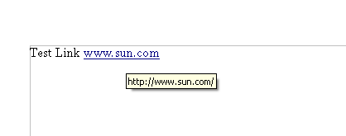Illustration 1: Mouse over hyperlink shows address and gives mouse pointer feedback (mouse pointer not shown in illustration)
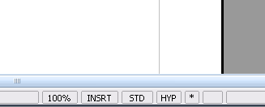Illustration 2: HYP/SEL toggle mode in Writer status bar

Microsoft Office 2003
In Microsoft Office 2003 each main application shows a different handling of hyperlinks.

Word
In Word there are many different elements that can be named hyperlink, because they point to a target and allow to jump to this target.

Web Hyperlinks
Hyperlinks will not be executed on a left mouse click. Ctrl key must be pressed while left clicking the link to execute the hyperlink.
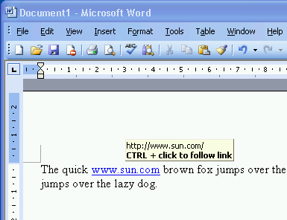Illustration 3: Word 2003 showing tip help on a mouse over link

References
References are handled like links. So the Ctrl key has to be pressed to jump to referenced text.
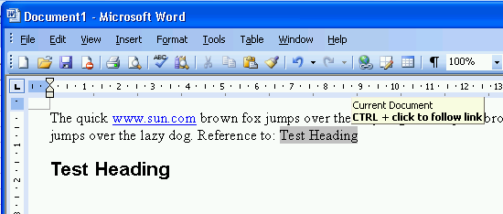Illustration 4: Word 2003 does not execute references. Same behavior as shown for hyperlinlks.

Footnote
The anchor of a footnote allows to jump to the footnote text in the footer by a double click on the anchor.
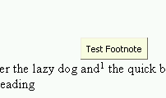Illustration 5: Double click on Foot note anchor allows to follow link.

Excel
Excel executes links on a left click, but offer a special behavior of a long click to enter the cells edit mode.
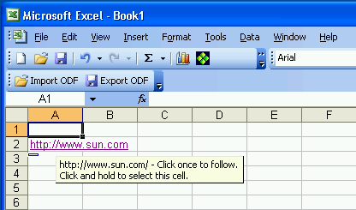Illustration 6: Excel showing tip help how to select the cell without executing the link

PowerPoint
No execution of hyperlinks in edit mode of presentation at all. The presentation mode allows to execute links on a single left mouse click.

Microsoft Office 2007
Links in Microsoft Office 2007 are handled the same way like in Microsoft Office 2003.

Macromedia/Adobe DreamWeaver
A hyperlink in the edit view is not active. Links can be executed only in Web browser preview mode.
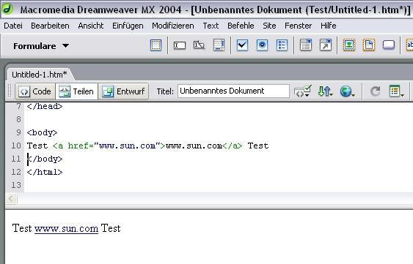Illustration 7:

Detailed Specification
Currently the behavior is changed for Writer only. Please see Open Issues section for further steps to be made.

Writer
The HYP/SEL mode, available thru the Writer status bar, gets removed.

Hyperlinks and SmartTags
Writer now provides a tip help above SmartTags and Links and will not execute those links on a left mouse click anymore. Now the Ctrl key has to be pressed down while clicking the link. The tool tip shows the link and the hint to press the Ctrl key.

- “Ctrl + click to open Smart Tag Menu” - Tip Help Properties |  | Comment
Label: | Ctrl-click to open Smart Tag menu |  | EN-US
Label: | Strg-Klick um das Smarttag-Menü zu öffnen |  | DE

- “Ctrl + click to open hyperlink - Tip Help Properties |  | Comment
Label: | Ctrl-click to open hyperlink: <URL> |  | EN-US
Label: | Strg-Klick um Hyperlink zu öffnen: <URL> |  | DE

References / Footnote Achors
References and footnote anchors in Writer will still be executed on a left click. The shortcut Alt, to temporally deactivate hyperlinks, will be kept to select cross references.

Read-Only and (Issue 79950, has to be further discussed with FME)
Links in read-only documents can be further executed without holding down the Ctrl key and show a browser like behavior. This happens because those documents and sections could not be edited.

Calc
Classical behavior is kept.

Draw
Classical behavior is kept.

Impress
Classical behavior is kept.

Migration
None.

Configuration
See security specification (p. 58/59) for details about how to configure this security related hyperlink behavior.

File Format
None.

Open Issues
Issue | Initials | Date
Extend context menu by  1) Edit Hyperlink...  2) Select Hyperlink  3) Open Hyperlink  4) Copy Hyperlink  5) Remove Hyperlink | FL | 25 July, 2007
Ctrl key equivalent on a Mac is the command key. So the tip help depends on the platform. | FL | 27 July, 2007
Calc, Draw, Impress should adapt this change in future versions too. | FL | 01 August, 2007
References in Writer should show same behavior links do | FL | 01 August, 2007

Document Change History
Rev. | Change | Initials | Date
1 | Initial specification | FL | 25 July, 2007
2 | Competitive analysis | FL | 27 July, 2007
3 | Minor changes | FL | 01 August, 2007
<...>

This selection mode was mostly unknown to users and limited to Writer only.
See SmartTags specification for details: http://specs.openoffice.org/appwide/SmartTags/Smart_Tags_Specification.odt
http://specs.openoffice.org/appwide/security/Electronic_Signatures_and_Security.sxw

