Software Specification Document

OpenOffice.org
Online Update: Download and Installation

Specification Status
Last Change | 05.07.07
Status

Abstract
Every modern application offers the option to check for newer versions and optional allows the download and installation of that new version. This document shows how this functionality will be presented to the user in OpenOffice.org 2.3.
In OpenOffice.org the user can download directly the notified update from within the OpenOffice.org application without the need to select the appropriate update in a web browser as in the former OpenOffice.org release. The installation of the update can be started from within the application, too.
Additionally the user can switch on a further option for automatic downloading.

i-Team Members
Role | First Name, Last Name, Initials | E-Mail Address
Project Lead | Oliver Braun (obr) | obr@openoffice.org
Specification Owner | Bettina Haberer (bh) | bh@openoffice.org
User Experience | Bettina Haberer (bh) | bh@openoffice.org
Development | Dirk Völzke (dv) | dv@openoffice.org
Development | Oliver Braun (obr) | obr@openoffice.org
Quality Assurance | Olaf Felka (of) | of@openoffice.org
Documentation | Uwe Fischer (ufi) | ufi@openoffice.org
Other roles
<State reason here, if one role is not represented in i-Team.>

Contents
Abstract 1
i-Team Members 1
References and Reference Documents 3
Acronyms and Abbreviations 3
1 Detailed Specification 4
1.1 Notification bubble and dialogs 4
1.2 The manual checking and it's appropriate dialogs 4
1.2.1 After selecting the help menu entry 'Check for Updates...' 4
1.2.2 Check failed 7
1.2.3 Status up to date 8
1.3 An update for download is available 9
1.3.1 A new update is found 9
1.3.2 The download has been started 12
1.3.3 The automatically started download 14
1.3.4 Avoiding several downloads 15
1.3.5 Pausing the download 16
1.3.6 Resuming the download 18
1.3.7 Canceling the download 19
1.3.8 Running a download, when a new update is found in parallel 19
1.3.9 An error occurred 20
1.3.10 Unpacking the downloaded archive 22
1.3.11 Automatic download currently not available 22
1.4 Starting the installation 24
1.5 The “installation wizard” on Linux / Solaris 27
1.6 Appearing notifications after the start of OpenOffice.org 28
1.7 The page 'Online Update' in Tools / Options 29
1.8 Hooks for opening the landing page 29
1.9 Presenting the update status in the 'Check for Updates' dialog with columns 30
2 Migration 30
3 Configuration 30
4 File Format 30
5 Open Issues 30
Document Change History 30

References and Reference Documents
Reference Document | Check | Location (URL)
Specification Process Entry Check |  | N/A
Issue i72386 |  | <Please enter location here>
Product Concept Document |  | <Please enter location here>
Competitive Analysis |  | <Please enter location here>
Test Case Specification (required)
Software Specification Rules | N/A | N/A
<Other, e.g. references to related specs>

Acronyms and Abbreviations
Acronym / Abbreviation | Definition
<WYSIWYG> | <What You See Is What You Get>

Detailed Specification

Notification bubble and dialogs
The user will be informed about the availability of new updates or the current status of the download of that newer version in one of two ways. When the 'check for updates' dialog is shown, the current status will be shown in the status area of that dialog, otherwise (the dialog is closed or minimized) a notification bubble will be shown at the update-available icon for every status change ( new version available, download started, download finished, ... ). The notification bubbles will disappear after 10 seconds but will reappear (with an actual status message) while the mouse is over the notification icon. Clicking the notification icon shows the 'check for updates' dialog as will choosing help/check for updates in the menubar.

The manual checking and it's appropriate dialogs
When the user chooses help/check for updates in the menubar, the 'check for updates' dialog opens. If no previous (automatic or manual ) search has found a newer version of the office, a search for an update will be stated immediately, otherwise the current status ( update available / download in progress / ready to install ) will be shown in the dialog.

After selecting the help menu entry 'Check for Updates...'
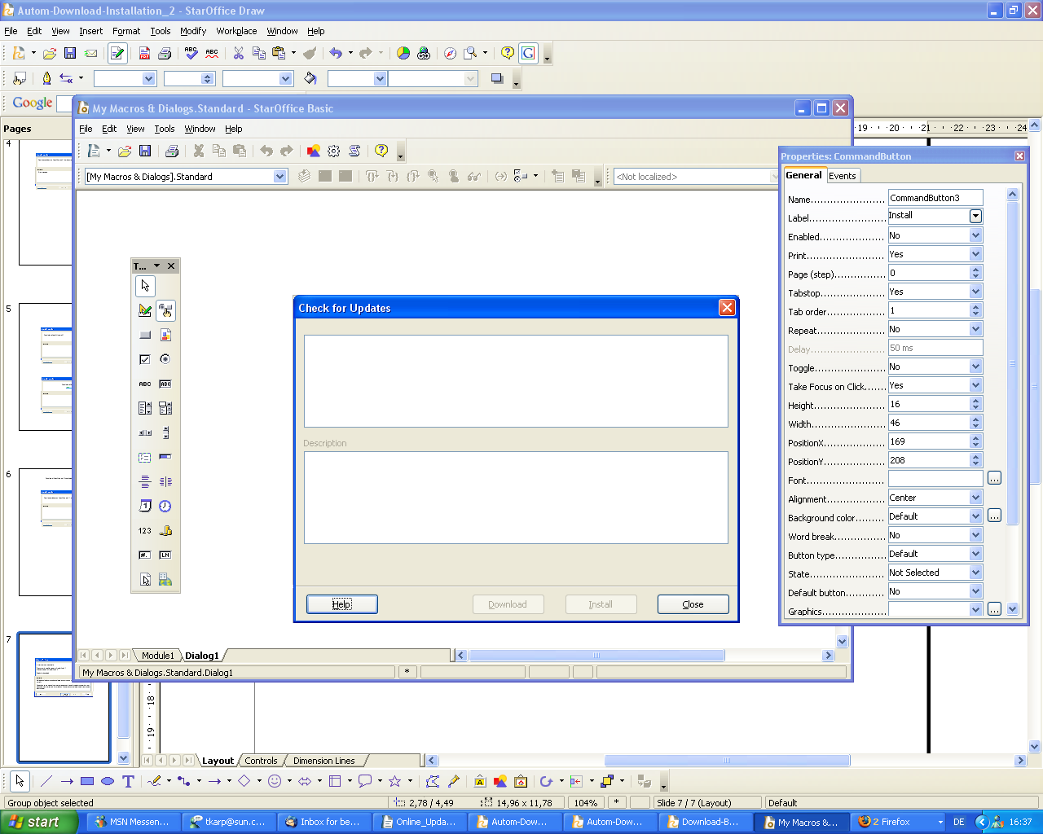
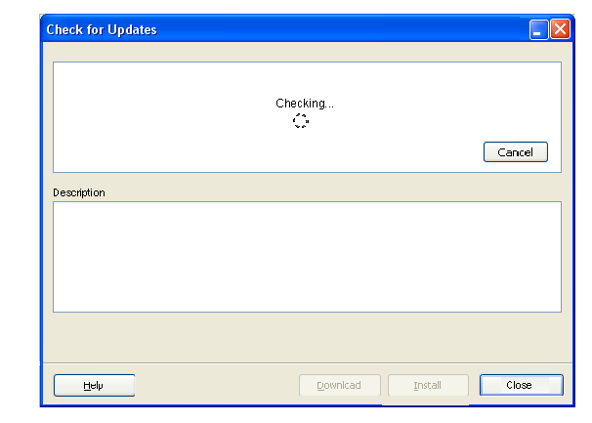


Figure 1: The running check for an update.
Status
Checking...
Description
Close
Close

String Table Figure 1
# | Type | Properties |  | Comment
<#> |  | Control Properties  State: modeless  Closable: yes  Resizable: no  Always On Top: no  A11Y Text: none  Other...: none
<#> |  | Check for Updates | Suche nach Updates
<#> |  | Control Properties  Enabled: yes
<#> |  | String English  Checking... | String German  Suche läuft...
<#> |  | Control Properties  Enabled: yes  Editable: no
<#> |  | String English  Description | String German  Beschreibung
<#> |  | Control Properties  Enabled: yes
<#> |  | String English  ~Help | String German  ~Hilfe
<#> |  | Control Properties  Enabled: no  Icon: no  Resizeable: no  Has Menu: no  Menu Items: none  ToolTipText: none
<#> |  | String English  ~Download | String German  Herunter~laden
<#> |  | Control Properties  Enabled: no  Icon: no  Resizeable: no  Has Menu: no  Menu Items: none  ToolTipText: none
<#> |  | String English  ~Install | String German  ~Installieren
<#> |  | Control Properties  Enabled: no  Icon: no  Resizeable: no  Has Menu: no  Menu Items: none  ToolTipText: none
<#> |  | String English  Close | String German  Schließen
<#> |  | Control Properties  Enabled: yes  Icon: no  Resizeable: no  Has Menu: no  Menu Items: none  ToolTipText: none
<#> |  | String English  Cancel | String German  Abbrechen
<#> |  | Control Properties  Enabled: yes  Editable: no
<#> |  | String English  Status | String German  Status

The dialog offers the opportunity to be minimized to the task bar during the check or download, so that the user can continue the work without the need to navigate the dialog around. The dialog is modeless.The modeless dialog remembers the last status.
The status of the current actions becomes visible in the status box of the dialog, where the found update version will be listed.
The description box is an area, which can contain hints or error messages. Furthermore the main new features or enhancements of an update shall be visible as a bulleted list. A vertical scroll bar will appear in the description field in case the text to be provided needs more lines then available with the default field height.
As long as a check runs, the close button keeps disabled.
In case the cancel button is clicked, the dialog will be closed and the check will be aborted.

Check failed
In case an error occurs during the check, the dialog becomes visible as follows:

Figure 2: The checking failed.
Close
Error message.
Error message.
Description
Status
Checking for an update failed.
Error message.

String Table Figure 2

# | Type | Properties |  | Comment
<#> |  | Control Properties  Enabled: yes
<#> |  | String English  Checking for an update failed. | String German  Die Suche nach einem Update ist fehlgeschlagen.

Status up to date
When the check has finished, the status is visible in the dialog. As no new update was found, no notification icon becomes visible.
The dialog can be closed manually or via the task context menu in the system tray.
Figure 3: No new update was found.
Close
Error message.
Error message.
Description
Status
OpenOffice.org 2.0 is up to date.

String Table Figure 3

# | Type | Properties |  | Comment
<#> |  | Control Properties  Enabled: yes
<#> |  | String English  %PRODUCTNAME %PRODUKTVERSION is up to date. | String German  %PRODUCTNAME %PRODUKTVERSION ist auf dem neuesten Stand.

An update for download is available

A new update is found
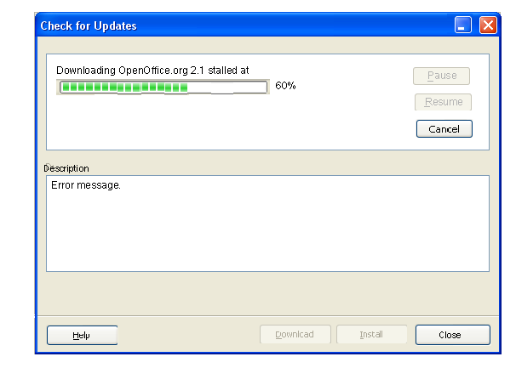
Figure 4: Ready for download.
Close
Error message.
Error message.
Description
Status
Download
OpenOffice.org 2.1 is available.

The installed version is OpenOffice.org 2.0.

Note: Before downloading this update, ensure that you have sufficient access rights to install it.
A password, usually the administrator's or root password, may be required.
The download location is: C:\Documents and Settings\xy4711\Desktop.

Under Tools - Options... - OpenOffice.org - Online Update you can change the donwload location.

String Table Figure 4
# | Type | Properties |  | Comment
<#> |  | Control Properties  Enabled: yes
<#> |  | %PRODUCTNAME %NEXTVERSION is available.\n\nThe installed version is %PRODUCTNAME %PRODUCTVERSION.\n\nNote: Before downloading an update, please ensure that you have sufficient access rights to install it.\n A password, usually the administrator's or root password, may be required. | %PRODUKTNAME %NEXTVERSION ist verfügbar.\n\nDie installierte Version ist %PRODUCTNAME %PRODUCTVERSION.\n\nHinweis: Bevor Sie ein Update herunterladen, vergewissern Sie sich bitte, dass Sie die benötigten Rechte zur Installation haben.\nEin Passwort, normalerweise das eines Administrators oder das Root Passwort, könnte erforderlich sein.

<#> |  | Control Properties  Enabled: yes  Icon: no  Resizeable: no  Has Menu: no  Menu Items: none  ToolTipText: none
<#> |  | String English  ~Download | String German  Herunter~laden
<#> |  | Control Properties  Enabled: no  Icon: no  Resizeable: no  Has Menu: no  Menu Items: none  ToolTipText: none
<#> |  | String English  ~Install | String German  ~Installieren
<#> |  | Control Properties  Enabled: yes
<#> |  | String English  The download location is: %DOWNLOAD PATH.\n\nUnder Tools – Options... - %PRODUCTNAME – Online Update you can change the download location. | String German | New string, please translate into German.

In case the 'Check for Updates' dialog is not visible, the notification comes up for about 10 seconds as shown in Figure 5. As long as no download is started, the notify text is visible at mouse over at the notification icon.
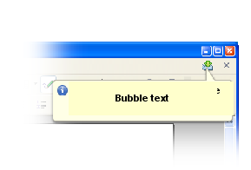
Figure 5: A new update is found.
OpenOffice.org update available
Click here to start the download.
String Table Figure 5

Item | English | German | Comments
Notification bubble | %PRODUCTNAME update available | %PRODUCTNAME Update verfügbar
Notification bubble | Click here to start the download. | Klicken Sie hier, um das Update herunterzuladen.

The download has been started
The status shows the progress of download by a progress bar. Besides the progress bar the percentage value is shown.
The download status in the dialog: The description box is enabled for showing possible messages. The close button get's the focus. In case close is clicked, the dialog closes and the download continues.
After the user has clicked on the download button, the progress bar and the buttons shall appear all at once.
Figure 6: The running download.
Close
Error message.
Error message.
Description
Status
Downloading OpenOffice.org 2.1...
60%
Resume

String Table Figure 6
Item | English | German | Comments
Status label | Downloading %PRODUCTNAME %NEXTVERSION... | Herunterladen von %PRODUCTNAME %NEXTVERSION...
Progress Value | %PERCENT% | %PERCENT% | Please don't translate %PERCENT as it is a placeholder.

<#> |  | Control Properties  Enabled: no  Icon: no  Resizeable: no  Has Menu: no  Menu Items: none  ToolTipText: none
<#> |  | String English  ~Download | String German  Herunter~laden
<#> |  | Control Properties  Enabled: no  Icon: no  Resizeable: no  Has Menu: no  Menu Items: none  ToolTipText: none
<#> |  | String English  ~Install | String German  ~Installieren
<#> |  | Control Properties  Enabled: yes  Icon: no  Resizeable: no  Has Menu: no  Menu Items: none  ToolTipText: none
<#> |  | String English  ~Pause | String German  ~Anhalten
<#> |  | Control Properties  Enabled: no  Icon: no  Resizeable: no  Has Menu: no  Menu Items: none  ToolTipText: none
<#> |  | String English  ~Resume | String German  ~Fortsetzen
<#> |  | Control Properties  Enabled: yes  Icon: no  Resizeable: no  Has Menu: no  Menu Items: none  ToolTipText: none
<#> |  | String English  Cancel | String German  Abbrechen

When the download has finished (after having run until 100%):
- The progress bar disappears
- the download button becomes disabled and the install button becomes enabled
- and the following string is shown:

String Table Figure 14 / Figure 15 notifying the finished download.
Item | English | German | Comments
Status label | Download of %PRODUCTNAME % NEXTVERSION completed\n Ready for installation. | Das Herunterladen von %PRODUCTNAME % NEXTVERSION ist abgeschlossen\nBereit zur Installation.

<#> |  | Control Properties  Enabled: no  Icon: no  Resizeable: no  Has Menu: no  Menu Items: none  ToolTipText: none
<#> |  | String English  ~Download | String German  Herunter~laden
<#> |  | Control Properties  Enabled: yes  Icon: no  Resizeable: no  Has Menu: no  Menu Items: none  ToolTipText: none
<#> |  | String English  ~Install | String German  ~Installieren

The automatically started download
When an automatic check ends with a found update and the user has had checked the option 'Download updates automatically' under Tools / Options / OpenOffice.org / Online Update, the notify informs about the started download. At click on the notify icon the dialog opens and shows detailed information.
The bubble is shown for 10 seconds the first time.

Figure 7: The automatically started download is notified.
OpenOffice.org update available
Download of update begins.
String Table Figure 7
Item | English | German | Comments
Notification bubble | %PRODUCTNAME update available | %PRODUCTNAME Update verfügbar
Notification bubble | Download of update begins. | Das Herunterladen des Updates beginnt.

At mouse over the notification icon the progress of the download is visible.
Figure 8: Notifying the download progress.
Download of update in progress
String Table Figure 8
Item | English | German | Comments
Notification bubble | Download of update in progress |  | Please translate.

Avoiding several downloads

In case an update was downloaded but not installed while the option 'Download updates automatically' has been switched on, it is necessary to assure, that no further needless download will happen.
If in above case a new update has been found the versions of the already downloaded update and the found new update need to be compared.

If both updates have the same version number, the new update will not be downloaded. The notification then is visible as shown in Figure 14. When pressing the download button, the user will be asked (by a standard message box) whether the file already present on disk shall be overwritten or not . If the user chooses to download again, the dialogs proceed as shown in Figure 6, otherwise as shown in Figure 15.

If the found new update has a higher version number, the new update will be downloaded. The notification then is visible as shown in Figure 4 / 5.

Pausing the download

Figure 9: Notifying a paused download.
Download of update paused
Click here to resume.

String Table Figure 9
Item | English | German | Comments
Notification bubble | Download of update paused | Das Herunterladen des Updates wurde angehalten
Notification bubble | Click here to resume. | Klicken Sie hier, um es fortzusetzen.

Figure 10: The pause status in the dialog.
60%
Downloading OpenOffice.org 2.1paused at...
Close
Error message.
Error message.
Description
Status
60%
Downloading OpenOffice.org 2.1paused at...
Pause

String Table Figure 10
Item | English | German | Comments
Status label | Downloading %PRODUCTNAME %NEXTVERSION paused at... | Das Herunterladen von %PRODUCTNAME % NEXTVERSION wurde angehalten bei...
Progress Value | %PERCENT% | %PERCENT% | Please don't translate %PERCENT as it is a placeholder.

<#> |  | Control Properties  Enabled: no  Icon: no  Resizeable: no  Has Menu: no  Menu Items: none  ToolTipText: none
<#> |  | String English  ~Download | String German  Herunter~laden
<#> |  | Control Properties  Enabled: no  Icon: no  Resizeable: no  Has Menu: no  Menu Items: none  ToolTipText: none
<#> |  | String English  ~Install | String German  ~Installieren
<#> |  | Control Properties  Enabled: no  Icon: no  Resizeable: no  Has Menu: no  Menu Items: none  ToolTipText: none
<#> |  | String English  ~Pause | String German  ~Anhalten
<#> |  | Control Properties  Enabled: yes  Icon: no  Resizeable: no  Has Menu: no  Menu Items: none  ToolTipText: none
<#> |  | String English  ~Resume | String German  ~Fortsetzen
<#> |  | Control Properties  Enabled: yes  Icon: no  Resizeable: no  Has Menu: no  Menu Items: none  ToolTipText: none
<#> |  | String English  Cancel | String German  Abbrechen

After click on the 'Pause' button the download becomes paused, the pause button becomes disabled and the resume button becomes enabled. The progress bar stops and keeps at the current status.

Resuming the download
Figure 6 shows the status for resuming, after the user has clicked the resume button.
Figure 8 shows the status of the resumed download appropriately in the notify bubble.
In case that during the resuming an error occurs, the dialog shows the status as shown in Figure 11.
Figure 12 shows the status of the stalled download appropriately in the notify bubble.

In some case we have to avoid several notifies coming up at the same moment, so that the user does not become confused.
That might be the case in this situation: The user has running an Office on his notebook. He starts the download, which becomes interrupted and he closes his notebook. In the meantime the auto resume showed effort so that two notifies will appear directly one after another after when he continues his Office session, the first notify about the stalled download and the second about the resumed download.

Canceling the download
At clicking the cancel button during the running download, a warning message shall appear.
The same warning appears, when the cancel button is clicked at a paused download (when the 'pause' button is disabled and the 'resume' button is enabled).

String Table for the warning message box 1
Item | English | German | Comments
Text label | Do you really want to cancel the download? | Möchten Sie das Herunterladen wirklich abbrechen?
Button label | Yes | Ja
Button label | No | Nein

The 'No' button has the focus.
At click on the 'Yes' button
- The message box and the dialog get closed
- the download is canceled
- the canceled download shall be deleted
- in case the user opens the Check for Updates dialog again (manual check or via the still open notify icon), the status of the dialog becomes visible as shown in Figure 4.

In case of canceling a stalled download
- the download is canceled
- the canceled download shall be deleted
- in case the user opens the Check for Updates dialog again (manual check or via the still open notify icon), the status of the dialog becomes visible as shown in Figure 4.

Running a download, when a new update is found in parallel
As long as a download is in progress, no further checking for updates takes place.

An error occurred
When an error occurs at checking or downloading, the appropriate error message appears in the description box. Error messages are directly handed over from the error handler into the description box, means, errors, which do not need an own interaction, become readable in the description box, else they come up in an own message box. The messages are prefixed with the appropriate icon.
It is more helpful for the user to have the resume button disabled. If this button would be enabled, it would suggest him, to be able to resume the download again not knowing if that will work. Having this button disabled helps making the decision to close it without wasting time.
A programatically managed auto resume runs and in case it succeeds, the dialog is shown as in Figure 6 and the notify is shown as in Figure 8.

Figure 11: The description field as a place for an error message.
Close
Error message.
Error message.
Description
Status
Error message.
Downloading OpenOffice.org 2.1 stalled at
60%
Pause
Resume

String Table Figure 11
# | Type | Properties |  | Comment
<#> |  | Control Properties  Enabled: yes
<#> |  | String English  Downloading %PRODUCTNAME %NEXTVERSION stalled at | String German  Das Herunterladen von %PRODUCTNAME % NEXTVERSION wurde unterbrochen bei
<#> |  | Control Properties  Enabled: yes
<#> |  | String English  %PERCENT% | String German  %PERCENT% |  | Please don't translate, this is a progress value.
<#> |  | Control Properties  Minimum Value: 0  Maximum Value: 100  A11Y Text: none

<#> |  | Control Properties  Enabled: no  Icon: no  Resizeable: no  Has Menu: no  Menu Items: none  ToolTipText: none
<#> |  | String English  ~Pause | String German  ~Anhalten
<#> |  | Control Properties  Enabled: no  Icon: no  Resizeable: no  Has Menu: no  Menu Items: none  ToolTipText: none
<#> |  | String English  ~Resume | String German  ~Fortsetzen
<#> |  | Control Properties  Enabled: yes  Icon: no  Resizeable: no  Has Menu: no  Menu Items: none  ToolTipText: none
<#> |  | String English  Cancel | String German  Abbrechen

The bubble text hints to more information about an error, which occurred at the download of a found update. At click on the icon the dialog comes to front, opens or gets maximized showing the last status, in this case the error message.
Figure 12: An error occured hinting to more information about.
Download of update stalled
Click here for more information.

String Table Figure 12
Item | English | German | Comments
Notification bubble | Download of update stalled | Das Herunterladen des Updates ist unterbrochen worden
Notification bubble | Click here for more information. | Klicken Sie hier, um mehr Information zu erhalten.

Unpacking the downloaded archive
The Linux and Solaris installation sets consist of a number of native packages bundled into an tar.gz archive, which need to be unpacked prior to installation. This happens at the end of the download transaction, so the download progress might stay at 100% for a while before the dialog proceeds to the “ready to install” state.

Automatic download currently not available
In case the server does temporarily not support the automatic download, the user gets directed to the landing page supporting him with lots of information. On that page the user gets directed to the available download he was notified about. In that rare case The 'Check for Updates' dialog becomes visible with a relabeled download button. The install button keeps visible disabled.

<#> |  | Control Properties  Enabled: yes  Icon: no  Resizeable: no  Has Menu: no  Menu Items: none  ToolTipText: none
<#> |  | String English  ~Download... | String German  Herunter~laden...

String Table for the text shown in the description field
Item | English | German | Comments
Text label | The automatic download of the update is currently not available.\n\nClick 'Download...' to download %PRODUCTNAME % NEXTVERSION manually from the web site. | Das automatische Herunterladen des Updates ist momentan nicht verfügbar.\n\nKlicken Sie auf 'Herunterladen...', um %PRODUCTNAME % NEXTVERSION manuell von der Webseite herunterzuladen.

At click on the 'Download...' button the browser opens on the landing page and the 'Check for Updates' dialog is closed. The download now starts outside the Office process.

Figure 13: The automatic update is not available.
Close
Error message.
Error message.
Description
Status
Download...
OpenOffice.org 2.1 is available.

The installed version is OpenOffice.org 2.0.

Note: Before downloading this update, ensure that you have sufficient access rights to install it.
A password, usually the administrator's or root password, may be required.
The automatic download of the update is currently not available.

Click 'Download...' to download OpenOffice.org 2.1 manually from the web site.

The appropriate notification bubble becomes visible as shown in Figure 14:

Figure 14: Providing more information in case no automatic download is available.
OpenOffice.org update available
Click here for more information.

String Table Figure 14
Item | English | German | Comments
Notification bubble | %PRODUKTNAME update available | %PRODUCTNAME Update verfügbar
Notification bubble | Click here for more information. | Klicken Sie hier, um mehr Information zu erhalten.

The opening dialog (Figure 13) explains that the automatic download is not available and leads the user to the web site, where the user can download the new version manually.

Starting the installation
As long as the download has happened but the installation has not been started yet, the notification (fFigure 16) comes up at an Office start. Figure 15 shows the status in the dialog. The focus is on the install button.
When the dialog is not visible, the user is notified by the following text as seen in Figure 16. When the bubble appears, it is visible for about 10 seconds. The same text is shown at mouse over.

Figure 15: Ready for installation.
Close
Error message.
Error message.
Description
Status
Install
Download of OpenOffice.org 2.1 completed. Ready for installation.
OpenOffice.org 2.1 has been downloaded to C:\Documents and Settings\xy4711\Desktop.

String Table Figure 15
Item | English | German | Comments
Status label | Download of %PRODUCTNAME % NEXTVERSION completed. Ready for installation. | Das Herunterladen von %PRODUCTNAME % NEXTVERSION ist abgeschlossen. Bereit zur Installation.
Description label | %PRODUCTNAME % NEXTVERSION has been downloaded to %DOWNLOAD PATH. | %PRODUCTNAME % NEXTVERSION ist nach %DOWNLOAD PATH heruntergeladen worden.

Figure 16: The notification for installation.
Download of update completed
Click here to start the installation.

String Table Figure 16
Item | English | German | Comments
Notification bubble | Download of update completed | Das Herunterladen des Updates ist beendet
Notification bubble | Click here to start the installation. | Klicken Sie hier, um die Installation zu starten.

In case the install button in the 'Check for Updates' dialog is clicked, a warning message box appears with the following strings:

String Table for the warning message box 2
Item | English | German | Comments
Text label | To install the update, %PRODUCTNAME %PRODUCTVERSION needs to be closed. Do you want to install the update now? | Zur Installation des Updates wird %PRODUCTNAME %PRODUCTVERSION beendet. Möchten Sie das Update jetzt installieren?
Button label | ~Yes | ~Ja
Button label | ~No | ~Nein

The 'Yes' button in the message box has the focus.

At click on the 'Yes' button
- the message box is closed
- all the Office applications are closed
- and the installation wizard comes up starting the installation procedure (see )
- The notify icon disappears after having installed the update
- as long as no new update is found, the opened dialog shows the status as Figure 3
In case the installation does not start at click on the 'Install now' button, a warning text is shown in the description field which informs the user to start the installation manually.

Item | English | German | Comments
Description label | Could not run the installer application, please run %FILE_NAME in %DOWNLOAD_PATH manually. | Das Installationsprogramm konnte nicht gestartet werden! Bitte starten Sie das Programm %FILE_NAME im Verzeichnis %DOWNLOAD_PATH.

If OpenOffice.org could not be closed and the user runs the Office start manually, the starting setup tells him finally to close the Office himself.

The “Installation Wizard” on Linux / Solaris
The unix package manager are mostly command line tools and even though there are graphical frontends available for them, these mostly target updating from the vendors repository and do not suit a 3rd party applications requirements very well.
So on Linux/Solaris, the installation wizard is actually a terminal window popping up, which prompts the user for an administrative password (either through gksu/kdesu or directly in the terminal window) followed by the appropriate package management command sequence.
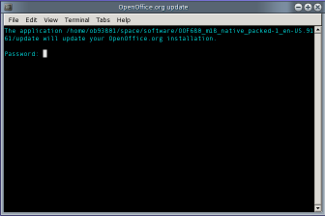Figure 17: super user authentication request before update

String Table Figure 17:
Item | English | German | Comments
Static Text | The application /path.../ will update your %PRODUCTNAME installation.

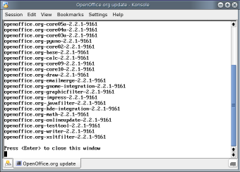Figure 18: Prompt before closing the terminal window

String Table for Figure 18
Item | English | German | Comments
Static Text | Press <Enter> to close this window.

Appearing notifications after the start of OpenOffice.org

This paragraph sums up the notify bubbles, which shall appear open after a start of OpenOffice.org:
- A manually or automatically resumed download will be notified with the notification shown in Figure 8.
- A paused download will be notified as shown in Figure 9.
- A stalled download will be notified as shown in Figure 12.
- When the download has finished but the installation has not been started, one of the situations described in 1.3.4 applies.

The page 'Online Update' in Tools / Options

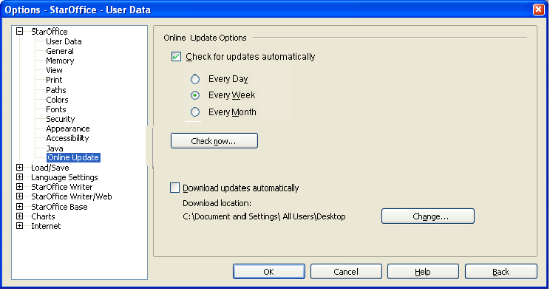
Figure 19: The option 'Download updates automatically' on the tabpage Online Update.
hl4711

On this page one finds a checkbox (default unchecked) for switching the option 'Download updates automatically'. Below the check box the user has the opportunity to see and change the download location pointing to the users local desktop directory. The default path could be found also under Tools / Options / Paths.

String Table Figure 19
Item | English | German | Comments
Checkbox label | ~Download updates automatically | ~Automatisches Herunterladen von Updates
Text label | Download location: | Herunterladen nach:
Button label | Ch~ange... | Ä~ndern...

Hooks for opening the landing page
To have the opportunity to offer the landing page during different steps of the workflow, some hooks will be implemented:
before the download starts
after the download ends
before the installation starts
after the installation ends
At next Office start

Presenting the update status in the 'Check for Updates' dialog with columns
A future task is to enhance the dialog for supporting more then just one entry. This includes displaying the several update entries in columns with their statuses, check boxes in front of each etc..

Migration
<Start typing here ----- If this part is irrelevant state a reason for its absence!>

Configuration
<Start typing here ----- If this part is irrelevant state a reason for its absence!>

File Format
<Start typing here ----- If this part is irrelevant state a reason for its absence!>

Open Issues
Issue | Initials | Date
<State Issue here, State “None”, if all issues are solved> |  | <Format: Dec 31, 2000>
<...>

Document Change History
Rev. | Change | Initials | Date
1 | Added the hint how to change the download location | BH | 05/30/07
2 | Added install for Linux & Solaris | OBR | 10/10/07
3
<...>

