Invitation
Dear OpenOffice.org Community,
I would like to officially propose Budapest as the location for the OpenOffice.org Conference 2008.
Often referred to as “the Paris of the East”, Budapest is the capital of Hungary, and is situated in the heart of Central Europe. This majestic and impressive metropolis consists of hilly Buda on the River Danube’s western bank, and flat, vibrant Pest to the east. The city boasts elegant historical buildings, monuments and numerous celebrated thermal baths.
Within 600km of Budapest, 12 different languages are spoken: German, Italian, Czech, Slovak, Polish, Ukrainian, Romanian, Bulgarian, Serbian, Croatian, Slovenian and, of course, Hungarian. All of these 12 nations have strong local OOo communities, which are active in both localization and development.
Let us use Hungary to illustrate the extent of the region’s OOo communities:
- Large and enthusiastic FSF.hu-organized community of localizers (who translated the OOo user interface in just three days in 2002, and also carried out the translation of the extended tips in the same short time period the following year).
- Active participation in quality assurance of OOo code (http://oopp.multiracio.com/)
- Development of Hunspell spellcheck library and maintenance of other language-related OOo code (Lingucomponent project leader Laszlo NEMETH is sponsored by FSF.hu)
- Extensive deployment at institutions, local governments, etc – see http://wiki.services.openoffice.org/wiki/Market_Share_Analysis and http://hu.openoffice.org/references.html (in Hungarian).
- Active participation in extension development: OxygenOffice, EuroOffice (http://extensions.services.openoffice.org)
- Value-added localized OOo code-based commercial distribution:
- StarOffice
- EuroOffice (formerly MagyarOffice) (www.magyaroffice.hu, www.multiracio.com/eurooffice)
The OOoCon2008 event in Budapest will attract a large number of potential supporters and sponsors including the government, local governments, state institutions, universities and vendors, as our preliminary negotiations have demonstrated.
The Budapest conference would also contribute to an accelerated building of open source communities in Central Europe, and support growing regional demand for Open Source solutions.

Budapest, 09 February 2008 Peter SZAKAL
Open SKM Agency Kft.
szakal.peter@openskm.com +36-70-704-5669

Key Question. Why is your location and the date you propose the best for OOoCon 2008?

Ideal location
- Easy access to international flights with regular low-cost flights (via Ferihegy Airport 1 and 2).
- Hungary is one of the world’s 15 most visited tourist destinations, with a capital city that is regarded as one of the most beautiful on Earth. http://geography.about.com/library/weekly/aa050899.htm
- Excellent food, outstanding local wines and national beverages.
- Unique spas and Turkish baths.

Enthusiastic local community activity
- Large and enthusiastic community of localizers, developers and users
- Active participation in other OOo focused events
- Extensive deployment at institutional and local governmental level, etc.
- Possibility of enhancement of open standards usage in Central Europe
- Active participation and important results in extension development

Location (country, city, university conference centre)
Budapest, Hungary
Lágymányos Campus, Déli Tömb, Pázmány Péter sétány 1/c.
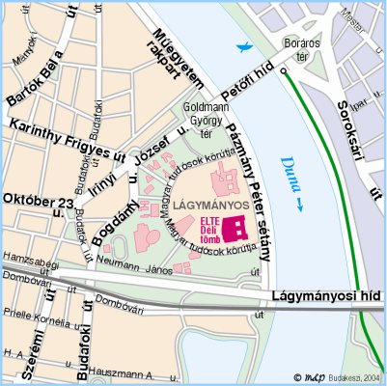

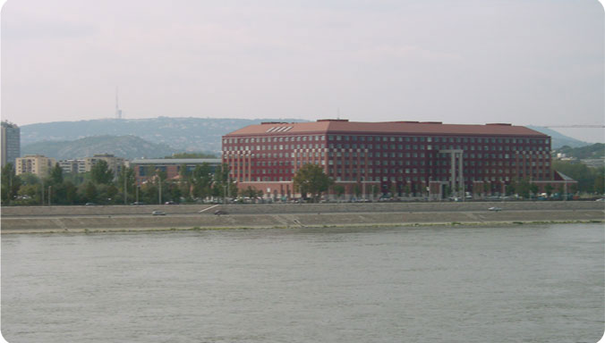

Proposed Date(s)
The first week of September 2-5 of September 2008
September 2-5 2008 is probably the most appropriate date: as participants could visit the city for a whole weekend, allowing a good length of time to enjoy the varied sights of the Hungarian capital.

Team Leader (main contact)
Péter SZAKÁL (Open SKM Agency Kft).

Team members (all members should be willing and able to commit at least three hours per day to planning the conference in the last two weeks before OOoCon 2008).
- Dr. Gábor Szentiványi, LIPSZ (Linux Industrial Association), Hungary
- Dr. Zsolt Bagoly, Eötvös University, Hungary
- Dr. Rudolf Ferenc, University of Szeged, Hungary
- János Szabó, IBM Hungary
- Tamás Polner, SUN Microsystems Hungary
- Kázmér Koleszár, MultiRáció Ltd., Hungary
- András Tímár, FSF.hu, Project-owner of the Hungarian Native-Lang projekt

Events taking place locally over the first weekend of September 2008
- EUROCALL conference September 3-6, 2008:
Open to anyone interested in e-learning and languages.

- DAPSYS 2008 September 3-5, 2008:
Seventh International Conference on Distributed and Parallel Systems.

Large local OpenOffice.org deployments (for user keynotes and success stories)
- The Hungarian Ministry of Agriculture uses OpenOffice on over 340 computers.
- A government IT project entitled E-Magyarország includes the utilisation of OpenOffice on more than 2,500 computers.
- The local governments of Szeged, Törökbálint, Salgótarján, Monorierdő, Zalakomár and other settlements use OpenOffice.
- The Budapest Metropolitan Court employs OpenOffice on over 1,500 computers.
- The regional court of “Vas megye” utilises Open Office.
- The Hungarian Ministry of Defense has initiated a project and employs OpenOffice on some 100 computers.
- Universities and high schools in various cities such as Szeged, Budapest, Debrecen, Nyíregyháza, Kisvárda, Gyula, and others, use different OOo code-based commercial distributions (EuroOffice, StarOffice).

Names of local OpenOffice.org developers (for development sessions)
- László NEMETH, FSF.hu
- Ferenc Rudolf, University of Szeged
- Daniel Darabos, BME

Names of local OpenOffice.org vendors/partners (potential sponsors)
- Prime Minister's Office e-Government Centre
- Ministry of Economy and Transport
- FsF.hu
- IBM Hungary
- Novell Hungary
- Multiráció Ltd
- Open SKM Agency Ltd
- SUN Microsystems Hungary
- ULX Open Source Consultation and Distribution
- Eötvös University
- University of Szeged

General travel information

Special visa or entry requirements
EU citizens are not required to obtain a visa.
The borderless region known as the Schengen area includes the following countries: Austria, Belgium, Czech Republic, Denmark, Estonia, Finland, France, Germany, Greece, Hungary, Iceland, Italy, Latvia, Lithuania, Luxembourg, Malta, The Netherlands, Norway, Poland, Portugal, Slovakia, Slovenia, Spain and Sweden.
All these countries issue standard multiple-entry Schengen visa, which allows the holder to travel freely within the borders of all the member states.
Note: Passport and visa requirements are liable to change at short notice. Travellers are advised to check their entry requirements with their embassy or consulate.
Non-EU citizens are required a visa in order to enter Hungary unless a special agreement exists between your home country and Hungary. These countries are:
The United States, Canada, Australia, Ireland, Japan, Taiwan, Korea, New Zealand.
If you are one of these nationalities, you may enter Hungary without a visa for stays of up to 90 days in any six-month period.
A visa is required for citizens of the following countries:
Albania
Armenia
Azerbaijan
Belarus
Bosnia and Herzegovina
Cambodia
China
Columbia
Cuba
Ecuador
Georgia
India
Iran
Jemen
Kazakhstan
Kyrgyzstan
Laos
Malta
Morocco
Moldova
Mongolia
Montenegro
Peru
Republic of Macedonia
Republic of the Philippines
Russia
Seychelles
Serbia
South-Afrika
Swaziland
Tajikistan
Thailand
Turkey
Tunisia
Turkmenistan
Ukraine
Uzbekistan
Vietnam

Obtaining a visa
If you require a visa to visit Hungary, please check the following page: http://www.traveldocs.com/hu/vr.htm.
If you are still unsure whether you require a visa, please check the Hungarian Ministry of Foreign Affairs website: www.kulugyminiszterium.hu.
NB. No vaccinations are required to enter Hungary.

Electrical appliances
Hungary’s electricity network operates at 230 Volts (50 Hz). Plugs are two-pin continental size.

Weather, Temperature and Time
Temperate zone, continental climate, four seasons. The average temperature in the first part of September is 20-25° Celsius/daytime and 12°-15° Celsius/night time, and the weather is usually sunny and sometimes windy.
Local time in Hungary is CET (GMT +1 hour, summer time – March to the middle of October – GMT+2 hours).

Currency / Credit cards
The currency is the Hungarian Forint (HUF). 1 EUR = approx. 250-260 HUF
Most hotels, restaurants, department stores and shops accept major credit cards, like American Express, Visa, Eurocard/Mastercard, Diners

Flight informations to Budapest
Hungary is located in the center of Europe therefore all big, worldwide known airlines (like British Airways, Lufthansa, Air France, Alitalia, SAS, Aeroflot, etc) are flying to Ferihegy Airport. The Hungarian national airline – MALEV offers also every day connections to all European capitals.

It is difficult to give a price quotation for the flight costs, because nowadays it depends on several conditions – e.g. the class, the period of the week and the time of the booking, the current booking situation of the flight, etc.

An average flight ticket from the European countries to Budapest may cost between EUR 250 and EUR 450 (retour) but flying by low cost airlines can make big savings.

Low cost Airlines flying to Hungary
Air Berlin
Air Finland
Air Lingus
EasyJet
FlyNordic
Germanwings
Ryanair at the lake Balaton
SmartWing
Wizzair

Accommodation costs (youth hostels, hotels)

Hotels
September is a favourite period of tourists for city breaks, so the organisers are ready to make block reservations for the participants at guaranteed rates to make hotel bookings easier. Please find a list of recommended hotels below in different categories which could be offered for accommodation. They have all easy access by public transportation to the conference venue. The rates are informative and will be fixed upon the final agreement with the hotels.
Take a look at a selection of some hotels in Budapest and their prices.

Hotel | Rate in €  sgl room | Rate in €  dbl room
Sofitel***** | 190 | 220 | www.sofitel-budapest.com
Hilton WestEnd***** | 170 | 190 | www1.hilton.com/en_US/hi/hotel/BUDWEHI-Hilton-Budapest-WestEnd-hotel/index.do
Novotel Congress**** | 120 | 150 | www.novotel-bud-congress.hu
Buda Mercure**** | 110 | 130 | www.mercure-buda.hu
Mercure City Centre**** | 110 | 135 | www.accor-pannonia.hu/mercure_budapestcitycenter_talalkozo.php
Gellért**** | 80 shw  120bath | 170 | www.danubiushotels.com/gellert
Flamenco**** | 110 | 120 | www.hotelflamenco.hu
Mercure Metropol***+ | 95 | 105 | www.mercure-metropol.hu
IBIS Centrum*** | 90 | 100 | www.ibis-centrum.hu
Mercure Duna*** | 80 | 95 | www.mercure-duna.hu
Bara*** | 70 | 80 | www.hotelbara.hu
Atlantic**+ | 52 | 70 | www.atlantichotel.hu
Griff Junior* (shower) | 29 | 39 | www.gerandhotels.com

All rates on the list are valid for 2008, with breakfast buffet (continental breakfast in Griff Junior), inclusive of taxes and service.

Average meal costs
You can enjoy fine dining at reasonable prices in Budapest, but it is good to know the price category to which the restaurant belongs. To help you we have indicated the different categories below (per person for a three-course meal without tip):
- Expensive: over €19 (HUF 5,000),
- Moderate: €7-19 (HUF 2,000-5,000)
- Cheap: around or under €7 (HUF 2,000)
See list of Cheap Restaurants in Budapest.

Please note that smaller restaurants often only accept cash.

Additional Services offered for the Open Office Conference

Transfer from Airport to hotels

Organized by the Airport Minibus service, which transports passengers directly to their hotels or to any private address in Budapest and back (reservations for return journey should be made 24 hours in advance).
Price for individuals: €10 / person / one-way
Groups: €80 / bus/44 person / one-way

Transfer from hotels to gala dinner venue and back
Price: €40 / bus /44 person /five hours

Transfer from hotels to congress venue
Price: €85 / bus /four hours

Social activities (half day programs)
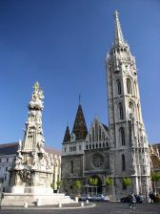
Budapest sight-seeing bus tour with English-speaking guide: includes visit to the interior of Matthias Church and Fishermen’s Bastion
Price: €18 / person

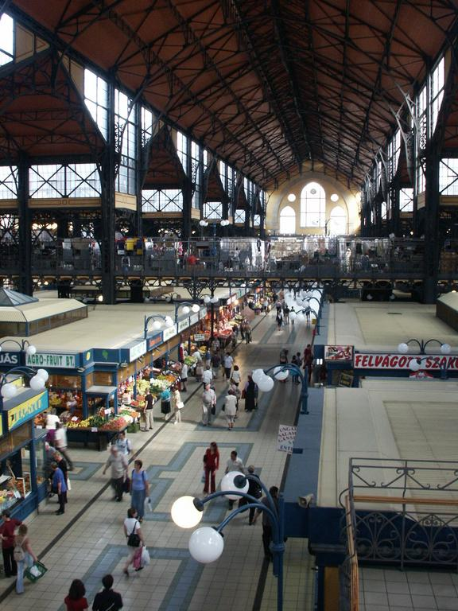

Cooking Courses: Visit the Budapest Market Hall, then prepare three Hungarian speciality dishes with the help of our expert chef. Following this guests can enjoy their own dishes, accompanied by a selection of Hungarian wines.
Price: €48 per person

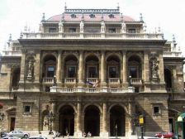
Visit to the Opera House: a tour of the backstage of the stunning building, including a glass of champagne and a short concert given by an opera singer.
Price: €36 / person

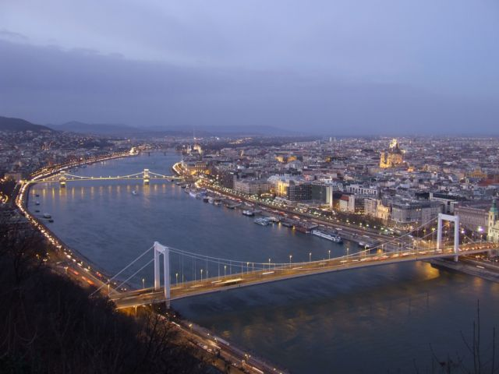
Danube sight-seeing, includes drink and informative tour.

Price: €33 per person
The tour can be accompanied with lunch or dinner on the boat.
Surcharge: from €20, depending on meal.

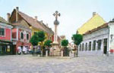

Excursion to Szentendre (artists village, 20km north of Budapest)
Walking tour through the narrow atmospheric streets, museum visits and shopping possibilities. Coffee and cakes in a traditional
café. Price: €42 per person

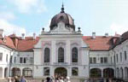

Excursion to Gödöllő Royal Palace
(20km east of Budapest)
Guided tour of Central Europe’s largest Baroque palace, and the preferred residence of Queen Elisabeth (also called Sissy). Coffee and cakes included.
Price: €45 per person

All the above prices include transportation costs by private bus, English-speaking guide and entrance fees, and apply to a minimum of 30 persons.

Special event
Hungarian evening at the Lázár Equestrian Park in Domonyvölgy
Date: 04 September 2008
Number of guests: 120-150 persons (max. 300)
www.lazarlovaspark.hu

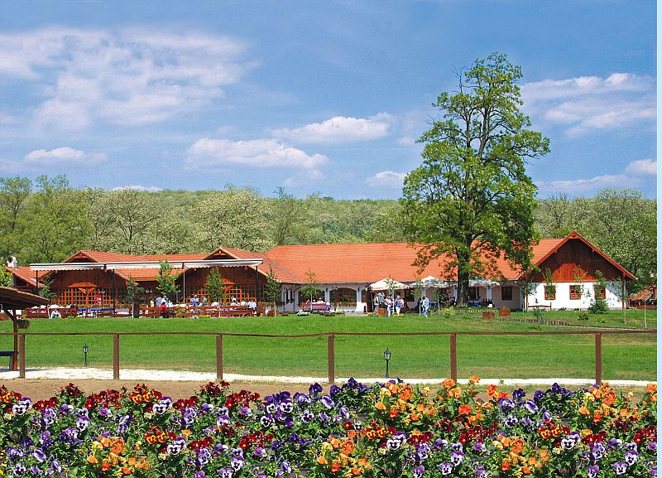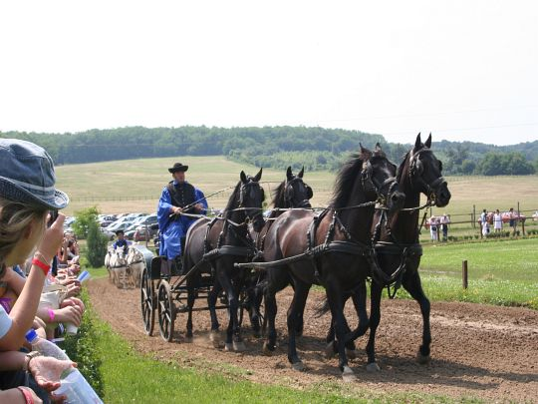

Itinerary of horse show, incorporating a guided bus tour of Budapest and dinner:

5.00pm: Departure from the Conference venue for guided bus tour, taking in Budapest’s Danube bridges, the UNESCO-protected Andrassy Street, Opera House and Heroes Square (with a photo stop), and City Park.
On arrival at the Lázár Equestrian Park (6.30pm, approx) guests are welcomed with “palinka” – a local form of fruit brandy – and some home made salted cakes, or “pogacsa”. There is the possibility to participate in carriage riding around the park, and visit the stables and small museum, which displays trophies and medals won by the world-champion coach-driving Lázár brothers.
The evening continues with a frenetic horse show, including:
- Four-hand drive, pony-driven carriage.
- Nomadic warrior archery display: on horseback, spear throwing, jumping through fire.
- Horse riding display: featuring a contest between the horsemen.
- Fun games involving the guests: knocking over a bottle with a whip.
- Puszta-five event.
- “Queen Elizabeth” horse display by “Sissi” riding side-saddle, in costume.
After the horse show a tasty traditional Hungarian dinner with wine will be served in the “csárda”, while Roma musicians entertain the diners.
Transfer to Budapest after dinner, arriving at the hotels or conference venue at 11.00pm.

Price: €45 / person

The price includes bus transfer, English-speaking guides, the above scheduled events, dinner (three-course menu, 2x200ml wine, mineral water, coffee)
Price is valid for a minimum of 30 participants.

Budapest cafés
After an intensive day of meetings and conferences, do as the Budapesters do and unwind over strong, flavoursome coffee and a sweet cake in a traditional, cosy café. There were over 400 coffeehouses in Budapest at the turn of the last century, which entertained everyone from soldiers and aristocrats, to poets and actors, and some of the best (Café Gerbeaud, Café New York, Café Central, Anna Café, Buena Vista…) remain in business to this day.

Thermal spas and historic bath houses
Budapest is the city of spas and Turkish baths. After a long working day, there is nothing better than relaxing in a Hungarian spa to refresh yourself for the following day, not to mention the cold refreshing beers to cool you down during and after a soak in a thermal bath, a sauna and a massage. Budapest’s most celebrated Turkish baths are: Bath Széchenyi, Bath Gellért, Bath Rudas)
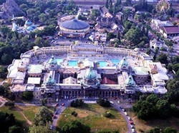
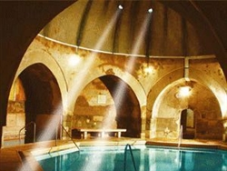

Other useful links
- Hungarian Tourist Board
This is the official site of the Hungarian Tourist Board Tourinform. Now nicely re-designed, it offers useful information for anyone considering a trip to Hungary.

- Travel to Hungary
A comprehensive, easily-navigable website offering practical and clear tourist information on Budapest.

- State Opera House
Many of the requests we receive concern events at the Budapest State Opera House. This beautifully laid-out site tells you all you need to know (in English).

- Herend
Website of Hungary's most famous porcelain factory. The site is easy to navigate, reflects the elegance of Herend’s hand-painted figures and dinner sets.

- Budapest Week
This bright, lively, well-designed site includes business news and restaurant listings, as well as upcoming performances and exhibitions (in English).

