Software Specification Document

OpenOffice.org 2.0.4 and higher
OpenOffice.org NetBeans Integration: Add-On wizard

Specification Status
Last Change | Feb 23, 2007
Status | - PRELIMINARY  status is the initial conception of a specification.  - STANDARD  A specification with status Standard is considered to be stable and has the approval of the i-Team.  - OBSOLETE  An Obsolete specification is a specification that has been identified unnecessary. For example due to; technology changes or changes in other standards or specifications.

Abstract
The intention of the OpenOffice.org NetBeans Integration: Add-On wizard is to simplify the development of OpenOffice.org Add-Ons. Modern IDE's provide a lot of useful tools to make the daily work for developers easier. Especially recurring tasks or some kind of templates/wizards are often used to provide special support inside an IDE. And exactly here should the OpenOffice.org NetBeans Integration: Add-On wizard provide some useful extensions to the NeBeans IDE to speed up the initial start working with the OpenOffice API. The (simple) version of the wizard will create all the code needed for an extension consisting of an arbitrary amount of functions that can be deployed into OpenOffice.org and are visible in the UI with icons and localizable names. To call these functions, a click on the name/icon in OpenOffice.org is enough.

i-Team Members
Role | First Name, Last Name, Initials | E-Mail Address
Project Lead | Jürgen Schmidt (jsc) | juergen.schmidt@sun.com
Specification Owner | Steffen Grund (sg) | steffen.grund@sun.com
User Experience
Development | Steffen Grund (sg) | steffen.grund@sun.com
Quality Assurance | Thorsten Bosbach (tbo) | thorsten.bosbach@sun.com
Documentation
Other roles
Based on a verbal agreement between Lutz Höger and Jürgen Schmidt, we decided that a team member of the office user experience team isn't necessary because this specification is off topic of normal office features and address developers only and provides an integration in an external application (NetBeans IDE).

Contents
Abstract 1
i-Team Members 1
References and Reference Documents 3
Acronyms and Abbreviations 4
1 Detailed Specification 5
2 Migration 7
3 Configuration 7
4 File Format 8
5 Open Issues 8
Document Change History 8

References and Reference Documents
Give references to any documentation relevant with regards to this specification.
Before writing a specification make sure that the items of the Specification Process Entry Check have been addressed.
Reference Document | Check | Location (URL)
Specification Process Entry Check |  | N/A
Product Requirement,, RFE, issue (required) |  | <Please enter location here>
Product Concept Document |  | <Please enter location here>
Competitive Analysis |  | <Please enter location here>
Test Case Specification (required) |  | <Please enter location here>
Software Specification Rules | N/A | N/A
<Other, e.g. references to related specs>

Acronyms and Abbreviations
State any acronyms and or abbreviations used in this specification in the table below.
Acronym / Abbreviation | Definition
SDK | Software Development Kit
Add-On | Specialized component type supporting UI enzries in the office to call the functionality.
deploy/deployment | Means the installation of office extension packages into an office installation
nbm | NetBeans module/plugin, comparable with an office extensions package, means a plugin extending the base functionality of NetBeans with some new functions.

Detailed Specification
This part of the NetBeans integration deals with a wizard for creating Add-Ons. See http://api.openoffice.org/docs/DevelopersGuide/Components/Components.xhtml#1_7_3_Add-Ons
for the chapter on Add-Ons in the Developer's Guide. Basically, the wizard consists of two separable parts, one part being the UI to collect all necessary information for the second part, the creation of the new project. The finished project will consist of xcu-files for adding the Add-On to the OpenOffice.org UI and empty function implementations that are called from the UI. The wizard is finished when the new designed project is opened and the empty Add-On functions can be filled with life.
UI for collecting all relevant information
- Panel 1: “Define Add-On Name and Location”
This panel asks for basic information and presents some overview of the created files (this panel looks similar in Add-In, Component and Add-On wizards):
  - Name of the project - a directory with this name will be created
  - Name of the Add-On
  - Java package - these will also be created as directories
  - Project Location - where the project will be stored
  - Project Folder – a view of the structure that will be created
  - Create backwards compatible Add-On (greyed for now) – create an Add-On for earlier OpenOffcie.org versions with “uno.pkg” extension rather than “oxt” extension.
  - Created files – a comprehensive list of all created files including their location
- Panel 2: “Define Commands”
In the UI, the user will see commands that he can click on – either in a menu or in a tool-bar. In this panel the commands are defined, the following two panels will deal with the placing of the commands in the UI. Select icons for the commands.
- Panel 3: “Menu entry”
Define a new menu entry with the commands inside. Select, in which part of the application the command will be visible.
- Panel 4: “Tool-bar entry”
Define a new tool-bar with the commands and select in which part of the application the command will be visible.

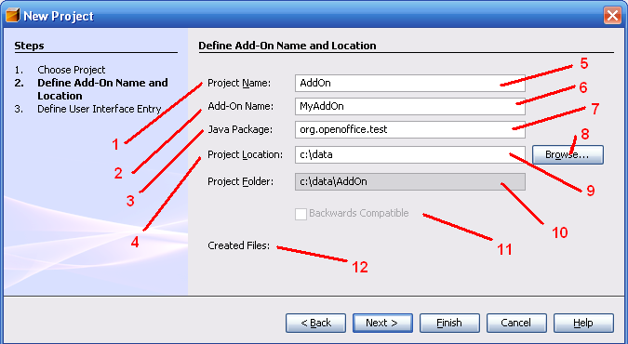Figure 1: new Add-On project

Table 1: User Interface elements of Figure 1
# | Type | Properties |  | Comment
1 |  | Control Properties  Enabled: Yes
1 |  | String English  Project Name: | String German  not localized for German
2 |  | Control Properties  Enabled: Yes
2 |  | String English  Add-On Name | String German  not localized for German
3 |  | Control Properties  Enabled: Yes
3 |  | String English  Java Package | String German  not localized for German
4 |  | Control Properties  Enabled: Yes
4 |  | String English  Project Location | String German  not localized for German
5 |  | Control Properties  Enabled: Yes  Editable: Yes  Initial Text Inside Field: Add-On  Drag Enabled: No  Initial Caret Position: 0  Characters Allowed: all for filenames  Characters not Allowed: all for filenames  Selection Starts:  Selection Ends:  Selected Text:  ToolTip Text:  A11Y Text:  Other...:  Password Field Properties  Echo Character:  Other...:
5 |  | String English | String German
6 |  | Control Properties  Enabled: Yes  Editable: Yes  Initial Text Inside Field: MyAddOn  Drag Enabled: No  Initial Caret Position: 0  Characters Allowed: all for filenames  Characters not Allowed: all for filenames  Selection Starts:  Selection Ends:  Selected Text:  ToolTip Text:  A11Y Text:  Other...:  Password Field Properties  Echo Character:  Other...:
6 |  | String English | String German
7 |  | Control Properties  Enabled: Yes  Editable: Yes  Initial Text Inside Field: org.yourorg.here  Drag Enabled: No  Initial Caret Position:  Characters Allowed: all for package names  Characters not Allowed: all for package names  Selection Starts:  Selection Ends:  Selected Text:  ToolTip Text:  A11Y Text:  Other...:  Password Field Properties  Echo Character:  Other...:
7 |  | String English | String German
8 |  | Control Properties  Enabled: Yes  Icon: No  Resizeable: No  Has Menu: No  ToolTipText:
8 |  | String English  Browse... | String German
9 |  | Control Properties  Enabled: Yes  Editable: Yes  Initial Text Inside Field: <user home directory>  Drag Enabled: No  Initial Caret Position: 0  Characters Allowed: all for system's path  Characters not Allowed: all for system's path  Selection Starts:  Selection Ends:  Selected Text:  ToolTip Text:  A11Y Text:  Other...:  Password Field Properties  Echo Character:  Other...:
9 |  | String English | String German
10 |  | Control Properties  Enabled: Yes  Editable: No  Initial Text Inside Field: #9 + SystemFileSeparator + #5  Drag Enabled: No  Initial Caret Position:  Characters Allowed:  Characters not Allowed:  Selection Starts:  Selection Ends:  Selected Text:  ToolTip Text:  A11Y Text:  Other...:  Password Field Properties  Echo Character:  Other...:
10 |  | String English | String German
11 |  | Control Properties  Enabled: No  Initially Checked: No  TriState: No  ToolTip Text:  Other...: |  |  | Not yet implemeted, therefore not enabled
11 |  | String English | String German
12 |  | Control Properties  Enabled: No  Editable: No  Linewrap: On  Maximum Row Count:  Visible Row Count: 8  Display Hori. Scrollbar: as needed  Display Vert. Scrollbar: as needed  Initial Text Inside Field: <all created files>  Drag Enabled: No  Caret position: 0  Characters Allowed:  Characters not Allowed:  Selection Starts:  Selection Ends:  Selected Text:  A11Y Text:  ToolTip Text:  Other...: |  |  | Empty, not yet implemented
12 |  | String English | String German

Table 2: Tab order of: Figure 1
Tab Order | Comment
#5, #6, #7, #9, #8

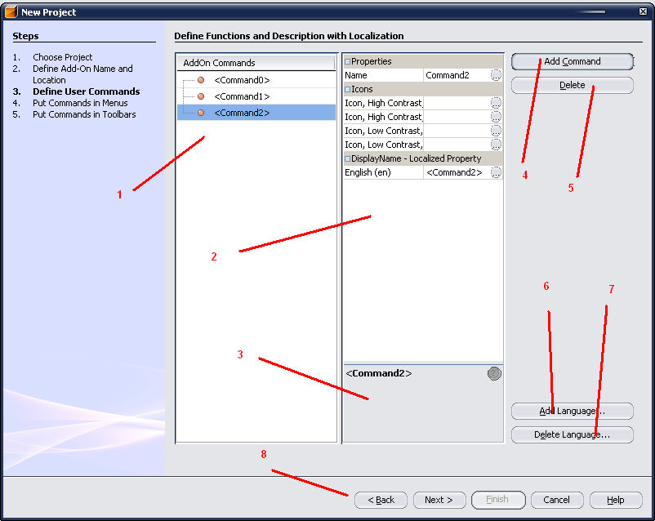Figure 2: Define User Interface and Functions

Table 3: User Interface elements of Figure 2
# | Type | Properties |  | Comment
1 |  | Control Properties  Features: NetBeans Tree View Control  Shows all commands with properties as a tree.  Avaliable properties:  Name: implementation name of the function  ReturnValue: return value of the function: void  Exceptions: all exceptions the function might throw  Icon: an icon associated with the function int the Office UI.  DisplayName: the localized name of the function in the Office UI
1 |  | String English | String German
2 |  | Control Properties  Features: NetBeans property sheet associated with a tree, in this case the tree shown in #1. The property sheet allows editing of the properties of the tree.  Properties and their editing:  Name: simple text editor (provided by NetBeans)  Icons: open a file chooser (provided by Java) to choose the icons. Possible Icons are:  - High Contrast, Size 26x26  - High Contrast, Size 16x16  - Low Contrast, Size 26x26  - Low Contrast Size 16x16  DisplayName: simple text editor (provided by NetBeans)
2 |  | String English | String German
3 |  | Control Properties  Features: Tool tip Area for PropertySheet #2 |  |  | Tool tip for the selected item of the property sheet.
3 |  | String English | String German
4 |  | Control Properties  Enabled: Yes  Icon: No  Resizeable: No  Has Menu: No  Menu Items:  ToolTipText: |  |  | Will insert a new function with a distinct default name
4 |  | String English  Add Command | String German  Not localized for German
5 |  | Control Properties  Enabled: Yes  Icon: No  Resizeable: No  Has Menu: No  Menu Items:  ToolTipText: |  |  | Deletes the current selected command; should be disabled if no command is selcted
5 |  | String English  Delete Command | String German
6 |  | Control Properties  Enabled: Yes  Icon: No  Resizeable: No  Has Menu: No  Menu Items:  ToolTipText: |  |  | Opens the “Add Language” dialog, return to this panel when the dialog fishes.
6 |  | String English  Add Language... | String German
7 |  | Control Properties  Enabled: Yes  Icon: No  Resizeable: No  Has Menu: No  Menu Items:  ToolTipText: |  |  | Opens the “Delete Language” dialog, return to this panel when the dialog fishes.
7 |  | String English  Delete Language... | String German
8 |  | Control Properties  Features: Navigation Area between panels; provided by NetBeans
8 |  | String English | String German

Table 4: Tab order of: Figure 2
Tab Order | Comment
#1, #2, #4, #5, #6 #7

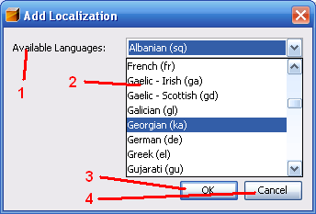Figure 3: Add Localization

The “Add Localization” dialog is also used when a language is deleted.

Table 5: User Interface elements of Figure 3
# | Type | Properties |  | Comment
1 |  | Control Properties  Enabled: Yes
1 |  | String English  Available Languages | String German
2 |  | Control Properties  Enabled: Yes  Maximum Row Count: <count of OOo languages>  Visible Row Count: 1  Initially Selected Item: <first language> Albanian  ToolTip Text:  A11Y Text:  Other...:
2 |  | String English | String German
3 |  | Control Properties  Enabled: Yes  Icon: No  Resizeable: No  Has Menu: No  Menu Items:  ToolTipText:
3 |  | String English  OK | String German
4 |  | Control Properties  Enabled: Yes  Icon: No  Resizeable: No  Has Menu: No  Menu Items:  ToolTipText:
4 |  | String English  Cancel | String German

Table 6: Tab order of Figure 3
Tab Order | Comment
#2, #3, #4

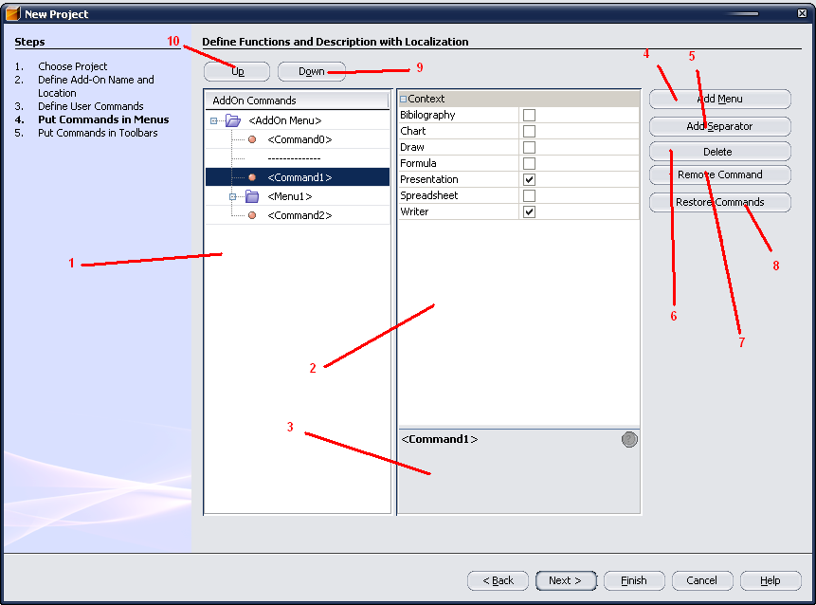Figure 4: Define Menus

Table 7: User Interface elements of Figure 4
# | Type | Properties |  | Comment
1 |  | Control Properties  Features: NetBeans Tree View Control  Shows a stylized view of the menu entries. Elements in this view are the commands defined on panel #3, separators and sub-menus. Only the commands and (sub-)menus have properties available in the property-sheet – not the separators.  Available properties for the commands:  Context: context in which the command is visible, meaning an application of StarOffice. Can be any combination of Bibliography, Chart, Draw, Formula, Presentation, Spreadsheet, Writer  Available Property for the menus:  Display Name: localized display name of the menu  No properties available for separators.
2 |  | Control Properties  Features: NetBeans property sheet associated with a tree, in this case the tree shown in #1. The property sheet allows editing of the properties of the tree.
2 |  | String English | String German
3 |  | Control Properties  Features: Tool tip Area for PropertySheet #2
3 |  | String English | String German
4 |  | Control Properties  Enabled: Yes  Icon: No  Resizeable: No  Has Menu: No  Menu Items:  ToolTipText: Add a new sub menu to the menu. |  |  | If this button is pressed, under the current selected element in #1, a new sub menu is created
4 |  | String English  Add Menu | String German
5 |  | Control Properties  Enabled: Yes  Icon: No  Resizeable: No  Has Menu: No  Menu Items:  ToolTipText: Add a new separator to the menu. |  |  | If this button is pressed, under the current selected element in #1, a new separator is created
5 |  | String English  Add Separator | String German
6 |  | Control Properties  Enabled: No, only when sub-menus or separators are enabled  Icon: No  Resizeable: No  Has Menu: No  Menu Items:  ToolTipText: Delete a separator or menu entry |  |  | This does NOT affect the commands, they can only be created and deleted in panel #3. When a menu is deleted with commands inside, they are inserted at the end of the top menu
6 |  | String English  Delete | String German
7 |  | Control Properties  Enabled: Yes  Icon: No  Resizeable: No  Has Menu: No  Menu Items:  ToolTipText: Remove a command from the menu structure |  |  | Removes a command from the menu structure. If no command is inside of the structure, it will not be created.  This may be used if no menu entry shall be created or if a certain command should only be available in a toolbar.  This button is disabled if no command is selected.
7 |  | String English  Remove Command | String German
8 |  | Control Properties  Enabled: No  Icon: No  Resizeable: No  Has Menu: No  Menu Items:  ToolTipText: Restore all removed commands |  |  | If one or more commands are removed, this button is enabled and restores the removed commands. They will be added at the end of the top menu.
8 |  | String English  Restore Commands | String German
9 |  | Control Properties  Enabled: Yes  Icon: Yes  Resizeable: No  Has Menu: No  Menu Items:  ToolTipText: Move the selected element down |  |  | A selected element in the menu hierarchy is moved down. If the element under the selected element is a menu, the element is moved inside the menu, to the first position. If it's inside of a sub-menu on the last position, it's moved outside below the sub-menu.
9 |  | String English  <Down Symbol> | String German
10 |  | Control Properties  Enabled: Yes  Icon: Yes  Resizeable: No  Has Menu: No  Menu Items:  ToolTipText: Move the selected element up |  |  | The selected element in the menu hierarchy is moved up. If the element above the selected element is a menu, the element is moved inside the menu, to the last position. If it's inside of a sub-menu on the first position, it's moved outside above the sub-menu.
10 |  | String English  <Up Symbol> | String German  <Enter String Here>

Table 8: Tab order of Figure 4
Tab Order | Comment
#1, #2, #4, #5, #6, #7, #8, #9, #10

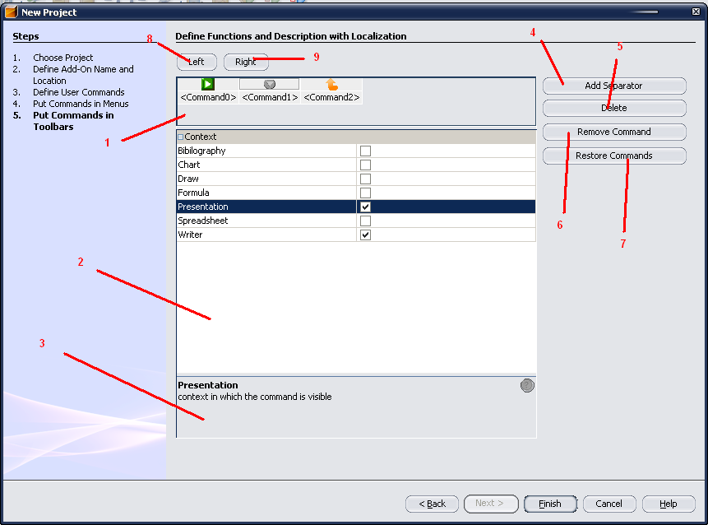Figure 5: Toolbar creation
Table 9: User Interface elements of Figure 5
# | Type | Properties |  | Comment
1 |  | Control Properties  Features: Preview of the toolbar with commnds and separators between them. Commands have an icon, and a name which are displayed. Clicking on one icon will select it.  Available properties for the commands:  Context: context in which the command is visible, meaning an application of StarOffice. Can be any combination of Bibliography, Chart, Draw, Formula, Presentation, Spreadsheet, Writer  No properties available for separators.
2 |  | Control Properties  Features: NetBeans property sheet associated with the selected command in #1. The property sheet allows editing of the properties of the tree.
2 |  | String English | String German
3 |  | Control Properties  Features: Tool tip Area for PropertySheet #2
3 |  | String English | String German
4 |  | Control Properties  Enabled: Yes  Icon: No  Resizeable: No  Has Menu: No  Menu Items:  ToolTipText: Add a new Separator |  |  | A new Separator will be inserted to the right of the current selected button – no button selected, insert at the beginning.
4 |  | String English  Add Separator | String German
5 |  | Control Properties  Enabled: No  Icon: No  Resizeable: No  Has Menu: No  Menu Items:  ToolTipText: Delete the selected Separator |  |  | Delete the selected separator. This button should only be enabled when a separator is selected.
5 |  | String English  Delete | String German
6 |  | Control Properties  Enabled: Yes  Icon: No  Resizeable: No  Has Menu: No  Menu Items:  ToolTipText: Remove the selected Command from tool-bar |  |  | This button is only enabled when a command is selected, it removes the button from the tool-bar.
6 |  | String English  Remove Command | String German
7 |  | Control Properties  Enabled: No  Icon: No  Resizeable: No  Has Menu: Yes  Menu Items:  ToolTipText: Restore the removed commands |  |  | Restore removed commands at the end of the tool-bar. When all commands are inside of the tool-bar, this button is disabled.
7 |  | String English  Restore Commands | String German
8 |  | Control Properties  Enabled: Yes  Icon: Yes  Resizeable: No  Has Menu: No  Menu Items:  ToolTipText: Move selected item left
8 |  | String English  <Left Symbol> | String German
9 |  | Control Properties  Enabled: Yes  Icon: Yes  Resizeable: No  Has Menu: No  Menu Items:  ToolTipText: Move selected item right
9 |  | String English  <Right Symbol> | String German

Open Issues
Questions and unsolved will arise during the creation process of the specification. Make sure that no open issue are left, when the specification gets the state “Standard”
Issue | Initials | Date
<State Issue here, State “None”, if all issues are solved> |  | <Format: Dec 31, 2000>
<...>

Document Change History
Rev. | Change | Initials | Date
1 |  |  | <Format: Dec 31, 2000>
2
3
<...>

