Software Specification Document

OpenOffice.org
Assign Keyboard Shortcuts Tab

Specification Status
Last Change | Jan 21, 2008
Status
Abstract
<Start typing here>

i-Team Members
Role | First Name, Last Name, Initials | E-Mail Address
I-Team Lead | Carsten Driesner (CD) | carsten.driesner@sun.com
Specification Author | Frank Loehmann (FL) | frank.loehmann@sun.com
User Experience | Frank Loehmann (FL) | frank.loehmann@sun.com
Development | Carsten Driesner (CD) | carsten.driesner@sun.com
Quality Assurance | <First Name, Last Name (Initials)> | <User@openoffice.org>
Documentation | Uwe Fischer (UFI) | uwe.fischer@sun.com
Other roles | <First Name, Last Name (Initials)> | <User@openoffice.org>
<State reason here, if one role is not represented in i-Team.>

Contents
Abstract 1
i-Team Members 1
References and Reference Documents 3
Acronyms and Abbreviations 3
1 Detailed Specification 4
1.1 Draft of the Keyboard Tab Page 4
1.1.1 Show all Functions 4
1.1.1.1 Default Appearance 4
1.1.1.2 Search Functions 5
1.1.1.3 Shortcut Already Assigned 5
1.1.2 Show Main Menu 5
1.1.3 Show Shortcuts 6
2 Migration 6
3 Configuration 6
4 File Format 6
5 Open Issues 7
Document Change History 7

References and Reference Documents
Reference Document | Check | Location (URL)
Specification Process Entry Check |  | N/A
Product Requirement, RFE, issue [Required] |  | <Please enter location here>
Product Concept Document |  | <Please enter location here>
Competitive Analysis |  | <Please enter location here>
IDL Specification |  | <Please enter location here>
Test Case Specification [Required] |  | <Please enter location here>
Software Specification Rules | N/A | N/A
Assign Keyboard Shortcuts to Styles |  | http://specs.openoffice.org/appwide/keyboard/assign_keyboard_shortcuts_to_styles.sxw
Acronyms and Abbreviations
Acronym / Abbreviation | Definition
<WYSIWYG> | <What You See Is What You Get>

Detailed Specification

Draft of the Keyboard Tab Page

Show all Functions

Default Appearance
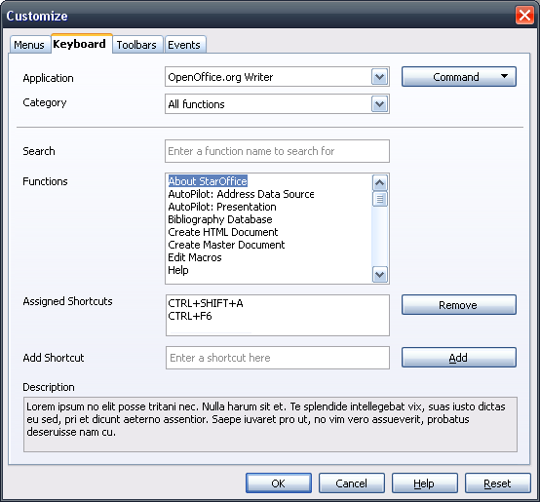Illustration 1: Default appearance of Keyboard tab

Search Functions
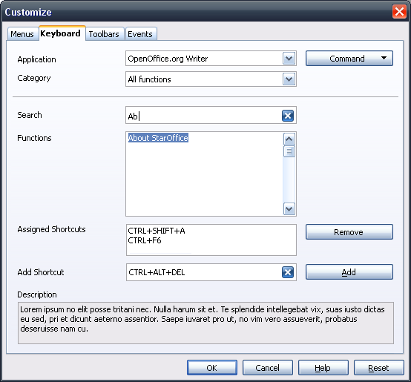Illustration 2: Search function in action

Shortcut Already Assigned
<Add Dialog Mock-up>

Show Main Menu
<Add Dialog Mock-up>

Show Shortcuts
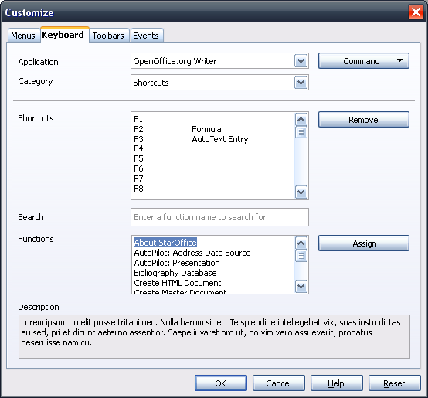Illustration 3: Shortcut view

Migration
<Start typing here ----- If this part is irrelevant state a reason for its absence!>

Configuration
<Start typing here ----- If this part is irrelevant state a reason for its absence!>

File Format
<Start typing here ----- If this part is irrelevant state a reason for its absence!>

Open Issues
Issue | Initials | Date
<State Issue here, State “None”, if all issues are solved> |  | <Format: Dec 31, 2000>
<...>

Document Change History
Rev. | Change | Initials | Date
1 | Create specification | FL | January 18, 2008
2 | Overwork dialog mock-ups | FL | January 21, 2008
3
<...>

