Software Specification Document

OpenOffice.org
Load Printer Settings with the Document Option

Specification Status
Last Change | Jul 3, 2007
Status
Abstract
OOo stores and restores printer settings with a document by default. In an enterprise environment with always available printers (i.e. around the world) this could result in printing a document on the other side of the world. Therefore a new option is added to suppress loading document printer settings on loading a document.
i-Team Members
Role | First Name, Last Name, Initials | E-Mail Address
I-Team Lead | Joost Andrae (JA) | joost.andrae@sun.com
Specification Author | Frank Loehmann (FL) | frank.loehmann@sun.com
User Experience | Frank Loehmann (FL) | frank.loehmann@sun.com
Development | Oliver Specht (OS) | oliver.specht@sun.com
 | Frank Schoenheit (FS) | frank.schoenheit@sun.com
Quality Assurance | Hasan Ilter (HI) | hasan.ilter@sun.com
 | Christoph Lukasiak | christoph.lukasiak@sun.com
Documentation | Uwe Fischer (UFI) | uwe.fischer@sun.com
Other roles | Kay Koll | kay.koll@sun.com
 | Rafaella Braconi | rafaella.braconi@sun.com

Contents
Abstract 1
i-Team Members 1
References and Reference Documents 3
Acronyms and Abbreviations 3
1 Detailed Specification 4
2 Migration 4
3 Configuration 4
4 File Format 5
5 Open Issues 5
Document Change History 5

References and Reference Documents
Reference Document | Check | Location (URL)
Specification Process Entry Check |  | N/A
Product Requirement, RFE, issue [Required] |  | i76855
Product Concept Document |  | <Please enter location here>
Competitive Analysis |  | <Please enter location here>
IDL Specification |  | <Please enter location here>
Test Case Specification [Required] |  | http://www.openoffice.org/nonav/issues/showattachment.cgi/46481/Load_printer_settings_with_document.odt.html
Software Specification Rules | N/A | N/A
<Other, e.g. references to related specs>
Acronyms and Abbreviations
Acronym / Abbreviation | Definition
<WYSIWYG> | <What You See Is What You Get>

Detailed Specification
The Options dialog gets extended by a new option to configure the behavior when loading documents. This new check box option is located on the Load/Save – General tab page and is checked by default. So the general behavior of restoring printer settings will not be changed, unless the option gets unchecked.
If the option gets unchecked, the printer settings will not be loaded with the document. The current printer settings will be stored with the document whether or not this option is checked.
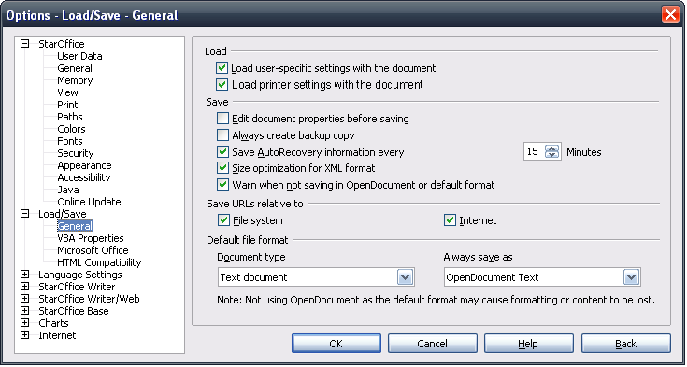

- “Load printer settings with the document ” - CheckBox Properties |  | Comment
Enabled: | Always
Tri-State: | None
Checked: | By Default
CheckBox Label: | Load printer settings with the document |  | EN-US
CheckBox Label: | Druckereinstellungen mit dem Dokument laden |  | e.g. DE

Migration
None.

Configuration
<Start typing here ----- If this part is irrelevant state a reason for its absence!>

File Format
No change in file format, because printer setting will only be ignored on loading the document. When saving the document, the printer properties will be stored.

Open Issues
Issue | Initials | Date
<State Issue here, State “None”, if all issues are solved> |  | <Format: Dec 31, 2000>
<...>

Document Change History
Rev. | Change | Initials | Date
1 | Initial Draft of Spec. | FL | May 07, 2007
2 | Set to Standard! | FL | July 3, 2007

