Software Specification Document

OpenOffice.org
Zoom Slider in Statusbar

Specification Status
Last Change | Aug 13, 2008
Status
Abstract
This specification adds a quick access to the zoom functionality of Writer, Draw, impress and Calc inside the statusbar.
i-Team Members
Role | First Name, Last Name, Initials | E-Mail Address
I-Team Lead | Frank Loehmann | frank.loehmann@sun.com
Specification Author | Frank Loehmann | frank.loehmann@sun.com
User Experience | Frank Loehmann | frank.loehmann@sun.com
Development | Kai Ahrens (KA)  Niklas Nebel (NN)  Christian Lippka (CL)  Maoyg | kai.ahrens@sun.com  niklas.nebel@sun.com  Christian.Lippka@sun.com  maoyonggang@RedOffice.com.cn
Quality Assurance | Oliver Crämer (OC)  Wolfram Garten  Christian Günther | oliver.craemer@sun.com  wolfram.garten@sun.com  christian.guenther@sun.com
Documentation | Uwe Fischer (UFI) | uwe.fischer@sun.com

Contents
Abstract 1
i-Team Members 1
References and Reference Documents 3
Acronyms and Abbreviations 3
1 Detailed Specification 4
1.1 Writer 4
1.2 Calc 4
1.3 Draw/Impress 4
2 File Format 5
3 Open Issues 6
Document Change History 6

References and Reference Documents
Reference Document | Check | Location (URL)
Specification Process Entry Check |  | N/A
Product Requirement, RFE, issue [Required] |  | Issue: 30522
Product Concept Document |  | <Please enter location here>
Competitive Analysis |  | See below, section 1.2
IDL Specification |  | <Please enter location here>
Test Case Specification [Required] |  | <Please enter location here>
Software Specification Rules | N/A | N/A
Multiple Pages per View and Zoom Control |  | http://specs.openoffice.org/writer/statusbar/Multiple_Pages_View_and_Zoom_Control.odt
Acronyms and Abbreviations
Acronym / Abbreviation | Definition

Detailed Specification
The slider allows easily setting the zoom-level to sensible values. The document display will be updated on the fly, giving the user feedback about the zoom-level.
Actions / Interactivity
The slider can be controlled while hovering over the slider / when the slider gets the focus by:
- clicking / dragging the slider using the mouse
- using the mouse wheel (Open Issue – OOo 3.x)
- using the '+' and '-' keypad keys [ACCESIBILITY] (Open Issue – OOo 3.x)
- clicking the '+' and '-' zoom-slider buttons: a long click on one of these buttons shall initiate an autorepeat event (Open Issue – OOo 3.x)

Writer
Please see following specification for Writer implementation: http://specs.openoffice.org/writer/statusbar/Multiple_Pages_View_and_Zoom_Control.odt

Calc
The status bar shows a Zoom-control in edit and page preview mode. The center of the slider will correspond to a zoom-level of 100%. The control is right aligned.
Illustration 1: Zoom slider in Calc

Draw/Impress
The status bar shows a zoom-control in all modes, except the slide sorter mode. The control is right aligned. The center of the slider corresponds to a zoom-level of 100%, the second snap point on the left (in the following mock-up) will show the entire page.
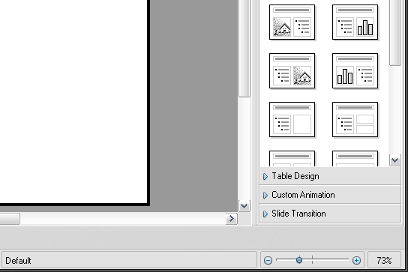Abbildung 2: Zoom slider in Impress
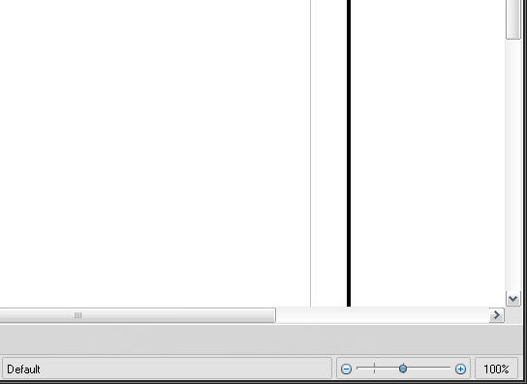Abbildung 3: Zoom slider in Draw

File Format
None

Open Issues
Issue | Initials | Date
Feedback: Tool-Tips for every button | FL | February 27, 2008
using the mouse wheel above the zoom slider | FL | February 27, 2008
Using the '+' and '-' keypad keys [ACCESIBILITY] | FL | February 27, 2008
Clicking the '+' and '-' zoom-slider buttons: a long click on one of these buttons shall initiate an autorepeat event | FL | February 27, 2008
Do not loose mouse capture if mouse is outside the zoom slider | FL | February 27, 2008
Mouse over feedback for controls in status bar | FL | February 27, 2008
Calc: Add page break preview to Calc | FL | July 2., 2008

Document Change History
Rev. | Change | Initials | Date
1 | First Draft | FL | 26.02.2008
2 | Add mock-ups | FL | 1.7.2008

