Software Specification Document

OpenOffice.org
Dialog Component Event Binding

Specification Status
Last Change | Jul 13, 2006
Status

Abstract
The “Assign Macro” dialog is extended to allow assigning handler methods in Components. This extension is only active if the dialog is used in the context of the Basic IDE Dialog Editor. In the scope of this extension also some layout changes are done. These changes are partly also valid in the context of the Form Control Property Browser and for the “Assign Macro” tab page in the Customize dialog.
i-Team Members
Role | First Name, Last Name, Initials | E-Mail Address
Project Lead | Andreas Bregas (ab) | ab@openoffice.org
Specification Owner | Andreas Bregas (ab) | ab@openoffice.org
User Experience | Christian Jansen | cj@openoffice.org
Development | Andreas Bregas (ab) | ab@openoffice.org
Quality Assurance | Thorsten Bosbach (tbo) | tbo@openoffice.org
Documentation | Uwe Fischer (ufi) | ufi@openoffice.org

Contents
Abstract 1
i-Team Members 1
References and Reference Documents 3
Acronyms and Abbreviations 4
1 Detailed Specification 5
2 Migration 7
3 Configuration 7
4 File Format 8
5 Open Issues 8
Document Change History 8

References and Reference Documents
Reference Document | Check | Location (URL)
Specification Process Entry Check |  | N/A
Product Requirement,, RFE, issue (required) |  | i66948, http://extensions.openoffice.org/files/documents/222/3586/ooo-gui-extensions.odt
Product Concept Document
Competitive Analysis
Test Case Specification (required) |  | http://qa.openoffice.org/source/browse/qa/qatesttool/framework/basic/f_basic_eventbinding.bas
Software Specification Rules | N/A | N/A
Concept / API description |  | http://specs.openoffice.org/ide/NonScriptDialogEvents.odt

Detailed Specification
The following figure shows the dialog when used in the Basic IDE Dialog Editor context. Besides Macros now also components - respectively a component's method can be assigned as action (button #3).

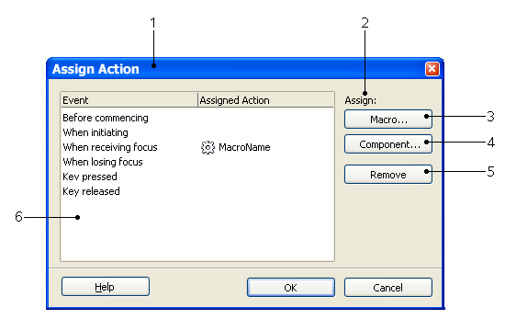
Figure 1: “Assign Action” dialog

Table 1: User Interface elements of Figure 1
# | Type | Properties |  | Comment
1 |  | Control Properties  Dialog Title: Assign Action  State: Modal  Closable: Yes  Close Operation: Dispose  Is iconifiable: No  Is maximizable: No  Resizable: No  Always On Top: No
1 |  | String English  Assign Action | String German  Aktion zuweisen
2 |  | Control Properties  Enabled: Yes
2 |  | String English  Assign: | String German  Zuweisen:
3 |  | Control Properties  Enabled: Yes  Icon: No  Resizeable: No  Has Menu: No |  |  | Opens “Macro Selector” dialog like “Assign” button did in OOo 2.0.3 and earlier
3 |  | String English  M~acro... | String German  M~akro...
4 |  | Control Properties  Enabled: Yes  Icon: No  Resizeable: No  Has Menu: No |  |  | Opens “Assign Component” dialog described below
4 |  | String English  Com~ponent... | String German  Kom~ponente...
5 |  | Control Properties  Enabled: Yes  Icon: No  Resizeable: No  Has Menu: No |  |  | Removes the binding for the entry selected in the listbox (#6)
5 |  | String English  ~Remove | String German  ~Entfernen
6 |  | Tabbed Listbox with two columns  Horizontal and vertical scrollbars visible on demand.  (for technical reasons this currently cannot be realized for the horizontal scrollbar, so it will always be visible)  Double click action:  On line with assigned action: Open dialog corresponding with the type of action.  On line without assigned action: Open Macro assignment dialog (default as much more used then assign component)  “Tabbed” Properties:  Initial splitting: 50 : 50  ToolTip Text left col: -  ToolTip Text right col: Assigned Action URL as now  Icon left col: -  Icon right col:  If the Assigned Action is a macro:  (default_images\svx\res\id018.png)  If the Assigned Action is a component (method):  (default_images\res\component_16.png)  Text left col: Event name  Text right col:  If the Assigned Action is a macro:  Macro name (including path, e.g. Basic library and module)  If the Assigned Action is a component (method):  Component method name  Control Properties  Enabled: Yes  Visible Row Count: 12  Item Selected: Depends on superior dialog usage
6 |  | String English caption left column:  Event  String English caption right column:  Assigned Action | String German caption left column:  Ereignis  String German caption right column:  Zugewiesene Aktion

Tab order of: 1
Tab Order | Comment
#6, #3, #4, #5

The following figure shows the dialog opened with the “Component...” button.

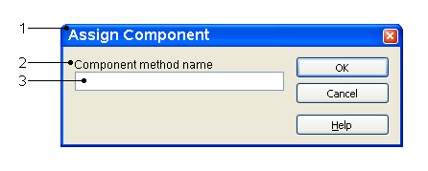
Figure 2: “Assign Component” dialog

User Interface Elements of: 2
# | Type | Properties |  | Comment
1 |  | Control Properties  Dialog Title: Assign Component  State: Modal  Closable: Yes  Close Operation: Dispose  Is iconifiable: No  Is maximizable: No  Resizable: No  Always On Top: No
1 |  | String English  Assign Component | String German  Komponente zuweisen
2 |  | Control Properties
2 |  | String English  Component method name | String German  Name der Komponenten-Methode
3 |  | Control Properties  Enabled: Yes  Editable: Yes  Initial Text Inside Field: Currently assigned method name  Drag Enabled: No  Initial Caret Position: End of text  Selection Starts: 0  Selection Ends: End of text (all selected)  Selected Text: Complete text selected
3 |  | String English | String German

Other contexts
The “Assign Action” (former “Assign macro”) dialog is implemented as tab page and also used in other contexts. The “Assign component (method)” functionality is only available in the Basic IDE Dialog Editor context.. The following figure shows the dialog when used in the Form Control context:
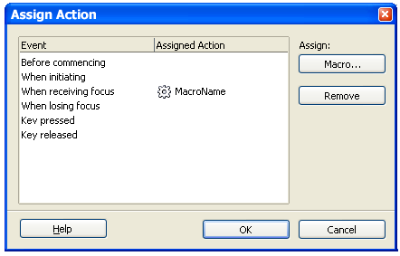
Figure 3: “Assign Component” dialog for Form Controls
When used as tab page in Tools/Customize/Events the layout should be similar to the “Form Control” layout. To reflect the larger size of the parent dialog the Event / Assigned Action listbox will be increased in size.

Runtime error message
So far only the assignment of Component methods at design time was described. At runtime an UNO handler object has to be specified when the dialog runtime instance is created. This is done by using the new UNO interface com.sun.star.awt.XDialogProvider2 (only as background information as this does not affect the User Interface).
The only subject that has to be specified here is the behaviour in case of an error. An error can occur if the user assigns a Component's method that does not really exists. In general this cannot be avoided because the component does not exist at design time and so it's not possible to browse through the available methods.
So if an event is bound to a method that does not exists or does not have the required signature (see concept document) an error message will be shown.
String English: An appropriate component method “%1”
could not be found.
Check spelling of method name.
String German: Eine passende Komponenten-Methode “%1”
konnte nicht gefunden weden.
Überprüfen Sie die Schreibweise des Methodennamens.
The %1 stands for the actual method name at runtime. Line wraps will be like shown above.

Migration
New usage of dialogs created with the Basic IDE Dialog Editor. The usage will be described in the Developers Guide and with SDK Samples.

Configuration
The configuration is not affected at all.

File Format
File Format is not affected as the new feature is only reflected in different values of XML already existing atttibutes in the Dialog XML file. The DTD does not change.

Open Issues
Issue | Initials | Date
Tool tip help displaying URL does not work for short URLs |  | July 12, 2006

Document Change History
Rev. | Change | Initials | Date
1 | First version |  | July 4, 2006
2 | Standard version |  | July 13, 2006
<...>

