Software Specification Document

OpenOffice.org
Software Update Notification

Specification Status
Last Change | Oct 9, 2006
Status

Abstract
As many other open source projects, OpenOffice.org is evolving over time and frequent releases add functionality or resolve existing issues. The Software Update Notification helps users to keep their OpenOffice.org up to date without having to monitor certain websites.

i-Team Members
Role | First Name, Last Name, Initials | E-Mail Address
Project Lead | Oliver Braun (obr) | obr@openoffice.org
Specification Owner | Oliver Braun (obr) | obr@openoffice.org
User Experience | Bettina Haberer (bh) | bh@openoffice.org
Development | Dirk Völzke (dv) | dv@openoffice.org
Quality Assurance | Olaf Felka (of) | of@openoffice.org
Documentation | Uwe Fischer (ufi) | ufi@openoffice.org
Other roles | <First Name, Last Name (Initials)> | <User@openoffice.org>
<State reason here, if one role is not represented in i-Team.>

Contents
Abstract 1
i-Team Members 1
References and Reference Documents 3
Acronyms and Abbreviations 3
1 Detailed Specification 4
1.1 Manually triggered check for updates 4
1.2 Automatically triggered check for updates 8
1.2.1 Notification in the menu bar 8
1.2.2 Notification via message boxes 10
1.3 Install time options 12
1.4 Run time options 15
1.5 Enhancing the case differentiation for the notify text (for next update > 4 or next release) 18
1.6 Make the bubble help window configurable 18
1.7 Enhanced message boxes at online connection failure 18
1.8 Automatic update notify and language support 19
1.9 Activation of "Automatic update notification" during the build 19
2 Migration 19
3 Configuration 19
4 File Format 19
5 Open Issues 19
Document Change History 19

References and Reference Documents
Reference Document | Check | Location (URL)
Specification Process Entry Check |  | N/A
Product Requirement,, RFE, issue (required) |  | http://qa.openoffice.org/issues/show_bug.cgi?id=66949
Product Concept Document |  | <Please enter location here>
Competitive Analysis |  | <Please enter location here>
Test Case Specification (required) |  | http://www.openoffice.org/nonav/issues/showattachment.cgi/38107/online%20update%20step2.html
Software Specification Rules | N/A | N/A

Acronyms and Abbreviations
Acronym / Abbreviation | Definition

Detailed Specification

Manually triggered check for updates
The help menu includes the entry “Check for Update...”. When selected, the code checking for updates gets triggered and a dialog informs the user about this ongoing check (Figure 1.1).
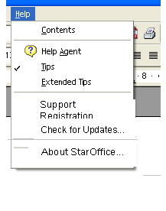Figure 1.1: The help menu entry

String list
Item | English | German | Comments
Menu label | Check for ~Updates... | Suche nach ~Updates... | The Help Menu gets a further entry.

During this check it is proofed, which StarOffice/OpenOffice.org version is installed on the client. The resulting version number then gets compared to those existing for download. If an update is found, which is newer then the version installed on the client, the user gets forwarded to the appropriate web site, where he can start manually the download of that newest update.

Depending on the check-results the following cases need to get covered:
- It is not possible to get an online connection to the server, the user has to try it again.
- The result of the check is, that the version installed on the client is the newest one, no update is necessary.
- An update was detected, which is newer that the version installed on the client.

After the help menu entry has been selected, a dialog as shown in Figure 1.2, opens. The check automatically begins shown by the progressbar.

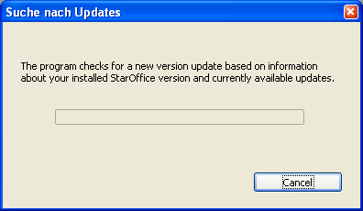Figure 1.2: Checking for an update

At click on the cancel button the check procedure stops and the dialog gets closed.
The cancel button in this dialog is the only one; due to that it is not possible to put the focus elsewhere then on this button. As this function, the manually started check is intended by the user it does not mean a problem.

Table 1: User Interface elements of Figure 1.2
# | Type | Properties |  | Comment
1 |  | Control Properties  State: modal  Closable: yes  Resizable: no  Always On Top: yes
1 |  | Check for Updates | Suche nach Updates
2 |  | Control Properties  Enabled: Yes
2 |  | String English  The program checks for a new version update based on information about your installed %PRODUCTNAME version and currently available updates. | String German  Das Programm sucht nach einem neuen Versions Update basierend auf Informationen über Ihre installierte %PRODUCTNAME Version und aktuell verfügbare Updates.
3 |  | Control Properties  Enabled: Yes  Icon: no  Resizeable: no  Has Menu: No  Menu Items: none  ToolTipText: none
3 |  | String English  Cancel | String German  Abbrechen

If it is not possible to get an online connection to the server, an appropriate error message appears (already existing). Otherwise the “last checked” date (needed for the automated check) gets updated and the corresponding timer / listener get reset [1].

When the result of the check is, that the version installed on the client is the newest one, no update is necessary. The following dialog appears:

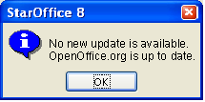Figure 1.3: Info Box: The version on the client is the newest one.

The OK button has the focus.
Table 2: User Interface elements of Figure 1.3
# | Type | Properties |  | Comment
1 |  | Control Properties  State: Modal  Closable: Yes  Resizable: no  Always On Top: yes
1 |  | %PRODUCTNAME | %PRODUCTNAME
2 |  | Control Properties  Enabled: Yes
2 |  | String English  No new update is available.\n  %PRODUCTNAME is up to date. | String German  Es ist kein neues Update verfügbar.\n  %PRODUCTNAME ist auf dem neuesten Stand.
3 |  | Control Properties  Enabled: Yes  Icon: no  Resizeable: no  Has Menu: no  Menu Items: none  ToolTipText: none
3 |  | String English  OK | String German  OK

In case an update version was detected on the server, which is newer that the OpenOffice.org version installed on the client, the following dialog opens:

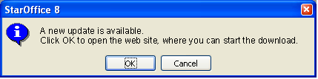Figure 1.4: Info Box: New download available

Table 3: User Interface elements of Figure 1.4
# | Type | Properties |  | Comment
1 |  | Control Properties  State: Modal  Closable: yes  Resizable: no  Always On Top: yes
1 |  | %PRODUCTNAME | %PRODUCTNAME
2 |  | Control Properties  Enabled: Yes
2 |  | String English  A new update is available.\n Click OK to open the web site, where you can start the download. | String German  Ein neues Update ist verfügbar.\n Bei Klick auf OK werden Sie auf die Webseite weitergeleitet, auf der Sie den Download starten können.
3 |  | Control Properties  Enabled: Yes  Icon: no  Resizeable: no  Has Menu: no  Menu Items: none  ToolTipText: none
3 |  | String English  OK | String German  OK
4 |  | Control Properties  Enabled: Yes  Icon: no  Resizeable: no  Has Menu: no  Menu Items: none  ToolTipText: none
4 |  | String English  Cancel | String German  Abbrechen

At click on the OK button the browser opens (if it has not already been opened) on the web site, where the user selects the appropriate update to download it.
At click on the Cancel button the dialog closes.
The OK button has the focus.
StarOffice/OpenOffice.org does not to get closed; that will happen automatically with an appropriate message, in case a download gets installed on the client.

Automatically triggered check for updates

During late initialization the office checks whether the user configurable time (default: Every Week) since the last check for updates has already elapsed. If it's not, it registers a timer to be called when it is.
As soon as the pause time has elapsed, the office checks for an available internet connection and registers itself as a “connection established” listener if there currently is none available.
Regardless of whether there is an update available or not, a successful check results in a new “last check” date to be written (ToDo: specify where). Note: a manual check also results in a new "last checked" Date, see [1].
There will only be notifications for available updates. Connection failures or successful checks with a result of “no updates available” will not be reported. In case a connection failure occurs, the trial of rebuilding the connection will follow (1x hourly, 5 times in succession).
NOTE: The UI for changing the update check period needs either to be able to reset the timer and to (de-) register the connection listener or warn the users that his/her changes will have no effect until the next restart.
NOTE: the automatic check for updates in OpenOffice.org 2.0.4 is disabled by default because there was not enough time left to implement and translate a user notification about the internet access required by this feature. OpenOffice.org 2.1 gets an additional first-start-wizard page for that purpose. See http://specs.openoffice.org/appwide/migration/spec_migration.sxw for details.

Notification in the menu bar
When an available update has been detected, this will be symbolized by an icon in the menu bar of each open document (unless online update has been disabled in the user settings). Clicking the icon will open the default web browser with the URL of a web-page where the user can download the update. The icon will be visible until all available updates have been installed.
Additionally, in the active document window (or the first one that becomes active), a bubble help window anchored at the software update notify icon appears to make sure the users notices the update notification without disturbing his/her workflow. The bubble-help window disappears when clicking on it or automatically after a certain amount of time (10 seconds) and re-appears when the user moves the mouse over the update notification icon.
In case the check gets started manually, and a new update is available, the notify icon does not appear during the same OpenOffice.org session, but after the next OpenOffice.org start, because it is possible, that
the user immediately starts the download, it makes not much sense to notify him in the same session about a new (in this case his already downloaded new) update.
The bubble-help window should function according the RTL handling (auto RTL).

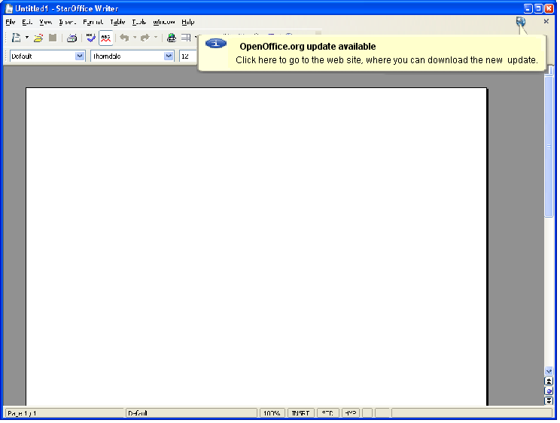Figure 1.5: mock-up of update availability notification

Table 4: User Interface elements of Figure 1.5
# | Type | Properties |  | Comment
1 |  | Control Properties  Enabled: Yes
1 |  | String English  %PRODUCTNAME update available | String German  %PRODUCTNAME Update verfügbar
2 |  | Control Properties  Enabled: Yes
2 |  | String English  Click here to go to the web site, where you can download the new update. | String German  Klicken Sie hier, um zur Webseite zu gelangen, auf der Sie das neue Update herunterladen können.

The figure below shows the notification icon:

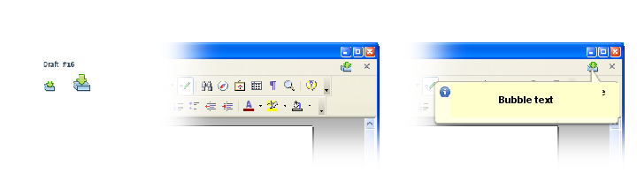
Figure 1.6: mock-up of the notify icon.

Table 5: User Interface elements of Figure 16
# | Type | Properties |  | Comment
1 |  | Control Properties  Enabled: yes  Icon: yes  Resizeable: no  Has Menu: no  Menu Items: none  ToolTipText: none
1 |  | <Enter English String Here> | <Enter German String Here>

Notification via message boxes
In case the software update notification should work with OpenOffice.org < 2.0.4, some UI elements used above will not be available. If there is a need to support this, it will be considered in a later update.
Figure 1.7: mock-up of message box used in OpenOffice.org < 2.0.4
Focus is on button OK.

Table 6: User Interface elements of Figure 1.7
# | Type | Properties |  | Comment
1 |  | Control Properties  State: modal  Closable: yes  Resizable: no  Always On Top: yes  A11Y Text: <If needed specify text here>  Other...: <If needed specify text here>
1 |  | String English  %PRODUCTNAME | String German  %PRODUCTNAME
2 |  | Control Properties  Enabled: Yes
2 |  | String English  A new update is available.\n Click OK to open the web site, where you can start the download. | String German  Ein neues Update ist verfügbar.\n Bei Klick auf OK werden Sie auf die Webseite weitergeleitet, auf der Sie den Download starten können.
3 |  | Control Properties  Enabled: Yes  Icon: No  Resizeable: no  Has Menu: No  Menu Items: None  ToolTipText: None
3 |  | String English  OK | String German  OK
4 |  | Control Properties  Enabled: yes  Icon: no  Resizeable: no  Has Menu: no  Menu Items: none  ToolTipText: none
4 |  | String English  Cancel | String German  Abbrechen

Install time options
Software update notification will become an install time module, which makes it easy for administrators of multi-user installations to disable the software update notification.

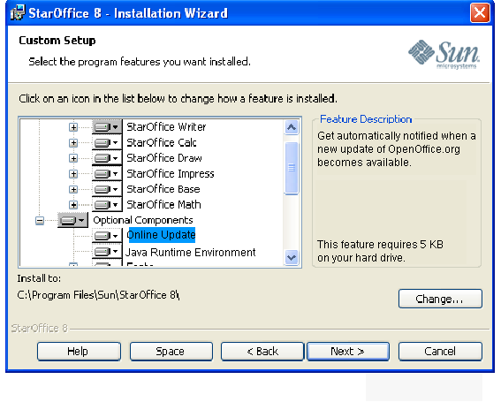Figure 1.8: The new optional component Online Update in the tree list

The module description $subject in the setup of a respin version is as follows:
Table 7: User Interface elements of Figure 1.8
# | Type | Properties |  | Comment
1 |  | Control Properties  Features: Custom Tree Control
1 |  | Online Update | Online Update
2 |  | Control Properties  Enabled: yes  Editable: no
2 |  | String English  [STR_DESC_MODULE_OPT_ONLINEUPDATE]  "Get automatically notified when a new update of %PRODUCTNAME becomes available." | String German  [STR_DESC_MODULE_OPT_ONLINEUPDATE]  "Informiert Sie über das Erscheinen eines neuen Updates von %PRODUCTNAME."

Run time options

The run-time options for software updates will appear in the Tools – Options – OpenOffice.org section when the online update module is installed. The “Download updates automatically” check box and the “Download location” option are reserved for future use and will not be visible initially.
If the user wants to switch of the automatic notification feature, he can uncheck the option “Check for updates automatically”. At the moment, the user switches the automatic notify off, the icon in the menu bar disappears.
The download location gets identified and the path will be displayed shortened in the options dialog.

Stati:
“Check for updates automatically” is default selected. Options “Every Day”, “Every Week” and “Every Month” are enabled, option “Every Week” is default selected.
When “Check for updates automatically” is switched off, the options “Every Day”, “Every Week” and “Every Month” get disabled.

Tab order:
- 'Check for updates automatically'
- the selected option, default 'Every Week'
- 'Check now...'
- 'Download updates automatically'
- 'Change...'
- Ok, Cancel, Help, Back

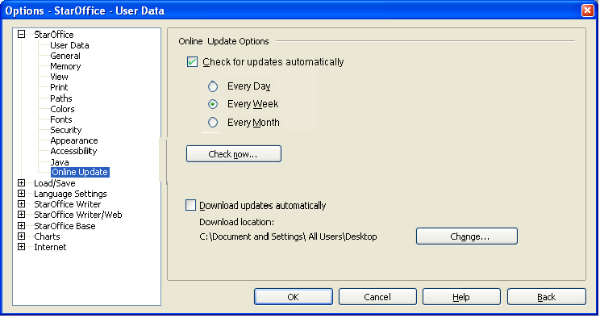Figure 1.9.: Online Update options tab page
Table 9: User Interface elements of Figure 1.9
# | Type | Properties |  | Comment
1 |  | Control Properties  Features: tree node
1 |  | Online Update | Online Update
2 |  | Control Properties  Label:
2 |  | String English  Online Update Options | String German  Online Update Optionen
3 |  | Control Properties  Enabled: yes  Initially Checked: yes  TriState: no  ToolTip Text: <If needed specify tip here>  Other...: <If needed specify here>
3 |  | String English  ~Check for updates automatically | String German  ~Automatisch nach Updates suchen
4 |  | Control Properties  Enabled: Yes  Icon: no  Resizeable: no  Has Menu: No  Menu Items: none  ToolTipText: none
4 |  | String English  Check ~now | String German  Jetzt ~suchen
5 |  | Control Properties  Enabled: Yes  Initially Checked: No  TriState: no
5 |  | String English  ~Download updates automatically | String German  Updates automatisch ~herunterladen
6 |  | Control Properties  Enabled: Yes
6 |  | String English  Download destination: | String German  Herunterladen nach:
7 |  | Control Properties  Enabled: Yes  Icon: no  Resizeable: no  Has Menu: no  Menu Items: none  ToolTipText: none
7 |  | String English  Ch~ange | String German  Ä~ndern
8 |  | Control Properties  Enabled: yes  Initially Selected: yes
8 |  | String English  Every ~Week | String German  Jede ~Woche
9 |  | Control Properties  Enabled: yes  Initially Selected: no
9 |  | String English  Every ~Month | String German  Jeden ~Monat
10 |  | Control Properties  Enabled: yes  Initially Selected: no
10 |  | String English  Every Da~y | String German  Jeden ~Tag

Enhancing the case differentiation for the notify text (for next update > 4 or next release)

Currently at showing the bubble help text we textual only cover the case, when a new update is available for the machine. But textually we don't differentiate between the installation and a download, which has not been installed. And another case is, when a downloaded OpenOffice.org update is not installed and a new update was found.
First case (recognize a new update, currently covered): A new update was found, the bubble says: “Go to the download web site.”
Second case (recognize a downloaded but not installed update, a further check has not found a new update): Even in case, a new update was found and downloaded (so the newest update is already available on the machine), but not installed, the same text currently appears, which is not exactly fitting to the case.
Instead the program should get able to recognize the downloaded, but not yet installed OpenOffice.org update and show a notify bubble help text like “Your downloaded new update is not installed yet.”
Third case (recognize a downloaded but not installed update and a further check recognizes a new update): In this case the program needs to differentiate between an older download on the machine and a newer available update on the server site. A fitting text in the notify bubble help could be “The current download is not up to date. Click here to download the new update”.

Make the bubble help window configurable

The new introduced bubble help window in OpenOffice.org shall be made configurable within VCL for further usage within OpenOffice.org. If this does not get done for update 4, this will be done for the next update > update 4.

Enhanced message boxes at online connection failure

If during the automatic check the establishing of an online connections fails, we will have an appropriate message in the next update > 4, coming up after some automatic retries.
If establishing of an online connections fails during a manual started check , the currently used message needs to get a bit more enhanced to offer a more helpful text (pointing to possible reasons of failure). But other existing message, coming up in the context of online connection should also get reworked. As that would take more time, this is a goal for an update > update 4.

Automatic update notify and language support
As each OpenOffice.org user should have available the automatic check for online updates, so that he can work with a newest version, this feature is kept language independent. That means, that he might get the notify in his OpenOffice.org version, but as this language might not be supported on the appropriate web site where the downloads are available, he at least has the opportunity to get the newest update in another language.

Activation of "Automatic update notification" during the build
The check for updates functionality is implemented as an extension.
This extension is not packaged by default during the build to avoid conflicts with platform provided notification mechanisms.
The packaging is enabled with the environment variable BUILD_SPECIAL. A URL for the server to check against has to be provided.

Migration
This milestone is fully compatible with the previous one (manual checks only).

Configuration
Only private data in Jobs.xcu and Addons.xcu. No new schema(s).

File Format
The feature is independent of the ODF file format.

Open Issues
Issue | Initials | Date
Language and Language-Pack support | OBR | September 26, 2006
Functionality not existing in vanilla OpenOffice.org builds from CVS | OBR | September 26, 2006
<...>

Document Change History
Rev. | Change | Initials | Date
1 | Initial public release | OBR | July 27, 2006
2 | Minor formal changes | OBR | July 27, 2006
3 | Added paragraph 1.3.1 Inform user about the internet access of the automatic update check | DV | September 21, 2006
4 | Removed paragraph 1.3.1 again in favor off disabling the functionality by default for OpenOffice.org 2.0.4 | OBR | September 26, 2006
5 | Removed StarOffice Update Installation part | OBR | October 9, 2006
<...>

