Software Specification Document

OpenOffice.org 2.0.4 and higher
OpenOffice.org NetBeans Integration: Calc Addin wizard

Specification Status
Last Change | Mar 1, 2007
Status

Abstract
The intention of the OpenOffice.org NetBeans Integration: Calc Addin wizard is to simplify the development of OpenOffice.org extensions as well as the general development for or with the OpenOffice.org API. Modern IDE's provide a lot of useful tools to make the daily work for developers easier. Especially recurring tasks or some kind of templates/wizards are often used to provide special support inside an IDE. And exactly here should the OpenOffice.org NetBeans Integration: Calc Addin wizard provide some useful extensions to the NeBeans IDE to speed up the initial start working with the OpenOffice API. The plan is to provide wizards for various tasks and new project types as well as the support of scripting support from within the IDE. General support for UNOIDL and other office specific file types like *.xcu, *.oxt.

i-Team Members
Role | First Name, Last Name, Initials | E-Mail Address
Project Lead | Jürgen Schmidt (jsc) | juergen.schmidt@sun.com
Specification Owner | Jürgen Schmidt (jsc) | juergen.schmidt@sun.com
User Experience
Development | Steffen Grund (sg) | steffen.grund@sun.com
Quality Assurance | Thorsten Bosbach (tbo) | thorsten.bosbach@sun.com
Documentation
Other roles
Based on a verbal agreement between Lutz Höger and Jürgen Schmidt, we decided that a team member of the office user experience team isn't necessary because this specification is off topic of normal office features and address developers only and provides an integration in an external application (NetBeans IDE).

Contents
Abstract 1
i-Team Members 1
References and Reference Documents 3
Acronyms and Abbreviations 4
1 Detailed Specification 5
2 Migration 7
3 Configuration 7
4 File Format 8
5 Open Issues 8
Document Change History 8

References and Reference Documents
Reference Document | Check | Location (URL)
Specification Process Entry Check |  | N/A
Product Requirement,, RFE, issue (required) |  | <Please enter location here>
Product Concept Document |  | <Please enter location here>
Competitive Analysis |  | <Please enter location here>
Test Case Specification (required) |  | <Please enter location here>
Software Specification Rules | N/A | N/A
<Other, e.g. references to related specs>

Acronyms and Abbreviations
Acronym / Abbreviation | Definition
SDK | Software Development Kit
Add-in | Specialized component type supporting Calc built-in functions
deploy/deployment | Means the installation of office extension packages into an office installation
nbm | NetBeans module/plugin, comparable with an office extensions package, means a plugin extending the base functionality of NetBeans with some new functions.
UNOIDL
simple UNO bootstrap feature | link zu erklärung

Detailed Specification
This new project type will create an adapted J2SE class library project with special support for an UNO component library and an office extension package. The wizard will collect necessary information for new Calc built-in functions and abstracts from the underlying UNO technology.

OpenOffice Calc Add-In Project Type
The OpenOffice.org Calc Add-In wizard creates a new extended J2SE class library project with office API support and additional support for creating and deploying office extension packages. That means the office library is added to the project to provide code completion and context sensitive help for the office API and the context menu (see Figure 1) of the project node is extended with two new menu entries for creating and deploying an office extension.
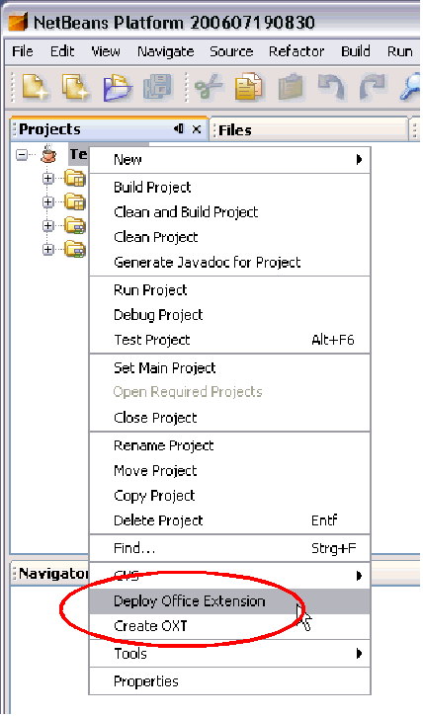Figure 1: Project Node context Menu - Office Extensions Create/Deploy entries

The wizard collects all necessary information for a J2SE class library project and collects information for new Calc add-in functions. The Add-In name is used to specify a new Add-In service and interface description and the implementation class name. The Java package name is used as package for the implementation class and is mapped to UNOIDL modules for the service and interface specification.
For example:
A specified Add-In name MyTestAddIn and package org.test results in
- Service name = org.test.MyTestAddIn
- Interface name = org.test.XMyTestAddIn
- Implementation name = org.test.MyTestAddInImpl
The new defined Calc Add-In methods are specified as interface methods of the Add-In interface. And in fact of this the specification of the functions is limited to the UNOIDL capabilities and in addition it's limited to a subset of possible types for the return and parameter values. The wizard takes care of this limitation and offers only the possible types (see the reference documentation of com.sun.star.sheet.AddIn).
The collected data about the Add-In functions is more than the pure UNOIDL definition. Additional information is collected and used in a new configuration file for Calc Add-Ins which is part of the final office extension package. The new configuration allows later to retrieve information about new Add-In functions directly from the configuration and an instantiation of the Add-In component is only necessary when a new Add-In function is used.
Overview of the collected Add-In function data:
- Function Name
The implementation function name which is used in the UNOIDL interface definition, in the configuration file to identify the node section for this function and when you want to use the Add-In function programmatically.
- Display Name
A human readable function or parameter name which is shown in the UI of the function dialog. This name is localizable and it is common to specify at least an English name. The display name becomes part of the configuration file only.
- Description
A human readable description of the function or parameter which is shown in the UI of the function dialog. This description is localizable and it is common to specify at least an English description. The description becomes part of the configuration file only.
- Category
The function dialog categorized the functions in different categories and it is possible to select a predefined category where the the new function should appear later in the function dialog. The description becomes part of the configuration file only. The wizard allows currently only the selection of a predefined category because free definition of categories is not implemented yet.
For detailed information about the possible categories please refer the reference documentation of com.sun.star.sheet.XAddIn interface.
- Category Display Name (not supported yet)
The category display name is currently not supported because you can only select from a list of predefined categories. But in the future it is planned to support the definition of new categories and then the category display name provide a localized display name for the new category.
- Compatibility Name
Compatibility names are localized names of Add-In functions that are used to import files from other applications. If on import a localized function name is read, this list of compatibility names is used to find the internal name of the function. For more information about compatibility names please read the appropriate section in the Developer's Guide and see also the reference documentation of the com.sun.star.sheet.XCompatibilityNames interface.
- Return Type
The return type of the Add-In function and the list provides all valid types because Add-In functions don't support all UNOIDL types as return types but only a subset.
For detailed information about the valid types please refer the reference documentation of com.sun.star.sheet.AddIn service.
- Parameter Name
The implementation parameter name which is used in the UNOIDL interface definition. It is possible to define a localized display name and a description for the parameter as well as for the function itself.
- Parameter Type
The parameter type of an Add-In parameter and the list provides all valid types because Add-In functions don't support all UNOIDL types as parameter types but only a subset.
For detailed information about the valid types please refer the reference documentation of com.sun.star.sheet.AddIn service.
The project wizard supports two different modes.
- Default mode is to generate a minimal Calc Add-In skeleton which means UNOIDL service and interface definition, configuration file CalcAddIn.xcu and minimal UNO component skeleton implementing the new Add-In service + necessary component interfaces. All functions of the new defined Add-In interface are default implemented. This kind of Calc Add-In extension is usable since OO.org 2.0.4.
- The second mode is a backward compatibility mode which means that additional to the new defined Add-In service the former necessary com.sun.star.sheet.AddIn service is also implemented and all related interfaces are implemented and map the functionality to the still generated configuration file. The appropriate configuration schema is generated in the project as well and becomes part of the final extension package. This enables the usage of such an extension in older office versions as well.
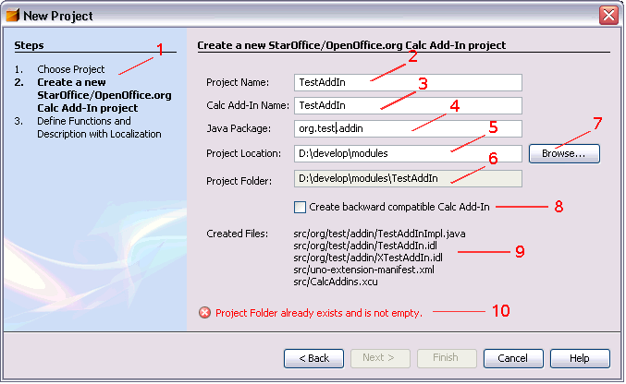Figure 2: New Project Dialog – StarOffice/OpenOffice.org Calc Add-In Project Tab 1

Table 1 User Interface elements of Figure 2
Table <Table Number>: User Interface elements of Figure <Figure Number>
# | Type | Properties |  | Comment
1 |  | Control Properties  Features: View of the steps during project creation. This view is provided by NetBenas. Only the entries come from the different panels of the wizard
1 |  | Create a new StarOffice/OpenOffice.org Calc AddIn-project  Define functions and Description with Localization |  |  | Step 1 of the wizard  Step 2 of the wizards
2 |  | Control Properties  Enabled: Yes  Editable: Yes  Initial Text Inside Field: AddIn  Drag Enabled: No  Initial Caret Position: <End>  Characters Allowed: All characters for NetBeans projects  Characters not Allowed:  Selection Starts: 0  Selection Ends: 0  Selected Text:  ToolTip Text:  A11Y Text:  Other...:  Password Field Properties  Echo Character:  Other...:
2 |  | String English  Project Name: | String German
3 |  | Control Properties  Enabled: Yes  Editable: Yes  Initial Text Inside Field: AddIn  Drag Enabled: No  Initial Caret Position: <End>  Characters Allowed: File Name characters  Characters not Allowed: No file name chars  Selection Starts: 0  Selection Ends: 0  Selected Text:  ToolTip Text:  A11Y Text:  Other...:  Password Field Properties  Echo Character:  Other...: |  |  | If this field is not edited by itself, the entries will be the same as in field #2, using the same name for the project and the Add-In as default.
3 |  | String English  Calc Add-In Name: | String German
4 |  | Control Properties  Enabled: Yes  Editable: Yes  Initial Text Inside Field: org.openoffice  Drag Enabled: No  Initial Caret Position: 0  Characters Allowed: all for Java packages/file folders  Characters not Allowed:  Selection Starts: 0  Selection Ends: 0  Selected Text:  ToolTip Text:  A11Y Text:  Other...:  Password Field Properties  Echo Character:  Other...:
4 |  | String English  Java Package: | String German
5 |  | Control Properties  Enabled: Yes  Editable: Yes  Initial Text Inside Field: <User Home Directory>  Drag Enabled: No  Initial Caret Position: <End>  Characters Allowed: all for folders  Characters not Allowed: all for folders  Selection Starts: 0  Selection Ends: 0  Selected Text:  ToolTip Text:  A11Y Text:  Other...:  Password Field Properties  Echo Character:  Other...: |  |  | If button #7 is used, the result will be entered in this field, overwriting the content.
5 |  | String English  Project Location: | String German
6 |  | Control Properties  Enabled: Yes  Editable: No  Initial Text Inside Field: <added result from #2 and #5>  Drag Enabled: No  Initial Caret Position: 0  Characters Allowed:  Characters not Allowed:  Selection Starts:  Selection Ends:  Selected Text:  ToolTip Text:  A11Y Text:  Other...:  Password Field Properties  Echo Character:  Other...:
6 |  | String English  Project Folder: | String German
7 |  | Control Properties  Enabled: Yes  Icon: No  Resizeable: No  Has Menu: No  Menu Items:  ToolTipText: |  |  | This button will open the Java file browser. This dialog is Java specific and must not be specified here.
7 |  | String English  Browse: | String German
8 |  | Control Properties  Enabled: Yes  Initially Checked: No  TriState: No  ToolTip Text:  Other...:
8 |  | String English  Create backward compatible Calc Add-In | String German
9 |  | Control Properties  Enabled: Yes  Editable: No  Linewrap: On  Maximum Row Count: 10  Visible Row Count: 10  Display Hori. Scrollbar: Never  Display Vert. Scrollbar: Never  Initial Text Inside Field:  Drag Enabled: No  Caret position: 0  Characters Allowed:  Characters not Allowed:  Selection Starts:  Selection Ends:  Selected Text:  A11Y Text:  ToolTip Text:  Other...: |  |  | This field displays all created files. These are:  - Service and Interface definition as idl files  - Implementation, Java file  - Manifest (xml)  - Configuration (xcu)  - if #8 is checked:  Configuration (xcs)
9 |  | String English | String German
10 |  | Control Properties  Enabled: No |  |  | Label for Error Messages, normally disabled (except the initial settings produce an error)
10 |  | String English | String German

Table 2 Tab order of Figure 2
Tab Order | Comment
#2, #3, #4, #5, #7, #8

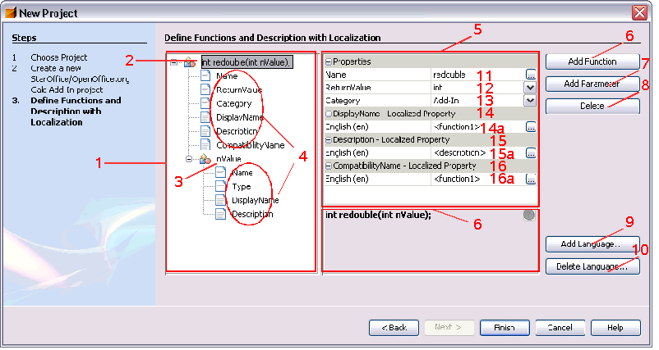Figure 3: New Project Dialog – StarOffice/OpenOffice.org Calc Add-In Project Tab 2

Table 3 User Interface elements of Figure 3
# | Type | Properties |  | Comment
1 |  | Control Properties  Editable: No  Enabled: Yes  DnD Enabled: No  Row Height: <Specify value here e.g. 16 px>  Scrolls on Expand: Yes  Display Hori. Scrollbar: As needed  Display Verti. Scrollbar:As needed  A11Y Text: -  ToolTip Text: - |  |  | TreeControl, showing an overview of the new defined add-in functions. Root nodes representing new functions and sub nodes representing either properties or if folding, parameter nodes related to this function.
1 |  | <Enter English String Here> | <Enter German String Here>
2 |  | Control Properties  Enabled: Yes |  |  | Label for a function node. The label display name depends on the function signature and is changed accordingly
2 |  | String English  <Enter String Here> | String German  <Enter String Here>
3 |  | Control Properties  Enabled: Yes |  |  | Label for a function parameter node. The label display name depends on the defined parameter name and is changed accordingly
3 |  | String English  <Enter String Here> | String German  <Enter String Here>
4 |  | Control Properties  Enabled: <Yes/No> |  |  | Label for different properties related to wither the function or a function parameter.
4 |  | String English  Property nodes are currently:  - Name  - ReturnValue  - Category  - DisplayName  - Description  - CompatibilityName  - Type | String German  <Enter String Here> |  | Properties 1- 6 are use for function nodes and 1,4,5 and 7 are used for parameter nodes
5 |  | Control Properties  Features: Property Editor Control showing properties related to a selected node in #1. Common properties are collected under “Properties” which groups the properties and allows to fold the group for visibility. Localized properties has their own group section to combine all localization entries for this property and these groups can be folded as well.
5 |  | String English  <Enter String Here> | String German  <Enter String Here>
6 |  | Control Properties  Enabled: Yes  Icon: No  Resizeable: No  Has Menu: Yes, context menu on function node in #1  Menu Items: Add Function  ToolTipText: adds a new add-in function
6 |  | String English  Add Function | String German  <Enter String Here>
7 |  | Control Properties  Enabled: Yes  Icon: No  Resizeable: No  Has Menu: Yes, context menu on function and parameter node  Menu Items: Add Parameter  ToolTipText: adds a new parameter to the currently selected add-in function
7 |  | String English  Add Parameter | String German  <Enter String Here>
8 |  | Control Properties  Enabled: Yes  Icon: No  Resizeable: Yes  Has Menu: Yes, context menu on function and parameter node  Menu Items: Delete Function, Delete Parameter  ToolTipText: deletes either the selected parameter or the whole add-in function
8 |  | String English  Delete | String German  <Enter String Here>
9 |  | Control Properties  Enabled: Yes  Icon: No  Resizeable: No  Has Menu: No  Menu Items: -  ToolTipText: adds a new language to all localized add-in function properties
9 |  | String English  Add Language... | String German  <Enter String Here>
10 |  | Control Properties  Enabled: Yes  Icon: No  Resizeable: Yes  Has Menu: No  Menu Items: -  ToolTipText: deletes the selected language from all localized properties from all functions
10 |  | String English  Delete Language... | String German  <Enter String Here>
11,12,13 |  | Control Properties  Features: Property group section which is part of a property editor control #5.  The property section can be folded to hide the content properties which consist of a name (left) and a value (right). The value field can be a custom editor
11,12,13 |  | String English  Properties  - Name  - ReturnValue  - Category | String German  <Enter String Here>
11 |  | Control Properties  Enabled: Yes  Editable: Yes  Initial Text Inside Field: default add-in function name  Drag Enabled: No  Initial Caret Position: -  Characters Allowed: [a-zA-Z0-9_]  Characters not Allowed:  Selection Starts: 0  Selection Ends: end  Selected Text: <Specify string here>  ToolTip Text: <If needed specify text here> |  |  | Property value “Name” describing the name of the add-in function
11 |  | String English  Name | String German  <Enter String Here>
12 |  | Control Properties  Enabled: Yes  Visible Row Count: 1  Item Selected: int |  |  | Add-in functions supports only a subset of possible IDL types:  The possible types are:  int, double, String, int[][], double[][], String[][], Object[][], XVolatileResult, Object
12 |  | String English  ReturnValue | String German  <Enter String Here>
13 |  | Control Properties  Enabled: Yes  Visible Row Count: 1  Item Selected: Add-In |  |  | Later it might be possible to define new own categories but currently only predefined categories are supported.  Possible categories are:  Add-In, Database, Date&Time, Financial, Information, Logical,  Mathematical, Matrix, Statistical, Spreadsheet, Text
13 |  | String English  Categroy | String German  <Enter String Here>
14,15,16 |  | Control Properties  Features: Property group section which is part of a property editor control #5.  The property section can be folded to hide the content properties which consist of a name (left) and a value (right). The value field can be a custom editor
14,15,16 |  | String English  DisplayName  Description  CompatibilityName | String German  <Enter String Here>
14a, 15a, 16a |  | Control Properties  Features: TextEditor with functionality to edit it inline or start a separate editor window |  |  | Left field represents the language in which the right text field is localized
14a, 15a, 16a |  | String English  Language Identifier, e.g.  English (en) | String German  <Enter String Here>
17 |  | Control Properties  Enabled: Yes  Visible Row Count: 1  Item Selected: int |  |  | This field is only in the context of parameters visible but is comparable with #12  Possible values are:  int, double, string, int[][], double[][], String[][], Object[][], Object, XCellRange, XPropertySet, Object[]
17 |  | String English  Type | String German  <Enter String Here>

Table 4 Tab order of Figure 3
Tab Order | Comment
#1, #5, #11, #12, #13, #14, #15, #16 | The tab order can changed and depends of the selected node in the left tree view

Migration
No migration involved.

Configuration
<Start typing here ----- If this part is irrelevant state a reason for its absence!>

File Format
No file format changes currently but this can change and this section gets reused later when scripting capabilities are specified in detail because scripts can be part of documents and in fact of this part of a zip document container package.

Open Issues
Issue | Initials | Date
wizard for new IDL type definitions I69757 | sg | <Format: Dec 31, 2000>
general UNO component wizard I69758 | sg
uno-skeletonmaker support for add-on components i69760 | jsc
wizard for Add-On components i69761 | sg
debug support for UNO components in NetBeans i69762 | jsc
prepare/design new icons for UNO components in NetBeans i69763 | jsc
improve UNOIDL editor -> syntax highlighting i69781 | sg

Document Change History
Rev. | Change | Initials | Date
1 | Integrate feedback from TBO | jsc | Sep 22, 2006
2 | Separated this file from general specification. | sg | Mar 1, 2007
3
<...>

http://api.openoffice.org/docs/common/ref/com/sun/star/sheet/XAddIn.html#getProgrammaticCategoryName
http://api.openoffice.org/docs/DevelopersGuide/Spreadsheet/Spreadsheet.xhtml#1_6_Spreadsheet_Add-Ins
http://api.openoffice.org/docs/common/ref/com/sun/star/sheet/XCompatibilityNames.html
http://api.openoffice.org/docs/common/ref/com/sun/star/sheet/AddIn.html

