Software Specification Document

OpenOffice.org Writer
Set Language Attribute for Text

Specification Status
Last Change | Feb 18, 2010
Status
Abstract
Changing the language attribute of text is a much too complicated task in OOo 2.2. Therefore a new control in the status bar of Writer will be introduced to show the language at the current cursor position/selection. Furthermore the entire document language can be changed.
i-Team Members
Role | First Name, Last Name, Initials | E-Mail Address
I-Team Lead | Carsten Driesner (CD) | carsten.driesner@sun.com
Specification Author | Frank Loehmann (FL) | frank.loehmann@sun.com
User Experience | Frank Loehmann (FL) | frank.loehmann@sun.com
Development | Lili Sun  Thomas Lange (TL)  Carsten Driesner (CD) | sunnyfire@hotmail.com  thomas.lange@sun.com  carsten.driesner@sun.com
Quality Assurance | Stefan Baltzer (SBA) | stefan.baltzer@sun.com
Documentation | Uwe Fischer (UFI) | uwe.fischer@sun.com

Contents
Abstract 1
i-Team Members 1
References and Reference Documents 3
Acronyms and Abbreviations 3
1 Detailed Specification 4
1.1 New Language Control in Status Bar 4
1.1.1 Selection with Different Languages 4
1.1.2 Context Menu for Language Control 4
1.1.2.1 Behavior of More... Entry from Text Language Context Menu 6
1.1.2.2 Behavior of More... Entry from Paragraph Language Context Menu 6
1.1.3 Dynamic Language List Generation for Context Menu 6
1.1.4 Change Document Language 7
1.2 Extension of Tools-Language Menu 8
1.2.1 Western & Asian & CTL Languages 8
1.3 Extension of Context Menu for Misspelled Words in Text 10
1.3.1 Current (Old) Context Menu for Misspelled Words 10
1.3.2 New Context Menu for Misspelled Words 11
1.3.2.1 Set Language Entries 11
1.4 Format – Default Formatting Behavior (i78856) 12
1.5 Set Text Language to Input Language Automatically (Windows Only, i1035) 12
2 Migration 12
3 Configuration 12
4 File Format 13
5 Future Issues 13
6 Future Features (See Issue 77208) 13
6.1 New Format Entry 14
6.2 New Context Menu for Text 15
6.3 Text in Non-Writer, OLE and Writer Objects 16
6.3.1 Writer Frames 16
6.3.2 Drawing Objects (Text boxes) 16
6.3.3 OLE Objects 16
6.4 Tools Options 16
Document Change History 17

References and Reference Documents
Reference Document | Check | Location (URL)
Specification Process Entry Check |  | N/A
Product Requirement, RFE, issue [Required] |  | IssueZilla: 1034 / 77208 / 78856 / 60412, 92982
Product Concept Document |  | http://specs.openoffice.org/appwide/linguistic/STATUS_BAR_CONTROL_FOR_LANGUAGE_Minutes_2007-04-23.odt
Competitive Analysis |  | none
IDL Specification |  | none
Test Case Specification [Required] |  | http://qa.openoffice.org/ooQAReloaded/TestcaseSpecifications/OpenOffice.org_2.4/Word_Processor/Set_Language_Attribute_for_Text.html
Software Specification Rules | N/A | N/A
Acronyms and Abbreviations
Acronym / Abbreviation | Definition
CTL | Complex Text Layout
CJK | Chinese Japanese Korean

Detailed Specification
Assigning a language attribute to a text in Writer depends on many different aspects like current selection, language type (Wester, CJK, CTL) and text object type (Writer, OLE, Drawing Object). So many dependencies have to be covered for this new feature.

New Language Control in Status Bar
The Writer status bar contains a new text field. This text field always shows the language set at the current cursor position. The width of that field is fixed and the text content of this field is centered. This field offers a context defined below.
Illustration 1: New language control in Writer status bar showing “English (USA)”

Selection with Different Languages
In a selection or multi selection containing more than one language, the field shows the string “Multiple Languages”.
Illustration 2: Selection/multi selection of text with more than one language shows “Multiple Languages”

- “Language Control in Status Bar” - Text Field Properties |  | Comment
Enabled: | always
Disabled: | If an object like a frame or drawing object is selected.
Read Only: | yes
Initial String: | <dynamic content> | Name for a languages is taken from OOo's global list of languages.
 | Multiple Languages, Mehrere Sprachen | This string is shown when a selection has more than one language.
Other: | Text is centered

Context Menu for Language Control
The following context menu is shown, if a context menu (left or right mouse click) is called on the language control field in the status bar and if the control is not disabled at that time. Left click context menu will also work on all other status bar controls currently showing a context menu only on right mouse click. A double click on the language control is not supported.
The language control shows only languages from script types (i.e. Asian, CTL, Western) present in the current text selection.
If the selected text contains more than one language, the context menu shows no radio button indicating the current language. Furthermore no radio is shown in the paragraph and document language menu.

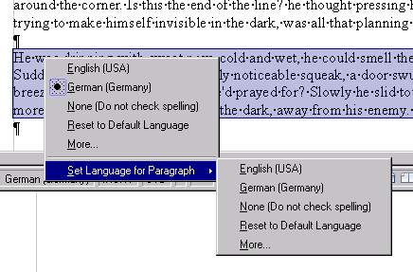Illustration 3: Context Menu on Language Control for Languages (only Western languages are shown in this example)
- “Context Menu of Language Control” - Menu Properties |  |  |  |  | Comment
Menu Items:
Items | Sub Items | Sub Items | KBD Shortcuts | Icon | Comment
<Dynamic List of Languages> |  |  |  |  | List of Languages is defined below
None (Do not check spelling) |  |  |  |  | If no grammar checker is installed.
None (Do not check spelling and grammar) |  |  |  |  | If a grammar checker is installed.
Reset to Default Language |  |  |  |  | Removes language attribute.
More... |  |  |  |  | [1]
------------- |  |  |  |  | Separator
Set Language for Paragraph, Absatzsprache festlegen |  |  |  |  | Western language for document calls a sub menu
 | <Dynamic List of Languages> |  |  |  | List of Languages is defined below
 | None (Do not check spelling) |  |  |  | If no grammar checker is installed.
 | None (Do not check spelling and grammar) |  |  |  | If a grammar checker is installed.
 | Reset to Default Language |  |  |  | Removes language attribute.
 | More... |  |  |  | [2]

Behavior of More... Entry from Text Language Context Menu
The More... entry [1] from of the context menu calls the Format-Character dialog and the Font tab page is shown. The appearance of the Font tab page changes depending on the language support activated in Tools-Options-Languages (Western, CJK, CTL).
The focus is set to the current script type detected for the current selection. In case of a selection with more than one script type, the focus is set to the western language control.
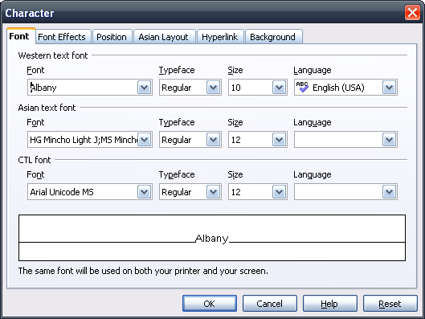Illustration 4: Font tab page with CJK and CTL language support being activated

Behavior of More... Entry from Paragraph Language Context Menu
The More... entry [2] from the paragraph language context menu calls the Tools-Options-Language Settings - Languages dialog.

Dynamic Language List Generation for Context Menu
The list of languages, shown in the context menu, is dynamically created from the following language settings and is limited to a maximum of 7 language entries and is sorted alphabetically. All shown languages are from the same scripting type (i.e. Asian, Western, CTL) present in the current text selection. If no selection is present all currently enabled script types are shown.
- Currently set language
- and locally set language from Tools-Options (OOo and operating system)
- and user Interface language from Tools-Options
- and guessed language from current paragraph
- (optional on Windows operating systems) currently used keyboard languages (called input languages on Windows systems)
- and languages already used in current document (Note: Number of languages is limited to 7 overall)
- and ignore attribute in form of the entry “Do not check spelling[ and grammar]”
The entry for no. 7 and the More... entry are always part of that menu, so the menu consist of a maximum of 9 entries. These entries are always shown at the end of the menu.

Change Document Language
The “Set Document language...” entry from the context menu (only shown if CTL or/and Asian language support is enabled) calls the described Options dialog and shows the Language tab page. The option “For the current document only” will be checked automatically but the setting is not persistent. The focus is always set to Western.
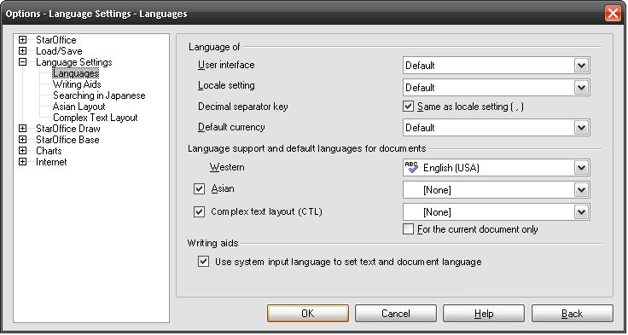Illustration 5: Tool-Options-Language Dialog with preselected control for Western

Extension of Tools-Language Menu

Western & Asian & CTL Languages
The Tools-Language tools can also set the document's language. Therefore the selected chosen language will be set to default in Tools-Options-Language Settings-Languages. Furthermore all hard language attributes will be removed from the document.
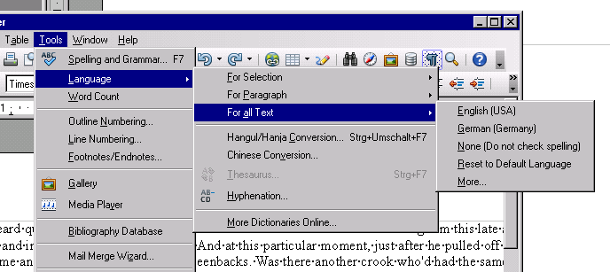Illustration 6: Extended Language Menu

- “Language” - Menu Properties |  |  |  |  | Comment
Menu Items:
Items | Sub Items | Sub Items | KBD Shortcuts | Icon | Comment
Language | For Selection | <Dynamic List of Languages>
 |  | None (Do not check spelling)
 |  | Reset to Default Language
 |  | More...
 | For Paragraph | <Dynamic List of Languages>
 |  | None (Do not check spelling) |  |  | If no grammar checker is installed.
 |  | None (Do not check spelling and grammar) |  |  | If grammar checker is installed.
 |  | Reset to Default Language |  |  | Removes language attribute.
 |  | More...
 | For all Text | <Dynamic List of Languages>
 |  | None (Do not check spelling) |  |  | If no grammar checker is installed.
 |  | None (Do not check spelling and grammar) |  |  | If a grammar checker is installed.
 |  | Reset to Default Language |  |  | Removes language attribute.
 |  | More...
 | ----------------
 | >Rest of current language menu<

Extension of Context Menu for Misspelled Words in Text
The context menu of a misspelled word shows the same extension like the Language menu described above.

Current (Old) Context Menu for Misspelled Words
Currently there are two different context menus shown for misspelled words.
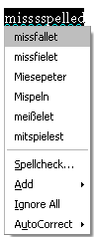Illustration 7: Without language suggestion
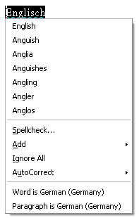Illustration 8: With language suggestion based on a match in one of the installed wordbooks

New Context Menu for Misspelled Words
The new menu uses the same strings and behavior used in the language menu described above. In opposite to the current (old) implementation, the set language extension is always part of this context menu.

Set Language Entries
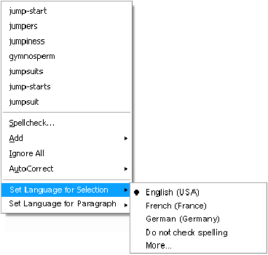Illustration 9: Set Language for text entry in context menu
- Context Menu for Misspelled Western Text - Menu Properties |  |  |  |  | Comment
Menu Items:
Items | Sub Items | Sub Items | KBD Shortcuts | Icon | Comment
>Current menu for misspelled words<
----------------
Format |  |  |  |  | Calls the format context menu for a paragraph
----------------
Set Language for Selection | <Dynamic List of Languages>
 | None (Do not check spelling) |  |  |  | If no grammar checker is installed.
 | None (Do not check spelling and grammar) |  |  |  | If a grammar checker is installed.
 | Reset to Default Language |  |  |  | Removes language attribute.
 | More...
Set Language for Paragraph | <Dynamic List of Languages>
 | None (Do not check spelling) |  |  |  | If no grammar checker is installed.
 | None (Do not check spelling and grammar) |  |  |  | If a grammar checker is installed.
 | Reset to Default Language |  |  |  | Removes language attribute.
 | More...

Format – Default Formatting Behavior (i78856)
The Format-Default behavior will not remove any language attribute anymore.

Set Text Language to Input Language Automatically (Windows Only, i1035)
On the Microsoft Windows operating system, the input language can be set via a Language Tool bar.
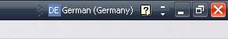Illustration 10: Language tool bar from Microsoft Windows
- This language will automatically be set for the text entered into OOo after changing the input language
  - if the input language is different from the current document language.
- This language will automatically set as document language for a newly created documents.
- The text language wont be set
  - if a text selection was present in OOo when changing the input language
  - or if the input language has not just been changed and is only different from current text language.
- This function can be turned off by an Option in Tools-Options-Language Settings-Language (see below).
- The option and the sections in tools-Options is only visible on Microsoft Windows systems.

Migration
None.

Configuration
None.

File Format
None.

Future Issues
Issue | Initials | Date
Set language attribute for drawing engine text | FL | May 07, 2007
Set language attribute for selected writer frames | FL | May 07, 2007
Introduce a kind of MRU list in language list boxes | FL | May 07, 2007
Show tip help on status bar controls | FL | May 15, 2007
Give feedback for status bar controls on mouse over | FL | May 15, 2007
Pre-selection of western language drop down in Character dialog does not work. | FL | October 25, 2007
Implement Language for Calc, Draw, Impress: 80665 | FL | November 12, 2007

Future Features (See Issue 77208)
The following features are not implemented yet, but already specified and stored here until their implementation.

New Format Entry
The context menu offers a new 'Format' entry. This entry calls the standard context menu for paragraphs without menu entries already present in the context menu for misspelled words (i.e. language entries & Paste entry). The following mock-up shows the new sub menu.
Illustration 11: Context menu for misspelled words with new Format entry to call the standard context menu for paragraphs.

New Context Menu for Text
It uses the same strings and behavior used in the Language menu described above. In opposite to the current (old) implementation, the set language extension is always part of this context menu.
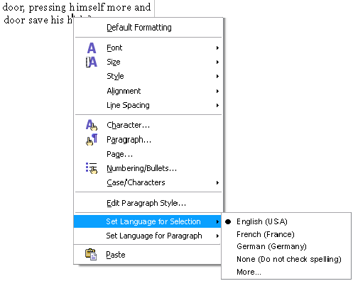Illustration 12: Set Language for text entry in context menu of normal text

- Context Menu for Western Text - Menu Properties |  |  |  |  | Comment
Menu Items:
Items | Sub Items | Sub Items | KBD Shortcuts | Icon | Comment
>Current menu for text<
----------------
Set Language for Selection | <Dynamic List of Languages>
 | None (Do not check spelling)
 | More...
Set Language for Paragraph | <Dynamic List of Languages>
 | None (Do not check spelling)
 | Reset to Default Language
 | More...

Text in Non-Writer, OLE and Writer Objects
A Writer document can contain objects like Writer frames and drawing objects/text boxes. Currently the language control could set language of Writer text and drawing objects. In edit mode of drawing object the control does not . So the user has to enter the edit mode and has to select the text to change the language of it. Non-Writer objects like OLE or drawing objects are not supported by the language control and menus at all.

Writer Frames
If a Writer text frame is selected, the language control is empty and the corresponding menu entries are disabled. If the edit mode of a Writer text frame is active, the language control gets enabled again and behaves like described above.

Drawing Objects (Text boxes)
If a drawing object is selected, the language control is empty and the corresponding menu entries are disabled. In edit mode the control does work like in Writer text.

OLE Objects
If an OLE object is selected or activated, the language control is empty and the corresponding menu entries are disabled.

Tools Options
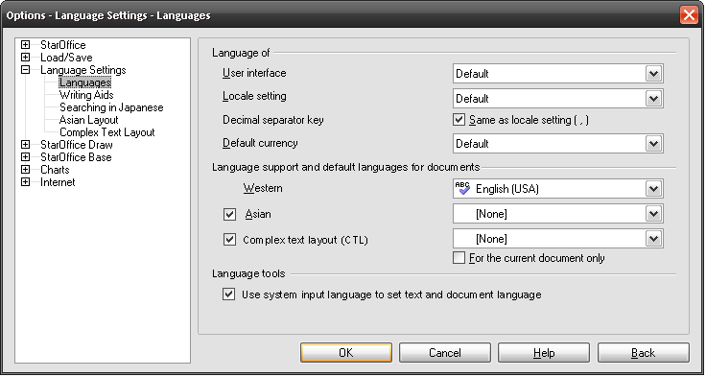Illustration 13: Input language sets text language by default on Windows systems

- Label for CTL language list box age Tools - CheckBox Properties |  | Comment
Visible: | always
List Box Label: | Complex text layout (CTL) | EN-US

- Language Tools – Section Properties |  | Comment
Visible: | On Windows operating systems only
CheckBox Label: | Language Tools | EN-US

- Option to Set Input Language for Text/Document Automatically - CheckBox Properties |  | Comment
Enabled: | On Windows operating systems only
Checked: | By default
CheckBox Label: | Use system input language to set text and document language | EN-US

Document Change History
Rev. | Change | Initials | Date
1 | Initial creation of document/First Draft | FL | April 24, 2007
2 | Second Draft | FL | April 25, 2007
3 | Update UI specification | FL | April 27, 2007
4. | New mock-ups and reworked western document language behavior | FL | May 02, 2007
5. | Added description for new context menu for misspelled words | FL | May 04, 2007
6. | Finalization | FL | May 08, 2007
7. | Finalization | FL | May 10, 2007
8. | Rework UI. User must not know about the different language types, so that there is only one list of languages | FL | May 11, 2007
9. | Finalization | FL | May 14, 2007
10. | Finalization | FL | May 15, 2007
11. | Rework input language behavior | FL | May 23, 2007
12. | Change Format – Default Formatting behavior i78856 | FL | June 25, 2007
13. | Update mock-up of context menu for misspelled words and introduce a new Format sub entry to call the standard context menu. | FL | June 29, 2007
14. | Move parts of the spec. to the future section due to missing resources. | FL | October 25, 2007
15. | Change menu entries for document language & text | FL | October 25, 2007
16. | Add follow up issues IDs for Calc. Draw, Impress | FL | November 12, 2007
17. | Add new ignore (language) attribute to set language feature (issue #92982) | FL | August 21, 2008
18. | Add Reset to Default Language Function | FL | February 18, 2010

i.e. when an object like a frame is selected.
Language guessing component is used to determine the language of the current paragraph.

