Software Specification Document

OpenOffice.org
ODF Version Handling

Specification Status
Last Change | Dec 5, 2008
Status
Abstract
OpenOffice.org 3.x supports ODF 1.2, but not all features will be implemented for OpenOffice.org 3.x are part of the ODF 1.2. This specification describes how to handle these features
i-Team Members
Role | First Name, Last Name, Initials | E-Mail Address
I-Team Lead | Frank Loehmann | Frank.Loehmann@sun.com
Specification Author | Michael Brauer | Michael.brauer@sun.com
User Experience | Frank Loehmann | Frank.Loehmann@sun.com
Development | Ingrid Halama (Chart) | Ingrid.Halama@sun.com
Development | Ocke Janssen (Base) | Ocke.Janssen@sun.com
Development | Christian Lippka (Impress) | Christian.Lippka@sun.com
Development | Eike Rathke (Calc) | Eike.Rathke@sun.com
Development | Oliver Wittman (Writer) | Oliver.Wittman@sun.com
Quality Assurance
Documentation | Uwe Fischer | uwe.fischer@sun.com

Contents
Abstract 1
i-Team Members 1
References and Reference Documents 3
Acronyms and Abbreviations 3
1 Introduction 3
1.1 Introduction 3
1.2 Requirements 3
1.3 Non Requirements 4
2 Detailed UI Specification 5
2.1 Preselect Current Standard Filter in Save as Dialog for unsaved documents 5
2.2 ODF Settings in Tools-Options Dialog 6
2.2.1 Alien Format Warning 7
2.2.2 ODF Level Warning 9
2.2.3 Notification if OOo is not the Default File Handler for ODF (Windows only) 9
2.2.3.1 ODF Notification 9
2.2.3.2 Option To Enable/Disable ODF File Handler Check 10
3 ODF File Format 11
4 Configuration 11
5 File Format 11
5.1.1 Document Samples and Templates 11
5.1.2 AutoText 11
6 Open Issues 12
Document Change History 12

References and Reference Documents
Reference Document | Check | Location (URL)
Specification Process Entry Check |  | N/A
Product Requirement, RFE, issue [Required]
Product Concept Document |  | <Please enter location here>
Competitive Analysis |  | <Please enter location here>
IDL Specification |  | <Please enter location here>
Test Case Specification Chart [Required]
- Graphics [Required]
- Spreadsheet [Required]
- Word processor [Required]
Software Specification Rules | N/A | N/A
File format names specification |  | http://specs.openoffice.org/appwide/fileIO/FileFormatNames.sxw
Default file format specification |  | http://specs.openoffice.org/appwide/options_settings/default_file_format_setting.sxw
ODF 1.2 Migration specification |  | http://specs.openoffice.org/appwide/odf/odf_1-2_migration.odt
Acronyms and Abbreviations
Acronym / Abbreviation | Definition
ODF | OASIS Open Document Format
OASIS | Organization for the Advancement of Structured Information Standards
OOo | OpenOffice.org

Introduction

Introduction
OpenOffice.org 3.x supports ODF 1.2. While ODF 1.2 is still under development, it is foreseeable that feature will be requested for OpenOffice.org that are not contained in ODF 1.2. This specification describes how to handle the situation in the user interface and in the ODF import and export.

Requirements
- OpenOffice.org must be able to save document that conform to the ODF specification and that do not contain any OpenOffice.org specific extensions, except those that are intentionally left undefined by ODF (like macros). The background of this requirement is as follows:
  - Many organizations in the public sector adopt ODF. Adopting ODF means adopting ODF as specified by the ODF specification. It does not mean adopting ODF as used by OpenOffice.org.
  - Any extension to ODF that OpenOffice.org or another application stores in ODF files causes an interoperability issue, because other applications will not be able to process the extension.
  - OASIS is in the progress of creating an OpenDocument Interoperability and Conformance Technical Committee (OIC TC). The deliverables of the OIC TC will be guidelines for testing conformance and interoperability as well as test suites. A result of this will be that conformance and interoperability will get more attention than before (which is good).
Document that conform to the ODF specification and do not contain any extensions will be called strictly conforming ODF documents in the following.
- OpenOffice.org users must be able create and edit document that conform to ODF specification in a reasonable way. That means that documents that a user saves as conforming ODF documents should look the same when the user loads the documents again.
- OpenOffice.org must be able to save features that are not contained in ODF. The background of this requirement is as follows:
  - While ODF in many cases is one of the reasons to deploy OpenOffice.org, there are still many deployments where just OpenOffice.org shall be deployed, and where ODF is of minor importance.
  - Many deployments depend on particular feature requests. If the features cannot be implemented because of a missing feature in ODF, then the deployment will not happen.

Non Requirements
- It is not required that OpenOffice.org can convert ODF documents that contain extensions into strictly conforming ODF documents in a reasonable way. This has the following reason:
  - If OpenOffice.org is deployed because ODF has been adopted, then it can be assumed that all documents that are exchanged are strictly conforming ODF documents. A document that does contain extensions can be considered to be invalid, and should never have been received.

Detailed UI Specification
The “ODF format version” configuration setting described in the ODF 1.2 Migration specification is extended by a new value “ODF 1.2++”. The other values get new names that do not include “OpenOffice.org” and an OpenOffice.org version number, but only ODF version numbers.
If the value of the “ODF format version” configuration setting is “ODF 1.2” (or “ODF 1.1”), all features that cannot be stored in ODF 1.2 are
- disabled in the user interface, or
- enabled, but a message appears if the feature is used. In this message, the user is asked to either cancel the use of the feature, or the configuration setting is set to “ODF 1.2++”, or
- converted into an ODF 1.2 feature (provided this is possible) when the document is saved, or
- silently ignored when saving (this is only an option for features for which the impact of ignoring the feature at save time seems to be acceptable).
Which of the methods is used is left to the individual specifications of the features that cannot be stored in ODF 1.2. In any case, documents that are stored have to be conforming ODF 1.2 documents if the setting has the value “ODF 1.2”.
If an ODF 1.2 document is loaded that contains extensions and the configuration setting has the value “1.0/1.1” or “1.2”, when a warning is displayed if the document is saved.
If the value of the configuration setting is changed from “1.2++” to “1.2” or “1.0/1.1”, then a warning appears that some features cannot be saved. There will be no information whether these features are used, and what these features are.
The configuration settings does not have an effect on the OpenOffice.org API. New features can be inserted into documents using the API even if the “ODF format version” configuration setting has the value “ODF 1.2”.
The setting further does not have an impact on the clipboard. Which means new features may be inserted into documents using the clipboard. The assumption is that such features will never be in the clipboard, because this requires loading a document that contains such features, and such documents can be considered to be invalid in ODF 1.2 based deployments.
All details below have been taken over from the ODF 1.2 Migration specification. They are not up to date.
New UI elements are needed to change the ODF version used by default when saving in ODF format.

Preselect Current Standard Filter in Save as Dialog for unsaved documents
The Save as dialog for unsaved documents automatically chooses the current default file format filter set in Tools-Options-Load/Save-General-Standard File Format.

ODF Settings in Tools-Options Dialog
A new ODF section is introduced in the Tools-Options dialog.
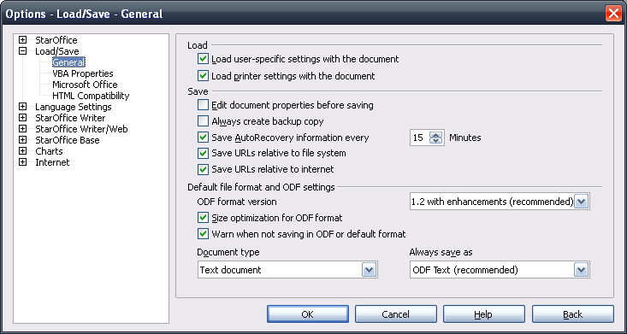Illustration 1: Default appearance
- “Options-Load/Save-General” - Dialog Properties |  | Comment
State: | Modal
Type: | Dailog
Closable: | Yes
Resizable: | No
Titel: | Options | EN-US
- “Default file format and ODF settings” - Label Properties |  | Comment
Label: | Default file format and ODF settings | EN-US
- “ODF Version” - ComboBox Properties |  | Comment
Enabled: | Always
Disabled: | Newer
Max. Row Count: | 2
Rows Visible: | 2
Items: | - 1.2 with enhancements (recommended)  - 1.2  - 1.0/1.1 | EN-US
Item Selected: | 1
ComboBox Label: | ODF format version | EN-US
- ODF size opt.” - CheckBox Properties |  | Comment
Enabled: | Always
Disabled: | Never
Tri-State: | Never
Checked: | Default
CheckBox Label: | Size optimization for ODF format | EN-US
- “Alien Warning” - CheckBox Properties |  | Comment
Enabled: | Always
Disabled: | Never
Checked: | Default
CheckBox Label: | Warn when not saving in ODF or default format | EN-US
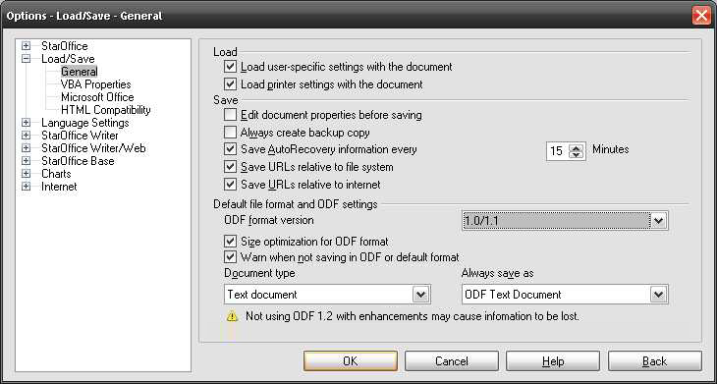Illustration 2: 1.0/1.1 ODF Version
Default file name drop downs has not been changed. Please see ODF file name specification for details about new ODF file names shown in that list box.
- “Format Warning” - Label Properties |  | Comment
Visible | If ODF version is not the most current version or standard filter is set to a non ODF format.
Label: | Not using ODF 1.2 with enhancements may cause information to be lost. | EN-US

Alien Format Warning
The following table describes when the alien warning dialog is shown:
Action | Case 1 | Case 2 | Case 3 | Case 4
Modified Document | X | X | X | X
Save as (Dialog) | X | X
Save |  |  | X | X
Non-ODF Format Filter | X |  | X
Non-Default Filter |  | X |  | X
Dialog Action: | Show Alien Warning | Show Alien Warning | -- | --
The alien format warning is changed like shown in the following mock-up:
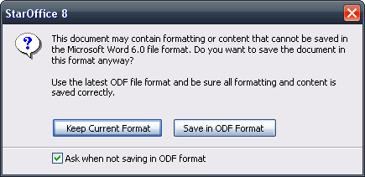Illustration 3: Alien Warning
- “%PRODUCTNAME %PRODUCTVERSION” - Dialog Properties |  | Comment
State: | Modal
Type: | Dialog
Closable: | Yes
Resizable: | No
Titel: | %PRODUCTNAME %PRODUCTVERSION | EN-US
- “Warning text” - Label Properties |  | Comment
Label: | This document may contain formatting or content cannot be saved in the %FORMATNAME file format. Do you want to save the document in this format anyway?\n\nUse the latest ODF file format and be sure all formatting and content is saved correctly. | EN-US
- “Keep Current Format” - Button Properties |  | Comment
Enabled: | Always and default focus
Disabled: | Never
Press: | Document is saved using the selected file format
Button Label: | Keep Current Format | EN-US
- “Save in ODF Format” - Button Properties |  | Comment
Enabled: | Always
Disabled: | Never
Press: | Saved in default ODF Format
Button Label: | Save in ODF Format | EN-US

ODF Level Warning
The following level warning dialog is shown, if the current document is saved in a higher level of ODF. The option can be disabled by the option shown at the end of the dialog. This option corresponds with the option for the format alien warning in Tools-Options.
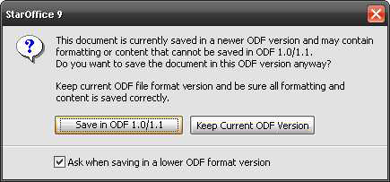Illustration 4: ODF level warning

Notification if OOo is not the Default File Handler for ODF (Windows only)
The ODF format is implemented by many programs on the desktop and web. All these program may change the file type association for the ODF formats. Therefore OOo performs a check on start-up and offers to register OOo as the default ODF file type handler.

ODF Notification
The following notification dialog is shown during start-up of OOo, if OOo is not the default handler for the ODF format. This notification can be disabled by un-checking the option at the end of the dialog. This setting can also be checked/un-checked in Tools-Options. See following section for details.
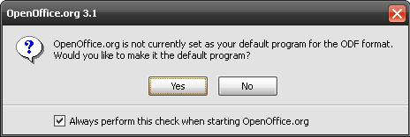Illustration 5: Default ODF file type check
- “%PRODUCTNAME %PRODUCTVERSION” - Dialog Properties |  | Comment
State: | Modal
Type: | Dialog
Closable: | Yes (equal to a click on “No” button.)
Resizable: | No
Titel: | %PRODUCTNAME %PRODUCTVERSION | EN-US
- “text” - Label Properties |  | Comment
Label: | %PRODUCTNAME is not currently set as your default program for the ODF format./nWould you like to mae it the default program? | EN-US
- “Yes” - Button Properties |  | Comment
Enabled: | Always and default focus
Disabled: | Never
Press: | Sets OOo as default application for all ODF formats on the current.
Button Label: | Yes | EN-US
- “No” - Button Properties |  | Comment
Enabled: | Always
Disabled: | Never
Press: | Cancels dialog this time
Button Label: | No | EN-US
- Always perform this check” - CheckBox Properties |  | Comment
Enabled: | Always
Disabled: | Never
Checked: | By default
CheckBox Label: | Always perform this check when starting %PRODUCTNAME | EN-US

Option To Enable/Disable ODF File Handler Check
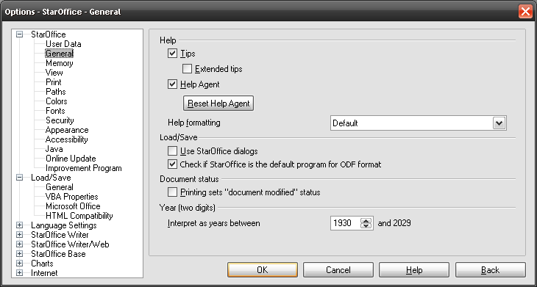Illustration 6: Tools-Options Dialog with new option to enable/disable ODF check
- Always perform this check” - CheckBox Properties |  | Comment
Enabled: | Always
Disabled: | Never
Checked: | By default
CheckBox Label: | Check if %PRODUCTNAME is the default program for ODF format | EN-US

ODF File Format
All file format changes that are required to implement a feature must be proposed to Sun's OpenDocument Technical Committee (ODF TC) members. If ever possible, the proposals should be taken to the ODF TC and, should be accepted by the TC before the child workspace that implements the feature is integrated.
The following rules apply to file format implementation of these features:
- Features are saved as proposed to and accepted by the ODF TC, except that all new elements and attributes don't get any of the ODF namespaces, but OpenOffice.org specific ones.
- The OpenOffice.org specific namespaces correspond to the ODF namespaces. That is, for each ODF namespace that is required by a new feature, there is an OpenOffice.org namespace with a similar name.
- The ODF import recognizes the new elements and attributes if they occur in the namespace defined by ODF and if they occur in the OpenOffice.org specific counterpart. This enables OpenOffice.org to still load the new feature even then OpenOffice.org has been upgraded to a new ODF version.
- The namespace declaration for the Ooo namespaces will not occur at the root elements, but at those elements that actually require them. This way it is ensured that the namespace declaration appear only in documents that contain extensions.
- The ODF import considers an ODF 1.2 document as a document that contains extensions if it detects an Ooo namespace while reading the document.

Configuration
All details below have been taken over from the ODF 1.2 Migration specification. They are not up to date.
The odf default version will be saved in the configuration file Office.Common under the node Save/ODF/DefaultVersion. It will be saved as an enum.
The valid values are:
0 == Unknown
1 == ODF version 1.0
2 == ODF version 1.1
3 == ODF version 1.2

File Format

Document Samples and Templates
Already existing documents and templates keep their file format. If an old template is used, the created document is saved in the current standard format anyway. If an old document is changed the alien warning is shown to force the user saving the document in the current default file format.

AutoText
AutoText files will be converted/saved into the new Open Office format if an AutoText is modified.

Open Issues
Issue | Initials | Date

Document Change History
Rev. | Change | Initials | Date
1 | Initial revision | MIB | 29.08.08
2 | Updated with meeting results | MIB | 10.10.08
3
4
5
6
7

This is a work name. A proper name has to be defined.
Spec: http://specs.openoffice.org/appwide/options_settings/default_file_format_setting.sxw
Spec: http://specs.openoffice.org/appwide/fileIO/FileFormatNames.sxw
Defined in Tools-Options-Load/Save-General-Standard File Format

