Electronic Signatures and Encryption
Graphical User Interface (GUI)
OpenOffice.org (OOo) and StarOffice (SO)
Note: Dialog Mockups Do Not Show Final Strings. Always Use Final Strings from Tables

Document - ID | Specification Owner | Last Change | Status
 | Frank Loehmann | March 11, 2010 | Final
Conforms to
Applies to | Writer, Calc, Impress, Draw, Scripting
Task ID(s) | I20883, 102146, i79170, i83129
Category | Feature
The following spec defines only user interface/interaction (UI/GUI).
Abstract
Security for office document content can be divided into two features, digital signatures and encryption.
Digital signatures themselves are a relative new topic for office applications. However, the requirement to protect data from being modified is existing for a long time. In the past, it has been addressed by features that protect documents from being edited within the office application. With digital signatures, these features will be enhanced to offer secure protection of document content, inside OpenOffice.org(OOo)/StarOffice (SO), and outside of it.
Macro security is a very important topic, because when you download some macros or receive them via email you can't know if you can trust them or if they may harm your system.
You can not easily figure out if the macro could do any harm, so the decision whether to trust a macro or not to trust can be made based on the trustworthiness of the macro author. But how can you know that the macro really comes from the author it claims to come from, or that it was not modified by somebody else?
The best way to do this are digital certificates and signatures. The author can sign the macro with his private keys, everybody can verify the signature with the authors public keys. The digital signature will also assure that the content was not modified.
Encryption is a feature that is supported by office applications for a long time. Enhancement in this area mainly affected the encryption algorithm itself, that became more secure. However, since there was no standardized way how encryption algorithms are applied to documents, processing such document files outside an office application was elaborate. By supporting new XML encryption standards, and due to OO.o/SO's XML file format, this will become much easier.
i-Team Members
 | Name | E-mail Address
Specification Owner | Frank Loehmann (FL) | frank.loehmann@sun.com
User Experience | Frank Loehmann (FL) | frank.loehmann@sun.com
Development | Michael Brauer (MIB) | michael.brauer@sun.com
 | Matthias Huetsch | matthias.huetsch@sun.com
Quality Assurance | Frank Stecher (FST) | frank.stecher@sun.com
Documentation | Uwe Fischer (UFI) | Ufi@sun.com

Approved for Implementation
 | Approved by | Date
User Experience | Frank Loehmann | 01/29/2004
Development | Matthias Hütsch | 01/29/2004
Quality Assurance | Frank Stecher | 08/13/2004
Documentation | Uwe Fsicher | 07/23/2004
String Review | Paul Compton/Elizabeth Matthis | 07/05/04/ 06.07.04 / 03.02.05

Document Change History
Rev. Level | Change | Initials | Date
1.0 | Working of 1. Draft | FL | 10/23/2003
1.1 | Add Q PRD Issues | FL | 10/30/2003
1.2 | Create "Final" Draft | FL | 01/23/2004
1.3 | Work on last changes | FL | 01/26/2004
1.4 | Work on last changes | FL | 01/27/2004
1.5 | Work on finalization and splitting specification into 3 parts | FL | 01/29/2004
1.5 | Change "Passwort" to "Kennwort" in German | FL | 04/01/2004
1.6 | Add macro signing behavior and make small changes to GUI | FL | 05/27/2004
1.7 | Add 4 new dialogs to Add... and view a signatures + add comments from MT | FL | 05/28/2004
1.8 | Work on comments from FS | FL | 06/11/2004
1.9 | Work on comments from FS | FL | 06/22/2004
2.0 | Work on string tables | FL | 06/28/2004
2.1 | Work on comments from MT/MIB/FST | FL | 07/20/2004
2.2 | Work on comments from UFI | FL | 07/23/2004
2.3 | Work on comments from MT | FL | 07/28/2004
2.4 | Move new password dialogs into feature section | FL | 08/11/2004
2.5 | Add Digital Signature... menu entry to Tools-Macros sub menu | FL | 27. October 04
2.6 | Add APOC "Protected" feature to security tab page | FL | 12/07/2004
2.7 | Strings for trusted file locations dialog have been changed to fix issue i44251 | FL | 08/19/2005
2.8 | Add new password dialog specification from feature section (i21923) | FL | 05/29/2007
2.9 | Change macro security description | FL | 10/02/2007
3.0 | Redesign of the Security tab | FL | 08/11/2007
3.1 | ODF 1.2 required for signing | FL | 17/04/2008
3.2 | Behavior with regard to ODF 1.2. | JL | 18/04/2008
3.3 | Add new password dialog | FL | 08/09/08
3.4 | Changed Web Connection Handling | FL | 12/01/2008
4 | Incorporated specification Electronic Signatures and Encryption , OpenOffice.org 2.0.1 (OOo) and StarOffice (SO) 8 PP1 | JL | 3. August 2009
5 | Moving specification from sxw to odt format | JL | 29. August 2009
6 | Changes regarding ODF1.2, signing macros will remove document signatures, signatures created with OOo older than 3.2 are displayed as “partially signed documents” | JL | 29. August 2009
6.1 | Clarifying behavior of warning, when signing macros or removing macro signatures of a document which contains a document signature | JL | 31. August 2009
6.2 | New password dialog for authentication | FL | March 10, 2010
6.3 | Updated Digital Signatures dialog (Illustration 15: Digital Signatures - document content) on page 35. | FL | May 08, 2010
6.4 | File-Properties-Security tab | FL | May 08, 2010

Contents
Glossary 1
1 Motivation 4
2 User Scenarios 4
2.1 Security Related Scenarios 4
1.1 Signatures Related Scenarios 6
2.2 Macro Security Related Scenarios 8
3 Goals for Macro and Document Security 9
4 Requirements and Dependencies 9
4.1 Dependencies 9
4.2 Requirements 9
5 Detailed Specification 10
5.1 Security Options (Issue: 82892) 10
5.1.1 Master Password for Web Connections 10
5.1.1.1 Storing Password for Web Connection 10
5.1.1.2 Storing Password/Connection Settings 12
5.1.1.3 Master Password Turned off by User 13
5.1.2 Security Options and Warnings Section 13
5.1.3 Macro Security Section 13
5.2 Security Tab in Document Properties 13
5.2.1 File Sharing Section 13
5.2.1.1 Open Read-Only 13
5.2.1.2 Record Changes 14
5.3 New Password Dialogs 14
5.3.1 Set Password Dialog 14
5.3.2 Enter Password Dialog 14
5.3.3 Password for Web/Server/Data base Connections 15
5.3.3.1 Remember Password Handling 15
5.3.3.2 Typical Dialog to Connecting to a Web Server 15
5.3.3.3 Dialog Showing all Possible Dialog Elements 16
5.3.4 Master Password Dialog 17
5.4 Handling of inconsistent documents. 19
5.4.1 Handling of broken documents. 19
5.4.2 Handling of encrypted documents with non-encrypted streams. 19
5.5 Security Options Dialog 20
5.5.1 Ctrl-Click Required to Follow Hyperlinks (83402 and 79950) 21
5.6 Stored Web Connection Information Dialog 21
5.7 Show warning dialogs if the document contains recorded changes, versions or notices when 22
5.8 The Menu Entries for Signing 25
5.8.1 Entry in the File Menu 25
5.8.2 Entry in the Tools-Macros Sub Menu 25
5.8.3 Digital signature info dialogs 26
5.8.4 Open a Signed Document with an Invalid Signature 28
5.9 Digital Signatures 28
5.9.1 Signature Validation Results and Icons 28
5.9.2 Status Bar 29
5.9.3 Behavior with regard to ODF 1.2 32
5.10 Digital Signatures Dialog 35
5.10.1 Digital Signature Dialog For Documents 35
5.10.2 ODF 1.2 Needed To Sign Notification Message Box 36
5.10.3 Digital Signature Dialog For Document Macros 37
5.10.3.1 Remove Document Signature when Signing Macros 37
5.10.4 Digital Signature Dialog For Program Packages 37
5.10.5 Select Signature (Add...) Dialog 38
5.10.6 View Certificate Dialog 39
5.11 Document Properties 43
5.11.1 Changed Default Setting in Tools-Options 44
5.12 Macro Security 44
5.12.1 Security Warning Dialog 45
5.12.2 Macro Security Dialog 45
5.12.3 Trust Source of Macro Dialog for Signed Macros 48
5.12.4 Enable/Disable Document Macro Dialog for Unsigned Macros 49
5.12.5 Macro Warning for Security Setting High and Very High. (Issue 83129) 50
5.13 Error Conditions 50
6 Future Tasks (not relevant for OO.org 2.0) 50
6.1 Signing of Microsoft Office Documents 51
6.2 Signing on PDF Export 51
6.3 Signing of Sections in Writer 51
6.4 Signing of Table Sheets in Calc 52
6.5 After Beta Tasks 52
6.5.1 Warning Dialog if Mozilla Profile is not Found (#i37609) 52
6.6 Normal Writer Edit Mode Behavior 53
6.6.1 Links in Read-Only / Form Use Mode / Help System 53
6.6.2 Smart Card Support for Signing Documents 53
7 Legal Issues 53
8 Notes 54
9 References and Links 55

Glossary
Term | Description
digital signature | Forgery is a growing concern among Netizens. After all, who's to say that a message with your name on it is really from you and not somebody pretending to be you? Digital signatures are a means of proving that a file or email message belongs to a specific person, much as a driver's license proves identity in real life. Digital signatures have the added benefit of verifying that your message has not been tampered with. When you sign a message, a hash function--a computation that leaves a specific code, or "digital fingerprint"--is applied to it. If the fingerprint on the recipient's message doesn't match the original fingerprint, the message has been altered.  Digital signatures are often used in combination with strong-encryption software to create a secure channel of communication, in which both privacy and identity are protected.
Encryption | Encryption is the process of changing data into a form that can be read only by the intended receiver. To decipher the message, the receiver of the encrypted data must have the proper decryption key. In traditional encryption schemes, the sender and the receiver use the same key to encrypt and decrypt data. Public-key encryption schemes use two keys: a public key, which anyone may use, and a corresponding private key, which is possessed only by the person who created it. With this method, anyone may send a message encrypted with the owner's public key, but only the owner has the private key necessary to decrypt it. PGP (Pretty Good Privacy) and DES (data encryption standard) are two of the most popular public-key encryption schemes.
Digital Certificate | Citing concerns about security, many people are still wary of online transactions. In an attempt to assuage those fears, software vendors, security specialists, and online vendors have developed the concept of digital certificates. A digital certificate is a password-protected file that includes a variety of information: the name and email address of the certificate holder, an encryption key that can be used to verify the digital signature of the holder, the name of the company issuing the certificate, and the period during which the certificate is valid. Certificate authorities (CAs) gather information about a person or company and then issue certificates. These certificates can be used as online identification, much in the same way a driver's license can verify your identity in the physical world. If an email message or order form comes through with an attached digital certificate, the recipient can be more confident that the document is genuine. Several technologies (including SET, SSL, and Authenticode) are currently competing for market share, each hoping to become the certificate of choice.
One-Way Hash Functions | A one-way hash function is an important building block to help achieve data integrity.  Informally, a one-way hash function is a function that is easy to compute but difficult to reverse.  Also, it is difficult to find two input values for which the function would compute the same output value.  You can use the hash function to calculate the hash value of a document, which can be a lot shorter than the document content. This value can be stored on a separate place or as part of the digital signature. Later you can use the same hash function to compute the hash value of the current document and verify these hash value to assure the content was not altered.
Symmetric Ciphers | A symmetric cipher is a transformation, operated under a secret key, that can translate its input, called plaintext, to its output, called ciphertext, in such a way that, excluding cryptanalysis, only those entities possessing the secret key can recover the plaintext from the ciphertext.  Examples for symmetric ciphers are the quite old Data Encryption Standard (DES) and the more secure Advanced Encryption Standard (AES) .  Symmetric ciphers are also called secret-key ciphers because the two communicating parties must share a secret key. This requirement creates some difficulties in key management and key distribution.  Symmetric ciphers can also be stacked to improve the crypto strength of the whole system, such as in the case of triple-DES.
Asymmetric Ciphers | An asymmetric cipher is similar to a symmetric cipher, but instead it depends on a pair of keys rather than on only one key. The public key of the pair is used to encrypt plaintext. The private key of the pair is used to decrypt ciphertext. The keys are generated such that it is easy to deduce the public key, given the private key; the reverse, however, is very difficult. This property enables people to exchange their public keys over public channels and still conduct private communications.  A distinct property of some asymmetric systems is that the encryption and decryption are reversible. This means that one can apply the decryption operation with the private key to the plaintext to get ciphertext, and one can recover the plaintext by applying the encryption operation with the public key to the ciphertext. In this case, because the public key is public, no confidentiality protection is provided. However, because only the holder of the private key can generate the ciphertext with these systems, the ciphertext can serve as a digital signature of the plaintext, and anyone with the public key can verify the authenticity of the signature.  RSA (named for its creators—Rivest, Shamir, and Adleman) is perhaps the most widely used asymmetric system that can also be used to produce digital signatures. Another system, Digital Signature Algorithm (DSA), can perform only digital signature functions; it cannot be used for encryption.  To prove that it is the real owner of a public key, one party can present a certificate for verification by the other party. A public-key certificate is a digitally signed statement from one entity, saying that the public key and some other information of another entity have some specific value. A chain of certificates is possible, whereby each certificate contains a public key that is used to certify the public key in the succeeding certificate. The first certificate, often called the root certificate, does not have another public key to certify it. Thus, it normally is a self signed certificate in that its own public key is used to certify itself.
Digital Certificates | Users of public-key applications and systems must be confident that the public key of a subject—a user, organization, or other entity, such as a service—is genuine, that is, that the associated private key is owned by the subject. Public-key certificates are used to establish trust. A public-key certificate is a binding of a public key to a subject, whereby the certificate is digitally signed by the private key of another entity, often called a Certification Authority (CA).  The standard digital certificate format is ITU-T X.509.  An X.509 certificate binds a public key to a Distinguished Name.  Frequently, such a certificate is called an identity certificate
Authentication | A basic security issue is authentication. Authentication is the process of confirming the identity of an entity (a user, a machine, or a machine operating on behalf of a user).
Authorization | Authentication serves as the basis for authorization. Specifically, once it knows the identity of a subject, an application may then specify what set of operations that subject may perform.  The set of permissions granted can be configured within an external access control policy.

Motivation
Many governments in different countries are starting to move to paper-less communication with their citizens. Examples for this are the “BundOnline” e-government initiative in Germany or eGov in the US.
Since in many cases confidential and personal data needs to be exchanged it is mandatory to use appropriate security mechanisms like digital signatures and encryption. This is necessary in order to ensure that information does not get changed on the way between the citizen and the public authority.
Also it must be possible to securely identify the author of a document. This is especially true for documents that are used for requesting ID related documents like a driver license, passport or a badge.
People become more and more sensitive about security issues, and macro viruses can do a lot of harm. People must have the possibility to configure which macros are allowed to run and which not, so digital signatures and authentication are very important for them.
In addition, after tragic events like the airplane attack on September 11 people are more and more concerned about security issues in general. Companies fear “cyber attacks” and viruses like the ILOVEYOU and Melissa macro virus, that caused a lot of damage.

User Scenarios
This specification covers security and signature related issues. So the user scenarios are separated into two parts.

Security Related Scenarios
- User A is an attorney at law and uses OpenOffice to edit/revise legal related documents. She uses change tracking in her documents very often, but she is aware of the potential danger of those working draft information when those might become public, because others can use such information against herself. Susan spends a lot of time controlling her final documents, that they do not contain track changes information anymore, but she always has a bad feeling using change tracking function at all.
  - Add a new application privacy option to warn the user about tracked changes, versioning and notice information in current documents when the user saves, prints (not for versioning), PDFs (not for versioning) or sends a document.
- User B works for the Police Department as a secretary. She works in a department working on police internal inquiries. She writes down reports recorded on tapes. Since she has fears that her name could become known to the reported person, she always takes care that she removes her name from the properties of the document before saving the file. She always has a bad feeling, because she has to do it manually, but she could not remove her name from the User settings options of OOo, because in letters templates the fields will not be filled in were she needs her name in.
    - There is no automatism to do not store personal information within the file in OOo.
  - Add an application privacy option to do not add personal information to the file properties when saving a file.
- User C works as a Controller in a company. He creates reports in Calc about the departments he is responsible for as a financial controller. He provides his report to the executive management of the company, but the report will be forwarded to the assistant of his manger. The information he is providing is very crucial and he has fears that the data could be changed before reaching his manager. Since the manager's assistant must have rights to print the document, because his manager insists of having a printed copy for his records, he has to give modify rights also to the assistant.
    - No real solution for this problem until a document rights management model is supported by OOo. All other solutions like separate passwords for opening and modifying of a document are only generating a false sense of security, because a document that could be opened could be saved as a new doc or could be copied to a new document via the clipboard and then saved as a new file. Thus allows to modify the document's copy...
- User D works in a bank. He often has to encrypt documents, because the content is related to customer's financial background. He is used to work with MS Office and hasn't used OOo before. When evaluating OOo he tries to encrypt a document. When calling the Save as dialog, he recognizes that there is a checkbox “Save with password”. He is wondering, where he has to enter the password first to save it with the file. He checks the complete dialog for options to set the password, but did not find any.
    - Problem at this point is, that he did not know that the password dialog appears when saving the document because he had never used OOo before. Once he is used to this behavior, the function could be easily accessed.
  - Change the check box into a button. If this is not possible, the password dialog has to appear directly after checking the box or the wording has to be changed.
- User E works at the University: She works on confidential data for her professor, so she decides to encrypt the document. Since she has worries not to remember the password, she decides to use her boyfriend's sure and last name as a password. She types in “Greg Smith” and recognizes the space between the names. She removes the Space, since she is not sure if it is allowed within a password. Then she works on the data and saves her changes frequently. In the evening she closes the document and shuts down the computer. On the next day she has an appointment with her professor and tries to open the document. She types in “Gregsmith” in one word at the password prompt, since she remembers that she has removed the space in the middle. Then she confirms the password dialog, but the document could not be loaded and OOo raises a dialog that the password is wrong. She calls the product support to decrypt the document, but the support could not help her. The document's data is lost.
    - She does not know that passwords are case sensitive and that spaces would have been allowed within the password. Furthermore she was not aware, that there is no way back when the password is lost and so she has not stored the password in a save place.
  - Add a hint to the password dialog to explain that passwords are case sensitive and could contain spaces and other special characters. Furthermore we have to add a note that there is no way to decrypt the file without the password.
- User F is a Manager: He uses many different text document templates for his work. One of these templates is used for the monthly report of his division. Since these reports contain crucial data, he must ensure that this document is always saved with a password. He is missing a document option to force or recommend encrypted saving of the document.
  - Add a new document option to prompt a dialog when saving documents that currently have no given password and recommended to save this document always with a password.
- User G is an English teacher: She works on courses written as text documents. These documents will be printed by her customers at home. Some customers saved changes to the document by mistake in the past, because the documents have read write access.
  - Already possible in OOo 1.1. to publish those document as a PDF files via the integrated PDF export. Furthermore the setting “Printing modifies document” in Tools-Option of OOo has to be deactivated. Furthermore the document could already be opened Read-only by a checkbox in the File-Open Dialog. But maybe this one is an issue when supporting signatures, because modifying the document (properties) will withdraw document's signature.
- User H has to use a specific encryption method, because it fulfills the defined security requirements
  - User can choose between different encryption types. The dialog to choose from available methods can be called by the Tools-Options-Security-Security option-Advanced... button.

Signatures Related Scenarios
- Department of Defense (DOD): The DOD is currently rolling out the DOD Common Access Card to all the employees. The card holds certificates and supports Java. Microsoft offers a solution for signing emails and potentially documents using the DOD Common Access Card.
Typically a user would use encryption for the email in order to prevent that unauthorized users can access the content. Attached documents would be signed for non-repudiation and integrity purposes but not encrypted. The email would not necessarily be signed, because the enclosed document would be the critical element. Besides, it often is not desired to encrypt documents because once the email has been received the document can be stored at a secure location. However, for both encrypting the email and signing the document the same technology (i.e. the DOD Common Access Card) should be used.

- Government: An example for a scenario in the government space would be a foreign citizen who needs to extend/renew his passport. First, he would either download a form from a public web site or via email from a consulate employee. Maybe this form would already have some personal and confidential data. Thus this form would have to be both signed and encrypted. Now the citizen would complete the form, sign and encrypt it and send it back. Finally the consulate employee would check the content of the form and send a signed (approved) and encrypted copy back to the citizen.
  - Sign Complete OOo Documents
  - Encrypt complete documents
- Education: Signing and encrypting documents in the education area is interesting, because it can replace the paper process of correcting dissertations, etc. Students would send their signed dissertations to professors, who would make annotation, sign these annotation and send the signed document back to the student.
  - Sign Complete OOo Documents
  - Encrypt complete documents
  - Protect content via password and allow to add annotations (comments) or tracked changes only
  - Sign tracked changes or annotations (not for OO.org 2.0)
- Enterprise: In enterprise environments signed documents can replace contracts and legal agreements. For this purpose documents often go through many reviews by different people that belong to different departments and companies. Therefore, it's required that it's always verifiable who made changes to a document at what time. In addition, there are often predefined approval processes that the office suite and related collaboration tools could support.
  - Sign Complete OOo Document
  - Allow multiple signatures
  - Protect content via password and allow to add annotations (comments) or tracked changes only.
- User AA writes contracts in Writer. The contracts will be personalized directly in Writer. Since some parts must not be changed he want's to protect these section and to sign them.
  - Sign Section in Writer (not for OO.org 2.0)
  - Protection for signed sections (not for OO.org 2.0)
- User AB works on official company wide calculations. These calculations must not be changed and are tested. The data will be collected by Managers. Each Manager saves the document after he has filled in his data and saves it as a new version in the document. This saved version will be signed.
  - Sign Single Table in Calc (not for OO.org 2.0)
  - Sign versions of a document
- GUI related requirements
  - Show Signatures
      - Application title “(Signed)”
      - Symbol in status bar
      - Symbol on objects, Calc tables, sections
      - Document properties
  - Warning Dialogs
      - Signature is lost when
        - saving document in non OOo XML format
        - save as (a copy) in XML-Format
        - Deleting a signature
        - document is modified
          - Undo after signing = modify = signature lost
        - Content is not completely visible due to
          - view settings
          - track changes with not accepted/rejected parts
          - notices
        - formatting (i.e. hidden)
        - linked sections, objects (i.e. graphics, OLE or DDE)
        - fields
- Renew signature if signed area has been changed
      - Withdraw all assigned signatures and sign new
- User AF works in a small company. They want to use signatures to sign documents, but the company do not want to create official certificates because these cost money. They want to trust themselves.
  - Create a self signed Certificate.

Macro Security Related Scenarios
- Macro security
  - Security 18: Authorization, Fine Grained Macro Security.
OOo should allow to restrict the level of access to resources that components and scripts have. Configure policies which code from which author is allowed to read and write files, make system calls and other things.
- Macro security
  - Security 21: Completely disable scripting.
Done in SO7: tools/options/security => Run macro never.
- Security Level
  - Security 23: Default macro security settings must be set to “high”.
- Security Level
  - Security 26: Support very high, high, medium and low security settings. Very high allows only execution of macros from trusted locations regardless of the signed status. Maximum security allows only signed macros to run. Medium allows signed macros to run and asks for execution of unsigned macros. Low executes all macros without any confirmation.
- User AD develops macros in OO.org. The macros will be attached to documents and will be used within the company. He has problems that users suppress the execution of this macro, but the companies management does not allow to disable macro warning in OO.org.
  - Sign OOo Script Projects. The user could trust a source, so that these macros will be executed automatically without displaying any further macro warnings.

Goals for Macro and Document Security
A must have for OpenOffice.org 2.0 are digital signatures for macros and authentication, so people can configure which macros are allowed to run and which not, based on the author of the macro.
Fine grained macro security, where you can configure in detail what macros from different authors are allowed to do would be nice, but this can not be done in the OpenOffice.org 2.0 time frame, because on top of digital signatures and authentication you need configuration of policies, and each API implementation that directly accesses any resources must check if the permissions for that are granted.
Please see scenario section above for detailed goals of Macro and Document Security based on digital Signatures.

Requirements and Dependencies

Dependencies
File passwords spec:
http://specs.openoffice.org/appwide/security/File_Passwords.odt

Requirements
Please see scenario section on page 4 (above) for requirements.

Detailed Specification
This specification defines the basic feature set for encryption, WebDav and signing document.

Security Options (Issue: 82892)
The security options tab page looks like the following dialog mock-ups. See sub section for interaction details.

Master Password for Web Connections

Storing Password for Web Connection
If activated this function stores URL, login name and password used to connect to a web page, if the check box to store the password is activated in the Login dialog. The next time this site will be accessed OOo uses the user name and password stored to logon the user automatically. A master password has to be defined to store those passwords in the list and it is also used to encrypt the password list. Thus the first time OOo accesses the list, the user is asked to enter the master password.
If this function is deactivated, OOo will store the passwords only for the current session and will not store any passwords to hard drive.
The button Master Password... is disabled if the check box to persistently save passwords is un-checked. This button calls the Set Master Password dialog if pressed. This dialog allows to change the master password. Un-checking the Persistently save passwords for web connections check box withdraws the password list and resets the master password (if present), after the following confirmation dialog has been confirmed with yes in case a master password has been set.
Confirmation Dialog
Item | English | German | Comments
Dialog Title | $PRODUCTNAME | -
Text | Disabling the function to persistently store passwords deletes the list of passwords stored and resets the master password./n/n  Do you want to delete password list and reset master password? | -
Button | Yes | -
Button | No | -
The Connections... dialog shows the Stored Web Connection Information dialog defined below, after the master password (if present) has been entered successfully. Entering the master password (if present) is required each time the dialog is called.
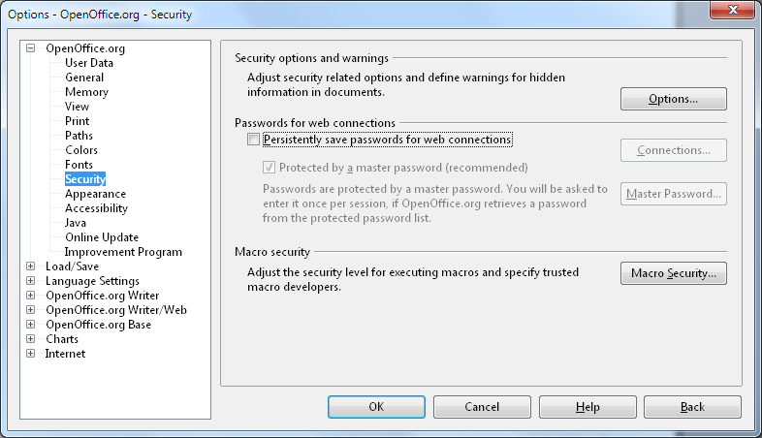Illustration 1: Tools- Options – Security dialog - Store Web Connection Persistently (default off)
Strings
Item | English | German | Comments
Label | Adjust security related options and define warnings for hidden information in documents.
Label | Passwords for web connections
Text | Persistently save passwords for web connections
 | Protected by a master password (recommended)
Text | Passwords are protected by a master password. You will be asked to enter it once per session, if $PRODUCTNAME retrieves a password from the protected password list.
Button Label | Master Password...
Button Label | Connections...
Label | Adjust the security level for executing macros and specify trusted macro authors. | Anpassen des Sicherheitsstufe für das Ausführen von Makros und Definieren der vertrauenswürdigen Makro-Autoren.
Button | Macro Security... | Makrosicherheit...
Label | File sharing options for this document | Optionen für gemeinsame Benutzung dieses Dokumentes
Label | Open this document in read-only mode | Dieses Dokument schreibgeschützt öffnen
Label | Record changes | Änderungen Aufzeichnen
Button | Protect... | Schützen...
Button | Unprotect... | Schutz aufheben... | TRANSLATORS! “Unprotect” means remove protection – it is not a real word but exists in computer software
Button | OK
Button | Cancel
Button | Help
Button | Back

Storing Password/Connection Settings
The function to store passwords/connections persistently can be turned on manually in Tools-Options-Security, or is activated automatically, if the user selects Remember password in a password dialog shown when logging on to a web connection.
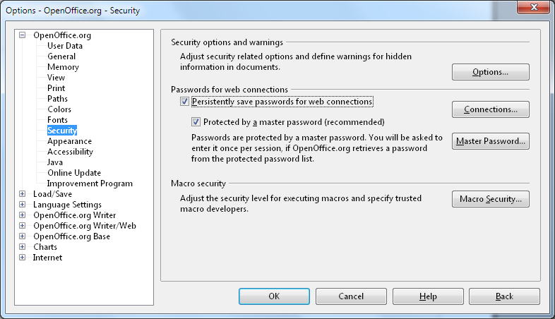Illustration 2: Tools- Options – Security dialog – Protect by Master Password (default on)

Master Password Turned off by User
The password protection by a Master Password is default, but can be turned off by user. If this option gets unchecked, the user is asked to enter the present master password.
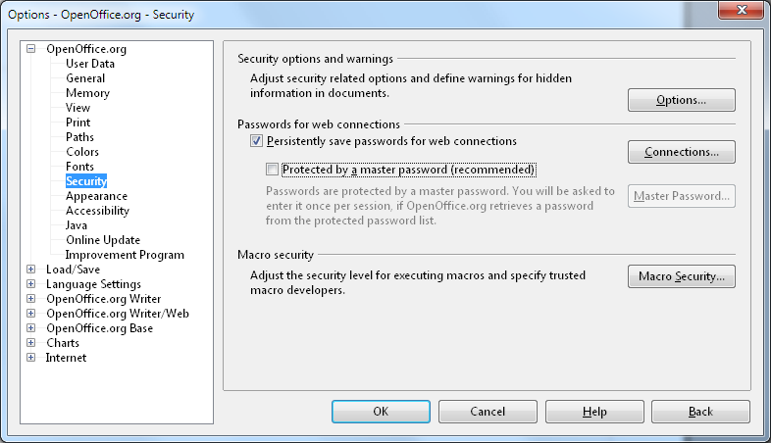Illustration 3: Tools- Options – Security dialog - Master Password optionally turned off by user

Security Options and Warnings Section
The option button calls the Security Options dialog show in Illustration 10. See additional specification for details: http://specs.openoffice.org/appwide/security/File_Passwords.odt

Macro Security Section
The Macro Security dialog is shown, if the Macro Security button is pressed. See additional specification for details: http://specs.openoffice.org/appwide/security/File_Passwords.odt

Security Tab in Document Properties

File Sharing Section
This section handles file sharing related options. See illustration below for details about the protection of recorded changes.

Open Read-Only
If checked, the current document will be opened Read-only by default when loading the document. But user can press Edit button to change document to edit mode manually.

Record Changes
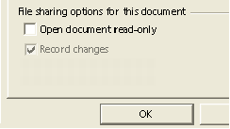
Illustration 4 The state of the "Record changes" check box will be enabled and disabled as long as a the state is protected.

New Password Dialogs

Set Password Dialog
The overworked password dialog replaces the current one office wide.
See separate spec.: http://specs.openoffice.org/appwide/security/File_Passwords.odt

Enter Password Dialog
An overworked Enter Password dialog replaces the current (OO.org 1.1) dialog. The notice shown is the same as in the define password dialog above. Text 2 (from the table below) is only shown instead of Text 1, if no path and filename information is available.
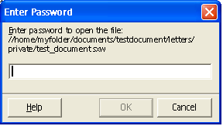Illustration 5 Overworked enter password dialog

Item | English | German | Comments
Text 1 | Enter password to open file: %DOCUMENTPATHANDNAME% | Kennwort für die Datei eingeben:%DOCUMENTPATHANDNAME%
Text 2 | Enter password to open file | Kennwort für die Datei eingeben
If the password entered does not match to the document password, the following dialog appears:
Warning Dialog:
Item | English | German | Comments
Notice Dialog | The password is incorrect. The document cannot be opened. | Das Kennwort ist ungültig. Das Dokument kann nicht geöffnet werden. | Dialog has an OK button.

Password for Web/Server/Data base Connections
The following dialog is shown if a connection requires authentication. The dialog allow to enable additional controls. See Illustration 7 for details.

Remember Password Handling
- User credentials will be stored for run time of office.
- 'Remember password' option stores the password persistently in the password container of OOo. The password container will be automatically configured to persistently save the password and the user is asked to set up a master password to protect the password container, if not deactivated in Tools-Options-Security (see 5.3.4 for details).

Typical Dialog to Connecting to a Web Server
Connection filed could show two different connection strings (depending from LF_NO_ACCOUNT)
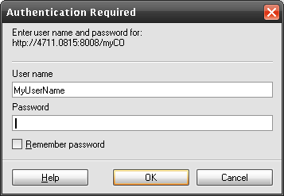Illustration 6: Authentication Dialog

Dialog Showing all Possible Dialog Elements
The dialog behavior is based on the already implemented behavior of the previous dialog. Only the layout has been changed to match other current UI of the Password/Login dialogs.
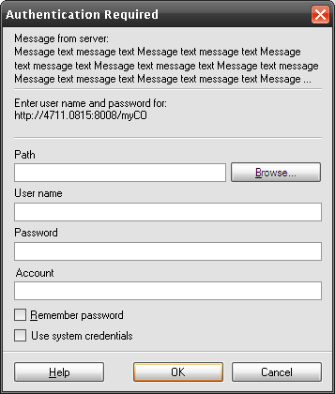Illustration 7:Authentication dialog showing all possible controls
See separate specification for details about 'Use system credentials' feature (aka 'single sign on').

Master Password Dialog
The following dialog replaces the old Master Password dialog.
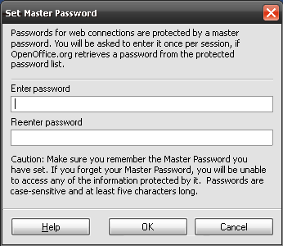Illustration 8: Set Master Password dialog
Set Master Password Dialog Strings
Item | English | Comments
Dialog title | Set Master Password
Label | Passwords for web connections are protected by a master password. You will be asked to enter it once per session, if %PRODUCTNAME retrieves a password from the protected password list.
Label | Enter password
Label | Reenter password
Text | Caution: Make sure you remember the Master Password you have set. If you forget your Master Password, you will be unable to access any of the information protected by it. Passwords are case-sensitive and at least five characters long.
Button | Help
Button | OK
Button | Cancel
User Interaction:
General:
- Edit fields do not echo characters entered. Each character will be replaced by a dot to hide password on screen.
- OK button is disabled as long
  - as no confirmation of the password has been entered and password length is below 5.
If no master password has been set:
- focus is set to Enter new password edit field
Password has to be confirmed in second edit field. If the two passwords do not match each other, the following error dialog is shown (same as for normal passwords):
Error Dialog:
Item | English | Comments
Notice Dialog | The password confirmation does not match. | Dialog has an OK button.
Button | OK
If the a master password has been set and should be changed or a password protected by the Master Password is being accessed the following dialog is shown to enter the current master password:
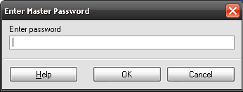Illustration 9: Enter Master Password
Enter Master Password Dialog:
Item | English | Comments
Dialog Title | Enter Master Password | Dialog has an OK button.
Label | Enter password
Button | Help
Button | OK
Button | Cancel
If the master password entered does not match the password set, the following error dialog is shown:
Error Dialog:
Item | English | Comments
Dialog Title | %PRODUCTNAME %PRODUCTVERSION | Dialog has an OK button.
Label | The wrong Master Password has been entered. %PRODUKTNAME could not access web login information protected by Master Password./n/nNote: Passwords are case-sensitive and at least five characters long.
Button | OK

Handling of inconsistent documents.

Handling of broken documents.
If an ODF document does not complain to the ODF specification it is treated as a broken one. A document could be broken as result of data transfer problems, or of manipulation.
If OOo detects a broken document it should notify the user about the problem and ask whether the document should be repaired. The macros in repaired document must be deactivated. The following dialog is used to do it:
Corrupted document handling dialog
Item | English | Comments
Dialog title | %PRODUCTNAME %PRODUCTVERSION
Text | The file '$(ARG1)' is corrupt and therefore cannot be opened. %PRODUCTNAME can try to repair the file.
Text | The corruption could be the result of document manipulation or of structural document damage due to data transmission.
Text | We recommend that you do not trust the content of the repaired document. Execution of macros is disabled for this document.
Text | Should %PRODUCTNAME repair the file?
Button | Yes
Button | No

Handling of encrypted documents with non-encrypted streams.
OOo expects that all streams in ODF documents of version 1.2 and later are encrypted ( the exception are the streams that are part of the package format: “mimetime”, “META-INF/manifest.xml” and signature streams in “META-INF” folder ).
In case an unexpected non-encrypted stream is detected the OOo should show the warning and disable execution of macros for the document. The following dialog should be used to show the warning:
Unexpected non-encrypted stream dialog
Item | English | Comments
Dialog title | %PRODUCTNAME - Non-Encrypted Streams.
Text | The encrypted document contains unexpected non-encrypted streams.
Text | This could be the result of document manipulation.
Text | We recommend that you do not trust the content of the current document. Execution of macros is disabled for this document.
Button | OK

Security Options Dialog
The following dialog is called by the Options button of the Security dialog tab page.
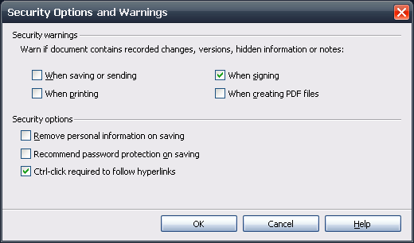Illustration 10: Security Options dialog called by the Options... button of the Security dialog

Item | English | German | Comments
Dialog title | Security Options and Warnings
Label | Security options
Check box | Warn if document contains recorded changes, versions, hidden information or notes: | Wenn ein Dokument aufgezeichnete Änderungen, Versionen, versteckte Informationen oder Notizen enthält, warnen beim:
Check box | When saving or sending | Speichern oder Senden
Check box | When printing | Drucken
Check box | When signing | Signieren | Defaulted
Check box | When creating PDF files | PDF-Dateien erzeugen
Label | Security options
Check box | Remove personal information on saving | Persönliche Informationen beim Speichern aus Dateien entfernen
Check box | Recommend password protection on saving | Kennwortschutz beim Speichern empfehlen
Check box | Ctrl-click required to follow hyperlinks
Button | OK
Button | Cancel
Button | Help

Ctrl-Click Required to Follow Hyperlinks (83402 and 79950)
This security option forces the user to hold down the Ctrl key if she wants to follow an internal or external hyperlink in a document.
Some further explanation:
- Smart tags are not affected by this option, a ctrl-click is always needed to activate a smart tag in the text.
- Read-only documents (i.e. the OOo help system) still use single click to follow a link. Tip help shown URL only.
- Ctrl-click places cursor to edit text or select objects, if the option is un-checked. A click follows the hyperlink in that case.

Stored Web Connection Information Dialog
The following dialog shows all stored web connection information. It shows the Website's URL and the user name stored on login to that web site. The passwords are never shown for security reasons, they are just used to login to a site.
The Remove and the Change Password buttons are disabled if no entry is selected. A multi selection in the Web login information list box is possible. The Remove All button is always enabled and removes all entries at once. The Change Password button calls the Change Password Dialog to enter a new password for the selected connection.
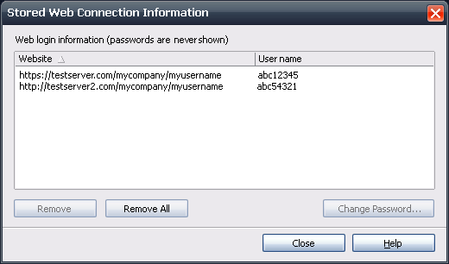Illustration 11: Stored Web Connection Information Dialog
Strings
Item | English | German | Comments
Dialog Title | Stored Web Connection Information
Label | Web login information (passwords are never shown)
Label | Website
Label | User name
Button | Remove
Button | Remove All
Button | Change Password... |  | Calls the Change Password dialog.
Button | Close
Button | Help

Apoc Settings (Issue #118519)
The Security tab page could be protected via a setting in the Apoc configuration manager. Each value and status (protected) of a control, except the enable/disable status for buttons, could be configured by Apoc. When protected a lock symbol is shown and the control itself is disabled.

Show warning dialogs if the document contains recorded changes, versions or notices when
- “Saving or sending documents” Option (default off)
The following warning dialog appears if one of the following is contained in a document and the document will be saved (or send as an email). Furthermore the “saving or sending documents warning” on the security tab page has to be turned on:
    - recorded changes
    - notices
    - document file contains versions
Warning Dialog String List
Item | English | German | Comments
Dialog text | This document contains: | Das zu speichernde Dokument enthält:
Dialog text | * Recorded changes | * Aufgezeichnete Änderungen | Displayed are only those things contained in the current doc.
Dialog text | * Notes | * Notizen | Displayed are only those things contained in the current doc.
Dialog text | * Document versions | * Dokumentversionen | Displayed are only those things contained in the current doc.
Dialog text | Do you want to continue saving the document? | Möchten Sie mit dem Speichern des Dokumentes fortfahren?
Button | Yes | Ja
Button | No | Nein
  - “Printing documents” Option (default off)
The following warning appears when printing a document, if one of the following is a visible part of the document and the warning function itself is turned on in Tools-Options-StarOffice/OOo-Security:
      - shown recorded changes
      - shown notices
Warning Dialog String List
Item | English | German | Comments
Dialog text | This document contains: | Das Dokument enthält:
Dialog text | * Recorded changes | * Aufgezeichnete Änderungen
Dialog text | * Notes | * Notizen | Displayed are only those things currently visible/printable in the current doc.
Dialog text | Do you want to continue printing the document? | Möchten Sie mit dem Drucken des Dokumentes fortfahren?
Button | Yes | Ja
Button | No | Nein
The Printing Options... button calls the Printing Options dialog, were the user can change the behavior for printing notes.
  - “Signing documents” Option (default on)
The following warning is shown directly before the Digital Signature dialog appears (please see page 35 in chapter 5.10 below for dialog details), if the document contains one of the following and the warning option is turned on in Tools-Options-Security:
      - recorded changes
      - document file contains versions
      - notices in Writer and Calc
      - fields
      - references to other sources (i.e. linked sections or linked graphics)
Warning Dialog String List
Item | English | German | Comments
Dialog text | This document contains: | Das aktuelle Dokument enthält:
Dialog text | * Recorded changes | * Aufgezeichnete Änderungen | Displayed are only those things contained in the current doc.
Dialog text | * Document versions | * Dokumentversionen | Displayed are only those things contained in the current doc.
Dialog text | * Notes | * Notizen
Dialog text | * Fields | * Felder | Displayed are only those things contained in the current doc.
Dialog text | * Linked data from other sources (e.g.linked sections or linked graphics) | * Verknüpfte Daten aus anderen Quellen (z.B. verknüpfte Bereiche oder Grafiken) | Displayed are only those things contained in the current doc.
Dialog text | Do you want to continue signing the document? | Möchten Sie mit dem Signieren fortfahren?
Button | Yes | Ja
Button | No | Nein
  - “Creating PDF-files” Option (default off)
The following warning dialog appears if the PDF export warning in Tools-Options-StarOffice/OOo -Security is turned on and if the document contains one of the following:
    - shown recorded changes in Writer
    - shown notices in Writer or Calc
Warning Dialog String List
Item | English | German | Comments
Dialog text | This document contains: | Das aktuelle Dokument enthält:
Dialog text | * Recorded changes | * Aufgezeichnete Änderungen
Dialog text | * Document versions | * Dokumentversionen | Displayed are only those things contained in the current doc.
Dialog text | * Notes | * Notizen
Dialog text | * Fields | * Felder | Displayed are only those things contained in the current doc.
Dialog text | * Linked data from other sources (e.g. linked section or graphics) | * Verknüpfte Daten aus anderen Quellen (z.B. verknüpfte Bereiche oder Grafiken) | Displayed are only those things contained in the current doc.
Dialog text | Do you want to continue creating a PDF file? | Möchten Sie mit dem Erstellen der PDF-Datei fortfahren?
Button | Yes | Ja
Button | No | Nein
  - “Remove personal information on saving” Option
    - Today these information could only be deleted manually in File – Properties – General by pressing the delete button. This new feature removes exactly the same information automatically on save.
  - “Recommend password protection on saving” option presets the Save with password option in the Save as dialog.
    - The user can un-check this pre-checked setting to save a file explicit without a password.
  - Record Changes
This setting activates the changes tracking function for the current document. Furthermore the records could be protected by pressing the Protect... button. If the records are protected, the button label changes to Unprotect.. If the button is pressed in this state the Enter Password dialog (see illustration Error: Reference source not found on page Error: Reference source not found) appears. If the password is entered correctly, the button changes back to the initial label "Protect..." and the Record checkbox is enabled again.
FST: Illustration ID and page Number is MIA
Furthermore the Changes submenu in the Edit menu will change as follows:
      - The "Record" menu entry is checked and disabled if "Protect Records" is active
      - The check box and button are only enabled if the current document is a Writer or Calc one.
      - The document modify status is set
        - if the record mode has been protected in Tools-Options
        - if state of record mode has changed
  - Open document read-only
This setting will be saved with the current document. The document will be loaded in the already known read-only mode if this options is set and the document is opened. Option is only enabled if current module is a Writer, Calc, Draw or Impress.

The Menu Entries for Signing

Entry in the File Menu
The following entries will be added to the menu of Writer, Impress, Draw, Calc and the basic IDE to sign the current document content or document macro (in the basic IDE). It is placed directly behind the properties section. In Basic IDE the entry creates a new group since no properties are available.
If the document uses ODF 1.1 and does not contain any signatures (macro or document), the document will be handled like an unsaved document. This also requires that the office is set to save documents using ODF 1.2.
Item | English | German | Comments
Main Menu entry | Digital Signatu~re... | Digitale Signatu~r... | Digital Signature dialog is called.

Entry in the Tools-Macros Sub Menu
The following entry will be added to the Tools-Macros sub menu of Writer, Impress, Draw, Calc and the basic IDE to sign the current document's macros. It is placed within the menu as follows:
Tools
Macros
Record Macro
Run Macro
Organize Macros ->
Digital Signature...
------------------------
Organize Dialogs ->

Item | English | German | Comments
Tools-Macros menu entry | Digital Signature... | Digitale Signatur... | Digital Signature dialog for macros is called.

Digital signature info dialogs
This chapter contains the specification of various dialogs, which may be displayed when a signing operation was started, but before the actual signature dialog is displayed.
The query message box appears, if the current document is modified and the document has not been saved to a file. There are also other situations where this message box is displayed. See section 5.9.3 for details.
The following dialog is shown, if the document is modified and contains a digital signature:
Item | English | German | Comments
Dialog text | The document has to be saved before it can be signed. Saving the document removes all present signatures. | Das Dokument muss gespeichert werden bevor es signiert werden kann. Das Speichern des Dokumentes entfernt alle vorhandenen Signaturen.
Dialog text | Do you want to save the document? | Möchten Sie das Dokument jetzt speichern?
Button | Yes | Ja | The Yes button is defaulted
Button | No | Nein
After confirming the Digital Signature info dialog , the Save as dialog appears. After saving the document, the Digital Signature dialog (please see page 35 in chapter 5.10 below for dialog details) appears to sign the document.

The following query message appears if the documentis modified AND unsigned or in other scenarios, which are explained in section 5.9.3.
Item | English | German | Comments
Dialog text | The document has to be saved before it can be signed. | Das Dokument muss gespeichert werden bevor es signiert werden kann.
Dialog text | Do you want to save the document? | Möchten Sie das Dokument jetzt speichern?
Button | Yes | Ja | The Yes button is defaulted
Button | No | Nein
Table 1:
In case the user selects 'Yes' then the document is being saved and the Digital Signature dialog appears. If the user selects 'No' then the message box is closed and nothing else happens. In case #1 the document may never have been saved before, that is, it was newly created. Then a save dialog would appear. Only after the user saved the document successfully the Digital Signature dialog will appear. See also section 5.9.3.
If the document is not modified and already signed, the Digital Signature dialog (please see page 35 in chapter 5.10 below for dialog details) appears to add/remove signatures of the document.

Also this error message may appear. See section 5.9.3 for the scenarios where this message is displayed.
Item | English | Comments
Dialog Title | PRODUCTNAME %PRODUCTVERSION
Dialog text | The document format version is set to ODF 1.1 (OpenOffice.org 2.x) in Tools-Options-Load/Save-General. Signing documents requires ODF 1.2 (OpenOffice.org 3.x).
Button | OK
Table 2:

Open a Signed Document with an Invalid Signature
If a document's signature is invalid, the following dialog is shown: For Document Content/Macros
Item | English | German | Comments
Dialog title | %PRODUCTNAME - Invalid Document Signature | %PRODUCTNAME - Ungültige Dokumentsignatur
Dialog text | The digitally signed document content and/or macros do not match the current document signature. | Der digital signierte Dokumentinhalt und/oder die Makros stimmen nicht mit der aktuellen Dokumentsignatur überein.
Dialog text | This could be the result of document manipulation or of structural document damage due to data transmission. | Dieses deutet auf eine Dokumentmanipulation oder einen Übertragungsfehler hin.
Dialog text | We recommend that you do not trust the content of the current document. Execution of macros is disabled for this document. | Wir empfehlen Ihnen, dem aktuellen Dokumentinhalt nicht zu trauen. Das Ausführen von Makros ist für dieses Dokument deaktiviert.
Button | OK | OK
For Program Packages:
Item | English | German | Comments
Dialog title | Invalid Package Signature | Ungültige Paket Signatur
Dialog text | The digitally signed package does not match the current package signature. | Das digital signierte Programmpaket stimmt nicht mit der aktuellen Paketsignatur überein.
Dialog text | This could be the result of package manipulation or of structural document damage due to data transmission. | Dieses deutet auf eine Dokumentmanipulation oder einen Übertragungsfehler hin.
Dialog text | We strongly recommend that you do not trust the current package. | Wir empfehlen Ihnen dringend, dem aktuellen Paket nicht zu trauen.
Dialog text | Do you want to continue adding the package? | Möchten Sie das Hinzufügen des Paketes fortsetzen?
Button | Yes | Ja
Button | No | Nein | The "No" button is defaulted.

Digital Signatures
Document content and document macros can be digitally signed independently.

Signature Validation Results and Icons
There are four different states regarding a signature:
Case A (Signed and valid):
The document is signed,
  - and the document contents match to what has been signed with the certificate attached to the document
  - and the certificate path for the certificate used signing the document could be verified
Icon:
Case B (Signed and valid, but certificate path could not be verified)
The document is signed
  - and if the document contents matches to what has been signed
  - but the certificates path of the certificate used for signing the document could not be verified. Reasons could be (among other things):
      - a certificate from the path has been revoked
Icon:
Case C (broken signature):
The document is signed, but the current document contents does not match to what has been signed originally.
Icon:
Case D (not signed)
There is no particular icon for this case.
Case E (Signed and valid, but an obsolete validation algorithms was used)
This currently applies only for the document signature. As of OOo 3.2 all files in a document except documentsignatures.xml are signed. The signature is regarded as invalid if there is another file, which is not signed. Using this algorithm with signatures created by OOo 3.0 or earlier, would result in an broken signature. This is because those signatures were not applied to all files as is expected by the validation algorithm in OOo 3.2. However, “old signatures” are validated using the algorithm used in the respective versions of OOo which produced this signature. The user will then be informed, that the “old” algorithm was used.
Icon:

In case the the signature is not completely valid or not valid at all (case A), then the cases apply with the following priority:
- case C: broken signature
- case B: signed and valid, but certificate path could not be verified)
- case E: Signed and valid, but an obsolete validation algorithms was used

Case B comes before E, because in case B the whole document cannot be trusted.

The icons are displayed in the status bar, the signature dialog , and the 'View Certificate' dialog.
The signature will be removed when the document is saved again. In this case the status changes to 'not signed'

Status Bar
The status about a document's digital signature is shown in the status bar of OOo Writer, Calc, Draw and Impress:
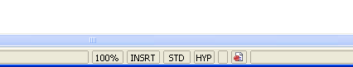
Illustration 12 Signed seal (Case A) in Writer status bar
String List for Tip Help in Status Bar
Item | English | German | Comments
Tip Help: Case A, | Digital Signature: The document signature is OK. | Digitale Signatur: Die Dokumentsignatur ist OK.
Tip Help:Case B, | Digital Signature: The document signature is OK, but the certificates could not be validated. | Digitale Signatur: Die Dokumentsignatur ist OK, aber die Zertifikate konnten nicht verifiziert werden.
Tip Help: Case C, | Digital Signature: The document signature does not match the document content. We strongly recommend you to do not trust this document. | Digitale Signatur: Die Dokumentsignatur stimmt nicht mit dem Dokumentinhalt überein. Wir empfehlen Ihnen dringend, diesem Dokument nicht zu trauen.
Tip Help: Case D, not signed | Digital Signature: The document is not signed. | Digital Signatur: Das Dokument ist nicht signiert.
Tip Help: Case E, | Digital Signature: The document signature and the certificate are OK, but not all parts of the document are signed. |  | The help dialog should show additional information.

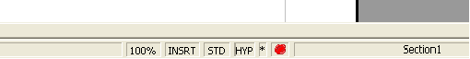Illustration 13 Signed seal in Writer status bar
  - A double click on the icon shows the dialog with signing information of current document.

The sign in the status bar has a context menu with the following entries:
Item | English | German | Comments
Context Menu | Digital Signature... | Digitale Signaturen... | Calls the Digital Signature Dialog
Furthermore the application title shows a note (Signed) or (Signed document macros) right behind the documents or basic libraries file name in the title bar.
The title bar shows the text "(Signed)" only in case A, like already implemented for OOo 2.0. So in case B, C and D the status is only shown in status bar via icons and tip helps.

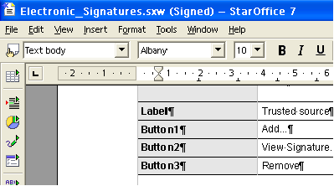Illustration 14 New note "(signed") in the title bar of an application

Item | English | German | Comments
Text | (Signed) | (Signiert) | for document content
Text | (Signed Macro) | (Signiertes Makro) | for basic macros
- Signing requires the OOo or Open Office (OASIS) Format file format.
The following warning dialog appears when a document is already signed and will be saved in whatever (including OpenOffice) format :
Warning Dialog String List
Item | English | German | Comments
Dialog text | Saving will remove all existing signatures. | Das Speichern entfernt alle existierenden Signaturen.
Dialog text | Do you want to continue saving the document? | Möchten Sie mit dem Speichern fortfahren?
Button | Yes | Ja | [Yes] button saves the document in the chosen format.
Button | No | Nein | [No] button aborts the saving and goes back to the Save dialog.
The following warning dialog appears when the document is saved in a non OpenOffice.org format and should be signed ("Save and Sign" functionality):
Warning Dialog String List
Item | English | German | Comments
Dialog text | This document must be saved in OpenDocument file format before it can be digitally signed. | Dieses Dokument muss im OpenDocument Dokumentformat gespeichert werden, bevor es digital signiert werden kann. | [
Button | OK | OK

- If a document has already been saved with a signature, OO.org raises a dialog when the user saves the document again.

Behavior with regard to ODF 1.2
As of OOo 3.0 documents will be stored using ODF 1.2. The digital signature will also be different. What has changed is described in the ODF specification. Here is the summary.
- The default namespace used for the xml elements in the signatures files, which is defined in <document-signatures>, is now:
urn:oasis:names:tc:opendocument:xmlns:digitalsignature:1.0
instead of
http://openoffice.org/2004/documentsignatures
- All files concering macros are also included in a document signature. That is, changing a macro will invalidate the document signature. Macro signatures have not been changed.

OOo 3.0 will not write signatures as used in previous versions of OOo, but can verify signatures in ODF 1.1 documents. It is also not possible to add or remove signatures to documents using ODF 1.1 or earlier. OOo 3.0 allows to save documents using ODF 1.1. This can be determined in the options dialog (Tools-Options-Load/Save General). If set to be using ODF 1.1 no signatures can be added or removed.
Because of the restriction in some scenarios the user may see new error messages. This can happen when either invoking the 'Digital Signature' dialog or when using the 'Add' or 'Remove' buttons of the dialog. This affects both, document and macro signatures. There are four possible ways of how the program proceeds depending on the user action and the combination of:
- the document's format
- the setting for the ODF version used when saving
- the document is signed

Ways to proceed are.
- Proceed the same way as in OOo 2.x
- Showing an error message, telling the user that she needs to configure OOo to save documents using ODF 1.2. See table 2 in section 5.8.3.
- Showing a message box, asking the user to save the document, because the document is modified or because the document will be converted from ODF 1.0/1.1 to ODF 1.2 while saving. See table 1 in section 5.8.3.
- Showing an error message, telling the user that no signatures cannot be added or removed because the document uses ODF 1.0/1.1. This message only appears after pressing 'Add...' or 'Remove' in the digital signatures dialog under particular circumstances. See section 5.10.2.

The following tables show different scenarios.

Document does not contain signatures:
Case | Document is modified | Office saves as 1.2 | Office saves as 1.1 | Document uses ODF 1.2 | Document uses ODF 1.1 | Action
1 | 0 | 1 | 0 | 0 | 1 | #3
2 | 0 | 1 | 0 | 1 | 0 | #1
3 | 0 | 0 | 1 | 0 | 1 | #2
4 | 0 | 0 | 1 | 1 | 0 | #1 (*1)
5 | 1 | 1 | 0 | 0 | 1 | #3
6 | 1 | 1 | 0 | 1 | 0 | #1 (*2)
7 | 1 | 0 | 1 | 0 | 1 | #2
8 | 1 | 0 | 1 | 1 | 0 | #2
Table 3: Scenarios with an unsigned document

*1: The save options need not to be changed to “save as ODF 1.2” because writing a signature does not save the document. Because the document uses ODF 1.2 and is already saved, the signatures can be added.
*2: The original behaviour was to ask the user to save the document (because it is modified). The message displayed here is the same as for action #3.
Document contains signatures:

Case | Document is modified | Office saves as 1.2 | Office saves as 1.1 | Document uses ODF 1.2 | Document uses ODF 1.1 | Action
1 | 0 | 1 | 0 | 0 | 1 | #4 (*1)
2 | 0 | 1 | 0 | 1 | 0 | #1 (*1)
3 | 0 | 0 | 1 | 0 | 1 | #4 (*1)
4 | 0 | 0 | 1 | 1 | 0 | #1 (*4)
5 | 1 | 1 | 0 | 0 | 1 | #1 (*2)
6 | 1 | 1 | 0 | 1 | 0 | #1 (*2)
7 | 1 | 0 | 1 | 0 | 1 | #2 ( *3)
8 | 1 | 0 | 1 | 1 | 0 | #2 (*3)
Table 4: Scenarios with a signed document

*1: Message appears when clicking the 'Add...' or 'Remove' button in the 'Digital Signature' dialog.
*2: The user will be asked to save the document before it can be signed.
*3: If the user invokes again the 'Digital Signature' dialog after changing the office to use ODF 1.2 when saving then the user will be informed that all signatures are lost when saving.
*4: The save options need not to be changed to “save as ODF 1.2” because writing a signature does not save the document. Because the document uses ODF 1.2 and is already saved, the signatures can be added.

Document is new (not saved yet)
Case | Office saves as 1.2 | Office saves as 1.1 | Action
1 | 1 | 0 | #1 (*1)
2 | 0 | 1 | #2
Table 5: Scenarios for a new document
*1: Message that the document needs to be saved before it can be signed.

Digital Signatures Dialog
The following dialogs are called when a document has to be signed.

Digital Signature Dialog For Documents
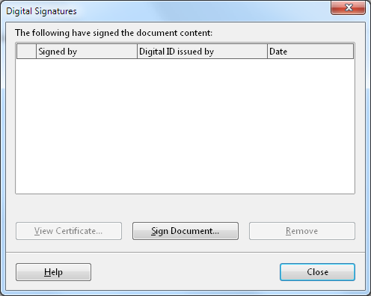Illustration 15: Digital Signatures - document content
The list box shows all currently assigned signatures of the current document. Furthermore a row shows the signature icon and a note is shown below the list box to explain the icon. If the signatures are not valid for the current document, the yellow exclamation sign is shown instead. Then notice 2 is shown in the dialog instead.
Warning Dialog String List
Item | English | German | Comments
Dialog text | The following have signed the document content: | Die Folgenden haben den Dokumentinhalt signiert:
Dialog text | Signed by | Signiert durch
Dialog text | Digital ID issued by | Digitale Signatur ausgestellt durch | TRANSLATORS!: note the preposition here. Where necessary in your language, choose a noun to have the same meaning as this phrase.
Dialog text | Date | Datum
Button | View Certificate... | Zertifikat zeigen... | Calls the View Certificate dialog described below
Button | Add... | Hinzufügen... | Calls the Select Certificate dialog described below or an error message.
Button | Remove | Entfernen | An error message may appear instead of removing the signature. See below.
The following cases are described in 5.9.1
Item | English | German | Comments
Text: Case A, | The signatures in this document are valid | <use current translation> | Default text
Text:Case B, | Certificate could not be validated | Zertifikat konnte nicht verifiziert werden | Text is shown if at least one documents signature could not be verified (Case B).
Text: Case C, | The signatures in this document are invalid | Die Signaturen in diesem Dokument sind ungültig | This text is shown if content does not match Signature (Case C).
Text: Case D, unsigned | - | - | nothing shown in this case
Text: Case E, | Not all parts of the document are signed |  | Signature was created with OOo previous to version 3.2

ODF 1.2 Needed To Sign Notification Message Box
If the user presses the 'Add'... or 'Remove' button then the following error message box appears provided that the document
- uses ODF 1.1 or and earlier version AND
- contain at least one signature (macro or document)

Strings
Item | English | Comments
Dialog Title | %PRODUCTNAME %PRODUCTVERSION
Dialog text | This document contains signatures in ODF 1.1 (OpenOffice.org 2.x) format. Signing documents in %PRODUCTNAME %PRODUCTVERSION requires ODF 1.2 format version. Thus no signatures can be added or removed to this document./n/nSave document in ODF 1.2 format and add all desired signatures again.
Button | OK
After closing the dialog no further action happens. See also section 5.9.3.

Digital Signature Dialog For Document Macros
See Illustration 15: Digital Signatures - document content on page 35 above for a dialog mock-up.

String List
Item | English | German | Comments
Dialog text | The following have signed the document macros: | Die Folgenden haben die Dokumentmakros signiert:

Remove Document Signature when Signing Macros
As of OOo 3.2 a macro signature can only be applied when there is no document signature. The reason is, that the document signature is applied to all files, including macros and macrosignatures.xml. Adding or removing a macro signature would therefore break the document signature. OOo informs the user that the document signatures will be lost and OOo will remove them if the user continues. Otherwise, the user would see a broken document signature after signing the macro, which could be confusing.
When the 'Add' or 'Remove' button is being pressed and the document contains a document signature then the following 'Query' dialog is displayed.

Item | English | German | Comments
Text | Signing macros will remove all document signatures.  Do you want to sign the macros? | <use current translation> | Default text
Label | Yes |  | The 'Digital Signature' dialog will be opened after closing this message box.
Label | No |  | Has the focus.
If the document uses ODF 1.1, then this message box is not displayed. Instead the message box regarding ODF 1.1, which is described at 5.10.2, is displayed. Otherwise the warning is displayed whenever the user presses one of these buttons, until the user pressed 'Yes' in the warning box. For example, the user presses 'Add' and the warning appears. The user then presses 'No' and the user has still the signatures dialog open. He presses again 'Add' and the warning shows again. The user closes the warning by pressing 'No', etc. Only if the user leaves the warning by pressing 'Yes' then the warning will not show again as long as the same signatures dialog is open.

Digital Signature Dialog For Program Packages
See Illustration 15: Digital Signatures - document content on page 35 above for a dialog mock-up.
String List
Item | English | German | Comments
Dialog text | The following have signed this package: | Die Folgenden haben das Paket signiert:

Select Signature (Add...) Dialog
The following dialog is called if the Add... button is pressed in the Digital Signature Dialog. The view button allows to view at the current selected certificate. If no certificate is selected (default when calling the dialog), the button is disabled.
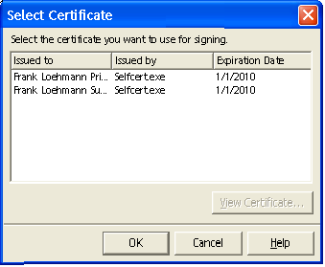Illustration 16 Select Certificate dialog
String List
Item | English | German | Comments
Dialog text | Select the certificate you want to use for signing. | Wählen Sie das Zertifikat aus, das Sie zum signieren benutzen möchten.
Button | View Certificate... | Zertifikat zeigen...

Item | English | German | Comments
Title | Select Certificate | Zertifikat auswählen
Label | Issued to | Ausgestellt für | TRANSLATORS!: note the preposition here. Where necessary in your language, choose a noun to have the same meaning as this phrase.
Label | Issued by | Ausgestellt durch | TRANSLATORS!: note the preposition here. Where necessary in your language, choose a noun to have the same meaning as this phrase.
Label | Expiration date | Ablaufdatum

View Certificate Dialog
The Certificate dialog is called when the View Certificate button is pressed in the Digital Signatures dialog. The dialog consists of three tab pages.
Valid Certificate
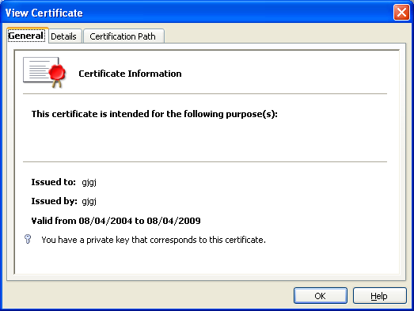
Illustration 17 Tab 1 - Certificate Dialog - Tab 1 - General

String List
Item | English | German | Comments
Tab page Label | General | Allgemein
Tab page Label | Details | Details
Tab page Label | Certificate Path | Zertifikatspfad
Label | Certificate Information | Zertifikatsinformationen
Label | Issued to: | Ausgestellt für: | TRANSLATORS!: note the preposition here. Where necessary in your language, choose a noun to have the same meaning as this phrase.
Label | Issued by: | Ausgestellt durch: | TRANSLATORS!: note the preposition here. Where necessary in your language, choose a noun to have the same meaning as this phrase.
Label | Valid from %SDATE% to %EDATE% | Gültig von %SDATE% bis %EDATE%
Label | You have a private key that corresponds to this certificate | Sie haben einen privaten Schlüssel, der mit diesem Zertifikat korrespondiert.
Text A | This certificate is intended for the following purposes: | (keep current translation already in the product)

Valid Certificate, But Not Enough Information to Verify Certificate:
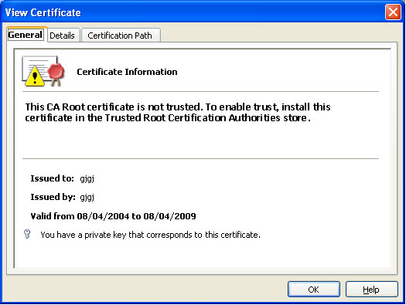Illustration 18 Tab 1 - Certificate Dialog with new icon for missing CA root certificate
String List

Item | English | German | Comments
Text | The certificate could not be validated. | Das Zertifikat konnte nicht verifiziert werden. | Bold text

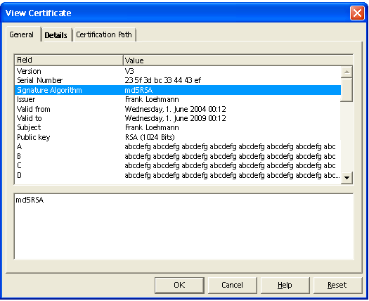Illustration 19 Certificate Dialog - Tab 2 - Details
String List
Item | English | German | Comments
Column Label | Field | Feld
Column Label | Value | Wert
Field label text 1 | Version | Version
Field label text 2 | Serial Number | Seriennummer
Field label text 3 | Issuer | Aussteller
Field label text 4 | Valid From | Gültig von | TRANSLATORS!: note the preposition here. Where necessary in your language, choose a noun to have the same meaning as this phrase.
Field label text 5 | Valid To | Gültig bis | TRANSLATORS!: note the preposition here. Where necessary in your language, choose a noun to have the same meaning as this phrase.
Field label text 6 | Subject | Betreff
Field label text 7 | Public Key | Öffentlicher Schlüssel
Field label text 8 | Enhanced Key Usage | Erweiterte Schlüsselverwendung
Field label text 9 | Authority Key Identifier | ?Autoritätsschlüsselbezeichner? | PJC/EM->MT/FL: decide on German pls. Suggestions (MSO) for authority depending on which authority you mean “Zertifizierungsstelle” or “Sicherheitsstelle”; It would be good break this big work into a genitive phrase.
Field label text 10 | Thumbprint Algorithm | Fingerabdruck-Algorithmus
Field label text 11 | Thumbprint | Fingerabdruck

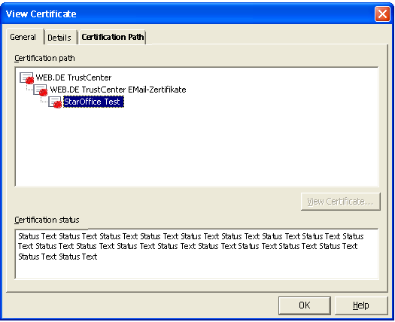Illustration 20 Certificate Dialog - Tab 3 - Certification Path
String List
Item | English | German | Comments
Label | Certificate path | Zertifikatspfad
Label | Certificate status | Zertifikatsstatus
String List
Item | English | German | Comments
Text A | The certificate is OK. | Das Zertifikat ist OK. | Shown certificate path could be verified.
Text B | The certificate could not be validated. | Das Zertifikat konnte nicht verifiziert werden. | Shown if certificate path could not be checked.

Document Properties
The document properties dialog shows the name, date and time when the document has been signed. If more than one signature is assigned to a document, the dialog shows only “Multiple signed document” instead of name and date of the signer.
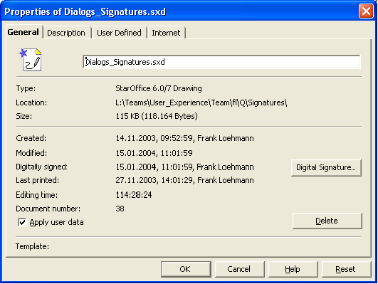Illustration 21 Document properties dialog with new signature field and View.. button
Item | English | German | Comments
Button | Digital Signature... | Digitale Signatur...
Label | Digitally signed: | Digital signiert:
Label | Multiply signed document | Mehrfach signiertes Dokument
The Digital Signature... button calls a the Digital signature dialog to show all currently assigned signatures. The Digital Signature dialog allows to remove a signature from the document.

Changed Default Setting in Tools-Options
In OO.org 1.1 printing sets the document modified status. This could be disabled by a Tools-Option setting, but the default is currently set to on, so that printing modifies the document. This causes a problem, because printing a signed document prompts for saving the document on closing, but saving would remove the assigned signature.
Since this is not only a problem when having a signature, the setting '[ ] Printing sets document modified status' in Tools-Options-StarOffice-General will be changed to off by default.

Macro Security
Signing of document macros works independently from signing the document's content. This allows to change the document's content and to renew document signatures without loosing a present macro signature. Furthermore this allows to create new documents from a document template without loosing the document macro signature in the newly created document.

Security Warning Dialog
The following dialog appears, if a document contains macros.

Macro Security Dialog
The Macro dialog is completely redesigned. The old concept of “trusted pathes” for libraries only has been dropped. The new dialog uses a security level concept. The levels Very High, High, Medium and Low are used. Security level High is default. The trusted file locations settings from the "Very high" level are valid on all other security levels as well.
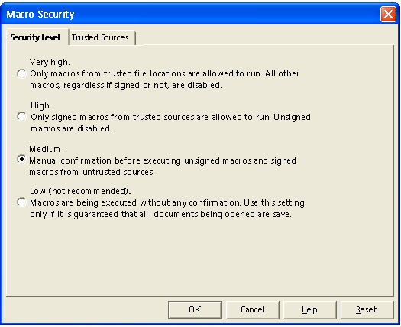Illustration 22 Macro Security Settings - Security Level tab
Apoc Settings (Issue #118519)
The radio button group of the Macro Security tab page could be protected via a setting in the Apoc configuration manager. The value of the radio group is fixed, disabled and a lock symbol is shown.
String List
Item | English | German | Comments
Option0 | Very high. Only macros from trusted file locations are allowed to run. All other macros, regardless whether signed or not, are disabled. | Sehr hoch. Nur Makros aus vertrauenswürdigen Dateiquellen werden ausgeführt. Alle anderen Makros, unabhängig ob signiert oder nicht, werden automatisch deaktiviert.
Option1 | High. Only signed macros from trusted sources are allowed to run. Unsigned macros are disabled. | Hoch. Nur signierte Makros aus vertrauenswürdigen Quellen werden ausgeführt. Nicht signierte Makros werden automatisch deaktiviert.
Option2 | Medium. Confirmation required before executing macros from untrusted sources. | Mittel. Bestätigung vor dem Ausführen von Makros aus nicht vertrauenswürdigen Quellen.
Option3 | Low (not recommended). All macros will be executed without confirmation. Use this setting only if you are certain that all documents that will be opened are safe. | Niedrig (nicht empfehlenswert). Alle Makros werden ohne Nachfrage ausgeführt. Diese Einstellung sollte nur benutzt werden, wenn sichergestellt werden kann, dass nur sichere Dokumente geöffnet werden.
Tab Name | Security Level | Sicherheitsstufe

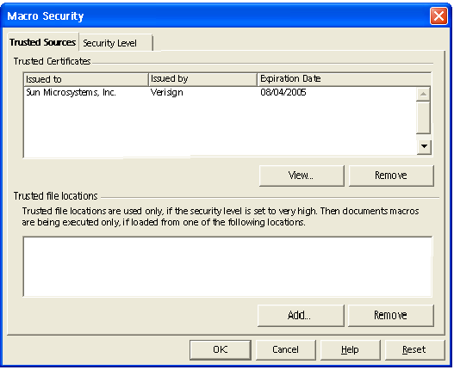Illustration 23 Macro Security Settings - Security Level tab - Strings outdated !-
Note: Please note that the Trusted Sources and Security Level tab pages are only switched in this mockup to reduce the design effort for this specification. Please also note that text in other languages than English may be much longer, so that a two line text must be able to become a three line text.
The Add... button calls a folder picker dialog. The Remove buttons are only enabled, if an entry is selected within the list box. The View button is also only enabled, if a certificate is selected and calls the View Certificate dialog described in chapter 5.10.6 View Certificate Dialog on page 39.
Apoc Settings (Issue #118519)
The trusted file location list box could be protected via a setting in the Apoc configuration manager. The values of the listbox are fixed, disabled and a lock symbol is shown. Furthermore the Add.. and Remove buttons are disabled.
The trusted certificates list box could be administrated by Apoc 1.1 in any way, because Apoc is not capable of loading data (in this case certificates) from a local disk.
Macro Organizer Dialog String - Modules List
Item | English | German | Comments
Label | Trusted certificates | Vertrauenswürdige Zertifikate
Label | Issued to | Ausgestellt für | TRANSLATORS!: note the preposition here. Where necessary in your language, choose a noun to have the same meaning as this phrase.
Label | Issued by | Ausgestellt durch | TRANSLATORS!: note the preposition here. Where necessary in your language, choose a noun to have the same meaning as this phrase.
Label | Expiration date | Ablaufdatum

Item | English | German | Comments
Tab Name | Trusted Sources | Vertrauenswürdige Quellen
Button1 | Add... | Hinzufügen...
Button2 | View... | Anzeigen...
Button3 | Remove | Entfernen
Label | Trusted file locations | Vertrauenswürdige Dateiquellen
Text | Document macros are always executed if they have been opened from one of the following locations. | Dokumentmakros aus den folgenden vertrauenswürdigen Dateiquellen werden immer ausgeführt. | Changed to fix issue i44251.

Trust Source of Macro Dialog for Signed Macros
OO.org raises a dialog if a signed macro will be loaded with the document and it's source has not been trusted before. This dialog allows the user to add the source to trusted sources and execute the macro.
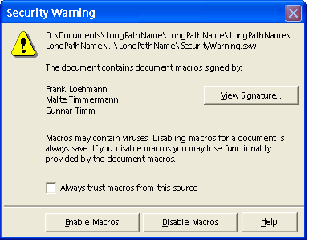Illustration 24 Security Warning Dialog
- The dialog closer (cancel action) is disabled to force the user to decide whether to enable or disable macros.
- The Disable Macros button is defaulted
- The Disable Macros button is disabled if the check box to trust macros is turned on
- The Enable Macros button is disabled if security level is high and the check box to trust macros is not turned on.
String List
Item | English | German | Comments
Title | %PRODUCTNAME - Security Warning | %PRODUCTNAME Sicherheitswarnung
Text | This document contains macros signed by: | Dieses Dokument enthält Makros, die signiert wurden von:
Button | View Signature... | Signatur zeigen...
Text | Macros may contain viruses. Disabling macros for a document is always safe. If you disable macros you may lose some functionality. | Makros können Viren enthalten. Es ist immer sicher, Makros zu deaktivieren. Dadurch geht eventuell Funktionalität verloren.
Text | Always trust macros from this source | Makros aus dieser Quelle immer vertrauen
Button | Enable Macros | Makros aktivieren
Button | Disable Macros | Makros deaktivieren

Enable/Disable Document Macro Dialog for Unsigned Macros
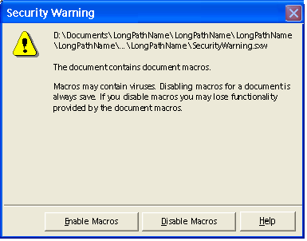Illustration 25 Security Warning - unsigned macros dialog
- The dialog closer (cancel action) is disabled to force the user to decide whether to enable or disable macros.
- The Disable Macros button is defaulted
String List
Item | English | German | Comments
Title | %PRODUCTNAME - Security Warning | %PRODUCTNAME - Sicherheitswarnung
Text | This document contains macros. | Dieses Dokument enthält Makros.
Text | Macros may contain viruses. Disabling macros for a document is always safe. If you disable macros you may lose some functionality. | Makros können Viren enthalten. Es ist immer sicher, Makros zu deaktivieren. Dadurch geht eventuell Funktionalität verloren.

Macro Warning for Security Setting High and Very High. (Issue 83129)
If a document contains macros and the macro will not be executed due to the macro security is set to high or very high, the following notification dialog appears after the document has been loaded.
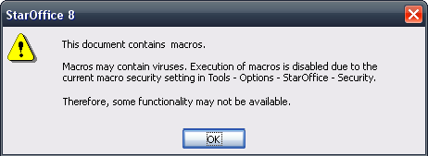Illustration 26: Macro Warning dialog for security setting high and very high.
String List
Item | English | German | Comments
Title | %PRODUCTNAME %PRODUCTVERSION |  | Should not be translated
Text | This document contains macros./n/n  Macros may contain viruses. Execution of macros is disabled due to the current macro security setting in Tools – Options – %PRODUCTNAME – Security ./n/nTherefore, some functionality may not be available.
Button | OK

Error Conditions
None

Future Tasks (not relevant for OO.org 2.0)
The following tasks are not planned to be implemented for OO.org 2.0.

Signing of Microsoft Office Documents

Signing on PDF Export

Signing of Sections in Writer

OO.org Writer allows to sign sections independently from signing the whole document.
- A signed section is automatically write protected (password is optional).
- The signature of a section gets lost, if the protection of the section gets removed.
- A double click on the signed icon in the status bar shows the signature.
- Only the content of the section will be signed. The formatting (i.e. paragraph templates) is not signed. This allows the section to be an active part of the document.
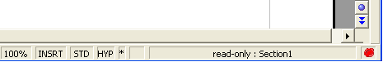Illustration 27 Signed section if Writer – Version A
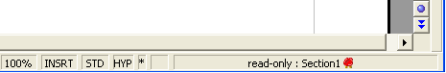Illustration 28 Signed section in Writer - Version B
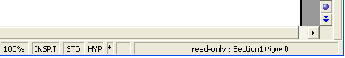Illustration 29 Signed section in Writer - Version C
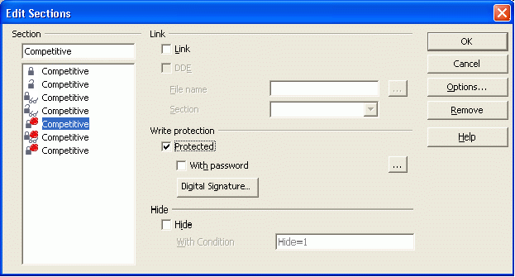Illustration 30 Sign a section in the section dialog.
Icons will be provided directly by Stella Schulze

Signing of Table Sheets in Calc
OO.org Calc offers the possibility to sign table sheets independently from signing the whole document. The table sheet will be signed as is with references, with fields and formulas.
- A signed table sheet gets protected without password.
- The signature of a table sheet gets lost, if the content of the signed sheet will be modified.
- A double click on the signature icon shows the signature.
Illustration 31 A table sheet could be signed in Calc
- The new password dialog layout will be used for protect document and protect table dialog
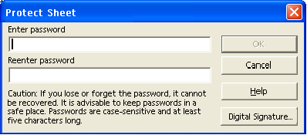Illustration 32 Protect Sheet dialog in Calc offers a new button Digital Signature... and uses the new dialog layout for assigning passwords.
Protect Sheet Strings
Item | English | German | Comments
Button | Digital Signature... | Digitale Signatur...

After Beta Tasks

Warning Dialog if Mozilla Profile is not Found (#i37609)
The Mozilla crypto engine is needed for using digital signatures in OOo on Unix systems. The following dialog appears, if the Mozilla user profile could not be found, i.e when calling Files - Digital Signatures function.
Warning Dialog String List
Item | English | German | Comments
Dialog text | Digital signatures functionality could not be used, because no Mozilla user profile was found. Please check the Mozilla installation. | Die digitale Signaturen Funktion kann nicht benutzt werden, da kein Mozilla Benutzerprofil gefunden wurde. Bitte überprüfen Sie die Mozilla Installation. | Dialog has OK button
Other Future Tasks
- Set permissions restriction for a document (User Rights Management)
  - Per User
  - Per Group
  - Permission types
    - Read/Write access to document
    - Add comments only
    - Read-only access to document
    - Load a different version of the document??
    - Saving document under a new file name / Send document (i.e. as an e-mail)
    - Content copying or extraction via clipboard
    - Form field fill-in
    - Signing
    - Content linking allowed (only possible if content is not encrypted
    - Printing / PDF creation
  - Problems
    - How to deal with MS documents with permissions?

Normal Writer Edit Mode Behavior
A tip help is shown (see string table below for details) when the mouse is placed on a URL. If the CTRL key is pressed, the i-beam cursor changes to a finger cursor and a click on the link opens the URL in the system's browser.
String list
Tip help | English | German | Comments
Tip help | <URL>  CTRL+click to follow link | <URL>  Strg+Klick zum Verfolgen der Verknüpfung | If target is not within the current document.  The URL tip help is limited to a width of 45 characters, because URLs could become very long.

Links in Read-Only / Form Use Mode / Help System
In read-only mode/Form use mode of a document (this includes the Writer help viewer), all links are live and the finger cursor is used by default.

Smart Card Support for Signing Documents
Has to be implemented to support government initiatives for digital documents within administration departments.

Legal Issues
None

Notes
Old Dialog:

Item | English | German | Comments
Dialog Tile | %PRODUCTNAME %PRODUCTVERSION | %PRODUCTNAME %PRODUCTVERSION
Dialog text | The document is already signed. | Das Dokument ist bereits signiert.
Dialog text | Do you want to add another signature or remove current signature(s) and sign again? | Möchten Sie eine weitere Signatur hinzufügen oder möchten Sie die vorhandenen Signatur(en) entfernen und das Dokument neu signieren?
Button | Add Signature... | Signatur hinzufügen... | Add signature button calls the Digital Signature dialog.
Button | New Signature... | Neue Signatur...
Button | Cancel | Abbrechen

- , the following dialog appears and recommends to open the current document in read-only mode:
Item | English | German | Comments
Dialog text | $PATHANDFILENAME should be opened in read-only mode unless changes to it need to be saved. | $PATHANDFILENAME sollte schreibgeschützt geöffnet werden, solange keine Änderungen an diesem Dokument gespeichert werden müssen. | TRANSLATORS! $PATHANDFILENAME is a placeholder. Do not translate it.
Dialog text | Do you want to open the document in read-only mode? | Soll das Dokument mit Schreibschutz geöffnet werden?
Button1 | Yes | Ja
Button2 | No | Nein
Button3 | Cancel | Abbrechen

For Document Macros
If present, document macro are tested before testing the signed document content. So if the user continues loading the document with a broken macro signature, he gets no separate warning for the broken document content, because this status could be seen in the status bar.
Item | English | German | Comments
Dialog Tile | Invalid Macro Signature | Ungültige Makro Signatur
Dialog text | The digitally signed document macros do not match the current document macro signature. | Die digital signierten Dokumentmakros stimmen nicht mit der aktuellen Dokumentsignatur überein.
Dialog text | This could be the result of document manipulation or of structural document damage due to data transmission. | Dieses deutet auf eine Dokumentmanipulation oder einen Übertragungsfehler hin.
Dialog text | We strongly recommend that you do not trust the current macro. | Wir empfehlen Ihnen dringend, dem aktuellen Dokumentmakros nicht zu trauen.
Dialog text | Do you want to continue opening the document? | Möchten Sie das Öffnen des Dokumentes fortsetzen?
Button | Yes | Ja
Button | No | Nein | The "No" button is defaulted. The "No" button is defaulted.

Additional password dialogs:
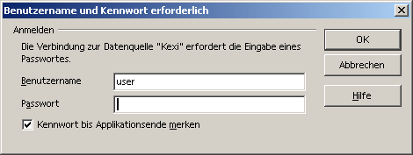
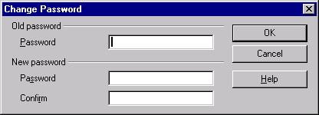

References and Links
Signatures:
http://www.w3.org/Signature/
Here is a list of rules and regulations that have special security requirements:
- Government Paperwork Elimination Act (GPEA)
- Health Insurance Portability and Accountability Act (HIPAA)
- 21 CFR Part 11 (pharmaceutical industry)
- German Act regarding Digital Signatures
(German: “Signaturgesetz” - http://www.bsi.de/esig/basics/legalbas/sigg2001.pdf)
- Electronic Signatures Directive by the EC
(http://www-personal.umich.edu/~rmann/Statutes/Electronic%20Signatures%20Directive.PDF)
- European Electronic Signature Standardization Initiative (EESSI)
- www.osci.de , http://www.bund.de/BundOnline-2005-.6164.htm
Illustration Index
Illustration 1 File Save dialog in MS Office XP with open Tools menu 12
Illustration 2 File Open dialog in MS Office XP with open Tools menu 13
Illustration 3 Security dialog of MS Office XP 14
Illustration 4 Warning if track changes warning is active an user saves, prints or send the document 14
Illustration 5 Dialog comes up on loading a doc, if read-only was recommended by the author 14
Illustration 6 Macro Security dialog – Security Level table 15
Illustration 7 Macro Security dialog – Trusted sources tab 15
Illustration 8 Encryption method can be chosen in Encryption Type dialog called by the Advanced button of the security dialog 16
Illustration 9 Protect Document dialog 16
Illustration 10 Word XP Tools Menu calls dialog shown in Illustration 9 16
Illustration 11 Button changes to Unprotect Document in Security dialog after choosing Document Protection for current document 17
Illustration 12 Dialog to confirm a password to ensure that the user did not make a typo when entering the password 17
Illustration 13 Problem when confirming the dialog with two given passwords – the user does not know which password he has to confirm 18
Illustration 14 Warning Dialog if the user changes the file format to not MS one 18
Illustration 15 Open a password protected file raises dialog 18
Illustration 16 Warning dialog if wrong password has been entered while opening the document 19
Illustration 17 Second password dialog to enter write access password 19
Illustration 18 Warning dialog if incorrect password has been entered 19
Illustration 19 Save options dialog - called from the Options menu in the file Save dialog 20
Illustration 20 Self-signed digital certificate 21
Illustration 21 Digital Signatures dialog of MS Office XP 21
Illustration 22 Warning if a signature is added to a document and document does not show all it's content 22
Illustration 23 Document has to be saved in Word Format 22
Illustration 24 Warning if track changes is active when signing a document 22
Illustration 25 Warning that unsaved documents have to be saved in Word format before signing 22
Illustration 26 Warning that saving in different format will remove signature 22
Illustration 27 Certificate Dialog – General tab 23
Illustration 28 Warning that save as will create a copy without signature 23
Illustration 29 Certificate - Details tab 24
Illustration 30 Certificate Dialog 24
Illustration 31 Certificate Properties 25
Illustration 32 Certificate - Certification Path tab 26
Illustration 33 Certificate dialog with open Show list box 26
Illustration 34 Digital Signature 27
Illustration 35 (Signed) indicate that document has been signed 27
Illustration 36 Certificate Export Wizard 27
Illustration 37 Certificate Export Wizard 28
Illustration 38 Certificate Export Wizard 28
Illustration 39 Certificate Export Wizard 29
Illustration 40 Certificate Export Wizard 29
Illustration 41 Certificate Export Wizard 29
Illustration 42 Saving a digitally signed document calls warning dialog 30
Illustration 43 Mozilla – Preferences 31
Illustration 44 Security Device Manger dialog 31
Illustration 45 Certificate Manager dialog 32
Illustration 46 Certificate Manager dialog 32
Illustration 47 Certificate Manager dialog 33
Illustration 48 Certificate Manager dialog 33
Illustration 49 Editing a certificate 34
Illustration 50 View a certificate 34
Illustration 51 View a certificate 35
Illustration 52 Self Signing Security Dialog 36
Illustration 53 Tools menu with two signature related functions 36
Illustration 54 Digital signatures menu is also available in task pane 37
Illustration 55 Compare two versions of a signed document 37
Illustration 56 Sign document dialog 37
Illustration 57 Show options enlarges dialog and offers additional functionality 38
Illustration 58 Reasons list box offers special settings in Signing dialog 38
Illustration 59 Document Security dialog 38
Illustration 60 Display Settings Dialog 39
Illustration 61 Document security dialog – list box call dialog when entry has been selected 39
Illustration 62 Dialog called via Acrobat Standard Security entry in security options list box 40
Illustration 63 Login Dialog 40
Illustration 64 Create a new user 41
Illustration 65 Self signing security dialog 41
Illustration 66 Self signing security dialog 42
Illustration 67 Self signing security dialog 42
Illustration 68 Self signing security dialog 43
Illustration 69 Called via New (appearance) button 43
Illustration 70 Trust a certificate 44
Illustration 71 E-mail a certificate 44
Illustration 72 Signature with default representation in the document 45
Illustration 73 Context menu on signature 45
Illustration 74 Signature properties 46
Illustration 75 Verify identity 46
Illustration 76 Certificate Attributes 47
Illustration 77 Macro Security in Word XP 48
Illustration 78 Tools - Digital Signature Dialog in Visual Basic Editor 48
Illustration 79 Select Certificate dialog (called by Choose... button) 49
Illustration 80 MS Office XP Security Warning Dialog 49
Illustration 81 Macro security dialog of MS Office 2003- Tab 1 50
Illustration 82 Macro security dialog of MS Office 2003 - Tab 2 50
Illustration 83 MS Office 2003 - Security Dialog Tab 1 (German) 51
Illustration 84 MS Office 2003 - Security Dialog Tab 2 (German) 51
Illustration 85: Tools- Options – Security dialog - Store Web Connection Persistently (default off) 53
Illustration 86: Tools- Options – Security dialog – Protect by Master Password (default on) 54
Illustration 87: Tools- Options – Security dialog - Master Password optionally turned off by user 55
Illustration 88 The state of the "Record changes" check box will be enabled and disabled as long as a the state is protected. 56
Illustration 89 Set a new password 57
Illustration 90 Overworked enter password dialog 58
Illustration 91: Set Master Password dialog 58
Illustration 92: Enter Master Password 59
Illustration 93: Security Options dialog called by the Options... button of the Security dialog 60
Illustration 94: Stored Web Connection Information Dialog 62
Illustration 95 Signed seal (Case A) in Writer status bar 70
Illustration 96 Signed seal in Writer status bar 70
Illustration 97 New note "(signed") in the title bar of an application 71
Illustration 98 Digital Signatures - document content 75
Illustration 99 Digital Signatures - document macros 77
Illustration 100 Digital Signatures - for packages 77
Illustration 101 Select Certificate dialog 78
Illustration 102 Tab 1 - Certificate Dialog - Tab 1 - General 79
Illustration 103 Tab 1 - Certificate Dialog with new icon for missing CA root certificate 81
Illustration 104 Certificate Dialog - Tab 2 - Details 82
Illustration 105 Certificate Dialog - Tab 3 - Certification Path 83
Illustration 106 Document properties dialog with new signature field and View.. button 84
Illustration 107 Macro Security Settings - Security Level tab 86
Illustration 108 Macro Security Settings - Security Level tab - Strings outdated !- 88
Illustration 109 Security Warning Dialog 89
Illustration 110 Security Warning - unsigned macros dialog 90
Illustration 111: Macro Warning dialog for security setting high and very high. 91
Illustration 112 Signed section if Writer – Version A 92
Illustration 113 Signed section in Writer - Version B 92
Illustration 114 Signed section in Writer - Version C 92
Illustration 115 Sign a section in the section dialog. 92
Illustration 116 A table sheet could be signed in Calc 93
Illustration 117 Protect Sheet dialog in Calc offers a new button Digital Signature... and uses the new dialog layout for assigning passwords. 93

Michael Brauer, May 2003 source: http://staroffice-doc.germany.sun.com:8080/Projects/StarOffice/SO_6.y/PCD/StarOffice-Q-PCD.sxw
Source: http://www.cnet.com/Resources/Info/Glossary/Terms/digitalsignature.html
Source: http://www.cnet.com/Resources/Info/Glossary/Terms/encryption.html
Source: http://www.cnet.com/Resources/Info/Glossary/Terms/digitalcertificate.html
The plan for “BundOnline” http://www.bundonline2005.de/ is to implement an security infrastructure that uses digital signatures and encryption until the end of 2005. The systems integrator CSC Ploenzke created a plugin for Adobe Acrobat that fulfills the requirements for BundOnline (German: http://www.adobe.de/products/acrobat/pdfs/CSC_Ploenzke.pdf ).
http://egov.gov/
http://wiki.services.openoffice.org/wiki/Specification_Authentication_Using_System_Credentials
See following spec for details about hyperlinks: http://specs.openoffice.org/appwide/hyperlinks/Behavior_of_Hyperlinks_in_OOo_Documents.odt
Currently implemented for Writer edit mode only. Will be introduced for Calc, Draw, Impress soon.
Protected means that those controls are disabled and a lock symbol is shown in front of the control. Please see http://so-doc.germany.sun.com/Projects/StarOffice/SO_6.x/Proposals/Drafts/ManagementConsole/Spec/Config_Items_rev8.sxw following behaviour was observered in SO8:
Changed from Medium to High for OOo 2.3 (i79170)
Protected means that those controls are disabled and a lock symbol is shown in front of the control. Please see http://so-doc.germany.sun.com/Projects/StarOffice/SO_6.x/Proposals/Drafts/ManagementConsole/Spec/Config_Items_rev8.sxw following behaviour was observered in SO8:
Protected means that those controls are disabled and a lock symbol is shown in front of the control. Please see http://so-doc.germany.sun.com/Projects/StarOffice/SO_6.x/Proposals/Drafts/ManagementConsole/Spec/Config_Items_rev8.sxw following behaviour was observered in SO8:

