Software Specification Document

OpenOffice.org
File Passwords

Specification Status
Last Change | Jun 15, 2010
Status
Abstract
Save file with password functionality needs to be extended by customer request. Beside the already implemented file encryption, an additional password to protect a document from being edited is implemented.
i-Team Members
Role | First Name, Last Name, Initials | E-Mail Address
I-Team Lead | Mathias Bauer (MBA) | Mathias.bauer@sun.com
Specification Author | Frank Loehmann (FL) | frank.loehmann@sun.com
User Experience | Frank Loehmann (FL) | frank.loehmann@sun.com
Development | Daniel Rentz (DR)  Henning Brinkmann  Sven Jacobi  Mikhail Voitenko | daniel.rentz@sun.com  henning.bringmann@sun.com  sven.jacobi@sun.com  mikhail.voitenko@sun.com
Quality Assurance | Thorsten Martens (TM) | thorsten.martens@sun.com
Accessibility | Thorsten Martens (TM) | thorsten.martens@sun.com
Documentation | Uwe Fischer (UFI) | uwe.fischer@sun.com
Program Management | Marcus Lange (MLA) | marcus.lange@sun.com
<State reason here, if one role is not represented in i-Team.>

Contents
Abstract 1
i-Team Members 1
References and Reference Documents 3
Acronyms and Abbreviations 3
1 Detailed Specification 4
1.1 Usage Scenarios 4
1.1.1 Protect 4
1.1.1.1 Encrypt File 4
1.1.1.2 Receiving an Encrypted Document 4
1.1.2 Share 4
1.1.2.1 Sharing a File With Others 4
1.1.2.2 Consuming a Document Shared With Others 4
1.1.2.3 Consuming a Document Shared With Others 4
1.2 Behavior 5
1.3 User Interface 5
1.3.1 Open File with Passwords 5
1.3.1.1 Open File with Password to Modify 6
1.3.1.2 Enter Password Dialog 6
1.3.1.3 Wrong Password Entered 6
1.3.2 Save Files with Passwords 7
1.3.2.1 Password Dialog 8
1.3.2.2 Sharing Options 9
1.3.2.3 File Properties Dialog 9
1.3.2.4 Password Check 10
1.3.2.5 Options Dialog 11
2 Accessibility 12
3 Migration 12
4 Configuration 12
5 File Format 12
6 Open Issues 12
Document Change History 13

References and Reference Documents
Reference Document | Check | Location (URL)
Specification Process Entry Check |  | N/A
Product Requirement, RFE, issue [Required] |  | N/A
Accessibility Check [Required] |  | See section 2 Accessibility below
Product Concept Document |  | <Please enter location here>
Competitive Analysis |  | <Please enter location here>
IDL Specification |  | <Please enter location here>
Test Case Specification [Required] |  | <Please enter location here>
Software Specification Rules | N/A | N/A
<Other, e.g. references to related specs>
Acronyms and Abbreviations
Acronym / Abbreviation | Definition
<WYSIWYG> | <What You See Is What You Get>

Detailed Specification

Usage Scenarios

Protect

Encrypt File
Peter is working on an important text document. He must send this document to a friend Andreas via email. He wants to be sure that nobody except his friend could open this document. So he encrypts the document with a password that only he and Andreas know.

Receiving an Encrypted Document
Andreas got an important document by email. We double click the attached file to open the file. The application asked him to enter a password. Andreas knows the password and the document is decrypted, so that he can finalize the document before he sends it back to the author Peter.

Share

Sharing a File With Others
Nils wants to share a document with his colleagues. The are two groups of colleagues. The first one, a group of managers, must be able to change something and to sign the document. The second group must not be able to change it, but needs to read it for transfer of information. He puts the document on a server to make the file available to all his colleagues and assigns a password protection so that he can be sure that only the first group of managers can change/sign the document.

Consuming a Document Shared With Others
Katrin gets a document for her information from one of her colleagues. She should read the document to be informed what is going on.

Consuming a Document Shared With Others
Kay is a manager and gets a document from one of his colleagues. He must read this document and has to digitally sign it to declare that he has read the document.

Behavior
- An file.
- Save file in ODF or MS Office format and assign password to modify.
- Open file with password to modify.
  - Open file in read-only mode automatically.
    - User whats to edit file.
      - Edit mode button/menu pressed/called.
      - Dialog to enter Password shown (incl. error handling)
      - File in edit mode.
      - User makes changes.
      - Save file with password to modify set.
    - User wants to edit a copy of document.
      - Save as from read-only mode.
      - Password will be removed on saving.
Copy of document is in edit mode
    - User wants to make copy of document.
      - Save as from edit mode.
      - Password will be removed on saving.
    - User wants to read document.
      - User closes document if done.

User Interface

Open File with Passwords
The File-Load dialogs (system and internal one) will be kept unchanged. If a password for loading the file has been set, the following dialog is shown and the user is asked to enter the password to decrypt the file. Default is the OK button.
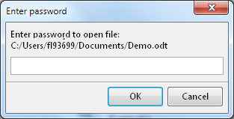Illustration 1: Password dialog to open
In case of a wrong password the following dialog is shown and loading will be aborted:

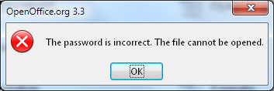Illustration 2: Error Message

Open File with Password to Modify
If a password to modify has been set for a file, this file will be directly opened in read-only mode. If the user presses the edit button, the following password dialog appears.

Enter Password Dialog

Wrong Password Entered
In case of a wrong password the following dialog is shown and read-only mode keeps active.
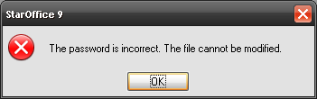Illustration 3: Error dialog

Save Files with Passwords
The File-Save dialog will be kept unchanged. User can check password option. If checked, the user is asked to enter a password when saving the file. The 'Save with password' check box gets disabled, if a filter is chosen that does not support encryption.
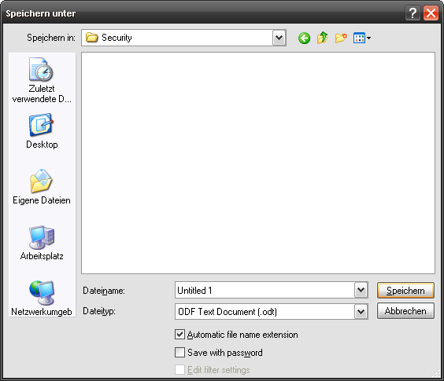Illustration 4: System Save as dialog

Password Dialog
The entered passwords will be checked on pressing OK. See 1.3.2.4 Password Check for details.

Initial State
Dialog shows a notice regarding passwords.
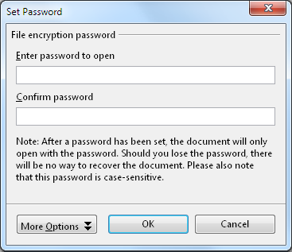Illustration 5: Initial Password dialog
Note: If the current file format does not support password for sharing (i.e. old StarOffice formats) then the 'More Options' button is hidden.

Sharing Options
The Password dialog could be extended by the 'More Options' button. Then the dialog shows an additional password to modify the document.

Initial State
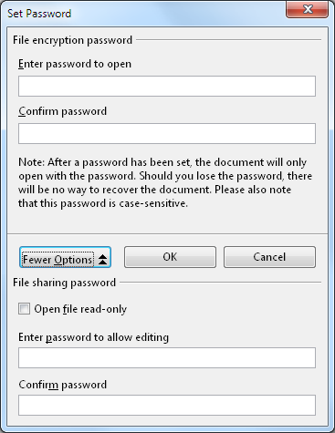Illustration 6: Initial state

File Properties Dialog
The Properties dialog of a document will be extended by a Security tab. For consistency reasons the Digital Signatures dialog gets integrated as another tab page.

Security Tab
The new Security tab will handle the password.
Passwords will be checked on OK. See 1.3.2.4 Password Check for details.
The document gets modified after a password has been set or changed, to ensure that the new password will be saved to file by the user. This is valid for all other settings in the Properties dialog. The encryption and sharing section are disabled, if a filter is chosen that does not support encryption.
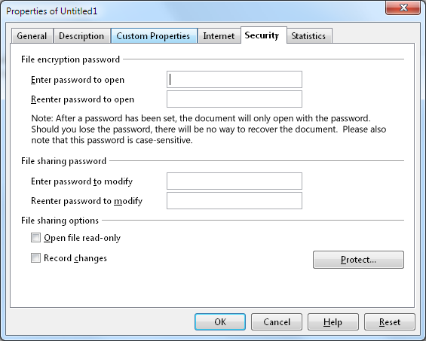Illustration 7: Security tab

Password Check

Wrong Password Confirmation
The following dialog is shown in case one password is wrong. After confirming the dialog, the focus is set to the corresponding ‘Reenter password....’ field and it’s content gets selected. So the user could start typing.
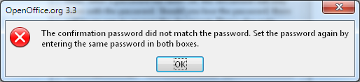Illustration 8: Warning message

Both Password Confirmations Wrong
The following dialog is shown in case of both password are wrong. After confirming the dialog, the focus is set to the ‘Reenter password to open’ field and it’s content gets selected. So the user could start typing.
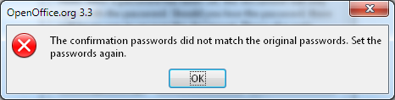Illustration 9: Both passwords have not been confirmed correctly

Options Dialog
The Security tab page of the Options dialog has changed slightly. The document relevant security settings have been migrated to the extended File Properties dialog and ‘web connection’
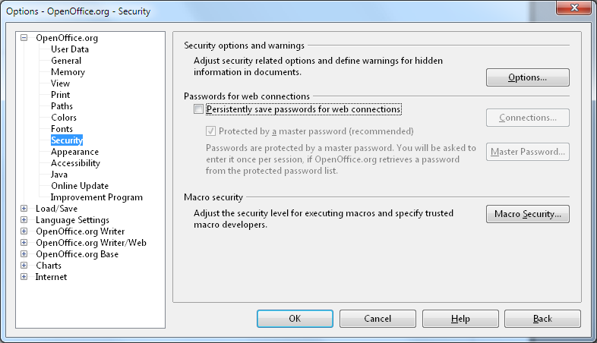Illustration 10: Tools – Options -Security dialog

Accessibility
Accessibility is the responsibility of the I-Team, beginning with UX, DEV and QA, to ensure that the following requirements are fulfilled:
- Is the feature fully keyboard accessible?
(Ex: “I can go everywhere and use every function using the keyboard only”)
Yes
- Have I specified visual alternatives for the case that the specified feature includes audio as output?
n/a
- Are text alternatives for all icons and graphics available?
n/a
- Don't provide important information in colors alone
(Ex: marking important information hard coded in red)
n/a
- Does the specified feature respect system settings for font, size, and color for all windows and user interface elements?
Yes.
- Have I ensured that flash rates do not exceed 2 hertz for blinking text, objects, or other elements? In any case, try to avoid flashing UI elements
Yes.
- Ensure that assistive technology(AT) (like ZoomText or Orca) is able to read everything.
<Start typing here> @Thorsten: One for you.

Migration
None, new feature.

Configuration
None.

File Format
<Start typing here ----- If this part is irrelevant state a reason for its absence!>

Open Issues
Issue | Initials | Date

Document Change History
Rev. | Change | Initials | Date
1 | Initial specification | FL | Feb 01, 2010
2 | Refined mock-ups | FL | Feb 02, 2010
3 | UI Refinements | FL | Feb 04, 2010
4 | Add behavior description | FL | Feb 05, 2010
5 | Recommend to open file read only | FL | March 3, 2010
6 | Change back to simple password check for accessibility reasons | FL | March 5, 2010
7 | New strings from Liz | FL | March 12, 2010
8 | Updated Document Properties – Security dialog. | FL | March 15, 2010

