Software Specification Document

OpenOffice.org Calc
AutoFilter Behavior

Specification Status
Last Change | Sep 26, 2007
Status
Abstract
The AutoFilter function allows to filter data in a spreadsheet by one criteria per column. This feature allows to run a quick analysis of data. The current support of multi column filtering shows some ease of use issues, therefore the AutoFilter list will be overworked with this specification.
i-Team Members
Role | First Name, Last Name, Initials | E-Mail Address
I-Team Lead | Niklas Nebel (NN) | niklas.nebel@sun.com
Specification Author | Frank Loehmann (FL) | frank.loehmann@sun.com
User Experience | Frank Loehmann (FL) | frank.loehmann@sun.com
Development | Thomas Benisch (TBE) | thomas.benisch@sun.com
Quality Assurance | Frank Stecher (FST) | frank.stecher@sun.com
Documentation | Uwe Fischer (UFI) | uwe.fischer@sun.com

Contents
Abstract 1
i-Team Members 1
References and Reference Documents 3
Acronyms and Abbreviations 3
1 Detailed Specification 4
1.1 Calc AutoFilter at a Glance 4
1.2 Auto Filter Drop Down List Box 5
1.3 AutoFilter Behavior Changes 5
1.3.1 Static Part of the Filter List 5
1.3.2 Dynamic Part of the Filter List 5
1.4 Data Pilot: Page Field List Box 6
2 Migration 6
3 Configuration 6
4 File Format 7
5 Open Issues 7
Document Change History 7

References and Reference Documents
Reference Document | Check | Location (URL)
Specification Process Entry Check |  | N/A
Product Requirement, RFE, issue [Required] |  | i27745
Product Concept Document |  | <Please enter location here>
Competitive Analysis |  | <Please enter location here>
IDL Specification |  | <Please enter location here>
Test Case Specification [Required] |  | Test Case Specification
Software Specification Rules | N/A | N/A
<Other, e.g. references to related specs>
Acronyms and Abbreviations
Acronym / Abbreviation | Definition

Detailed Specification
The general AutoFilter behavior keeps untouched. Changes from current implementation are described in the following sections.

Calc AutoFilter at a Glance
An AutoFilter can be applied by calling Data – Filter – AutoFilter from the menu. The cell range for the AutoFilter will be detected automatically if no selection of cells is present. Only one AutoFilter with automatic database range can be defined/applied per spreadsheet, but more than one for defined database ranges. The column headers of the selected or detected cell area will then be extended with a drop down button. A blue drop down button indicates, that a filter criteria has been applied to that column. Data that does not match a filter criteria will be hidden by hiding the row containing that data.
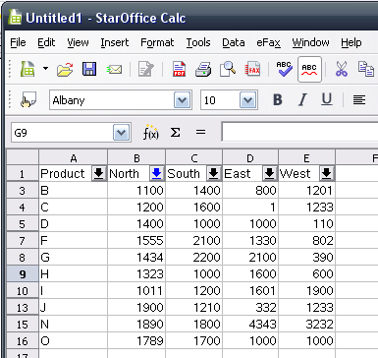Illustration 1: AutoFilter applied – some rows have been hidden

Auto Filter Drop Down List Box
The look of the drop down list box will be changed. See mock-up Illustration 2 and string table in following section for details.
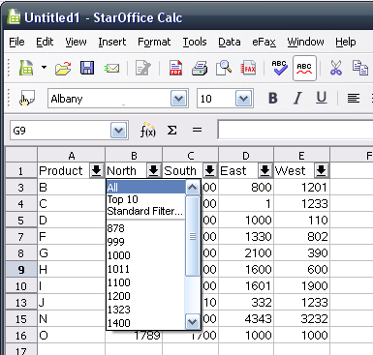Illustration 2: AutoFiler drop down list(box).

AutoFilter Behavior Changes
The AutoFilter list, shown in the drop down list box of an AutoFilter column header, consists of a static part with filter options/predefined filter criteria and a dynamically created part described in the following showing all available values of the current column.

Static Part of the Filter List
The options/predefined filter criteria are shown like described below:
Position | Filter List Entry | Description
1. | All | Clears filter for current column.
2. | Top 10 | - Top Ten -
3. | Standard Filter... | Calls the Standard Filter dialog.
4. | ---------------------------- | Divider

Dynamic Part of the Filter List
The dynamic part lists all visible cell values of the current column. So only values of rows are shown not hidden by a filter in other columns.

Data Pilot: Page Field List Box
The page field list box is related to the AutoFilter list box, but it's current setting is also shown inside the document. Therefore the entry "All" from the AutoFilter is here still called "- all -" to make clear that it is a filter setting. The possible filter values inside the drop down list box are now separated by the same divider used for AutoFilter. See illustration below for details.
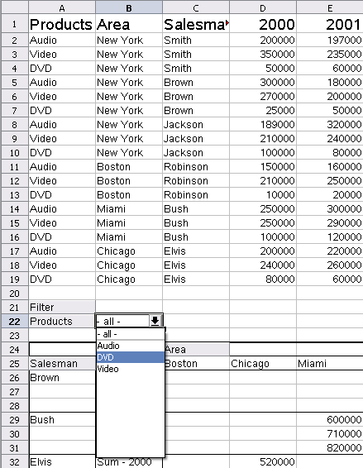Illustration 3: Page Field List Box (see B:22)

Migration
None.

Configuration
None.

File Format
None.

Open Issues
Issue | Initials | Date
None

Document Change History
Rev. | Change | Initials | Date
1 | Initial Spec | FL | July 30, 2007
2 | First Draft | FL | July 31, 2007
3 | Update mock-ups and add Custom Filter dialog | FL | August 01, 2007
4 | Remove tip help and change filter name to Standard Filter | FL | August 02, 2007
5 | Finalization | FL | August 03, 2007
6 | Change UI for Data Pilot List Box (81508) | FL | September 14, 2007
7 | Add link to test case spec | FL | September 18, 2007
8 | Fixed link to test case specification | TBE | September 26, 2007

