Software Specification Document

OpenOffice.org
Context Menus in Calc

Specification Status
Last Change | Oct 9, 2006
Status

Abstract
The context menu for Calc cells contains commands to manage notes. Terminology changes make is easier to insert and delete entire rows and columns.

i-Team Members
Role | First Name, Last Name, Initials | E-Mail Address
Project Lead | Matthias Müller-Prove /MMP | mprove@sun.com
Specification Owner | Matthias Müller-Prove /MMP | mprove@sun.com
User Experience | Matthias Müller-Prove /MMP | mprove@sun.com,
Development | Niklas Nebel /NN | nn@openoffice.org,
Quality Assurance | Frank Stecher /FST | fst@openoffice.org
Documentation | n/a
Other roles
context menus are not documented

Contents
Abstract 1
i-Team Members 1
References and Reference Documents 3
Acronyms and Abbreviations 3
1 Detailed Specification 4
1.1 Context Menu for Cells 4
2 Migration 5
3 Configuration 5
4 File Format 5
5 Open Issues 5
6 Competitive Analysis 6
6.1 MS Excel 2003 6
7 Document Change History 6

References and Reference Documents
Reference Document | Check | Location (URL)
Specification Process Entry Check |  | N/A
Product Requirement,, RFE, issue (required) |  | OOo 2.1: i8101, i47442, i60399^{h}
Product Concept Document |  | See the tasks
Competitive Analysis |  | Competitive Analysis
Test Case Specification (required) |  | Will be attached to issue
Software Specification Rules | N/A | N/A
<Other, e.g. references to related specs>

Acronyms and Abbreviations
Acronym / Abbreviation | Definition
OOo | OpenOffice.org

Detailed Specification

Context Menu for Cells
no note note
Default x x
---------------
Format Cells... x x
---------------
Insert... x x was Insert Cells...
Delete... x x was Delete Cells...
Delete Contents... x x
---------------
Insert Note x x new menu command
Delete Note x
Show Note x new position
---------------
Cut x x
Copy x x
Paste x x
Paste Special... x x
---------------
Selection List... x x

Insert Note is the same command as Insert>Note in the main menu structure. If the cell does not contain a note a new note is created. If the cell already contains a note, then this note is displayed for edit.
Delete Note is enabled for cells with notes. The command deleted the note. If the current selection contains more than one cell then for all selected cells the notes are deleted. The action can be undone.

Table 1: User Interface elements of context menu
# | Type | Properties |  | Comment
<#> |  | Control Properties  Icon: yes, same as in Insert>Note menu item  Enabled: always
<#> |  | String English  Insert ~Note | String German  ~Notiz einfügen
<#> |  | Control Properties  Icon: no  Enabled: if an only if the current collection contains at least one cell with a note
<#> |  | String English  D~elete Note | String German  N~otiz löschen
<#> |  | Control Properties  Icon: yes, same as in Insert>Note menu item  Enabled: always
<#> |  | String English  ~Insert... | String German  Zellen ~einfügen...
<#> |  | Control Properties  Icon: no  Enabled: yes
<#> |  | String English  De~lete... | String German  Zellen ~löschen...
<#> |  | Control Properties  Icon: no  Enabled: yes
<#> |  | String English  Delete C~ontents... | String German  Inhalte lö~schen...
<#> |  | Control Properties  Icon: no  Enabled: if an only if selection contains a cell with a note
<#> |  | String English  Sho~w Note | String German  Notiz ~anzeigen

Context Menu for Charts
Comment: i71560
Illustration 1: Context menu for selected Chart (MMP: 2-Jan-2007)
The menu command “Modify Data Range...” is no longer part of the context menu. The Data Range dialog can be accessed from the context menu once the Chart is active.
Comment: The context menu for active charts is defined in Chart Menu Structure.

Migration
it's just user interface

Configuration
no configuration change

File Format
no file format change

Open Issues
Issue | Initials | Date
i60399 | MMP | Aug 31, 2006

Competitive Analysis

MS Excel 2003
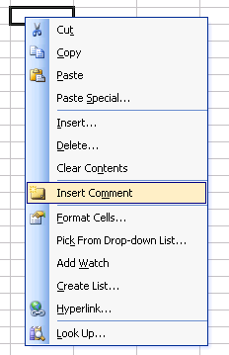Illustration 2: Context menu for empty cell
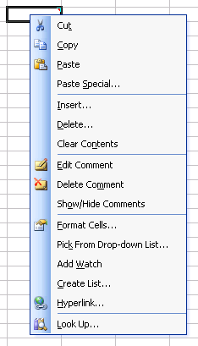Illustration 3: Context menu for cell with comment

Document Change History
Rev. | Change | Initials | Date
1 | new specification | MMP | Aug 31, 2006
2 | add “Delete Notes” command to context menu (row 48)  rename Delete Cells / Delete Contents commands according to i60399 | MMP | Sep 1, 2006
3 | Provide mnemonics  ”Delete Contents...” stay unchanged; we do not adopt MS's terminology “Clear Contents”  Spec is ready for implementation. | MMP | Sep 28, 2006
4 | This spec is “standard” for OOo 2.1  CWS is SRC680/notecontext | MMP | Oct 9, 2006
5 | Context menu for selected Charts | MMP | Jan 2, 2007

