Software Specification Document

OpenOffice.org
Options for Pie chart

Specification Status
Last Change | Feb 12, 2008
Status
Abstract
Two new options are available for pie and donut charts: starting angle and clockwise direction.
i-Team Members
Role | First Name, Last Name, Initials | E-Mail Address
I-Team Lead | Ingrid Halama (IHA) | iha@openoffice.org
Specification Author | Wei Zhao | weiz@office.org
User Experience | Christian Jansen | cj@openoffice.org
User Experience | Matthias Müller-Prove (MMP) | mmp@openoffice.org
Development | Wei Zhao | weiz@office.org
Development | Ingrid Halama (IHA) | iha@openoffice.org
Quality Assurance | Thomas Klarhöfer (TK) | kla@openoffice.org
Quality Assurance | Joerg Sievers (JSI) | jsi@openoffice.org
Documentation | Uwe Fischer (UFI) | ufi@openoffice.org

Contents
Abstract 1
i-Team Members 1
References and Reference Documents 3
Acronyms and Abbreviations 3
1 Detailed Specification 4
1.1 Starting angle 5
1.2 Clockwise direction 5
2 Migration 6
3 Configuration 6
4 File Format 6
5 Open Issues 6
Document Change History 7

References and Reference Documents
Reference Document | Check | Location (URL)
Specification Process Entry Check |  | N/A
Product Requirement, RFE, issue [Required] |  | 16776, 37823
Product Concept Document
Competitive Analysis
IDL Specification
Test Case Specification [Required] |  | http://www.openoffice.org/nonav/issues/showattachment.cgi/51479/TCS_Pie_rotation_direction.htm
Software Specification Rules | N/A | N/A
Acronyms and Abbreviations
Acronym / Abbreviation | Definition

Detailed Specification
There are two options available for pie and donut charts only. The dialog in which those settings can be made is shown here. This is the tab-page “Options” of the object properties dialog of a data series with chart type “pie chart”. The options are offered for all kinds of pie charts.
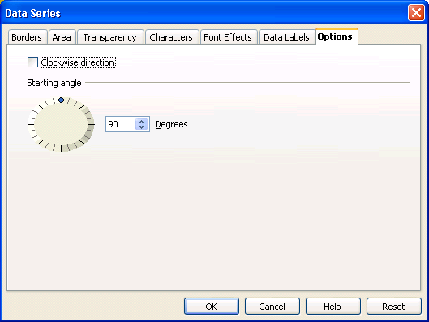
Figure 1: Options Tab Page for a data series of a pie chart

- “Options” - Tab Page Properties |  | Comment
Titel: | Options |  | EN-US
Titel: |  |  | DE

- “Clockwise” - CheckBox Properties |  | Comment
Enabled: | Always
Tri-State: | No
Checked: | When the direction of the pie chart is clockwise.
Other: | Default is not checked
CheckBox Label: | ~Clockwise direction |  | EN-US
CheckBox Label: |  |  | DE

- “Starting angle” - Fixed Line Properties |  | Comment
Label: | Starting angle |  | EN-US
Label: |  |  | DE

- “” - SpinField Properties |  | Comment
Enabled: | Always
Min. Value: | 0
Max. Value: | 359
Start Value: | Default is 90 degrees
Steps: | 5
Measurement Unit:
Other: | The spin field is connected with a standard dial control.
SpinField Label: |  |  | EN-US
SpinField Label: |  |  | DE

- “Degrees” - Label Properties |  | Comment
Label: | ~Degrees |  | EN-US
Label: |  |  | DE

Starting angle
The starting angle can have a value between 0 and 359. The value denotes the mathematical angle position. Thus having a value of 90 degrees the first piece of a pie starts at 12 o'clock (see figure 2).
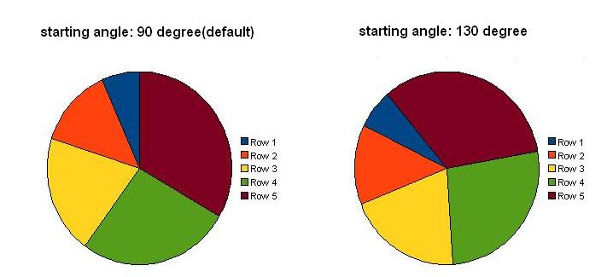
Figure 2: The effect of different settings for "starting angle"

Clockwise direction
The default direction in which the pieces of a pie chart are ordered is counterclockwise. Click the checkbox "clockwise direction" to draw the pieces in opposite direction (see figure 3 for examples).
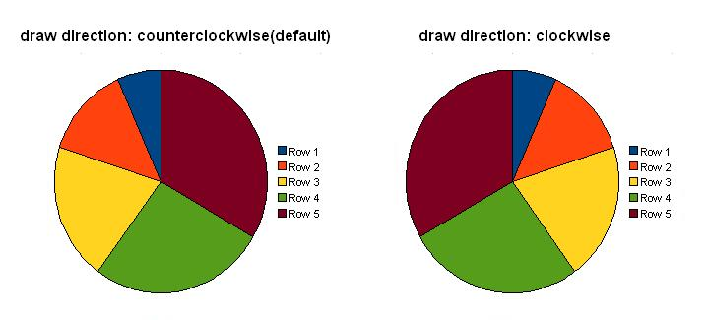
Figure 3: The effect of clockwise direction

Migration
In versions former to OOo 3.0 3D pie and donut charts where presented with an effective starting angle of 0 instead of 90 degrees ( what is the correct file format default ). Those documents are treated on import thus an starting angle of zero is set to those charts.

Configuration
Nothing needed here.

File Format
The value from spin field #1 is stored in an attribute “chart:angle-offset” at the auto style at a chart:plot-area element.
The value for checkbox #2 is stored in an attribute “chart:reverse-direction” at the auto style at the chart:axiselement for the y axis (that one with attribute chart:dimension="y"). When the check box is checked the value is "true" else "false".

Open Issues
Issue | Initials | Date
<State Issue here, State “None”, if all issues are solved> |  | <Format: Dec 31, 2000>
<...>

Document Change History
Rev. | Change | Initials | Date
1 | Created this document and added contents | Weiz | 2007-12-28
2 | Changed control layout, some wordings and formatting, added measurement unit, added file format description | IHA | Jan 8, 2008
3 | Changed layout and introduced dial control for starting angle | IHA | Jan 10, 2008
4 | Added link to test case spec + set to standard | IHA | Feb 12, 2008

