Software Specification Document

OpenOffice.org / StarOffice Writer
Simplify Insertion of Headers and Footers

Specification Status
Last Change | 04. April 2006
Status
Abstract
Usability tests showed, that the insertion of headers and footers in Writer is not understood by users. The feature as present in OOo 2.0 Insert menu is too complex. This specification defines a new behavior with reduced functionality for the menu. Overall capabilities of OOo Writer will not change.
i-Team Members
Role | First Name, Last Name, Initials | E-Mail Address
Project Lead | Frank, Loehmann (FL) | frank.loehmann@sun.com
Specification Owner | Frank, Loehmann (FL) | frank.loehmann@sun.com
User Experience | Frank, Loehmann (FL) | frank.loehmann@sun.com
Development | Oliver, Specht (OS) | oliver.specht@sun.com
Quality Assurance | Éric, Savary (ES) | eric.savary@sun.com
Documentation | Uwe, Fischer (UFI) | uwe.fischer@sun.com

Contents
Abstract 1
i-Team Members 1
References and Reference Documents 3
Acronyms and Abbreviations 3
1 Detailed Specification 4
1.1 Insert Menu in OOo 2.0.2 4
1.1.1 Insert - Header 4
1.1.2 Insert - Footer 5
1.2 New Simplified Insert Menu Entries 5
2 Migration 6
3 Configuration 6
4 File Format 6
5 Open Issues 6
Document Change History 6

References and Reference Documents
Reference Document | Check | Location (URL)
Specification Process Entry Check |  | N/A
Product Requirement,, RFE, issue (required) |  | i60426
Product Concept Document |  | <Please enter location here>
Competitive Analysis |  | <Please enter location here>
Test Case Specification (required) |  | <Please enter location here>
Software Specification Rules | N/A | N/A
<Other, e.g. references to related specs>

Acronyms and Abbreviations
Acronym / Abbreviation | Definition
Header | Recurring place at the top of a page which is assigned to a page style in Writer.
Footer | Recurring place at the bottom of a page which is assigned to a page style in Writer.

Detailed Specification

Insert Menu in OOo 2.0.2
The Insert menu of Writer has two separate entries for insertion of Headers and Footers. These entries have a submenu. This submenu shows the currently used page styles and a check mark indicating whether it is activated. Usability test showed that especially the "Default" entry unsettles the users, because they just want to turn on the header or footer. Those headers and footers are defined in the corresponding page style - "Default" in this case.

Insert - Header
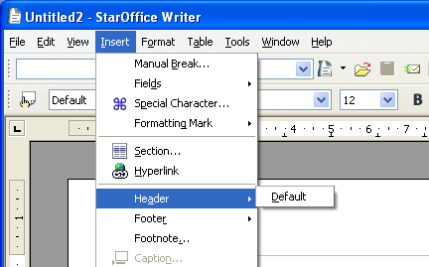Illustration 1: Insert menu in Writer: Header with submenu entry for an empty document
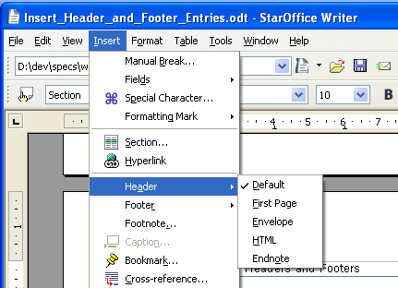Illustration 2: Insert menu in Writer: Header with submenu entry for a specification document

Insert - Footer
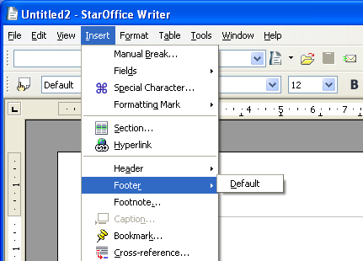Illustration 3: Insert menu in Writer: Footer with submenu entry for an empty document
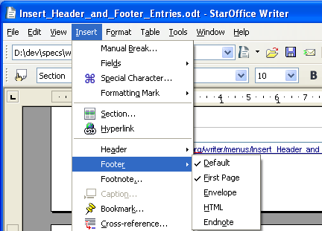Illustration 4: Insert menu in Writer: Footer with submenu entry for a specification document

New Simplified Insert Menu Entries
The new Header and Footer menu entries just turn on/off the header/footer for the page style of the current page. The current page is determined by the current cursor position. If a header/footer is turned on, the corresponding menu entry is checked like shown in Illustration 6 below.
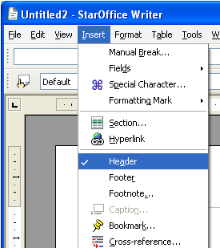Illustration 5: On state for header of current page
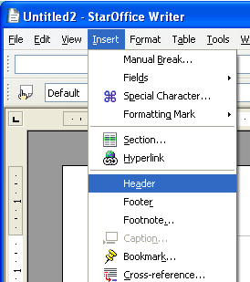Illustration 6: Off state for header of current page
Note: Footer menu entry behaves like the Header entry shown above.

Migration
Usability tests showed, that the insertion of headers and footers in Writer is not understood by users. The feature as present in OOo 2.0 Insert menu is too complex. This specification defines a new behavior with reduced functionality for the menu. Overall capabilities of OOo Writer will not change.

Configuration
<Start typing here ----- If this part is irrelevant state a reason for its absence!>

File Format
<Start typing here ----- If this part is irrelevant state a reason for its absence!>

Open Issues
Issue | Initials | Date
<State Issue here, State “None”, if all issues are solved> |  | <Format: Dec 31, 2000>
<...>

Document Change History
Rev. | Change | Initials | Date
1 | 1. Draft of document | FL | April 03, 2006
2 | Work on comments from UFI + finialization | FL | April 04. 2006
3

