Dialog Specification and Guidelines - Visual Design | Version 1.6
Christian Jansen , September 2001, Sun Microsystems

Content
Introduction 2
Layout 2
Size 2
Spacing and Positioning 2
Translation 5
Tooling improvements 6
Toolbars 7
Dock / Undock functionality 7
Toolbars Elements 8
Customizing Toolbars 9
Toolbar Icons 10
General 10
Cultural Impact 11
Icon Size 11
Icon Feedback 11
Common Toolbar Buttons 12
General Guidelines for Toolbar Icons 13
Guidelines for 16 Color Toolbar Icons 13
Guidelines for 256 Color Toolbar Icons 13
Guidelines for 32 bit Toolbar Icons 13
Menues 14
Menu Titles 14
Menu Parts 14
Item Groups in Menues 14

Introduction
Due to the new (Figure 1) definition of the standard tabbed dialog there is a need to define some visual guidelines for successfully complete layout.
The units which are used in this guideline are Map AppFont (ma) and Pixel (px). Map AppFont units are device and resolution independent. One Map AppFont unit is equal to one-eighth of the average character (Systemfont) height and a quart in width.

In the first draft, the dimension are only in pixels the will be replaced in the next version. The screen samples
were made on a system with a resolution of 1280 x 1024 at 96 dpi.
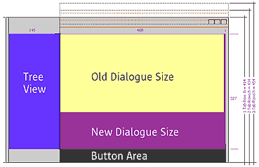Figure 1 shows the new size for a tabbed dialog.

Layout
One of the most critical area in visual design is to create a visually consistence in spacing, size, alignment etc. From the structural side (for western countries) the information should be provided as follows:
The most important information should be located in the upper left area.
After this content follows from left to right and top to the bottom.

Size
The following table lists the typical dimensions of common control which are used in StarOffice.

Control | Height | Width
Command Buttons | 14 | 50
Check Boxes | 8 | As wide as needed
Radio Buttons | 8 | As wide as needed
Drop down, combo and drop down list boxes | 12 | Size match other drop downs etc
Text boxes | 12 | As wide as needed
Text labels | 8 | As wide as needed
Other text | 8 | As wide as needed

Spacing and Positioning
Alignment is very important for a good dialog design. Try to create a consistent and clear layout. Use the dialog spaces shown in figure 2 and 3.

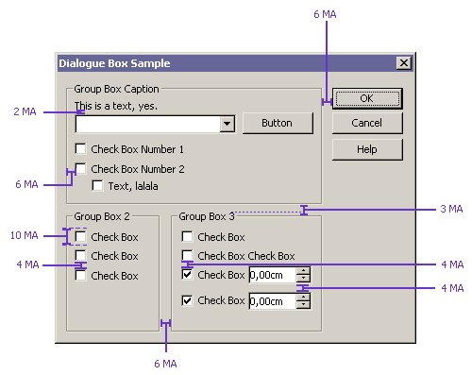Figure 2 Map Appfont spaces between dialog items.
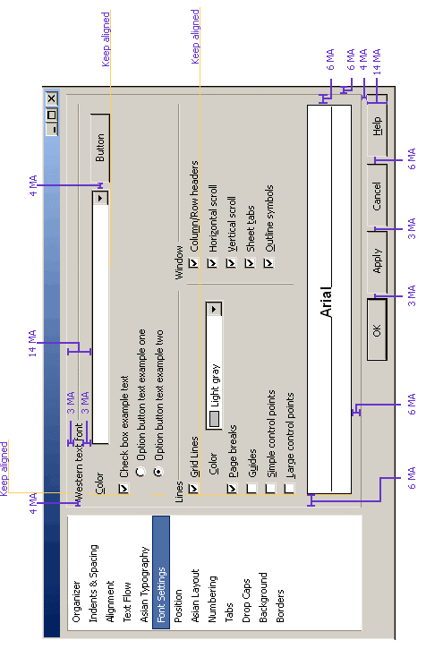 Figure 3 Map Appfont spaces between dialog items.
The following table list the recommended spacing between common dialog items.

Dialog item | Space between (MA)
Dialog Box Margins (Vertical) | 6
Dialog Box Margins (Horizontal) | 3
Fixed line Margins Vertical | 6
Between text paragraphs | 7
Between text label and their control for (example text beneath a list box) | 3
Between related controls | 4
Between unrelated controls | 7
First control in a group box or under a fixed line | 3
Between controls in a group box | 4  If a group box is used align vertical to the group box title
From the left edge to a group box / fixed line | 6
From the left edge to a preview | 6
Content: From the right edge of a group box / fixed line | 6
Content: From the top edge of a group box / fixed line | 3/6
Content: Above the bottom edge of a group box | 6
Text | 8

Translation
Translations from English to other languages can affect the size of the dialog for example:

- Increase the length of the text in the user interface.
- It can affect the layout of the controls.

To handle the text expansion it makes sense to allow approximately 30 percent or more space than for the English version (figure 4).

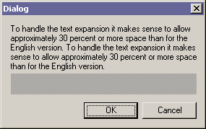Figure 4 A dialog with enough
space for translation.
If text is or must placed in front of controls like list boxes or text boxes leave enough space between the text and control item. In my opinion it looks better if the the text beneath the control is placed over the related control, because it cold not effect to large spaces in between (figure).
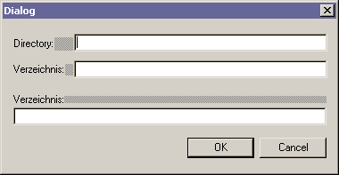Figure 5 The first two examples allow not enough
space for translation.

If a longer explanation above controls is needed, the text should be split into an information part and a header for the related control (figure 5)
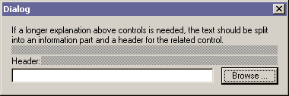Figure 6 For longer explanations split into two parts.
Tip:
To control the current text expansion space it is possible to enable in a NON Product Version, by pressing CTRL – SHIFT – D. The VCL Debug dialog will appear and several settings can be set. To enable the highlighting of the text expansion space check the “Dialog” entry in the “Test options” Group box. After enabling this feature Dialogs will be shown like in the screen shot below.0
Figure 6 A dialog with label
space visualization enabled.

Tooling improvements
To improve the translation process it would be helpful to add a flag for identifying the type of text / label /control. It would make the translation of the product much better, because the Translation could identify the of needed translation. For example:
Save as is written in the File menu 'Save As' but in the save dialog which appears after clicking on the menu item, the caption bar has the heading 'Save as' written with a small a in as.

Toolbars
The intended purpose of toolbars is that they proved a strong visual access to items like things on a desk.
The toolbars should provide a easy to use and self explaining user interface and item.
Toolbar items are accessible via mouse, in addition they should provide access via keyboard shortcuts.

Toolbar items must always provide a ToolTip

Toolbars should provide a flexible and configurable or customizable interface. If this is given the user could create his own world to solve his tasks.

Toolbars Elements
Each toolbar includes a grip handle to arrange the toolbar. A toolbar could contain the following items
listed below.

- Icons
- Text
- Icons & Text combinations
- Icons with drop down function
- Buttons
- Controls like Combo Boxes
- Grip Handles
- Separators
- Drop downs for toolbar configuration

Dock / Undock functionality
To enable an easy to use undock functionality for toolbars, a toolbar grip handle on the left end of the toolbar. If the use wants to move the toolbar he could drag it easily by pressing the left mouse button and drag over the grip handle of the toolbar.
If the new location is within the hot zone of an other toolbar edge, the toolbar should be docked at the edge when the user releases the mouse button. Otherwise if the new location is not within the hot zone of a edge the toolbar should be displayed as palette window.

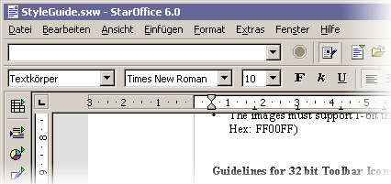Figure 7 StarOffice 6.0 Toolbars
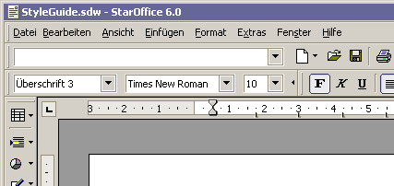Figure 8 Toolsbars with toolbar grip handle
While moving the toolbar a visual feedback should be given (Figure 9). If the user moves the toolbar into a hot zone of a docking location only the outline of the bar should be visualized. While moving over non docking are like the document area for example change the outline into a bolder dotted line to visualize a modification.
Providing support for toolbar location change makes it necessary to preserve the current position and size.

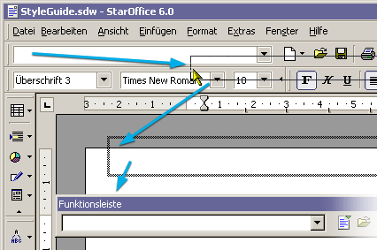Figure 9 Toolbar move by a pointer

Undocked Toolbars
Undocked toolbars or “Utility Windows” are needed to provide context sensitive tools.
E.G: The user inserts a picture into a text document. After inserting the picture an undocked toolbar appears with an optimal set of items (Figure 10).

Undocked Toolbars provide the same feature set like standard toolbars.
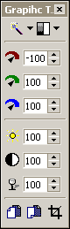
Figure 10 One toolbar first in horizontal view and than flipped by 90 dregree

Customizing Toolbars
A toolbar band (figure 10) could be collapsed or expanded by clicking with the mouse pointer on the triangle located on the right end of the toolbar group. Clicking on the triangle provides a collapse of the toolbar group by one group of items (a group is defined by items between two separators).

Figure 11 A toolbar band with three toolbar groups.
After a part of the toolbar is hidden the separators between two groups changes to a control which enables the user to collapse the left group or expand the currently hidden group (figure 11).

Figure 12 Toolbar with a hidden group.
To expand or collapse groups it is even possible to go via context menu provided by the toolbar bands. This menu is stays visible the hole time of editing the state of the items. The menu will be closed after clicking out side the menu location.

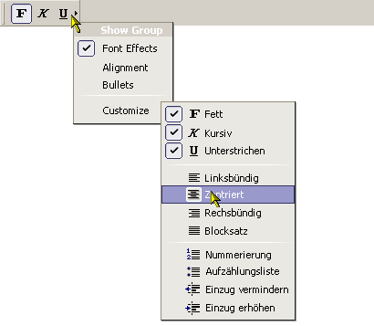Figure 13 Toolbar with context menu

Toolbar Icons

General
Icons should provide people easily access to items. Like tools on a desk, for example pens, rules a rubber gum and so on. One of the most important things is consistency in design of these images. They should be in scale, orientation and color consistent. The icons must fit homogeny into its environment (Figure7).

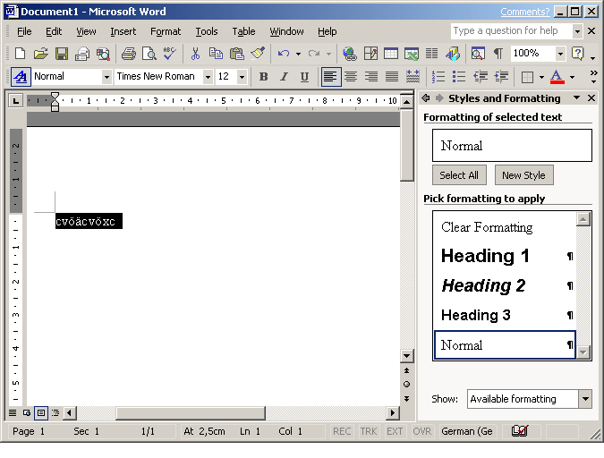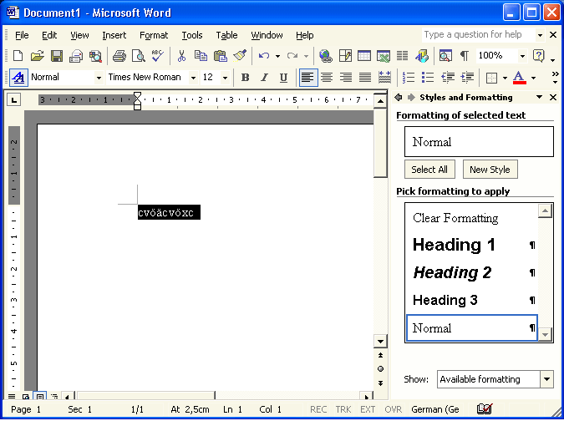Figure 14 One Program two different environments

Each icon should be easily and quickly distinguishable from the other item in the toolbar.
In addition they have to provide a sufficient contrast in the image to ensure that different parts could easily identify the elements. In this context icons should not match in similarity with common controls.

Cultural Impact
Cultural impacts should always considered in icon design. Critical icons should reviewed as early as possible in the development cycle of StarOffice. The problem is that metaphors, symbols or simple image may not have the same meaning around the world. Also the use of letters and words should be avoid whenever possible.

Icon Size
Currently StarOffice uses the size 16 pixels by 15 pixels (width by height) and 26 px by 25 px, for the large ones. These formats should changed to a new format. I would recommend 16 by 16 for the small ones and 32 by 32 for the large. The the large ones should provide a transparent border, with a minimum of 3 pixels to each side.

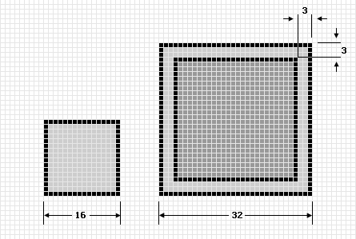Figure 15 StarOffice icon size

Icon Feedback

Currently the enabled items in the toolbars are sometimes hard to identify (Figure 9). A flat rectangular in prominent color and a filled area (same color like the border only with 90% transparency) helps a lot to identify the enabled items (Figure 11). To support a better tracking feedback when the mouse pointer is over the toolbar item a highlight area with a border and a drop shadow for the image. Provides a great feedback. Compare Figure 10 & 12 for this. In addition the hot (mouse over) state should have a slightly increased saturation.

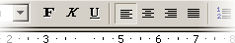Figure 16 StarOffice 6.0 Toolbar  with a enabled item. | 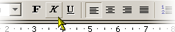Figure 17 StarOffice 6.0  Toolbar with hot (mouse over) item.
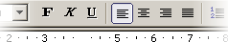Figure 18 Proposal of an  enabled toolbar item. | 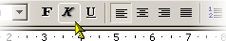Figure 19 Proposal of a  new mouse over feedback.

Common Toolbar Buttons

Consistent use of common tool images allows the user a better transfer of learning and skills from product to product. These images may only be used like in the table below.

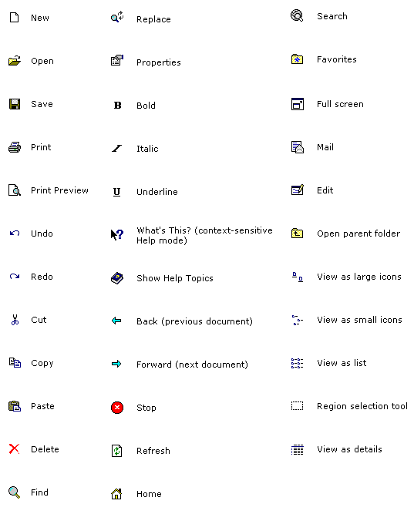Figure 20 List of standard ool bar images

General Guidelines for Toolbar Icons
- Use as many common toolbar images as possible
- Use the same hue and color saturation.

Guidelines for 16 Color Toolbar Icons
- The Windows 16 color palette must be used .
- The images shell flat in appearance may be with little dimension or shading.
- The images must support 1-bit transparency. The recommended color is Magenta (R: 255 G:0 B: 255, Hex: FF00FF)

Guidelines for 256 Color Toolbar Icons
- The Windows halftone palette must be used.
- Image should be more dimensional. The light source should be placed in the upper left. Shade if needed and/or appropriate.
- The images must support 1-bit transparency. The recommended color is Magenta (R: 255 G:0 B: 255, Hex: FF00FF)

Guidelines for 32 bit Toolbar Icons
- The images are 24bit in color depth with an 8bit alpha channel. This allows images with smoothed edges which could blend to every kind of background. (BMP/DIB and 24-bit with Alpha )
- Image should be more dimensional. The light source should be placed in the upper left. Shade if needed and/or appropriate.

Menues
Menus are lists of items, commands, attributes or states from which the user could choose from. Menus are based on the interface principle of “see and point”. The most important advantage of menus is that: People do not have to remember command or visual items, because they could choose from a list of available option at any time they want.

Menu Titles
Menu titles should be one word that describes easily the expected items.

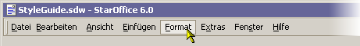Figure 21 The menu bar

Menu Parts

The parts of a menu are a title, items, separators, submenu indicators, keyboard accelerators and if needed a icon in front of the item.

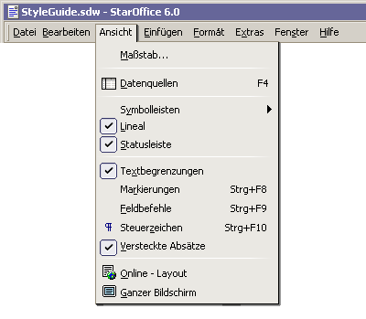

Item Groups in Menues

On of the most important aspect of adding items into menus is to group the items logically.
In general the most important or frequently used item should be the first item of a group or the menu.
how many separators are used in a menu is a aesthetic and only partly a usability decision.
But in general too many separators are confusing and make reading more difficult.

