System-Settings
OpenOffice.org 2.0

Document - ID | Specification Owner | Last Change | Status
 | Oliver Braun | 2007-04-06 | Standard
Conforms to | N/a
Applies to | all modules
Task ID(s) | i20364, i20369, i33580, i63557, i67985, i70478, i74947
Category | Feature

Abstract
One of the most annoying tasks for a user is if he has to enter common application settings into every application over and over again. Most desktop environments have a notion of shared application settings, so being a good citizen for OpenOffice.org 2.0 means here to read and honor settings the user has made in his/her desktop environment.

i-Team Members (The specification owner is part of the i-Team)
 | Name | E-mail Address
User Experience | Falko Tesch (FT)  Frank Loehmann (FL) | ft@openoffice.org  fl@openoffice.org
Development | Oliver Braun (OBR)  Éric Bischoff (EB) | obr@openoffice.org, ebischoff@openoffice.org
Quality Assurance | Thorsten Martens (TM) | tm@openoffice.org
Documentation | Uwe Fischer (UFI) | ufi@openoffice.org

Approved for Implementation
 | Approved by | Date
User Experience | Falko Tesch (FT)  Frank Loehmann (FL) | 2004-08-30  2006-04-12
Development | Oliver Braun (OBR)  Éric Bischoff (EB) | 2004-08-30  2005-04-12
Quality Assurance | Thorsten Martens (TM) | 2004-08-31  2006-04-25
Documentation | Uwe Fischer (UFI) | 2004-08-31  2006-04-12
String Review | Falko Tesch (FT) | 2004-09-02

Document Change History
Rev. Level | Change | Initials | Date
1.0 | Initial draft | OBR | 2004-08-10
1.99 | Final release | OBR/FT | 2004-09-02
1.100 | Add migration task id | OBR | 2004-09-03
2.0 | Second draft (KDE integration) | EB | 2006-03-27
2.1 | Added description for documents directory and AT tool support | OBR | 2006-04-10
2.2 | New functionality added (html and basic source fonts) | OBR | 2006-10-16
2.3 | Added system proxy configuration on Mac OS X | PJANIK | 2007-03-04

Contents
Glossary 1
1 Motivation 1
2 User Scenarios 1
2.1 Consistent behavior of all applications 1
2.2 Network environment profiles 1
3 Goals 1
4 Requirements and Dependencies 1
4.1 Requirements 1
4.2 Technical Dependencies 2
5 Competitive Analysis 2
6 Detailed Specification 2
6.1 Proxy settings (Windows/GNOME/KDE, Mac OS X) 2
6.2 Preferred email client (GNOME/KDE only) 3
6.3 Default document directory 4
6.4 Support for assistive technologies (GNOME + KDE) 4
6.5 Font settings for HTML and Basic sources (GNOME + KDE) 5
6.6 G11n 6
6.7 Error Conditions 6
6.8 Migration 6
7 Future Tasks 6
8 Notes 7
9 References 7

Glossary
Term | Description
GNOME | See http://www.gnome.org for more details
KDE | See http://www.kde.org for more details
MAPI | http://en.wikipedia.org/wiki/MAPI
Assistive technology (AT) tools | http://en.wikipedia.org/wiki/Assistive_technology

Motivation
To reduce the bad user experience of a “Error ..., please check your configuration” message for settings that could be read from the system.

User Scenarios

Consistent behavior of all applications
If a user switches his/her preferred email client, applications not following this switch occur broken except the user has set different manual settings in this application. However, reading the system setting is the expected default.

Network environment profiles
Some desktop environments support network environment profiles, which allow the user to switch between different Internet connection types and proxy settings very easily.

Goals
The goal is to provide an extensible framework to read desktop specific user settings:
- Proxy settings (Windows/GNOME/KDE, Mac OS X)
- Preferred email client (GNOME/KDE only)
- Location of the “Documents” folder
- Enable support for assistive technology tools (screen reader / magnifier etc.)
- Font settings for HTML and Basic sources (GNOME/KDE only)

Requirements and Dependencies

Requirements
The functionality of providing a system default for a setting can only be supported in desktop environments, which have a notion of a “default” for this particular setting.

Technical Dependencies
This feature currently applies to OpenOffice.org 2.0 running under Unix (GNOME or KDE, Mac OS X) or Windows.

Competitive Analysis
MS Office does not have any user interface to specify a proxy server or mail client, it always uses the Windows system defaults as defined by Internet Explorer and the Windows Messaging API (MAPI).

Detailed Specification
When running OpenOffice.org, each group of settings is read from the system as late as possible. However, as soon as they are read, they wont get updated until OpenOffice.org gets re-started, unless support for “on the fly” changes for a setting is explicitly mentioned in the detailed description below.

Proxy settings (Windows/GNOME/KDE, Mac OS X)

New Option (default)
In OpenOffice.org 2.0 under “Tools – Options – Internet - Proxy” a new entry will be introduced in the “Proxy server” drop-down list-box: System
This entry is available and selected by default when OpenOffice.org is running in GNOME, KDE, Windows desktop environment or Mac OS X, but disabled and hidden otherwise.
Any change to the “Proxy server” setting by the user will result in a permanent, different setting.
The new entry “System” causes all other proxy related settings to be read from the system and displayed as read-only in the corresponding edit fields, providing feedback to the user on which settings are actually in use.
Figure 6.1 New menu entry "system"

String list
Item | English | German | Comments
List box Item | System | System

Manual Settings
If the user formerly has chosen different manual entries and changes to “System” setting the old values must not be overwritten but stored in the configuration data. This way the user can easily reverse the setting by simply changing back from “System” to “Manual”. In this case the last stored data fro the setting “Manual” will be reverted.

Migration Issues
In case the user installs OpenOffice.org 2.0 with the migration option from an existing OpenOffice.org 1.x (which has no “System” setting) the appropriate setting/values (“Manual” w/ user settings or “None”) will be used instead of the new default “System”.

Transfer of Configuration Settings
In case the configuration settings from an OpenOffice.org 2.0 running under GNOME or KDE, Windows or Mac OS X is transferred to an installation running under a different system OpenOffice.org 2.0 will fall back the following way:
- Check for any entries made in “Manual” mode and install them as the new default if available.
- If the above does not apply use “None” as the new default.
In the reverse case OpenOffice.org 2.0 will always fall back to the new default “System”.

Preferred email client (GNOME/KDE only)
Starting with release 2.4, GNOME users are able to specify an email client in their “Preferred Applications” preferences. KDE has a similar setting in “KDE components” section.
OpenOffice.org 2.0 uses the specified value as the default for the “Tools – Options – Internet – Email” setting.
Note: this setting is not available on Windows. OpenOffice.org uses the default MAPI client (see [1] ).
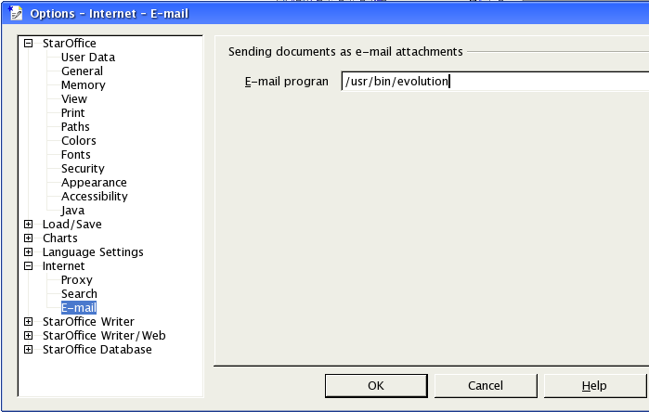Figure 6.2 E-Mail tab setting w/ default entry read from GNOME configuration
Tab Order
n/a
Key Board Shortcuts
n/a

Default document directory
The directory OpenOffice.org uses as a starting point for the file open/save dialogs can be configured in Tools – Options – OpenOffice.org – Paths – My Documents.
On Windows this settings defaults to the users “My Document” directory, which usually is located at C:\Documents and Settings\<login>.
On Unix/GNOME and Unix/KDE the default for this setting is ~/Documents if it exists and ~ (the users home directory) otherwise.

Support for assistive technologies (GNOME + KDE)
On Unix this setting is intended for internal use only. Possible values are “true” and “false”. If the value is “true”, certain optimizations in OpenOffice.org (e.g. dynamically filled menus) are turned off to meet the requirements of assistive technology tools.

Font settings for HTML and Basic sources (GNOME + KDE)
The default font setting for the OpenOffice.org HTML and Basic source editor dynamically gets overwritten by what is set in the user's desktop environment. The user is still able to chose a different font and size under Tools=>Options=>OpenOffice.org=>Fonts.
The GNOME “Font Preferences” panel in JDS 3 can be found at Preferences=>Desktop Preferences=>Display=>Fonts.

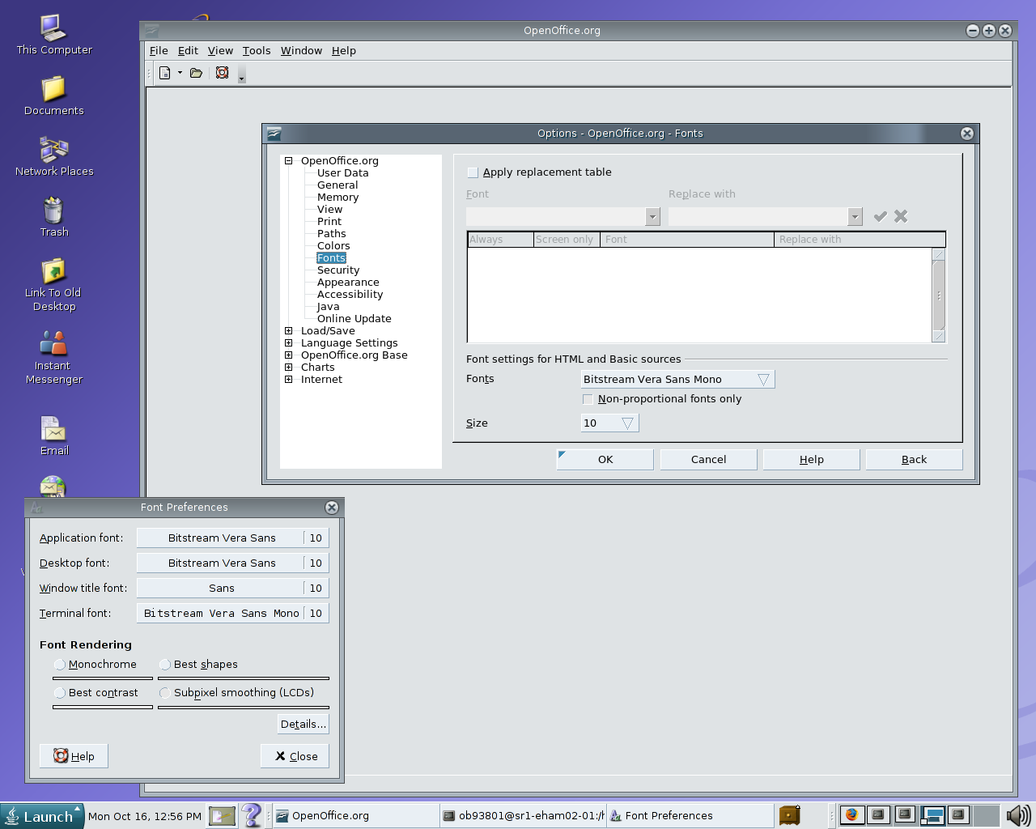Figure 6.3.: GNOME Fonts Preferences panel and OpenOffice.org Font Options
In KDE, the setting taken as the new default setting is Control Center => Appearance & Themes => Fonts => Fixed width:

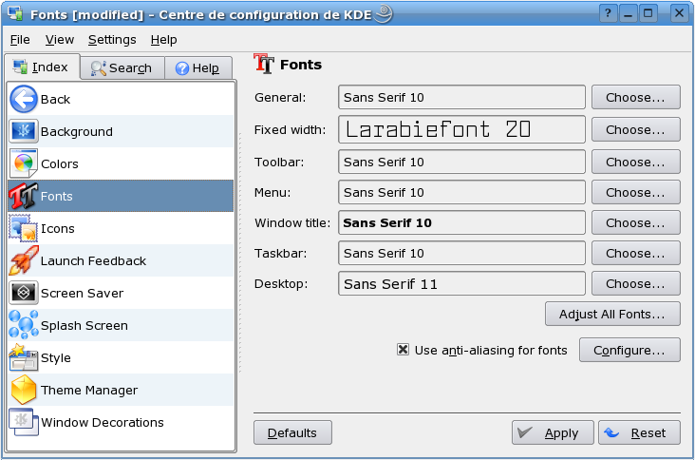Figure 6.4.: KDE Font Preferences Panel

G11n
N/a

Error Conditions
N/a

Migration
See “Transfer of Configuration Settings” at 6.1 Proxy settings (Windows/GNOME/KDE, Mac OS X) section. The migration task is covered by issue #33580#.

Future Tasks
In future releases an integration in other systems is advisable.
Also dynamic updates from the GNOME, KDE or Mac OS X settings should be possible.
System-wide settings could be extended to other information (User's name and email address, for example).

Notes
none

References
[1] Send Document As Email http://specs.openoffice.org/appwide/desktop_integration/send_as_email.sxw

