Software Specification Document

OpenOffice.Org Draw/Impress
HTML Export

Specification Status
Last Change | Jun 27, 2007
Status
Abstract
Documents the HTML Export functionality including the HTML Wizard in OOo Draw & Impress.

i-Team Members
Role | First Name, Last Name, Initials | E-Mail Address
I-Team Lead | Christian Lippka (cl) | Christian.Lippka@sun.com
Specification Author | Christian Lippka (cl) | Christian.Lippka@sun.com
User Experience | Matthias Mueller-Prove (mmp) | Matthias.Mueller-Prove@Sun.COM
Development | Christian Lippka (cl) | Christian.Lippka@sun.com
Quality Assurance | Christian Guenther (cgu) | Christian.Guenther@Sun.COM
Documentation | Uwe Fischer | Uwe.Fischer@sun.com
Other roles | <First Name, Last Name (Initials)> | <User@openoffice.org>
<State reason here, if one role is not represented in i-Team.>

Contents
Abstract 1
i-Team Members 1
References and Reference Documents 3
Acronyms and Abbreviations 4
1 Detailed Specification 5
2 Migration 7
3 Configuration 7
4 File Format 8
5 Open Issues 8
Document Change History 8

References and Reference Documents
Reference Document | Check | Location (URL)
Specification Process Entry Check |  | N/A
Product Requirement, RFE, issue [Required] |  | <Please enter location here>
Product Concept Document |  | <Please enter location here>
Competitive Analysis |  | <Please enter location here>
IDL Specification |  | <Please enter location here>
Test Case Specification [Required] |  | http://www.openoffice.org/nonav/issues/showattachment.cgi/46304/export_html.htm
Software Specification Rules | N/A | N/A
<Other, e.g. references to related specs>
Acronyms and Abbreviations
Acronym / Abbreviation | Definition
<WYSIWYG> | <What You See Is What You Get>

Detailed Specification
This specification should document the behavior of the HTML export feature in Draw and Impress, including the HTML Wizard for Draw and Impress. Currently this only specifies the addition of PNG to the possible graphic formats for the slides.
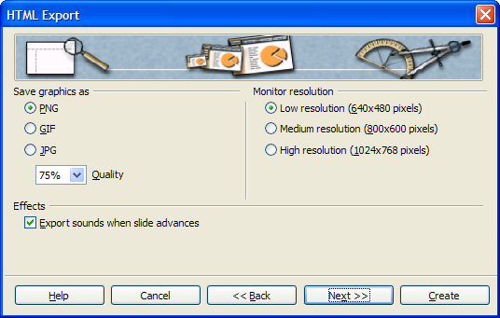Figure 1: A mock-up of page 5 of the Draw and Impress HTML Wizard
- “HTML Export” - Dialog OR Window Properties |  | Comment
State: | Modal
Type: | Dialog
Closable: | Yes
Resizable: | No
Other:
Titel: | HTML Export |  | EN-US

- “PNG” - RadioButton Properties |  | Comment
Enabled: | Always
Disabled: | Never
Selected:
RadioButton Label: | ~PNG |  | EN-US
RadioButton Label: | ~PNG |  | DE

Save graphics as
These radio buttons lets the user decide on the graphics format for the images that are created for each slide.

PNG
If selected, the slides are exported as PNG graphics. This is the Default

GIF
If selected, the slides are exported as GIF graphics.

JPG
If selected, the slides are exported as JPG graphics.

Quality
This Combobox is only active if JPG is selected. It can be changed by the user to change the compression that is used when generation the JPG graphics for each slide.

Migration
Not needed

Configuration
No new configuration

File Format
Does not change the file format

Open Issues
Issue | Initials | Date
<State Issue here, State “None”, if all issues are solved> |  | <Format: Dec 31, 2000>
<...>

Document Change History
Rev. | Change | Initials | Date
1 |  |  | <Format: Dec 31, 2000>
2
3
<...>

