OpenOffice.org Basic Library Export
OpenOffice.org 2.0.3 / StarOffice 8 PP3

Document - ID | Specification Owner | Last Change | Status
 | Andreas Bregas | April 5, 2006 | Final
Conforms to
Applies to | OpenOffice.org Basic / Basic IDE
Task ID(s) | i63968, i64017
Category | Feature

Abstract
Hint: In this text only “OpenOffice.org“ is used as product name, but everything also applies to StarOffice.
Currently the OpenOffice.org Basic IDE respectively the OpenOffice.org Basic Macro organiser only allow to import Basic libraries. It's also possible to deploy Basic libraries as Uno package but it's not possible to create an Uno package containing a Basic library using the office. This can only be done “by hand”. So a functionality to export Basic libraries as Uno package and in native BASIC format sould be created.

i-Team Members (The specification owner is part of the i-Team)
 | Name | E-mail Address
User Experience | Bettina Haberer (BH) | bettina.haberer@sun.com
Development | Andreas Bregas (AB) | andreas.bregas@sun.com
Quality Assurance | Jörg Skottke (JSK) | joerg.skottke@sun.com
Documentation | Uwe Fischer (UFI) | uwe.fischer@sun.com

Approved for Implementation
 | Approved by | Date
User Experience | Bettina Haberer (BH) | 04/05/2006
Development | Kai Sommerfeld (KSO) | 04/05/2006
Quality Assurance | Jörg Skottke (JSK) | 04/05/2006
Documentation | Uwe Fischer (UFI) | 04/05/2006
String Review

Document Change History
Rev. Level | Change | Initials | Date
0.1 | Initial revision | AB | 03/15/2006
0.2 | Revision after first i-Team meeting on March 20 | AB | 03/23/2006
0.3 | Some corrections | AB | 04/04/2006
1.0 | Removed alternatives not chosen | AB | 04/05/2006
1.1 | Added entry to References. This spec has been partly superseded by Package Manager Renaming specification | JL | 09/29/2006

Contents
Glossary 1
1 Motivation 1
2 User Scenarios 1
3 Goals 1
4 Requirements and Dependencies 1
4.1 Requirements 1
4.2 Technical Dependencies 1
5 Competitive Analyses 2
6 Detailed Specification 2
6.1 UI Location 2
6.2 Multiple library support 2
6.3 Digital signatures 2
6.4 UI integration 3
6.5 Error Conditions 6
7 Future Tasks 6
8 Notes 7
9 References 7

Glossary
Term | Description
-

Motivation
Currently it's not possible to create Uno packages containing Basic libraries using OpenOffice.org. It's also not possible to export Basic libraries in their native format (as they are stored on disk) from OpenOffice.org. This is a serious restriction concerning the usage of the corresponding import functionality realised in Package Manager for Uno packages and in the Basic Macro organiser for native Basic libraries, because so the import functionality can only be used for packages or native libraries that are created “by hand” using zip tools respectively file system operations. This probably limits the acceptance of Uno packages as medium to distribute Basic libraries substantially. So users currently prefer to use documents to deploy Basic libraries.

User Scenarios
Examples for both export of Basic libraries in Uno packages and in native BASIC format.
- As Uno package: A library author wants to give a library to another person. e.g. per mail. The appropriate way to do so is to create an Uno package containing the library. But currently he would have to do this by hand using a zip tool and also creating the package manifest file manually. With a package export functionality the user would only have to select the library/ies to be stored and a path and file name.
- In native BASIC format: Native BASIC library export can be usefull to place a set of libraries at a central place that can be accessed by any user in a network. A library author could export the library to this central place using the new export functionality instead of copying the library on file system level with the risk of making mistakes. A user then can access the library using the already existing library import functionality.

Goals
The goal is to provide a UI based Basic library export functionality both supporting the export to Uno packages and in native BASIC format.

Requirements and Dependencies

Requirements
Please see user scenario section for details.

Technical Dependencies
None, besides a export Basic Library Container Export API already realised in cws ab20lib (i63968).

Competitive Analyses
VB cannot be compared directly to the OpenOffice.org Basic system as VB is organised in projects that can be stored anywhere in the file system. And these projects are not used for deployment anyway because they are directly compiled into executables.
The VBA project organisation in Word 2000 is simple and only allows to move modules from the standard template file normal.dot to documents or vice versa. Newer MS office versions have not been inspected yet, but the Competitive Analyses doesn't make much sense here anyway because the new functionality has no real relation to competitor products. It should just close a clearly defined gap in the internal OpenOffice.org Basic library handling.

Detailed Specification

UI Location
The Basic Library export functionality will be integrated into the Libraries tab page of the OpenOffice.org Basic Macro Organizer (Menu “Tools/Macros/Organise Macros/OpenOffice.org Basic...”, Button “Organizer ...”, Tabpage “Libraries”. This is the natural place for this as all other Basic library related operations are also placed there, especially the (native) BASIC Library import (Button “Append...”). The only alternative regarding the export of Uno packages would be to integrate it into the Uno package manager dialog, but this wouldn't make much sense for several reasons:
- The package manager is designed to install and manage installed packages, not to create them.
- The package manager has no direct relation to OpenOffice.org Basic, users probably would not search a functionality like Basic library export there.
- Only the export of Basic Libraries as Uno package would make sense at all from the Package Manager. So the export of native BASIC Libraries would have to be located somewhere else anyway, what doesn't seem to make much sense.

Multiple library support
It has to be discussed if it should be possible to export more than one library at the same time? This question is important especially for package export, because this would be the only way to put multiple libraries in a package, whereas in native case exporting multiple libraries one after the other would bring the same result.
The advantage of multiple library export is more flexibility for the user. But a library is the natural unit for a macro project and there are only few cases imaginable where more than one library is really necessary. One of these cases is to ship a library together with a “tools” library providing helper functions. In this case combining the two libraries in one package would make sense, but deploying two packages would be no problem either and even gives the target user more control. So the advantage of multi library export is rather small.
On the other hand allowing multiple library export would cause considerable work as currently the library listbox at the “Organizer dialog/Libraries” tabpage does not support multi selection and none of the other functionality provided there (Edit, Password, Delete) supports it either. So the corresponding buttons would always have to be disabled in case of a multi selection. The bottom line is that the small advantage of multi library export does not seem to justify the additional work. So it will not be realised for now.

Digital signatures
For macros digital signatures are interesting as the execution of macros can be very risky. So it would be good to support digital signatures especially when exporting Basic Libraries to packages. Unfortunately the Package Manager does not yet support digital signatures. So currently it doesn't make sense to implement this feature in the scope of Library export. But in the future digital signatures could be supported by the Package Manager. So it should be kept in mind that support could also have to be added to Library Export later. This could influence the concept of how this feature is presented in UI.

UI integration
This is how the Libraries tabpage currently (SRC680/m156) looks like:

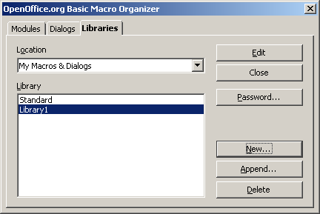

Solution: “Export...” button triggering a dialog to choose between “Package” and “BASIC” export
An “Export...” button will be added to the Libraries tabpage:

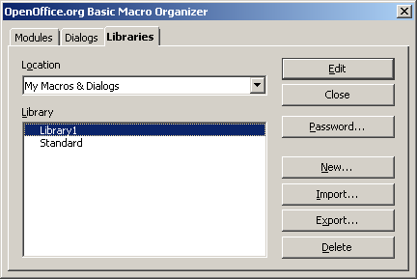

The displayed button order results from a decision made at the first Basic Library Export i-Team meeting on March 20. It has also been decided there to rename the former “Append...” button to “Import...” as this is consistant to the new “Export...” button and more adequate for this functionality anyway. Clicking on “Import...” opens a file dialog. This dialog's caption will also be changed from “Append libraries” to “Import libraries”.
The “Export...” button triggers a dialog to choose between “Package” and “BASIC” export:
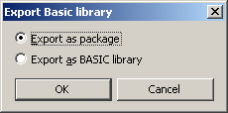

A disadvantage of this solution is that this further step is necessary. But exporting Basic libraries is no operation that will be performed very often, so this should be acceptable. If the chosen library is password protected, the password will be asked before openening the Export dialog. This is not necessary for security reasons, but currently forced by implementation details.
Depending on the selected operation the adequate “Save as” dialog will be opened.

For package export:
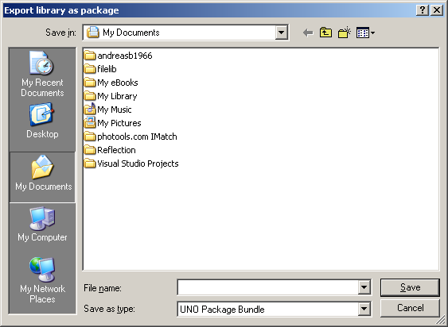

For BASIC export:
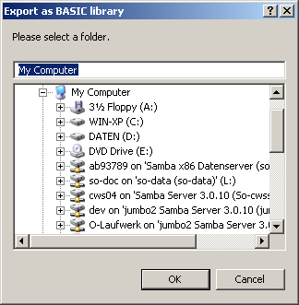

Initially the dialogs show the home / “My documents” directory. After the first export they will show the directory that has been chosen the last time (hint: this does not work for the System folder picker, at least in Windows. This is a bug not located in this cws). After the export (or cancellation) the user will be back on the “Organizer dialog/Libraries” tabpage.
Concerning the support of digital signatures this solution is trouble-free as for this purpose an additonal check box could be added to the dialog for choosing package/native export:

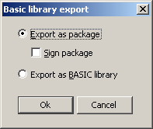

Hint: This screenshot is a draft created with the Basic dialog editor whereas the first one without “Sign package” is already final taken from the C++ implementation.
One general problem regarding digital signatures in Basic library export: Unlike for Office documents an “active document” there is nothing like an “active exported library”. So it's not possible to refer to an exportet library later. The signing has to be done in direct connection with the export operation.

String list
Item | English | German | Comments
Export button | Export... | Exportieren...
Former “Append” button | Import... | Importieren...
Caption “Append” file dialog | Import Libraries | Bibliotheken importieren
Export dialog title | Export Basic library | Basic Bibliothek exportieren
Export dialog package radio | Export as package | Als Package exportieren
Export dialog native radio | Export as BASIC library | Als BASIC Bibliothek exportieren
Package export file picker title | Export library as package | Bibliothek als Package exportieren
Native export folder picker title | Export as BASIC library | Als BASIC Bibliothek exportieren
Later: Sign check box | Sign package | Package signieren

Key Board Shortcuts
See string list.

Error Conditions
The Standard library cannot be exported as it cannot be imported either. This is not really an error condition, but the export functionality has to be disabled for the standard library.
The export of course could fail, e.g. because of missing rights in the target folder. This situation should be handled similar to saving documents concerning error message etc.

Future Tasks
Support of digital signatures is directly handled in “6. Detailed specification”.
Another future task could be multi-lib-support.

Notes
There are alternative solutions that were turned down during the specification discussion. These solution are kept here to make the decision for the chosen solution more clear.

Refused solution 1: “Export...” button triggering a “Save as” dialog
The “Libraries” tabpage in this solution would look like the one in the chosen solution.In this solution the user would have to choose in the file type list box at the “Save as” dialog if the library should be exported as package or in native BASIC format. The problem is that the package export requires the selection of a target file name whereas the native export requires the selection of a target folder. This can hardly be implemented currently as either a file or folder picker can be instantiated which has to be defined in advance. A way to handle this could be to always use a file picker and regard the library folder name as file name to be seleceted. But this also isn't nice as this folder should always have the same name as the library.
Concerning the support of digital signatures this solution is critical. One way to offer this functionality could be a dialog appearing after the export asking the user if he wants to sign the package. Another one would be an additional checkbox on the “File save” dialog allowing the user to choose if he wants to sign the package after saving.

Refused solution 2: Two buttons “Export...” and “Export as package” both directly triggering a “Save as” dialog
In this solution it's possible to directly open the adequate “Save as” dialog. For native library export a “path selection” dialog has to be used, for packages the normal file “Save as”. Disadvantages of this solution: Two new buttons are necessary filling up the remaining space in the Libraries tabpage completely. Maybe it's also necessary to make all buttons wider because of the longer string “Export package ...”. The “Libraries” tabpage then would look like this:

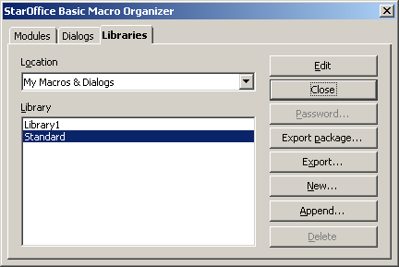

Concerning the support of digital signatures this solution mostly equals the previous one, but an additional dialog of course would only have to appear in the package export case respectively an additional check box in the Save file dialog used for package export.

References
This specification has been partly superseded by the specification Package Manager Renaming.
-

