Typography – Subscript, Superscript
OpenOffice.org 3.0

Document - ID | Specification Owner | Last Change | Status
 | Matthias Müller-Prove | 08/24/05 | draft
Conforms to
Applies to | Impress, Draw, TextBoxes in Writer – all text that is rendered by the EditEngine
Task ID(s) | i46563 (context menu)  i44551,  i50718 (sub/superscript should be the same for WriterCore and EditEngine)
Category | feature

Abstract
The typographic measures for subscript and superscript are changed to meet the visual appeal of OOo Writer and the competition.

i-Team Members (The specification owner is part of the i-Team)
 | Name | E-mail Address
User Experience | Matthias Müller-Prove /MMP | mprove@sun.com
Development | Sven Jacobi | Sven.Jacobi@Sun.COM
Quality Assurance | Christian Guenther | Christian.Guenther@sun.com
Documentation | Uwe Fischer | ufi@sun.com
 |  | mail to iTeam

Approved for Implementation
 | Approved by | Date
User Experience | <Name> | <Date>
Development
Quality Assurance
Documentation
String Review

Document Change History
Rev. Level | Change | Initials | Date
 | initial version | MMP | 02/05/05
1.0

Contents
Glossary 4
1 Motivation 5
2 User Scenarios 5
3 Goals 6
4 Requirements and Dependencies 6
4.1 Requirements 6
4.2 Technical Dependencies 6
5 Competitive Analysis 7
5.1 MS PowerPoint XP 7
5.2 OpenOffice.org 2.0 Impress 8
6 Detailed Specification 8
6.1 Context Menu for Text in Impress and Draw 8
6.2 Typographic Default Values 9
6.3 Placement of Bullet 9
6.4 Line Height 9
6.5 Migration 9
7 Future Tasks 10
8 Notes 10
9 References 10

Glossary
Term | Description
subscript | A subscript is a number, figure or indicator, that appears below the normal line of type, when used in a formula, mathematical expression or description of a chemical compound. Probably the most famous subscript is the number 2 in the formula for the molecule of water, H₂O. [Wikipedia]
superscript | A superscript is a number, figure or indicator, that appears above the normal line of type. Superscripts are often used in formulas, mathematical expressions, or descriptions of chemical compounds. Superscripts can also be used to indicate the presence of a footnote in a document. Sometimes, ordinal endings for numbers (e.g. the suffixes -st, -nd, -rd, and -th in 1st, 2nd, 3rd and 4th) are also rendered in superscript. Probably the most famous superscript is the number 2 in Einstein's theory of relativity, E = mc².[Wikipedia]
WriterCore | Text edit engine used in OOo Writer
EditEngine | Text edit engine used in OOo Impress, Draw and for TextBoxes in Writer
font size | decender length + x-height + ascender height

Dimensions of Fonts
Baseline and decender length are terms used in OOo engineering with a meaning as depicted below. Ascender height is used as x-height + ascender height. In order to avoid confusion with the typographical term Ascender height, the former (engineering) term is written as Ascender height_{OOo}.
Illustration 1: Dimensions of fonts

Motivation
The way subscript is rendered in OpenOffice.org Impress 2.0 is not optimal. Subscripts are too low. Furthermore, they increase the line feed which causes the lines to visually fall apart.

User Scenarios
In OpenOffice.org 2.0 Tom wants creates an informal expression with some indices. He looks for a subscript command in the Insert menu, the Format menu, the toolbar and in the context menu – without luck. A colleague tells him to try the Character dialog. In the Character dialog Tom finds the last tab called Position where he can set the subscript style.
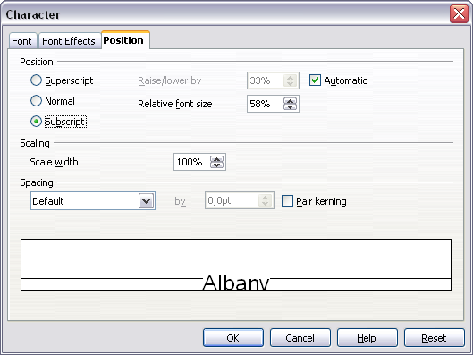Illustration 2: Character dialog in OOo 2.0 Impress
After pressing OK he is surprised that the default look is somewhat strange.
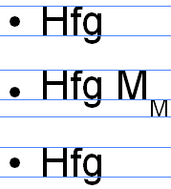Illustration 3: OOo Impress 2.0, Arial 32pt with subscript in second row. (blue guide lines added for clarification)
So he opens the dialog again and changes the value for “Raise/lower by” to a smaller value.

Goals
- Ease the way to create subscript/superscript.
- Change the default calculation of subscript/superscript to produce better looking results.
- Change the calculation to position the bullet. It should not move down when subscript is used.
- Same treatment of subscript in Writer and Impress

Requirements and Dependencies

Requirements
<State the requirement(s) of this feature here.>

Technical Dependencies
OOo has two text edit engines: WriterCore and EditEngine. They have different functionality which is apparent because of different handling of subscript in Impress and Writer.
With respect to the visual appearance of text both engines should create the same results.

EditEngine
The distance for subscript is measured in OOo's EditEngine as follows:
- 100% = font size (see glossary)
- baseline is the origin
- direction is downwards
The distance for superscript is measured in OOo's EditEngine as follows:
- 100% = font size (see glossary)
- baseline is the origin
- direction is upwards
The value can be entered in the textfield “Raise/lower by”.

Competitive Analysis

MS PowerPoint XP
Subscript and superscript can be assigned in the Font dialog.
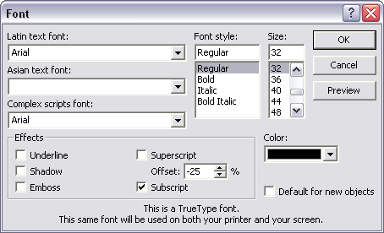Illustration 4: Font dialog in MS PowerPoint XP
Illustration 5: Sample Slide created in PowerPoint XP
Subscript moves the text down by 25% (of what??). The font size is 65% of the base font.
Superscript moves the text up by 30% (of what??). The font size is 65% of the base font.

OpenOffice.org Impress 2.0
Impress uses the EditEngine.
Illustration 6: Sample Slide created in OOo 2.0 Impress

Changes compared to PowerPoint
- The default line height is 8% larger than in PP.
- The font size is 58% of the base font. (PP: 65%)
- Subscript moves the text down by 33%. (PP: 25%)
- Superscript moves the text up by 33% (of what??). (PP 30%)
- The position of the bullet is calculated as the middle of the line height (?). Therefore the bullet for a line with subscript is lower than for lines without subscript styles. (PP: does not change the position of the bullet. It is always calculated in relation to the line height of the base text.)
- Subscript increases the line height. (Not so in PP)

OpenOffice.org Writer 2.0
Writer uses the WriterCore text edit engine. The parameters for subscript are:

on Automatic
- The font size is 58% of the base font
- Subscript moves the text down by 33% ??
- ##

Detailed Specification

Context Menu for Text in Impress and Draw
In order to ease the assignment of subscript/superscript the context menu for text gets two additional commands: the Styles submenu in the context menu for text is as follows:
Styles Comments
Bold
Italic
Underline
Strikethrough
Shadow
Contour “Contour” rather than “Outline” is used for all modules; cf. i49134
--------------- new item
Superscript new item
Subscript new item

The menu icons are the same as in OOo Writer.
Illustration 7: Mockup of Styles submenu in context menu for text
String list
Item | English | German | Comments
Menu command | Sup~erscript | Hochstellen
Menu command | Subscri~pt | Tiefstellen

Typographic Default Values
By default a subscript moves the base line down by 25%.
By default a superscript moves the base line up by 33%.

Placement of Bullet
The position of the bullet is always calculated in relation to the line height of the first character of the text. Therefore a subscript or superscript does not move the bullet. Even if the first character is marked as sub- or superscript the bullet does not move.

Line Height
TBD

Migration
<Any migration issues have to be stated here. For example how can users migrate from one version of a database to another?>

Future Tasks
<If there are features which couldn't be implemented but have to be implemented in the future. State these in here with a description why the feature couldn't be implemented right now.>

Notes
AMA-1:“Automatic is something different than 33%”

References
<Give references to related documentation, such as engineering designs, technical specs, and other sources for related units. Also include links to documents that other sections in this spec need to refer to, such as user opinions usability test reports.>

PowerPoint might use a different scale. cf. 4.2 Technical Dependencies

