Naming Single Drawing Objects
StarOffice 8 / OpenOffice Writer and Calc

Document - ID | Specification Owner | Last Change | Status
 | Frank Loehmann | 16. March 06 | Final
Conforms to
Applies to | Writer, Calc
Task ID(s) | i51726, i51351 , cws: swa11y203
Category | Feature

Abstract
Single drawing objects and text boxes, contrary to grouped drawing objects, could not be named in Writer and Calc. It is an accessibility requirement to be able to do so.
i-Team Members (The specification owner is part of the i-Team)
 | Name | E-mail Address
User Experience | Frank Loehmann (FL) | frank.loehmann@sun.com
Development | Oliver-Rainer Wittmann; Writer  Niklas Nebel; Calc | Oliver-Rainer.Wittmann@Sun.COM  niklas.nebel@sun.com
Quality Assurance | Michael Rüß (MRU); Writer  Frank Stecher (FST); Calc | michael.ruess@sun.com  frank.stecher@sun.com
Documentation | Uwe Fischer (UFI) | uwe.fischer@sun.com

Approved for Implementation
 | Approved by | Date
User Experience | Frank Loehmann  Chrisitian Jansen (review) | 13.03.06  15.03.06
Development | Niklas Nebel / Oliver-Rainer Wittmann | 15.03.06
Quality Assurance | Michael Rüß | 15.03.06
Documentation | Uwe Fischer | 15.03.06
String Review | Frank Loehmann | 13.03.06

Document Change History
Rev. Level | Change | Initials | Date
1.0 | Initial Draft | FL | 08. July 05
1.1 | Overworked | FL | 13. March 06
1.2 | Adding subchapters "Implication of naming drawing objects in Writer to XML import/export" and "Open a Writer document in OpenDocument file format in previous versions" | OD | 14. March 06
1.3 | Finalization | FL | 16. March 06

Contents
1 Current Behavior in Draw and Impress 1
2 Naming of drawing objects in Writer and Calc 1
2.1 Name Object Dialog 1
2.2 Context Menu in Writer and Calc 2
2.3 Implication of naming drawing objects in Writer to XML import/export 3
2.4 Open a Writer document in OpenDocument file format in previous versions 3
3 Future Tasks 3

Current Behavior in Draw and Impress
Draw / Impress already allows to assign a name to a single drawing object. The following "Name Object" entry is visible when a single object or a group of objects is selected. No object will get a default name.
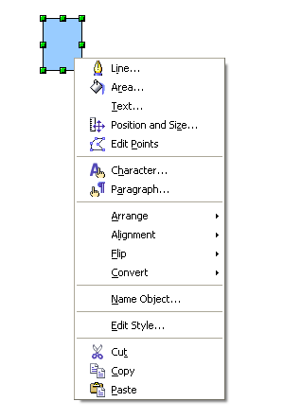Illustration 1: Context menu for a single Drawing object in Draw / Impress
The "Name Object" entry calls the following dialog. If the object already has a name, the Name edit shows this name. When calling the dialog, the edit has the default focus and thus the current name is preselected:
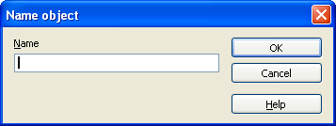Illustration 2: Name object dialog in Draw / Impress

Naming of drawing objects in Writer and Calc
In OOo 2.0 single (ungrouped) drawing objects could not be named in Writer and Calc. Calc and Writer will change their current behavior to the one already implemented by Draw / Impress.

Name Object Dialog
In OOo 2.0 the dialog title Name object does not use the correct case. So the title changes in all cases like follows.
Strings for Name Object Dialog
Item | English | German | Comments
Dialog Title | Name Object | use current translation

Context Menu in Writer and Calc
The context menu of a multi selection of drawing objects or grouped drawing objects must not contain the Name Objects entry. The entry is only visible for a single drawing object or group.

Writer
The Name Object context menu entry calls the Name Object dialog (see 2.1). In OOo 2.0, Writer sets a different dialog title (Name group) when naming a group. This will change to Name Object in both cases like described in 2.1.
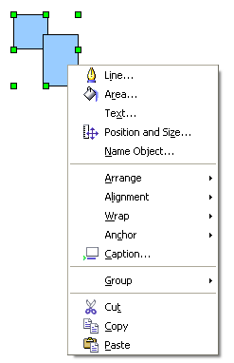Illustration 3: OOo 2.0 Writer naming of single objects

Calc
In OOo 2.0, the Name Object... entry is show below the Anchor entry. This entry moves upwards below the Position and Size... entry like in Writer.
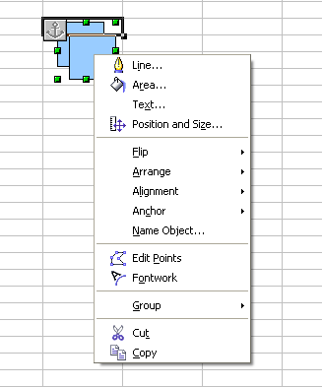Illustration 4: Naming of grouped drawing objects in OOo 2.0 Calc. Context menu entry "Name Object..." is on a false position.

Strings for Context Menu Entry in Writer and Calc
Item | English | German | Comments
Menu entry | ~Name Object... | use current translation

Implication of naming drawing objects in Writer to XML import/export
For objects of type graphic and text box exist two possible implementations in Writer – Writer graphic/text box or Draw graphic/text box. In the OpenDocument file format and the OpenOffice.org file format these two implementations can't be natively distinguished.

XML import
Currently, the existence of a name for an object is used to distinguish between Writer graphic/text box and Draw graphic/text box during the XML import. This distinctive feature can no longer been used. The new distinctive feature is that drawing objects in Writer documents have no style. They only have an automatic style without a parent style. This new distinctive feature will be implemented in the XML import of Writer documents in OpenDocument file format respectively OpenOffice.org file format.

XML export
Because the OpenOffice.org file format of a Writer document doesn't support names for drawing objects, except for grouped drawing objects, names of drawing objects won't be exported for this file format.

Open a Writer document in OpenDocument file format in previous versions
The previous versions of OpenOffice.org, namely OOo 1.1.5, OOo 2.0, OOo 2.0.1 and OOo 2.0.2, doesn't support names for drawing objects and distinguish between Writer graphic/text box and Draw graphic/text box by checking for the existence of a name. Thus, a named drawing object of type graphic or text box will be imported as Writer graphic respectively text box.

Future Tasks
none

