Software Specification Document

OpenOffice.org
Extension System Integration

Specification Status
Last Change | May 9, 2008
Status

Abstract
Extensions shall be recognized on desktops by using particular icons. It also shall be possible to install an extension by double clicking on the respective file.

i-Team Members
Role | First Name, Last Name, Initials | E-Mail Address
Project Lead | Joachim Lingner (JL) | jl@openoffice.org
Specification Owner | Joachim Lingner (JL) | jl@openoffice.org
User Experience | Bettina Haberer (BH) | bh@openoffice.org
Development | Joachim Lingner (JL), Stephan Bergmann (SB), Ivo Hinkelmann (ihi), Hennes Rohling (hro) | jl@openoffice.org, sb@openoffice.org, ihi@openoffice.org, hro@openoffice.org
Quality Assurance | Jörg Skottke | jsk@openoffice.org
Documentation | Uwe Fischer | ufi@openoffice.org
Other roles | <First Name, Last Name (Initials)> | <User@openoffice.org>
<State reason here, if one role is not represented in i-Team.>

Contents
Abstract 1
i-Team Members 1
References and Reference Documents 3
Acronyms and Abbreviations 3
1 Detailed Specification 4
1.1 Scenarios of System Integration 4
1.2 Installation of a Single Extension 4
1.2.1 Changes in the next version 6
1.3 GUI changes during Installation 6
1.4 Warning at having started more then one instances of unopkg 6
1.5 Installation of Multiple Extensions 7
1.6 Changes in unopkg 7
1.7 GUI Changes 8
1.8 Mime Type 9
1.9 Icons 9
1.10 Description 10
1.11 Integration in Windows 11
1.11.1 Icons and Description 11
1.11.2 Command Integration 12
1.11.3 Other unopkg Changes 13
1.11.4 Integration in other applications 14
1.12 Unix 17
1.13 Installing Extensions using the Console 20
2 Migration 20
3 Configuration 20
4 File Format 20
5 Open Issues 20
Document Change History 21

References and Reference Documents
Reference Document | Check | Location (URL)
Specification Process Entry Check |  | N/A
Product Requirement,, RFE, issue (required) |  | 69173
Product Concept Document |  | <Please enter location here>
Competitive Analysis |  | <Please enter location here>
Test Case Specification (required) |  | http://mahler.germany.sun.com/qa_tests/tests/test_list_detail.php?idx=72
Software Specification Rules | N/A | N/A
<Other, e.g. references to related specs>

Acronyms and Abbreviations
Acronym / Abbreviation | Definition
unopkg | A program for the administration of extensions. When starting unopkg without the gui option then the Extension Manager GUI is NOT displayed. unopkg offers more options to enable the administration by using solely the console.
unopkg gui | The option gui affects that the Extension Manager GUI is started.

Detailed Specification

Scenarios of System Integration
Extensions (.oxt files) shall be automatically installed, when a user activates it. In the simplest case, this could be a click or double-click on the .oxt file in a file browser, such as the Windows Explorer. Also other programs, such as mail clients and web browsers, may use the system integration. For example, when a web link in a HTML page targets a file with the extension .zip and the user clicks on this link, then the browser may offer to start the corresponding zip application. If the user accepts this then the application is started and the zip file is passed to that program. In the case of extensions, this would mean that the Extension Manager is started which then installs the extension.

Installation of a Single Extension
The user activates one .oxt file. unopkg is called and the Extension Manager GUI starts up. In case a office is already running then unopkg will start the Extension Manager of the office. Beginning with OpenOffice 3.0 unopkg will not be used as default application for .oxt files any longer. The Office will be used as the default application instead. Now a modal dialog comes up informing the user that he/she is about to install an extension. The content of this dialog depends on the scenario. These are:
- (case 1) An extension with the same name has not been installed yet.
- (case 2) An extension with the same name and a lower version is already installed.
- (case 3) An extension with the same name and with the same version is already installed.
- (case4) An extension with the same name and with a higher version is already installed.
The cases 2, 3, 4 are already handled in http://specs.openoffice.org/appwide/packagemanager/extensionversion.odt
The focus is on the OK button.

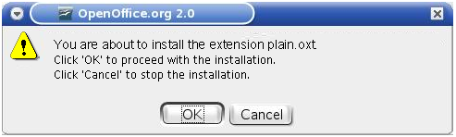Figure 1: Warning box in case 1.

Table 1: User Interface elements of Figure 1
# | Type | Properties |  | Comment
<#> |  | Control Properties  State: Modal  Closable: Yes  Resizable: No  Always On Top: Yes  A11Y Text: none  Other...: none |  |  | Info box
<#> |  | String English | String German
<#> |  | Control Properties  Enabled: Yes
<#> |  | String English  You are about to install the extension '%NAME'.\nClick 'OK' to proceed with the installation.\nClick 'Cancel' to stop the installation. | String German  Möchten Sie die Extension "%NAME" installieren?\nDrücken Sie "OK" um mit der Installation fortzufahren.\nDrücken Sie "Abbrechen" um die Installation abzubrechen. |  | %NAME is the display name of the extension. If the extenion does not provide a display name then it will be the file name.
<#> |  | Control Properties  Enabled: Yes  Icon: NO  Resizeable: NO  Has Menu: NO  Menu Items: none  ToolTipText: none |  |  | Has initial focus.
<#> |  | String English  OK | String German  OK
<#> |  | Control Properties  Enabled: Yes  Icon: No  Resizeable: NO  Has Menu: No  Menu Items: none  ToolTipText: none
<#> |  | String English  Cancel | String German  Abbrechen

When the user presses OK, the installation starts and the dialog closes. The extension is installed under “My Extensions”, that is in the user installation. Installing under “OpenOffice.org Extensions, that is installing in the shared installation, is not supported as part of the system integration.

The command that is executed in order to start the installation process is on Windows:
unopkg.exe gui extension
and on Unix
unopkg gui extension.

extension is the name of the extensions including the full path.

Changes in the next version
Beginning with OpenOffice 3.0 unopkg will not be used as default application for .oxt files any longer. The Office will be used as the default application instead. Activating an extension will always start the office directly without using unopkg. You can start the office and provide a full path to an extension. This will start the office with the extension manager asking you if you want to install that extension.
Starting with OpenOffice 3.0 the office supports installing an extension with simply choosing the extension in the office file open dialog, too.

GUI changes during Installation
During installation the buttons Add, Remove, Disable, Enable, Export are disabled. When the installation is done the buttons will be enabled if they would be enabled in this case in the usual gui mode. For example, the user double-clicks on an extension in a file browser. Then the Extension Manager dialog comes up and the buttons are disabled. Therefore the user cannot accidentally start another action. After the installation has completed, the buttons are enabled and the user can enable/disable extensions or add and remove extensions again.

Warning at having started more then one instances of unopkg
There are two cases, when the installation of an extension fails (this will be enhanced in the future):
- There is already an instance of unopkg running.
- An instance of OOo is running and the Extension Manager dialog is open.

In these cases a warning will be displayed. Because this is only a interims-solution, there is only one warning with a general text. Otherwise we would have to take into account:
- unopkg can be started with no, one, multiple arguments. That is the warning string could refer to no, exactly one or multiple extensions.
- The user may not know what unopkg is. For example, if the user always uses the double-click for installing extensions, he may never have typed unopkg in a console before. Therefore the warning string may in some situations not refer to unopkg (the user would not know what it is) but in other cases it would be more specific.

In case unopkg was started with the gui option, which is the case when starting unopkg via system integration, then the warning will be displayed in a dialog. If unopkg was started without the gui option, for example, the user typed in the console: unopkg add d:\extension.oxt, then the warning is displayed in the console.

Figure 2: Warning box

Table 2: User Interface elements of Figure 2
# | Type | Properties |  | Comment
<#> |  | Control Properties  State: Modal  Closable: Yes  Resizable: No  Always On Top: Yes  A11Y Text: none  Other...: none |  |  | Warning box
<#> |  | String English | String German
<#> |  | Control Properties  Enabled: <Yes/No>  Initially Selected: <Yes/No>  ToolTip Text: <If needed specify tip here>
<#> |  | String English  You need to close the already opened Extension Manager to continue. | String German  Schließen Sie den bereits geöffneten Extension Manager, um fortzufahren.
<#> |  | Control Properties  Enabled: Yes  Icon: NO  Resizeable: NO  Has Menu: NO  Menu Items: none  ToolTipText: none
<#> |  | String English  OK | String German  OK

Installation of Multiple Extensions
A User may also activate a selection of .oxt files. Then for every selected file, unopkg is executed the same way as if there is only one selected file. The operating system may execute the multiple unopkg instances concurrently. Then the installation may fail. See chapter 1.4.

Changes in unopkg
unopkg will be enhanced to support this invocation:
unopkg gui extension
or
unopkg gui list_of_extensions

See also chapter 1.4. This command is only for use with the system integration. Therefore unopkg –help will not show this command.

GUI Changes
The Extension Manager dialog, as well as the OpenOffice.org file dialog will display a new icon (see chapter 1.9) for a extension. OOo's file dialog will also display a description string (see also chapter 1.10)
The Extension Manager displays the “Toolbar” icon with the size 16X16 for extensions (see chapter 1.9).
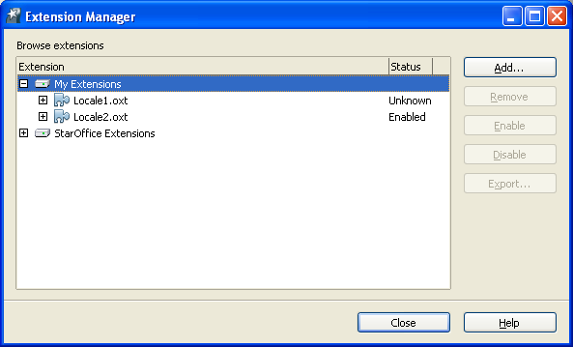Figure 3: New icon for extensions (.oxt files)

OpenOffice.org's file dialog displays the “Toolbar” icon with the size 16X16 for extensions (see chapter 1.9). It also shows a description string.

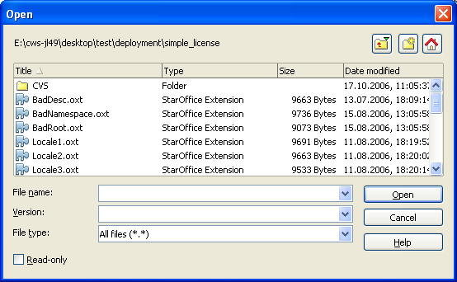Figure 4: New icon in file open dialog

Mime Type
.oxt files have the mime type
application/vnd.openofficeorg.extension

Icons
These icons are for use in OpenOffice.org. For examples see figure 3 and 4.
Office Icons | 16x16 | 26x26 | 16x16 | 26x26
Office Extension

These Icons are for use on the operating system's desktop:

Desktop Icons | 16x16 | 32x32 | 48x48
Office Extension
-> 24bit with Alpha channel
Office Extension
-> 24bit (no Alpha channel)
Office Extension
-> 8bit (no Alpha channel)
"Office Extention"  -> Low Contrast |  |  | 
Office Extension
-> High Contrast
"Office Extention"  -> High Contrast: Black/White | 
"Office Extention"  -> High Contrast: White/Black | 

Description
A description string may be displayed in
- file browsers
- file dialogs (including OOo's file dialog)
- other applications

String List
Type | English String | German String | Comment
Description | %PRODUCTNAME Extension | %PRODUCTNAME Extension | Example for usage can be found in figure 4 (String displayed in column “Type”) and figure 5

Integration in Windows
The Windows desktop will be adapted so as to support the installation of extension.

Icons and Description
The following icon formats are needed for a full featured Windows integration:
16x16, 32x32, 48x48
Each of them with the following color depths:
4 Bit, 8 Bit, 32 Bit (True-Color with Alpha Channel)
The icons will be visible in Windows Explorer shell for every file with an .oxt extension. See also chapter 1.9. Also a description string may be shown (see chapter 1.10).

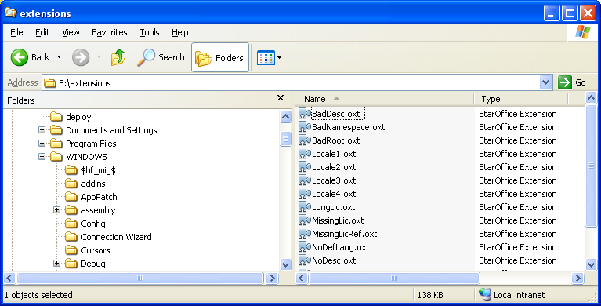Figure 5: New icon and description string in the Windows explorer
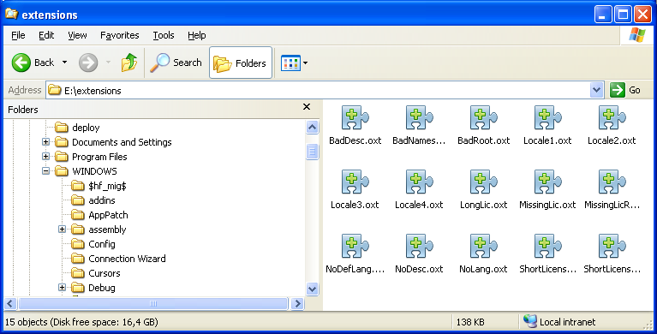Figure 6: Use of icons of size 32x32 in Windows explorer

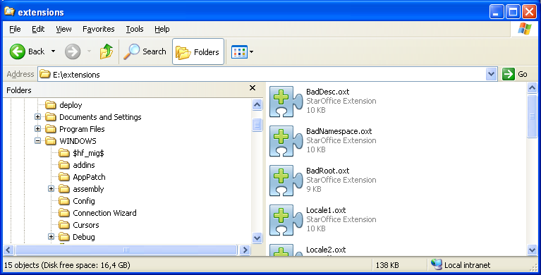Figure 7: Use of icons of size 48x48 in Windows Explorer

Command Integration
The .oxt file extension will be registered as a file class, which will be assigned a command “open”. The open command will have a display name “Install” and it will be the default command. This command will appear in the shortcut menu, which can be invoked, for example, by right-clicking an .oxt file in the Windows explorer.
The “Install” command will be highlighted. The default command is also executed when double clicking a file of that type or when selecting a file in the explorer and hitting <enter>. This command is also executed when typing the name of an .oxt file in a command shell – but this only works on Windows 2K and higher.

Figure 8: Command integration: E.g. Windows Explorer showing the install command as default for .oxt files

String List for figure 8
Type | English String | German String | Comment
Context menu entry | &Install | &Installieren | The string is the default command of the context menu, that is, is is displayed in bold. The'&' indicates that the following letter is the keybord shortcut. Note: Windows expects a & and not a ~.

Other unopkg Changes
unopkg.exe is currently a console application on Windows. That means, that it will always create a console unless it had been directly started from within a console. This would have the effect that when a user double-clicks an extension always a console is created as well as the Extension Manager dialog. This has to be prevented. However, in the case, where unopkg is started without the “gui” option, unopkg must write in the console to give the user feedback. This does not work when unopkg is a Windows GUI application. The solution is to provide another executable named unopkg.com which is a console application and to make unopkg.exe a Windows GUI application. unopkg.com starts unopkg.exe and connects to it via pipes. All console output from unopkg.exe is displayed by unopkg.com in its own console and all console input for unopkg.com is forwared to unopkg.exe.
When a user types “unopkg” in the console and presses enter then always unopkg.com is executed. To start unopkg without console output one has to type unopkg.exe.

Integration in other applications
Applications, such as e-mail clients and web browsers, should be able to start the installation of an extension. For example, when clicking on a link to a .oxt file, the browser should offer to start unopkg. When the user accepts this, unopkg should be started and the .oxt file is passed to it.

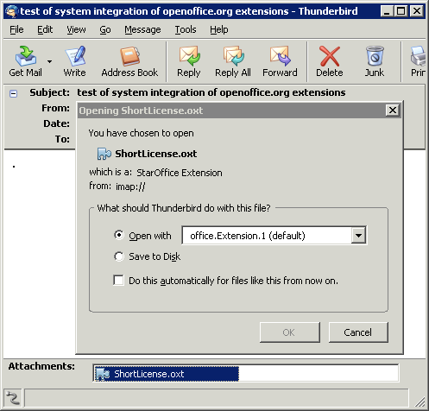Figure 9: Installing extension in thunderbird

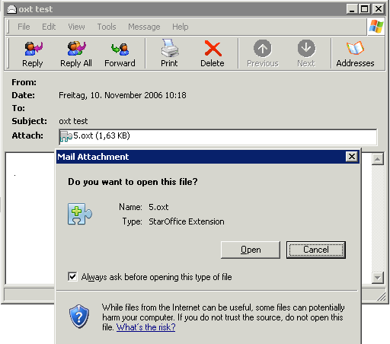Figure 10: Installing extension in Microsoft Outlook

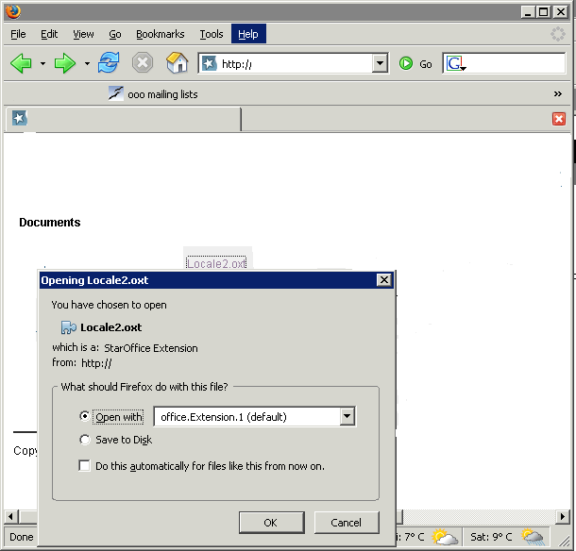Figure 11: Installing extension in Mozilla Firefox

Unix
The Unix System Integration supports the installation of new OpenOffice.org Extensions. All applications that are able to handle mimetypes like mailclients, file- and webbrowser can install new OpenOffice.org Extensions by calling the Extension Manager. Within filebrowsers the Extensions can be installed by clicking onto the displayed icon.
All applications run a script called “unopkg_gui” which calls the Extension Manager with the correct parameters.
Example of the Linux Gnome Nautilus System Integrations
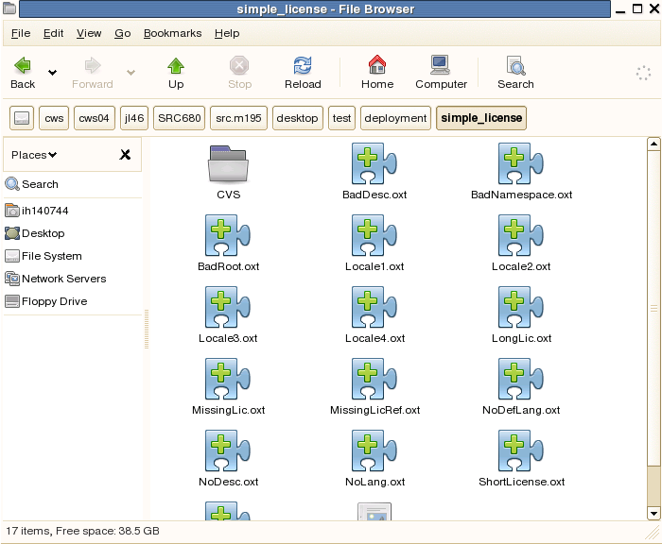
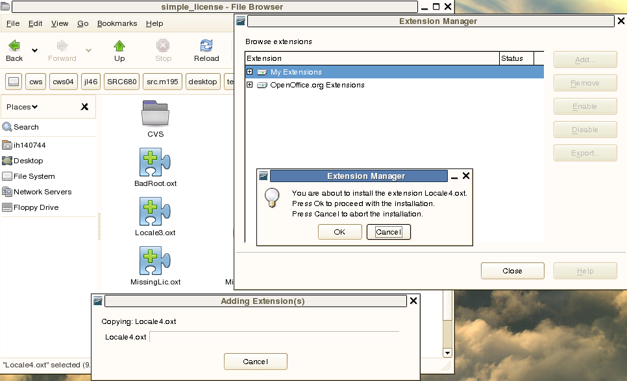

Example of the Linux Firefox System Integration
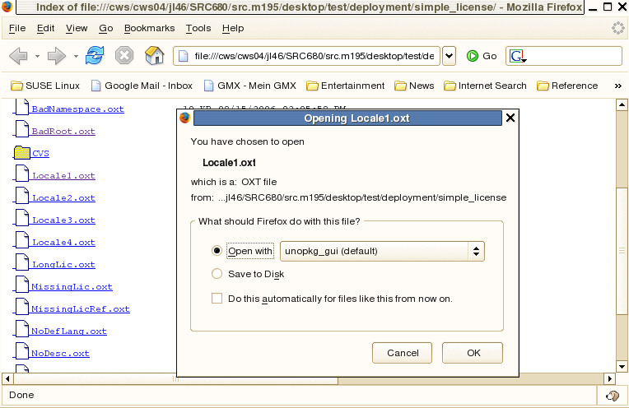
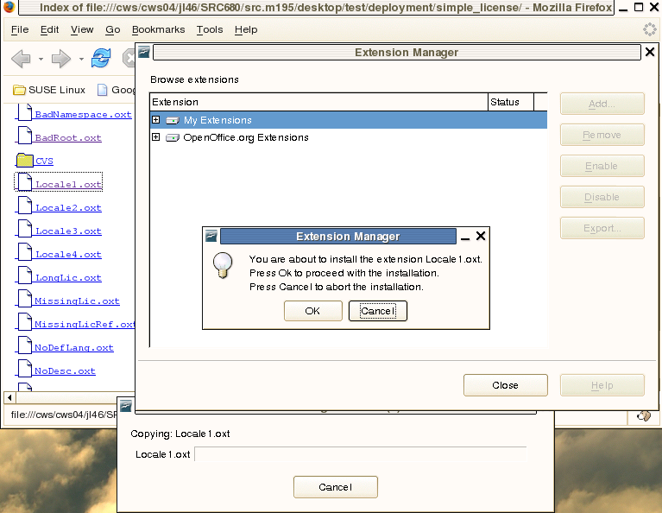

Example of the Linux Thunderbird System Integration
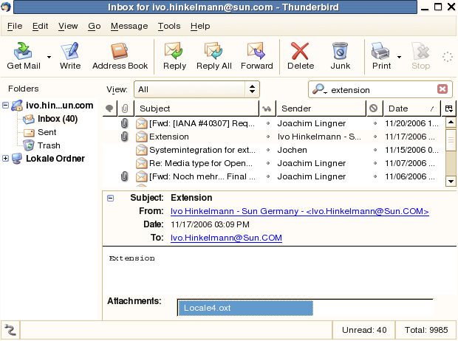

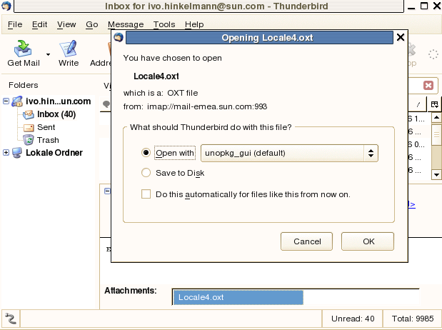

Example of the Gnome System Integration
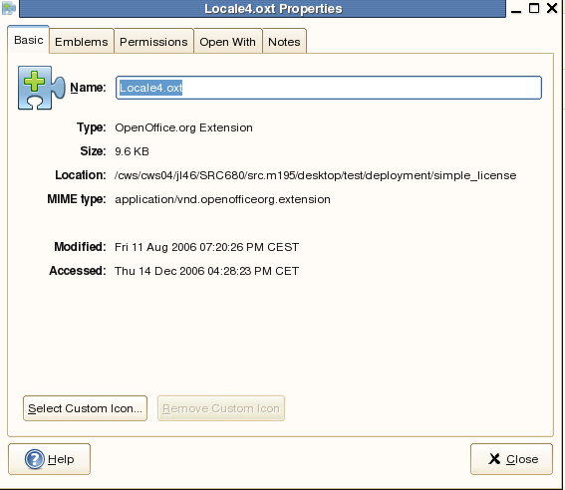

Installing Extensions using the Console
The installation of an extension which was triggered by the “system integration” will always use a GUI. Pure console installation will not be supported.

Migration
<Start typing here ----- If this part is irrelevant state a reason for its absence!>

Configuration
<Start typing here ----- If this part is irrelevant state a reason for its absence!>

File Format
<Start typing here ----- If this part is irrelevant state a reason for its absence!>

Open Issues
Issue | Initials | Date
71625 When starting unopkg from download window of firefox we use a name that is not easy recognized. |  | Dec 8, 2006
71623 Internet Explorer 6 regards the .oxt as zip file |  | Dec 8,

Document Change History
Rev. | Change | Initials | Date
1 | System integration of .oxt files changed | dv | May 9, 2008
2
3
<...>

