Software Specification Document

OpenOffice.org
Export Single Dialog from Library

Specification Status
Last Change | Jun 11, 2007
Status
Abstract
Currently dialogs are always embedded into a basic library. Especially for OOo extensions it would be helpful to have access to single dialogs. Therefore the dialog IDE gets a possibility to export the current dialog via a new button in the tool bar.

i-Team Members
Role | First Name, Last Name, Initials | E-Mail Address
I-Team Lead | Andreas Bregas (ABR) | andreas.bregas@sun.com
Specification Author | Frank Loehmann (FL) | frank.loehmann@sun.com
User Experience | Frank Loehmann (FL) | frank.loehmann@sun.com
Development | Andreas Bregas (ABR) | andreas.bregas@sun.com
Quality Assurance | Joerg Skottke (JSK) | joerg.skottke@sun.com
Documentation | Uwe Fischer (UFI) | Uwe.fischer@sun.com
Icon Design | Stella Schulze (STS) | Stella.schulze@sun.com

Contents
Abstract 1
i-Team Members 1
References and Reference Documents 3
Acronyms and Abbreviations 3
1 Detailed Specification 4
1.1 Dialog IDE 4
1.2 Basic IDE 6
2 Migration 6
3 Configuration 6
4 File Format 7
5 Open Issues 7
Document Change History 7

References and Reference Documents
Reference Document | Check | Location (URL)
Specification Process Entry Check |  | N/A
Product Requirement, RFE, issue [Required] |  | <Please enter location here>
Product Concept Document |  | <Please enter location here>
Competitive Analysis |  | <Please enter location here>
IDL Specification |  | <Please enter location here>
Test Case Specification [Required] |  | <Please enter location here>
Software Specification Rules | N/A | N/A
<Other, e.g. references to related specs>
Acronyms and Abbreviations
Acronym / Abbreviation | Definition
<WYSIWYG> | <What You See Is What You Get>

Detailed Specification

Dialog IDE
The dialog IDE changes like follows:
- a new Dialog tool bar is shown instead of the Macro toolbar
- all inactive buttons from the Macro tool bar are not shown in the new Dialog tool bar. See below for mock-up.
- the export button to export the current dialog is added to the toolbar
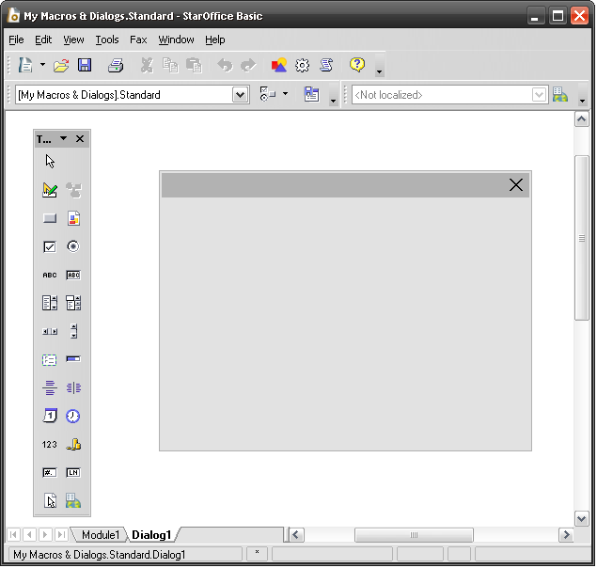Illustration 1: New Dialog tool bar with export button

- “Dialog” - Toolbar Properties |  | Comment
Toolbar Name: | Dialog |  | EN-US
Toolbar Name: | Dailog |  | DE
Has Closer: | Yes
Style: | Icon
Initial State: | Docked
Initial Docking Pos.: | Top | Replaces Marco toolbar
Initial Floating Pos.: | Default
List in "View/Toolbars": | Yes
Is Context Sensitive: | Automatically displayed in Dialog IDE
Toolbar Items:
Item Name: | Dialog |  | EN-US
Item Name: | Dialog |  | e.g. DE

- “Export Dialog” - Button Properties |  | Comment
Enabled: | In context of the dialog IDE
Press: | A Save as... dialog opens to save the current dialog to file
Other: | Icon: <Stella will provide the icon>
Button Label: | Export Dialog |  | EN-US
Button Label: | Dialog exportieren |  | e.g. DE

- “Export Dialog” - Dialog OR Window Properties |  | Comment
State: | Modal
Type: | Dialog
Closable: | Yes
Resizable: | Yes
Titel: | Export Dialog |  | EN-US
Titel: | Dialog exportieren |  | e.g. DE

Basic IDE
The Insert Control button gets removed from the Macro Toolbar, because is always disabled in Basic IDE. The separator on the left gets also removed, because there is only the Find Parenthesis button left.
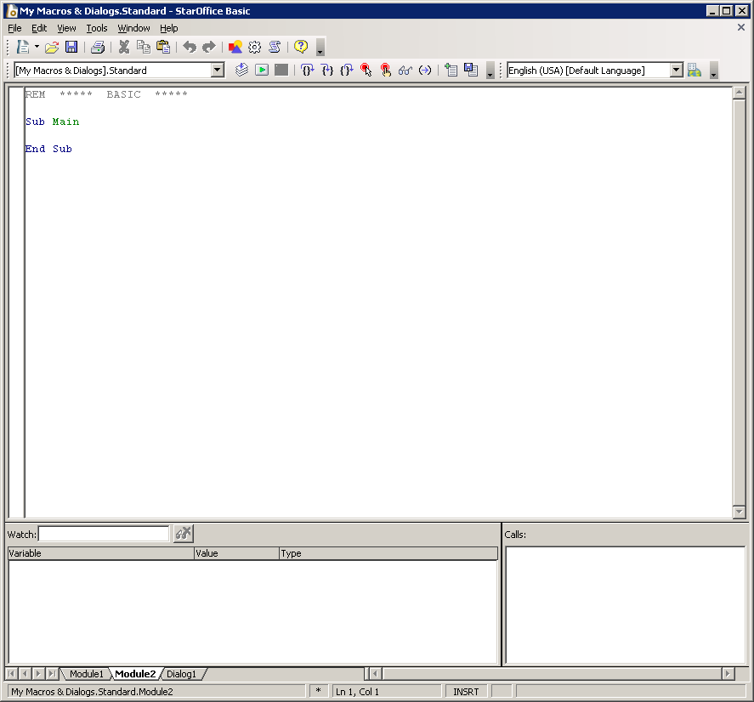Illustration 2: Basic IDE – Macro toolbar without Insert Control button

Migration
Not relevant. New function.

Configuration
No configuration needed.

File Format
Export so no change of current file format.

Open Issues
Issue | Initials | Date
<State Issue here, State “None”, if all issues are solved> |  | <Format: Dec 31, 2000>
<...>

Document Change History
Rev. | Change | Initials | Date
1 | Initial Draft of Spec. | FL | May 11, 2007
2
3
<...>

