Software Specification Document

OpenOffice.org
Import Dialog to Dialog IDE

Specification Status
Last Change | Sep 2, 2009
Status
Abstract
In addition to the already realized functionality to export dialogs described in
http://specs.openoffice.org/appwide/dialog_ide/Export_single_dialog_from_library.odt
it makes sense to also provide a corresponding import functionality. This completes the IDE feature set to handle single dialogs that are not managed within the Dialog Libraries. So a user e.g. can export a dialog, send it to anyone else, receiving a modified dialog and re-import it into his IDE. This includes all localization data.
i-Team Members
Role | First Name, Last Name, Initials | E-Mail Address
I-Team Lead | Andreas Bregas (ABR) | andreas.bregas@sun.com
Specification Author | Andreas Bregas (ABR) | andreas.bregas@sun.com
User Experience | Frank Loehmann (FL) | frank.loehmann@sun.com
Development | Andreas Bregas (ABR) | andreas.bregas@sun.com
Quality Assurance | Joerg Skottke (JSK) | joerg.skottke@sun.com
Documentation | Uwe Fischer (UFI) | Uwe.fischer@sun.com
Icon Design | Stella Schulze (STS) | Stella.schulze@sun.com

Contents
Abstract 1
i-Team Members 1
References and Reference Documents 3
Acronyms and Abbreviations 3
1 Detailed Specification 4
1.1 Dialog IDE 4
1.2 Basic IDE 5
1.3 Import handling 6
2 Migration 6
3 Configuration 6
4 File Format 6
5 Open Issues 6
Document Change History 6

References and Reference Documents
Reference Document | Check | Location (URL)
Specification Process Entry Check |  | N/A
Product Requirement, RFE, issue [Required] |  | http://www.openoffice.org/issues/show_bug.cgi?id=85434
Product Concept Document |  | <Please enter location here>
Competitive Analysis |  | <Please enter location here>
IDL Specification |  | <Please enter location here>
Test Case Specification [Required] |  | <Please enter location here>
Software Specification Rules | N/A | N/A
<Other, e.g. references to related specs>
Acronyms and Abbreviations
Acronym / Abbreviation | Definition
<WYSIWYG> | <What You See Is What You Get>

Detailed Specification

Dialog IDE
An import button to import a single dialog is added to the Dialog tool bar.
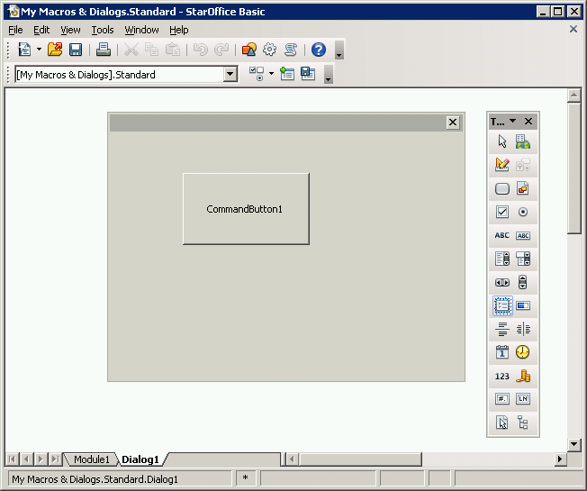Illustration 1: Dialog tool bar with additional Import Dialog button

- “Import Dialog” - Button Properties |  | Comment
Enabled: | In context of the Dialog IDE and Basic IDE (see 1.2)
Press: | An Open... dialog opens to import a dialog file
Other: | Icon:
Button Label: | Import Dialog |  | EN-US
Button Label: | Dialog importieren |  | e.g. DE

Basic IDE
The Import Dialog button will also be added to the Macro Toolbar in the Basic IDE, because otherwise the Import Dialog button won't be available at all if the library does not contain any dialog. The Import Dialog button is placed beside the Insert BASIC Source and Save BASIC buttons. A separator is added between the Basic Insert/Save and the Import Dialog button.
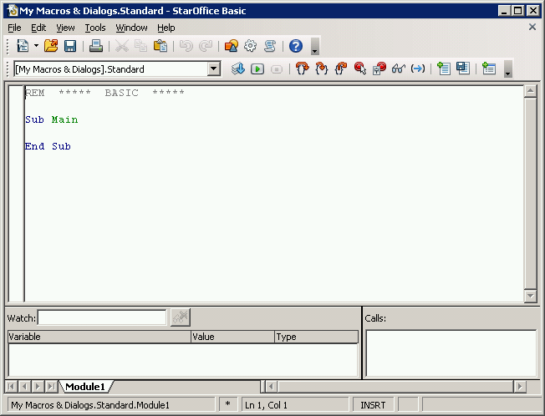Illustration 2: Basic IDE – Toolbar with Import Dialog button

Import handling
When importing a dialog some special situations need to be handled. First there can be a name conflict if the target library already contains a dialog that is named like the dialog to be imported. In this case the following dialog is shown:
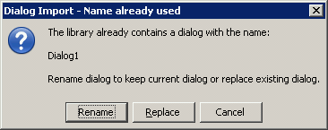Illustration 3: Dialog Import – Name already used info box
The user then can decide if he wants to rename the imported dialog (in this case the dialog will be renamed to the next free “automatic” name like when creating a new dialog) or if he wants to replace the existing one. If the user presses Cancel the dialog won't be imported at all.
Second there can be a mismatch concerning localization. If the library contains additional languages compared to the imported dialog (or if the imported dialog isn't localized at all) the additional languages will be silently added to the imported dialog using the strings of the dialog's default locale.
If the imported dialog contains additional languages compared to the library (or if the library isn't localized at all) the following dialog is shown:
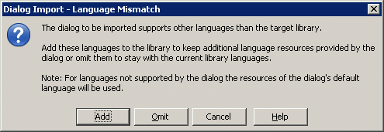Illustration 4: Dialog Import – Name already used info box
If the user decides to add the additional languages from the imported dialog for the already existing dialogs the resources from the library's default language will be used for the new languages. This is the same as if the user adds these languages manually.
If the user decides to omit the additional languages the library's language settings will stay unchanged. The imported dialog's resources for the omitted languages won't be copied into the library, but of course they remain in the imported dialog's source files.

Migration
Not relevant. New function.

Configuration
No configuration needed.

File Format
Import, so no change of current file format.

Open Issues
Issue | Initials | Date
<State Issue here, State “None”, if all issues are solved> |  | <Format: Dec 31, 2000>
<...>

Document Change History
Rev. | Change | Initials | Date
1 | Initial Draft of Spec. | AB | 09/01/09
2
3
<...>

