Software Specification Document

OpenOffice.org
Link to extensions.services.openoffice.org

Specification Status
Last Change | Jun 20, 2007
Status
Abstract

The Extension Manager dialog contains a link control, that opens a web browser with the openoffice extension web-site.
i-Team Members
Role | First Name, Last Name, Initials | E-Mail Address
I-Team Lead | Joachim Lingner (JL) | jl@openoffice.org
Specification Author | Joachim Lingner (JL) | jl@openoffice.org
User Experience | Bettina Haberer (BH) | bh@openoffice.org
Development | Peter Burow (PB), Joachim Lingner (JL) | jl@openoffice.org
Quality Assurance | Jörg Skottke (JSK) | jsk@openoffice.org
Documentation | Uwe Fischer (UFI) | ufi@openoffice.org
Other roles | <First Name, Last Name (Initials)> | <User@openoffice.org>
<State reason here, if one role is not represented in i-Team.>

Contents
Abstract 1
i-Team Members 1
References and Reference Documents 3
Acronyms and Abbreviations 3
1 Detailed Specification 4
1.1 Appearance in the Extension Manager's Dialog 4
2 Migration 5
3 Configuration 5
4 File Format 5
5 Open Issues 5
Document Change History 5

References and Reference Documents
Reference Document | Check | Location (URL)
Specification Process Entry Check |  | N/A
Product Requirement, RFE, issue [Required] |  | To RFE
Product Concept Document |  | <Please enter location here>
Competitive Analysis |  | <Please enter location here>
IDL Specification |  | <Please enter location here>
Test Case Specification [Required] |  | To Testcase
Software Specification Rules | N/A | N/A
<Other, e.g. references to related specs>
Acronyms and Abbreviations
Acronym / Abbreviation | Definition
<WYSIWYG> | <What You See Is What You Get>

Detailed Specification

Appearance in the Extension Manager's Dialog

Figure 1: The Extension Manager Dialog with the link control.
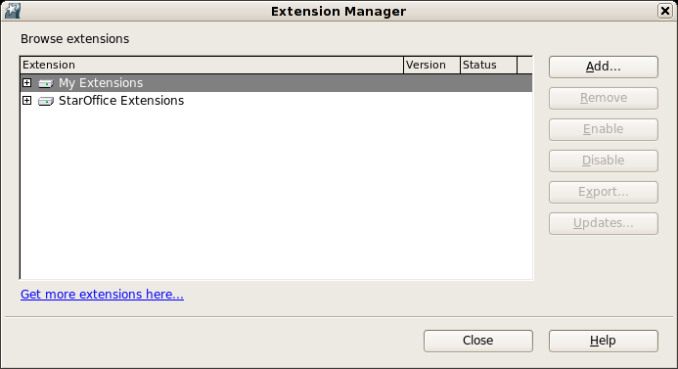

String list

Item | English | German
Link Control | Get more extensions here... | Hier finden Sie weitere Extensions...

A further, new element of the Extension Manager is a link to extensions.services.openoffice.org, the repository for extensions.
At mouse over this link the URL to the extension repository becomes visible as tool tip.
The unvisited link changes it's color to read, when it is visited. When the dialog is closed, the link again shows the unvisited status. The link is accessible by the tab key.

Migration
<Start typing here ----- If this part is irrelevant state a reason for its absence!>

Configuration

File Format
<Start typing here ----- If this part is irrelevant state a reason for its absence!>

Open Issues

Issue | Initials | Date
<State Issue here, State “None”, if all issues are solved> |  | <Format: Dec 31, 2000>
<...>

Document Change History
Rev. | Change | Initials | Date
1 | Replaced the utterly ugly mockup with a nice screenshot | JSK | Jun 20, 2007
2 | Replaced Sun internal links to public OOo links | JSK | Jun 20, 2007
3
<...>

